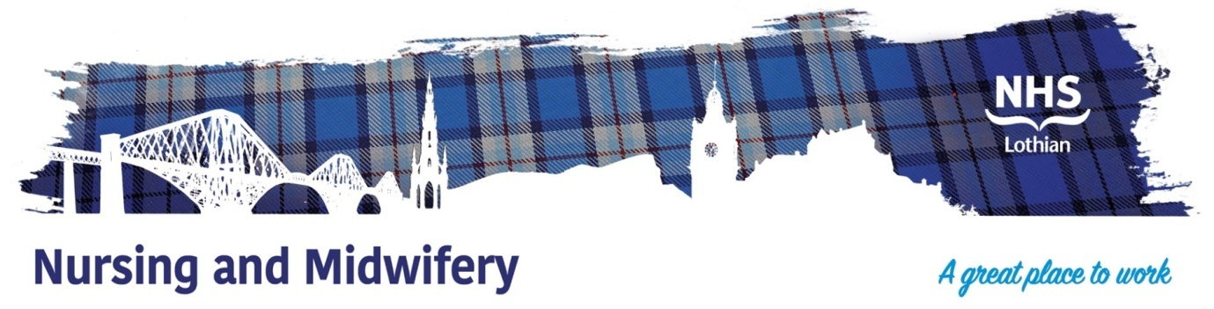

**NHS Lothian Edinburgh MAT Access Clinic (EDMAC)**

Exciting opportunity is available to join EDMAC within Edinburgh city centre. We have a Band 6 position available for a Registered Mental Health Nurse and we are looking for a passionate, caring, motivated person to join our highly skilled nursing team.

We offer the opportunity to work with talented teams within multidisciplinary environments and impact positively on the lives of thousands of patients and their families.

Find out what our staff say about working in NHS Lothian at https://careers.nhslothian.scot/acute-specialist-nurses/who-we-are/

**What We Can Offer You**

We have a range of vacancies for experienced and newly qualified nurses to join our innovative and dynamic teams across NHS Lothian – providing you with the opportunity to gain a breadth of knowledge and exposure to multiple specialties.

**Roles**

* Band 6 Community Mental Health Nurse

**Salary**

* Band 6 Range £37,831 - £46,100 (pro rata) per annum

**Benefits**

* A minimum of five weeks annual leave increasing with length of service
* A range of supportive employment policies including Flexible Working
* Full or part time hours considered
* We provide an extensive induction programme and excellent professional training and development opportunities.
* Access to the NHS Pension Scheme and Staff Benefits

EDMAC is a specialist secondary care multi-agency and multi-professional team. It comprises social care staff; health staff and third sector staff from CGL and Turning Point Scotland. It is based centrally at The Spittal Street Centre. With outreach to other sites if available based on service user need.

This team will offer an unambiguous entry point for **all** residents of Edinburgh to be assessed and offered treatment as appropriate.

*Target Population*

* People who use opiate drugs and would like to access support a prescription for MAT.
* People who require to be re titrated onto a prescription of MAT.
* People over the age of 18 (ASUS provides care for those people under 18).
* People requiring continuation of medication *commenced* in other settings i.e., police custody; prison liberation; hospital liaison where they do not have an ongoing prescriber.
* In exceptional circumstances where the local geographical service cannot provide a service (East, West, Midlothian) Non-Edinburgh residents can access the clinic.

This clinic enhances the current pathway and assists the care delivery model of locality-based Recovery Hubs by serving as the most common front-door to a central single access site with a no barriers approach.

Continuity of care will be ensured until transitioned safely to the appropriate downstream service i.e., Recovery Hubs/ Harm Reduction Team / Primary Care / Third Sector.

Colleagues in primary care, acute services, mental health, learning disabilities and criminal justice settings will be reassured they are able to direct people to access consistent, high quality, same day specialist secondary care services for people with substance use difficulties.

Wherever possible there will be an ethos of collaborative working with other services, particularly those with severe and multiple disadvantages.

 