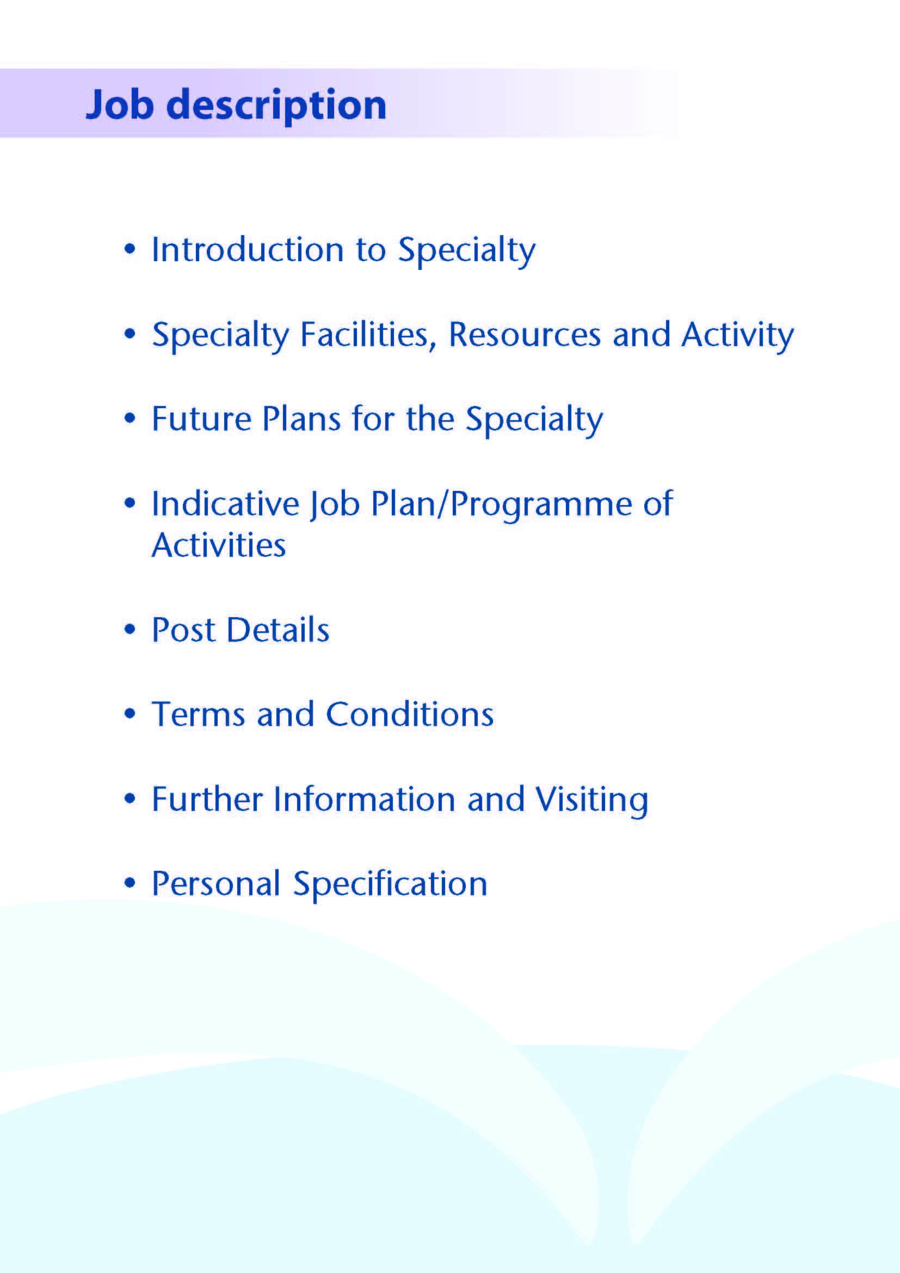



This replacement post comprises 10 sessions combining community paediatrics, safeguarding and acute medical paediatrics.

**Introduction**

The appointee will have a neuro-developmental caseload covering a geographical area of North Ayrshire. The appointee will work closely with a multidisciplinary team of AHPs co-located to that geographical area. The appointee will be fully supported by five Community Paediatrician colleagues.

The appointee will have sessional time for child protection and will contribute to acute child protection cover. The appointee will work alongside, and be supported by the Lead clinician for child protection and other colleagues.

The appointee will contribute 6 weeks each year to acute paediatric services. This will be in the form of hot weeks scattered through the year. The contribution will include inpatient care, the paediatric assessment unit and urgent out patient clinics. The appointee will also contribute to out of hours cover for acute paediatrics, resident until 9.30pm on weekdays, along with 10 colleagues and with prospective cover.

There will be time to develop a special interest in community paediatrics that complements the current provision. For example a neuro-respiratory service.

**About Ayrshire**

Situated in the picturesque south west of Scotland on the Firth of Clyde coastline, Ayrshire is a 30 minute drive from Glasgow, Scotland’s largest city, and an easy commute by road or rail to our capital city Edinburgh, making it an ideal location for those who want to enjoy city life, but who value the benefits and quality of life offered by living in a more relaxed semi-rural district.

The area boasts all you could ask for, whether you enjoy an active outdoor lifestyle, or take a more laid back approach to life enjoying the culture and heritage of the area, it’s all on your doorstep. There are first class sports and recreational facilities, including 40 quality golf courses and award winning visitor attractions in addition to a vast array of restaurants and bars.

The isle of Arran, less than an hour away by ferry, is known as Scotland in miniature, and provides an ideal “overseas” escape, while the Isle of Cumbrae boasts one of Scotland’s premier watersports centres.

The area is supported by excellent road and rail services. National and international flights are available from Glasgow International Airport, and our own local airport, Glasgow-Prestwick, offers a wide range of routes including daily flights to Dublin and a number of major European cities.

All this coupled with excellent housing, quality local authority and private schooling and excellent transport links, sets Ayrshire in an enviable position when it comes to offering a quality lifestyle for those who choose to live and work in the area.

For more information on what Ayrshire has to offer visit www.ayrshireandarran.com and for information on local authority services, including schooling, visit www.south-ayrshire.gov.uk ; www.north-ayrshire.gov.uk and www.east-ayrshire.gov.uk



NHS Ayrshire and Arran has a total population of approximately 370,000 with 70,000 children under the age of 16 years. There are approximately 3,000 deliveries a year.

**Facilities**

**Community Paediatrics and Community Child Health:**

The Community Child Health Service is delivered from numerous locations across Ayrshire and Arran. The Child Development Centre (Rainbow House) acts as our hub and is located at Ayrshire Central Hospital in Irvine. The Community Paediatric Team, comprising Medical, Nursing, Physiotherapy, Occupational Therapy, Clinical Child Psychology, Speech and Language Therapy and administrative staff, is located within Rainbow House.

Much of the clinical work of the Team is delivered at locations outside the Unit. Our unit assesses and coordinates investigation where there are early developmental difficulties. We support Individuals with an identified intellectual disability who have additional health needs, such as physical impairment or epilepsy. Our psychology service in Rainbow House provides the neuropsychology expertise for assessment of patients with epilepsy and brain injury and is a resource for other psychology teams in acute paediatrics and CAMHS. We continue to work with CAMHS to consider the needs of those children and young people whose needs stretch across our two services. The plan for a young person’s forensic unit on site reinforces this need for joint working.

In addition to neurodevelopmental clinics, specialist paediatric clinics held in Rainbow House include, Epilepsy, Neuromuscular (principally Duchenne MD), Communication Disorders (ASD), Tone Management and Botulinum Toxin Assessment and Review. Recent service development work includes the development of a transition pathway for young people with complex needs and work continues to link this with other agencies. One of our consultant colleagues has developed an interest in Foetal Alcohol Spectrum Disorder (FASD), and acts as a supportive resource for other colleagues, having piloted a flagship service for FASD. A nurse led sleep clinic has been established to support patients on the Rainbow House clinical caseload with sleep onset disorders. Each locality is additionally served at present by one paediatric specialty doctor to provide support for nurseries and schools, liaise with Education and Social Work and develop special interests, including adoption and fostering and autism assessment.

**General Paediatrics:**

The Paediatric Unit at Crosshouse Hospital is responsible for the in-patient and out-patient care of individuals up to their 16th birthday. A major reconfiguration of the service took place in 2006, bringing all inpatient services in Ayrshire on to one site. The general Paediatric Unit at Crosshouse Hospital was extended and completely refurbished to provide co-location of a dedicated Outpatient Suite with 6 consulting rooms, a 10-bedded Children’s Assessment Unit and a dedicated inpatient unit including not only medical paediatrics, but also paediatric surgical specialities (general paediatric surgery, orthopaedics, ENT, dental surgery and ophthalmology). There are 23 inpatient beds, including 4 in a dedicated adolescent facility. The majority of patients for elective surgery in the above specialities are catered for in the Day Surgery Unit (separate from the inpatient facilities).

Acute paediatrics is supported by five advanced nurse practitioners (APNPs) with another one in training. There is an APNP on shift 8am to 8pm seven days a week. The APNPs also have speciality roles and contribute to the asthma service and looked after and accommodated service. Other nursing colleagues have developed roles in rheumatology, gastroenterology, continence services and endocrinology, to name a few. The paediatric outpatient practitioners at Crosshouse provide a phlebotomy service and have certification in plastering.

The Ayr Hospital also has a dedicated Paediatric out-patient suite. In addition, General Paediatric out-patient clinics are held at Ayrshire Central Hospital in Irvine, East Ayrshire Community Hospital in Cumnock, the Davidson Hospital in Girvan and the War Memorial Hospital in Lamlash on the Isle of Arran. Most clinics are of a general nature, but there are dedicated epilepsy, cystic fibrosis, diabetes, rheumatology, gastroenterology, renal and genetics clinics. A number of the specialty clinics are held locally with a visiting specialist from Glasgow Children’s Hospital.

The Consultant Paediatricians operate a hot week system of working in general paediatrics and the appointee will participate in this. The RCPCH Facing the Future recommendations envisage consultants taking an active role in evening working in leading the team and managing handovers. The consultant is expected to be resident on call in the evening until 9.30pm on weekdays and this is built into the job plan with a time shifted day off each week.

**Neonatology:**

Ayrshire Maternity Unit is the only maternity unit in Ayrshire, catering for approximately 3,000 deliveries per annum. It is a Local Neonatal unit with close links to the Queen Elizabeth University Hospital in Glasgow. There are 18 cots, with 8 designated as intensive care/high dependency, and a 4-bed transitional care area in the postnatal ward.

Community Paediatric links with the Neonatal Unit include in-reach with joint consultation for families, with colleagues from the Neonatal Unit in the perinatal and neonatal period. The appointee will not have any acute or on-call responsibilities in the neonatal unit.

**Education:**

Undergraduates from Glasgow and Dundee Universities come to Ayrshire for paediatric blocks. Foundation Year 2 and General Practice Specialty Trainees in their first 3 years of training constitute the tier 1 rota. West of Scotland Specialty Paediatric Trainees come to Ayrshire at various stages of their training for periods of up to one year on our middle grade rota. Up to 4 specialty trainees at a time are allocated to Rainbow House to achieve their community child health competencies. The appointee will be expected to contribute to medical student teaching.

We have an active CME programme in General Paediatrics including visiting speakers, peer review of medical and child protection cases and general case discussions. Community Paediatrics host additional departmental teaching and peer review sessions.

**Medical Staff Resources**

**Consultants**

Community Paediatricians

Dr Gemma Duffy (Clinical lead Community and LAAC/ Neurodisability)

Dr Nuno Cordeiro (Neurodisability/Epilepsy/Muscle and tone/Realistic medicine)

Dr Mona Rahim (Child Protection/Neurodisability)

Dr Sarah Brown (LAAC/Fetal Alcohol Syndrome/Neurodisability)

Dr Ruth Addison (Clinical Lead Child Protection, LAAC/ Neurodisability)

General Paediatricians

Dr Bridget Oates (Clinical Director/Rheumatology)

Dr Calum Morrison (Cardiology/Epilepsy, Deputy Medical Director)

Dr Lawrence Armstrong (Gastroenterology)

Dr Scott Williamson (Endocrinology/Diabetes)

Dr Christine Findlay (Diabetes/Epilepsy)

Dr Natalie Connell (Respiratory)

Dr Amani Yacoub (Diabetes/ Child Protection/Haematology)

Dr Geetika Kumar (Nephrology/Allergy/TB/Undergraduate teaching lead)

Neonatologists

Dr Tim Adams (Clinial Lead/Respiratory)

Dr Raju Sunderesan (Undergraduate lead for Dundee students)

Dr Althaf Ansary (Cardiology)

Dr Beata Kamsuella

Dr Sue Ann Lim (RCPCH College tutor)

**Associate Specialist:**

Dr Fiona Barnes (Neonates)

**Speciality Doctors:**

Dr Sarah Coy (General / Palliative Care lead)

Dr Jamila Siddique (Neonates/Realistic medicine)

Dr Adarsh Vijayan (Community/Vision impairment)

Dr Gerald Lui (Community/Autism)

Dr Cara Owens (Neonates /General)

Dr Andrea McKeown (Community/LAAC lead/Realistic Medicine lead)

Dr Theresa Carswell (Adoption and Fostering)

**Trainees:**

11 Paediatric STs, 6 GPSTs, 7FY2s, 1 BBT

**Activity**

**Figures for outpatient appointments in Community Paediatrics**

|  |  |  |  |
| --- | --- | --- | --- |
| Area and Clinic Type | New | Review | Locality totals |
| South Ayrshire New | 505 | 820 | 1325 |
| North Ayrshire New | 764 | 780 | 1544 |
| East Ayrshire New | 470 | 754 | 1224 |



Various challenges face our service at present. We anticipate a steady reduction in middle grade posts over the next few years and are planning to cope with this using a combination of strategies including development of more nurse practitioners and specialist nurses as well as changes in consultant working patterns.

We also face challenges with future proofing a service to cope in the longer term with retirements and the ongoing reorganisation of children’s services. We would anticipate further amalgamation of traditionally community based and acute services in terms of providing a single well-coordinated service to meet all the health care needs of the children of Ayrshire.

Providing a robust Safeguarding service is also a pressure point and service re-development is ongoing.

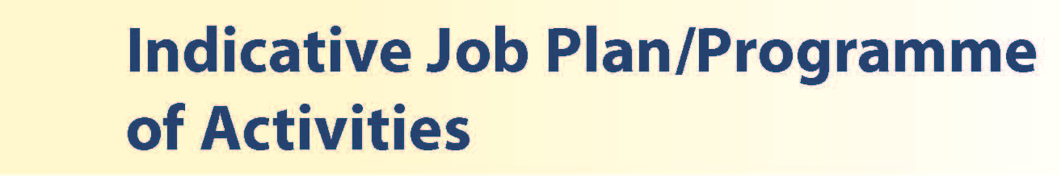

A prospective timetable for non-hot weeks for the 10 PA post is given below; while total sessions are correct, the times of different activities may change depending on availability of clinic space and commitments, including agreed Supporting Professional Activity (see notes on the programme). This is an example only and the appointee will be able to discuss their needs for time shifted days off / half days with the Clinical director / clinical lead for community paediatrics

|  |  |  |  |
| --- | --- | --- | --- |
| **DAY** | **HOSPITAL/ LOCATION** | **ACTIVITY** | **TOTAL HOURS PER ACTIVITY INCLUDING TRAVEL TIME** |
| Monday  9am – 1pm  1pm – 5 pm | AM Rainbow House  PM Rainbow House | Clinic  Patient admin | 4 DCC  4 DCC |
| Tuesday  9am – 1pm  1pm - 4 pm | AM Rainbow House  PM Rainbow House | Child Protection  SPA | 4 DCC  4 SPA |
| Wednesday  9am – 1pm  1pm – 5pm | AM Rainbow House  PM Rainbow House | Develop special interest  Patient admin | 4 DCC  4 DCC |
| Thursday  9am – 1pm  1pm – 5pm | AM Rainbow House  PM Rainbow House | Clinic  Patient admin | 4 DCC  4 DCC |
| Friday  9am – 1pm  1pm – 5pm | AM Off  PM Off | Time shifted for OOH  Time shifted for OOH | 4DCC  4 DCC |
|  |  |  | **36 DCC**  **4 SPA** |

Hot weeks are based in general paediatrics, and entirely devoted to clinical work and education of students and trainees. The appointee will have 6 weeks distributed across the year.

The job plan will be reviewed with the successful candidate no later than 3 months following appointment and where possible discussion may take place in advance of appointment. Job plan review thereafter will be no less frequent than annually. Opportunities may exist for Extra Programmed Activities to be undertaken subject to service requirements and in accordance with national terms and conditions of service.

**Notes on the Programme**

**Patient Administration**. This activity covers the management of individual patients including Out Patient administration, results reporting, letters/’phone calls to parents, carers, GPs and members of the wider multidisciplinary team involved in the patients’ care.

**Hotweeks:** the time allocated is indicative and will be discussed with the appointee. Ward work will include teaching ward rounds as required.

**On call arrangements:** Resident until 9.30pm on weekdays. On call rota with another 10 colleagues and prospective cover.

**Travel:** Any travel allocation will be included within the Total Programmed Activities and will be determined by location at which Direct Clinical Care and Supporting Professional Activities are carried out.

**Supporting Professional Activities:** NHS Ayrshire and Arran recognise the important role Job Planning has in ensuring consultants are supported in delivering high quality, safe, sustainable clinical care to patients. It is therefore important to ensure there is an adequate balance between direct clinical care activities and activities which support both the personal and professional development of the consultant workforce and facilitates agreed contribution to activities including:

* Under and post graduate teaching/training
* Clinical Governance
* Quality and Patient Safety
* Research and Innovation
* Service management and planning
* Work with professional bodies

All consultants will have 1 SPA as a minimum to support job planning, appraisal and revalidation. However the final balance of SPA and DCC activity will be agreed between the appointee and clinical manager prior to contracts being agreed.

There may be a requirement to vary the DCC outlined in the indicative timetable above when the final balance of DCC and SPA is subsequently agreed. There may also be opportunities to contract for Extra Programmed activities subject to service requirements and in accordance with national terms and conditions of service.

If the post-holder will be responsible for the formal training and supervision of post-graduates and under-graduates, a suitable additional allocation of SPA time will be made in accordance with national guidance.

The total programme is 10 PAs.

**Job Plan Review**

New appointees will discuss the indicative job plan with the Clinical Director, prior to commencement and will at that time review the balance of activities. Where it is possible to agree revisions to the indicative plan in advance of commencement this will be acted upon. In any event however, there must be an interim Job Plan review conducted at 3 months post commencement to agree and finalise the Job Plan. The consultant at time of induction should ask for an interim review date to be scheduled. The agreed job plan will include all the consultant’s professional duties and commitments, including agreed Supporting Professional Activities.    Thereafter Job Planning will be carried out annually as part of the Boards Job Planning process.

**Private Practice:** If the post-holder wishes to undertake any private practice, they are obliged to inform their employer at the time of appointment of their intentions to do so. This should be submitted in writing to the Clinical Director. The conduct of private practice will be in accordance with the Consultant Contract (Scotland) Terms and Conditions.

The post-holder shall be free to undertake private practice without approval provided such work is undertaken outside the time agreed in the job plan for programmed activities. (Refer Section 6 of the New Consultant Contract).



* The post-holder will be accountable to the Clinical Director for Paediatrics and Child Health, Dr Bridget Oates, who will agree the Job Plan.
* The post-holder will be expected to work with local managers and professional colleagues in the efficient running of services and will share with Consultant colleagues in providing the medical contribution to management.  Subject to the provisions of the Terms and Conditions of Service, they are expected to observe the Directorate’s agreed policies and procedures, drawn up in consultation with the profession on clinical matters, and to follow the standing orders and financial instructions of NHS Ayrshire & Arran.
* In particular, where the postholder formally manages employees of NHS Ayrshire and Arran, the postholder will be expected to follow the local Board and National Employment and Personnel Policies and Procedures.
* The postholder is required to comply with the Organisation's Health and Safety Policies.

**Resources**

The staff resources of the department are listed elsewhere.  The postholder will have access to such general administrative support as is required for the discharge of his/her duties and responsibilities. This will include the provision of adequate secretarial and clerical support and the availability of accommodation, equipment etc.

The postholder will receive support from such other professional staff as are employed within the Directorate and are deployed to his/her area of patient care.

The postholder will be provided with necessary personal devices to enable the fulfilment of their duties and responsibilities.

**Duties and Responsibilities**

The main duties and responsibilities of the post include:

* The new appointee will be responsible, with consultant colleagues, for the care and management of children in Ayrshire who require secondary level care.
* Responsibilities for carrying out teaching, accreditation and examination duties as required, and for contributing to undergraduate andpostgraduate medical education. The postholder will be expected to comply with College recommendations on Continuing Medical Education.
* The postholder will be required to comply with Organisational Policies on Clinical Governance.
* Contribution to the child protection team, acute and comprehensive medicals.
* The successful applicant will be encouraged to participate in research and to develop a relevant sub-specialty interest, subject to resources and local priorities. An interest in Neuro-respiratory is particularly welcome.
* Requirements to participate in medical audit and in continuing medical education
* Managerial, including budgetary, responsibilities (where appropriate).

**Annual Appraisal & Job Planning**

The postholder will also be required to participate in annual appraisal.   Job planning is linked closely with, but is separate from, the agreed appraisal scheme for consultants.   The job plan review will take into account the outcome of the appraisal discussion and reflect the agreed personal development plan.

**Summary**

The successful applicant will join a friendly, hard-working team striving to provide excellent care and to develop services in a department with a relaxed and supportive ethos.



The Terms and Conditions of Service are those determined by the Terms and Conditions of the New Consultant Grade (Scotland) as amended from time to time. The distance that a consultant can reside from the principal base hospital, where travel time is seen as more important than mileage, is subject to the agreement of the Executive Medical Director, but it is usually anticipated that a journey that takes no more than 30 minutes for any emergency situation would be acceptable.



Please come to visit us and have a look about! Applicants wishing further information about the post are invited to contact Dr Gemma Duffy or Dr Bridget Oates, with whom visiting arrangements can also be made.

It is anticipated that the interviews will take place on Monday 14th April 2025 with a view to the successful candidate coming into post at a date which is mutually convenient to all parties.



**Post of: Consultant Community Paediatrics**

**Location: Rainbow House, Ayrshire Central Hospital, Irvine**

## Qualifications:

|  |  |
| --- | --- |
| Essential | Desirable |
| Full GMC Registration with current Licence to Practice |  |
| **Existing Consultants**: Inclusion on the GMC Specialist Register  **New Consultants**:  CCT in Paediatrics or be within 6 months of anticipated award of a CCT/CESR at the time of  interview for the post. | Sub specialty training leading to CCT in Community Child Health |
| Membership of Royal College of Paediatrics and Child Health or equivalent |  |
| **APLS or equivalent paediatric resuscitation certificate** |  |

**Skills/Knowledge/Competence**

|  |  |  |
| --- | --- | --- |
| **Requirements** | **Essential** | **Desirable** |
| **General Experience:**   * Expertise in Generalist field * Expertise in sub-specialty field | * Comprehensive knowledge of paediatrics * Wide and relevant training in the assessment of child development and multiagency working in community paediatrics * Ability to communicate effectively with children of all ages and their families and with all levels of staff * Ability to work efficiently and timeously * Experience of child protection | * IT literacy * Necessary knowledge and skills to develop a neuro-respiratory service |
| **Team Working** | * Ability to lead others and think strategically * Effective Team Player |  |
| **Development** | * Evidence of relevant Continuing Professional Development * Evidence of satisfactory compliance with appraisal requirements |  |
| **Teaching & Training** | * Ability to deliver high quality teaching to medical students, junior medical staff and colleagues in other health professions | * Interest in and knowledge of advances in medical education and training. |
| **Research & Publications** |  | * Evidence of publications of a high standard relating to specialty |
| **Clinical Audit** | * Evidence of interest and experience in medical audit |  |
| **Management and Administration** | * Ability to lead a clinical team * Commitment to effective departmental management * Proven organisational skills | * Proven management experience * Understanding of resource management and quality assurance. |
| **Personal and Interpersonal Skills** | * A willingness to accept flexibility to meet the changing needs of the NHS in Scotland * Effective communicator and negotiator * Demonstrate effective leadership * A willingness to develop special interests which conform to the needs of NHS Ayrshire and Arran * Ability to operate on a variety of different levels | * Knowledge of recent changes in the NHS in Scotland |