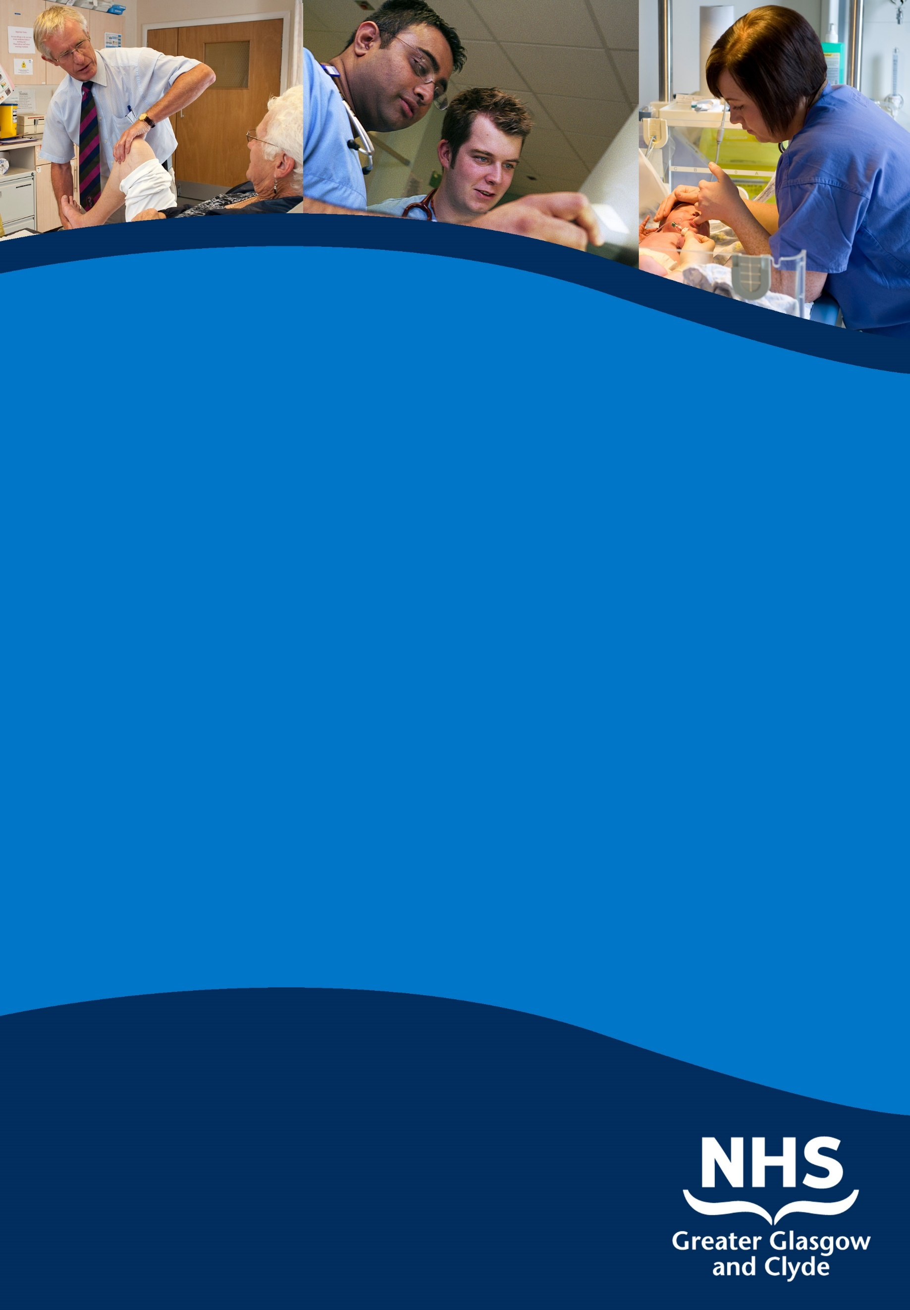

**senior clinical fellow in neurosurgery**

**QUEEN ELIZABETH UNIVERSITY hospital**

**Information pack**

**reF:**

**Closing Date:**

www.nhsggc.org.uk/medicaljobs

**SUMMARY INFORMATION**

**Post: senior clinical fellow in neurosurgery**

**Base: Queen Elizabeth University Hospital, Institute of Neurological Sciences**

This post is designed to meet the needs for further sub-specialty training for those with, (but not essential), a recently-acquired CCT (or equivalent) in neurosurgery. The appointments are for one year from as soon as possible and will be based in the Department of Neurosurgery, Institute of Neurological Sciences, Queen Elizabeth University Hospital, Glasgow. The spectrum of adult sub-specialties are practised within the department and there will be flexibility allowed in the choice of which interests the candidate pursues and include Skull base and Pituitary, Complex spine and Neuro-oncology.

The successful candidates will also be expected to contribute to the general neurosurgical workload of the unit, including on-call duties at SpR level, training of juniors, and administrative duties.

This post has no formal approval as a Post CCT Fellowship but will conform as far as possible to the principles accepted as necessary for good training in the chosen sub-speciality.

**REGIONAL SERVICES DIRECTORATE – NHS GREATER GLASGOW AND CLYDE HEALTH BOARD**

**SENIOR CLINICAL FELLOW (SCF) IN NEUROSURGERY**

**Job Description**

**1. INTRODUCTION**

These are already established post assigned to meet the need for further sub-specialty training for those whom either have ideally acquired CCT (or equivalent) in neurosurgery The appointments are for one year from as soon as possible and will be based in the Department of Neurosurgery, Institute of Neurosciences (INS), Queen Elizabeth University Hospital (QEUH), Glasgow. The spectrum of adult and paediatric sub-specialties are practised within the department and there will be flexibly allowed in the choice of which interests the candidate pursues and include Skull base and Pituitary, Complex spine and Neuro-oncology.

The appointee will also be expected to contribute to the general neurosurgical workload of the unit, including on-call duties at senior SpR level, training of juniors, and administrative duties.

This post has no formal approval as a Post CCT Fellowship but will conform as far as possible to the principles accepted as necessary for good training in the chosen sub-speciality. There is a solid training atmosphere within the department and the unit has a good success rate of trainees passing the FRCS (SN). Most of our trainees go onto consultant positions within the UK or abroad. Training as well as research opportunities are available and encouraged in the department. The appointee will not practise independently, and the responsibility for individual patient management will always rest with the consultant concerned. However a degree of clinical freedom will be given to those appointees with suitable skills.

Specialty teaching is organised locally in the unit with weekly educational meetings and quarterly teaching sessions, including FRCS exam viva practice. Also regional teaching for registrars may be available to the fellow, this is tailored to the neurosurgical syllabus in preparation for the FRCS.

Research opportunities are available in the unit and will be supported. The new Imaging Centre for Excellence (ICE) building with a 7 tesla MRI is co-located adjacent to the INS. Additionally there is excellent ICP research coming from the BrainIT group from the University of Glasgow with team members based in the INS.

The Department of Neurosurgery in Glasgow is the largest in Scotland. It has the range of sub-specialties represented in neurosurgery, including national services for deep brain stimulation, spinal cord injuries, paediatrics and selective dorsal rhizotomy. We receive referrals predominately from the West of Scotland but also from the rest of the country. This post will therefore allow a good training experience and help build a solid foundation for a career as a consultant.

**2 THE DEPARTMENT**

**Queen Elizabeth University Hospital**

The QEUH is a 1,677-bed acute hospital located in in the South-West of Glasgow. The hospital is built on the site of the former Southern General Hospital and opened in 2015. The hospital comprises a newly built 1,109 bed adult hospital, a 256-bed children’s hospital (Royal Hospital for Children) and two major Emergency Departments, one for adults and one for children, in addition to buildings retained from the former hospital. The retained buildings include maternity services, the INS and the Langlands Unit for medicine of the elderly and rehabilitation. The facility is operated by NHS Greater Glasgow and Clyde which is the largest health board in the UK.

Services include Accident and Emergency, Major Trauma Centre, Dermatology, ENT, General Medicine (including sub-specialties), General Surgery (including sub-specialties), Medicine for the Elderly (including Assessment, Rehabilitation and Day Services), Gynaecology, Neonatal Paediatrics, Obstetrics, Ophthalmology, Orthopaedic Surgery, Urology, Physically Disabled Rehabilitation and Continuing Care. In-patient Maxillofacial (trauma and elective surgery and specialist provision for head and neck cancer), Dermatology and the Assessment and Rehabilitation service for the Physically Disabled are also provided for the whole city from the QEUH.

There is also a wide range of therapeutic services including Audiology, Clinical Psychology, Dietetics, Occupational Therapy, ECG, Physiotherapy, Radiology (including MRI and CT provision for the general hospital service) and Speech Therapy.

**The Institute of Neurological Sciences**

The INS is based on the QEUH campus and provides Neurosurgical, Neurological, Clinical Neurophysiology, Neuroradiological and Neuropathology facilities for the West of Scotland and other regions of Scotland.

The INS is equipped with a Magnetic Resonance Imaging Suite, SPECT ­Scanner, two Computerised Axial Tomography Scanners, and angiography facilities. The INS has ICU, HDU and outpatient facilities and also houses ENT and Oral & Maxillofacial Services. The new ICE is located within the INS and has a 7 Tesla MRI. This will allow an exciting research potential and will be actively encouraged in the department.

**Spinal Injuries Unit**

The QEUH National Spinal Injuries Unit for Scotland provides a spinal injuries ­service to the whole of Scotland. This is housed in a purpose-built facility also co-located in the INS. The department receives referrals from across Scotland and also allows excellent training exposure for spinal trauma and surgical management.

**University Links**

The QEUH has built a sound academic and research base over the years, and has an excellent teaching reputation with libraries and lecture suites with comprehensive audio/visual facilities on site. There are close links with the University of Glasgow's Faculty of Medicine including Professors within Neurosciences.

**3. NATIONAL MANAGED SERVICE NETWORK**

The Department of Neurosurgery in Glasgow is one of four Scottish Neurosurgical centres who are now part of a national managed service network (MSN). Formed in 2009, the MSN is an innovative model, the first of its kind in Scotland. Building on the fundamental principles of Managed Clinical Networks and extending these across the whole service, it aims to ensure that neurosurgical services in Scotland are equitable and consistent in terms of access and quality. The MSN is responsible for ensuring a national approach to the development of services, for the development, implementation and assessment of nationally agreed service standards and care pathways, and for the promotion of nationally coordinated research and development. Good quality, consistent data are fundamental to progress in these areas.

The MSN offers enormous opportunity for the pursuit of specialist interest(s) within the Scotland-wide context provided by the Network. In addition to taking a full share of the general neurosurgical workload in Glasgow and developing and strengthening services locally, the post holder will be encouraged to take an active role in working within the MSN to develop specialist services within a national perspective.

The MSN structure is headed by a Network Board and supported by an operational management group which is chaired by the national Clinical Director, Ms Jennifer Brown, Consultant Neurosurgeon, QEUH, Glasgow.

**4. WORK OF THE DEPARTMENT**

The Department of Neurosurgery is situated within the main block of the INS at the QEUH. The Unit supplies a regional service to a population of almost 3 million, mainly from the West of Scotland (NHS Greater Glasgow and Clyde, NHS Ayrshire & Arran, NHS Lanarkshire, NHS Highland and NHS Western Isles), although some patients are referred from other areas of Scotland or England for sub-specialty care. This includes both adult and paediatric referrals.

Neurosurgery is part of the Regional Services Directorate for NHS Greater Glasgow and Clyde. Dr David Dodds is Associate Medical Director for the Directorate, Ms Susan Groom is Director and Ms Cathy McLean is General Manager for Neurosciences, Oral & Maxillofacial Services and Spinal Injuries. Each Department within Neurosciences, OMFS and Spinal Injuries has a management-appointed Lead Clinician.

The department has close links with the Departments of Neurology, Neuropathology, Neuro-anaesthesia, Neuroradiology, Maxillofacial Surgery, Neuropsychology and Clinical Physics, with Paediatric services at the Royal Hospital for Children and with the Oncology Services at the Beatson Cancer Centre. The department also has visiting specialists from Neuro-ophthalmology and Neuro-otology.

The Neurosurgical Department works on a team system with three clinical adult teams and one paediatric team. Consultants are involved in undergraduate and postgraduate teaching, and are usually offered an honorary position by the University of Glasgow. There is a long history of successful clinical research and all consultants and junior staff are encouraged to participate. There are opportunities through the University Department of Clinical Neurosciences to carry out basic research.

There are 69 adult neurosurgical beds and a suite of three neurosurgical theatres located next to the two maxillofacial theatres. In addition, there is a six-bedded ITU and a four-bedded HDU shared with the other specialties within the Division. The Neurosurgical teams are based around the three adult wards. There are 10 specialist trainees at ST3 or above in addition to this post, as well as 10 further junior trainees at FY2/ST1-2/ Junior Clinical Fellow grades who rotate between the teams. Routine emergency and elective work within the Unit is sub-divided approximately equally between teams but within this framework the development of special interests is established and encouraged.

The post offers excellent opportunities for modern neurosurgical practice. There is close collaboration with Interventional Radiologists, Maxillofacial Surgeons, and Neuro-otologists. The National Spinal Injuries Unit is located in an adjoining building to the INS, and there is a close working relationship between the two units.

**3 ENTRY REQUIREMENTS**

The Trainee will be appointed by a Committee comprising representatives of the Department of Neurosurgery, QEUH, Regional Services Directorate.

Candidates must possess a CCT, CCST or equivalent experience in Neurosurgery, and be in a position to benefit from such an appointment. It is expected that the successful candidate will already be competent to manage most common neurosurgical conditions, both urgent and elective. The appointee will require excellent communication skills in English, good leadership qualities, and the confidence to work in a robust clinical atmosphere.

**4 DUTIES OF THE POST**

The duties will be those of an experienced senior trainee and include the overall management of patients in the ward, theatre and clinic under the supervision of neurosurgical consultants. The post holder will be expected to help and supervise the more junior trainees. The level of responsibility allowed in patient management and operating will be related to the individual’s level of experience, but is expected to be close to that of a recently-appointed consultant.

Every effort will be made to facilitate further training in the sub-specialist area(s) of the candidate’s choice. On-call support is available 24/7 from both an adult and a paediatric consultant neurosurgeon.

Administration

The trainee will be expected, when appropriate, to participate in the day to day running of the department by undertaking administrative activities such as organisation of some postgraduate training or meetings, patient reports and letters*.*  The SCF may be required to attend the weekly or fortnightly Neurosurgical Divisional Meetings as the junior staff representative. If so, he/she will be primarily responsible for supervising and co-ordinating the junior staff leave and on-call requirements.

The development of other administrative or management skills will be encouraged as appropriate.

Communication

This will include discussion with neurosurgical consultants regarding clinical problems, communication with General Practitioners, liaison with other specialists, and interaction with other agencies such as the Procurator Fiscal, police etc.

## Teaching

The SCF will be expected to take part in departmental teaching for junior staff, undergraduates, nursing staff, etc.

**5** **HOURS OF WORK AND PAY**

The post is subject to the EWTD. The post-holder will be part of an 16-person, 2 resident on call rota design. The standard day duty commences at 08.30 and finished at 17:00; the long day shift commences at 08:30 and finishes at 21:00, and the evening duty commences at 20:30 and finishes at 09:30. There will be a half-hour handover every morning and evening. Annual leaves and study leaves are covered prospectively.

**6 EDUCATION**

Continuing Education

The Trainee will be expected to participate in educational activities on a local and national basis.

Within the INS, Wednesday mornings are set aside as an academic morning with a programme of meetings, lectures and clinical or clinico-pathological case presentations. There is a monthly meeting to audit deaths which have occurred within the unit and there is a weekly neuro-oncology MDT meeting.

During the Academic year, there are weekly clinical meetings for the whole hospital.

**7 LEAVE**

There will be an annual leave entitlement based on the point of the scale a person is appointed to, therefore point 1/2 equates to 28 days plus 8 public holiday and point 3 and above equates to 33 days plus 8 days public holiday. However the SCF will not be permitted to take more than three weeks leave in the first six months of the post. The procedure and rules governing annual leave requests will be the same as for hospital consultants. Leaves will also have to be co-ordinated with the shift.

Study leave is discretionary for the SCF, but approval will be given where appropriate and consistent with the needs of the service.

**8 VISITS TO THE DEPARTMENT**

Applicants are strongly encouraged to visit the department prior to interview to discuss their training requirements and all other aspects of the post.

In the first instance contact: Mr. Nigel Suttner, Consultant Neurosurgeon, nigel.suttner@ggc.scot.nhs.uk, 0141 201 2108.

# TERMS AND CONDITIONS OF SERVICE

The conditions of service are those laid down and amended from time to time by the Hospital and Medical & Dental Whitley Council.

|  |  |
| --- | --- |
| **TYPE OF CONTRACT** | Fixed Term (1 year) |
| **GRADE AND SALARY** | Senior Clinical Fellow  £ 34,901 - £ 54,879 per annum (pro rata)  New Entrants to the NHS will normally commence on the minimum point of the salary scale, (dependent on qualifications and experience). Salary is paid monthly by Bank Credit Transfer. |
| **HOURS OF DUTY** | Full Time 40.00 |
| **SUPERANNUATION** | You have the option to join the NHS Superannuation Scheme, to participate in the State Earnings Related Pension Scheme or to take out a Personal Pension. Employee’s contributions to the NHS Scheme are Tiered based on your earnings and the employers contribution equates to 13.5 % of salary. Employees in the NHS Scheme are “Contracted-out” of the State Earnings Related Pension Scheme and pay a lower rate of National Insurance contributions. Employees who choose to participate in the State Earnings Related Pension Scheme pay the higher rate of National Insurance contribution. A Stakeholder Pension is also available. A Personal Pension is a private arrangement agreed with the pension provider that will be an organisation such as a Bank, Building Society or Insurance Company. |
| **REMOVAL EXPENSES** | Assistance with removal and associated expenses may be given and would be discussed and agreed prior to appointment. |
| **EXPENSES OF CANDIDATES FOR APPOINTMENT** | Candidates who are requested to attend an interview will be given assistance with appropriate travelling expenses. Re-imbursement shall not normally be made to employees who withdraw their application or refuse an offer of appointment. |
| **TOBACCO POLICY** | NHS Greater Glasgow and Clyde operate a No Smoking Policy in all premises and grounds. |
| **DISCLOSURE SCOTLAND** | This post is considered to be in the category of “Regulated Work” and therefore requires a Disclosure Scotland Protection of Vulnerable Groups Scheme (PVG) Membership which currently costs £59.00. The cost of the PVG Membership will be initially paid by NHS Greater Glasgow and Clyde and will required to be repaid through a payroll deduction mandate from the successful candidate’s first salary. |
| **CONFIRMATION OF ELIGIBILITY TO WORK IN THE UK** | NHS Greater Glasgow and Clyde (NHSGGC) has a legal obligation to  ensure that it’s employees, both EEA and non EEA nationals, are legally entitled to work in the United Kingdom. Before any person can commence employment within NHS GGC they will need to provide documentation to prove that they are eligible to work in the UK. Non EEA nationals will be required to show evidence that either Entry Clearance or Leave to Remain in the UK has been granted for the work which they are applying to do. Where an individual is subject to immigration control under not circumstances will they be allowed to commence until the right to work in the UK has been verified. ALL applicants regardless of nationality must complete and return the Confirmation of Eligibility to Work in the UK Statement with their completed application form. You will be required provide appropriate documentation prior to any appointment being made. |
| **REHABILITATION OF OFFENDERS ACT 1974** | The rehabilitation of Offenders act 1974 allows people who have been convicted of certain criminal offences to regard their convictions as “spent” after the lapse of a period of years. However, due to the nature of work for which you are applying this post is exempt from the provisions of Section 4 of the Rehabilitation of Offenders Act 1974 by virtue of the Rehabilitation of Offenders Act 1974 (Exceptions Orders 1975 and 1986). Therefore, applicants are required to disclose information about convictions which for other purposes are “spent” under the provision of the act in the event of employment, failure to disclose such convictions could result in dismissal or disciplinary action by NHS Greater Glasgow and Clyde. Any information given will be completely confidential. |
| **DISABLED APPLICANTS** | A disability or health problems does not preclude full consideration for the job and applications from people with disabilities are welcome. All information will be treated as confidential. NHS Greater Glasgow and Clyde guarantees to interview all applicants with disabilities who meet the minimum criteria for the post. You will note on our application form that we ask for relevant information with regard to your disability. This is simply to ensure that we can assist you, if you are called for interview, to have every opportunity to present your application in full. We may call you to discuss your needs in more detail if you are selected for interview. |
| **GENERAL** | NHS Greater Glasgow and Clyde operates flexible staffing arrangements whereby all appointments are to a grade within a department. The duties of an officer may be varied from an initial set of duties to any other set, which are commensurate with the grade of the officer. The enhanced experience resulting from this is considered to be in the best interest of both NHS Greater Glasgow and Clyde and the individual. |
| **EQUAL OPPORTUNITIES** | The postholder will undertake their duties in strict accordance with NHS Greater Glasgow and Clyde’s Equal Opportunities Policy. |
| **NOTICE** | The employment is subject to three months’ notice on either side, subject to appeal against dismissal. |
| **MEDICAL NEGLIGENCE** | In terms of NHS Circular 1989 (PCS) 32 dealing with Medical Negligence the Health Board does not require you to subscribe to a Medical Defence Organisation. Health Board indemnity will cover only Health Board responsibilities. It may, however, be in your interest to subscribe to a defence organisation in order to ensure you are covered for any work, which does not fall within the scope of the indemnity scheme. |

**FURTHER INFORMATION**

For further information on NHS Greater Glasgow and Clyde, please visit our website on www.show.scot.nhs.uk

**View all our vacancies** at www.nhsggc.org.uk/medicaljobs

**Subscribe to our Medical Jobs Vacancy Bulletin** Click Here

**Register for Text Alerts for medical vacancies** – email your mobile number and the grade and specialty you are interested in to gg-uhb.medicaljobs@nhs.net

**How to apply**

To apply for these posts please include your CV and names and addresses of 3 Referees, along with the following documents; (click on the hyperlinks to open)

Medical and Dental Application and Equal Opportunities Monitoring Form

Declaration Form Regarding Fitness to Practice

Immigration Questionnaire

Alternatively please visit www.nhsggc.org.uk/medicaljobs and click on the “How to Apply” tab to access application for and CV submission information.

**Return of Applications**

Please return your application by email to nhsggcrecruitment@nhs.net or to the recruitment address below;

Medical and Dental Recruitment Team

NHS Greater Glasgow and Clyde Recruitment Services

West Glasgow ACH, Dalnair Street, Yorkhill, G3 8SJ

**CLOSING DATE**

The closing Date will be 5pm