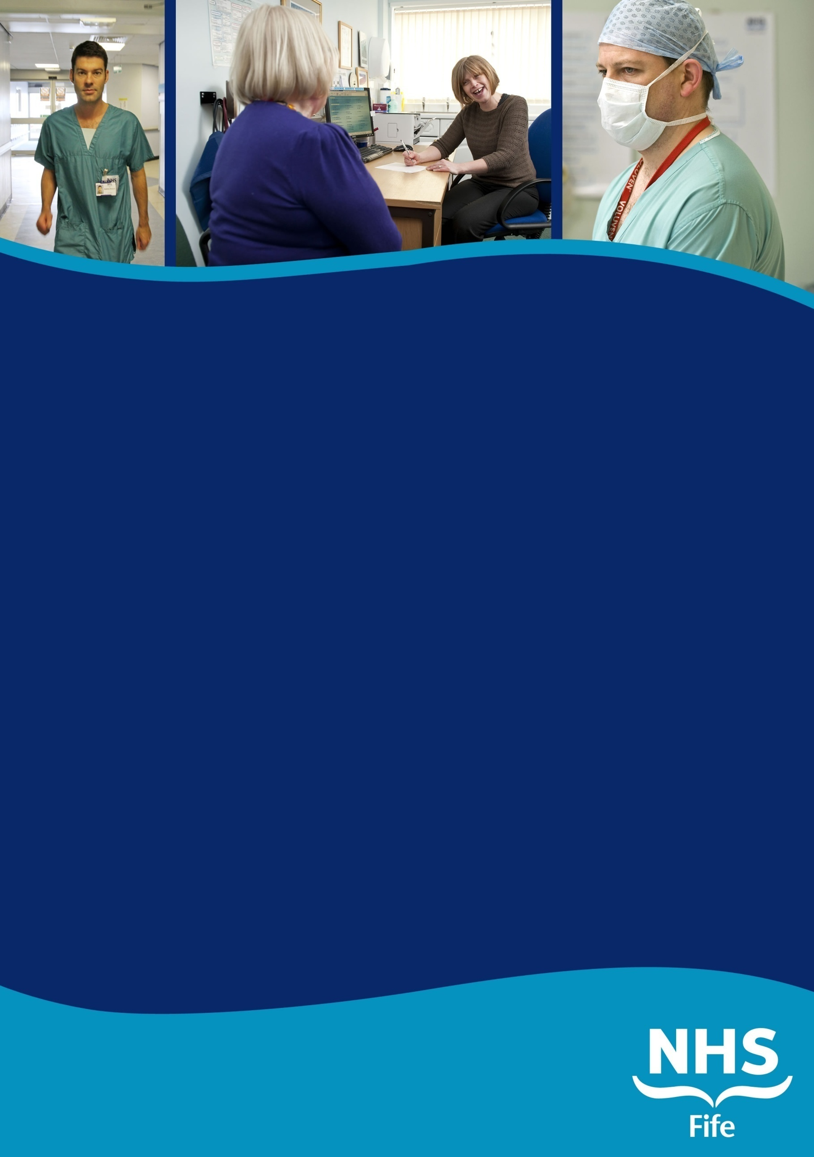

www.medicaljobs.scot.nhs.uk  
www.nhsfife.org

CONSULTANT IN  
PAEDIATRIC INTENSIVE  
CARE

ROYAL HOSPITAL FOR  
SICK CHILDREN

INFORMATION PACK

www.medicaljobs.scot.nhs.uk  
www.nhsfife.org

CONSULTANT IN  
PAEDIATRIC INTENSIVE  
CARE

ROYAL HOSPITAL FOR  
SICK CHILDREN

INFORMATION PACK

**Information for Candidates**

**CONSULTANT IN OBSTETRICS & GYNAECOLOGY**

**ACUTE SERVICES DIVISION**

**NHS FIFE**

**INFORMATION PACK**

CLOSING DATE:

# CONTENTS

|  |  |
| --- | --- |
|  | **Page(s)** |
|  |  |
| Job Description  Current Staffing | 3-4  4 |
| Duties & Responsibilities | 5-6 |
| Job Planning | 6-7 |
| Person specification | 8 |
| Terms and Conditions of Service | 9-10 |
| About Fife | 11 |
| How to Apply | 11 |

**NHS FIFE WOMEN’S SERVICES**

**Women’s Services (Directorate of Women, Children & Clinical Services)**

The clinical services within the NHS Fife Acute Operational Division are organised into different Directorates – “Planned Care”, “Emergency Care”, “Women and Children”, and “Laboratory services and radiology”. Women and children sits as a standalone directorate with a service manager and general manager and medical management. Medical managers include a gynaecology clinical lead, a maternity clinical lead and the Associate Medical Director.

Directorate General Manager Jane Anderson

Associate Medical Director Dr John Morrice

Clinical Director Dr Keith Morris

Clinical Lead – Obstetrics Dr Jenny Boyd

Clinical Lead – Gynaecology Dr Omar Thanoon

Head of Midwifery and Nursing Aileen Lawrie

Service Manager Lynne Johnston

# JOB DESCRIPTION

We are interested in a Post CCT candidate with a strong general background in both Obstetrics and Gynaecology. Obstetrics and Gynaecology services moved to a new state-of-the-art unit at Victoria Hospital in Kirkcaldy (VHK) from Forth Park Hospital in 2012.Over 15 years ago we embarked on a path of subspecialty service provision that continues to develop in order to deliver the highest level of care that a DGH can provide. Some consultants take part in both O&G emergency care. Others form a second on call rota for Gynaecology. Consultants tend to have an Obstetric or Gynaecology subspecialty interest. Currently, day time emergency cover is provided by two teams, one for Obstetrics, and one for Gynaecology. Combined non-resident consultant care is provided for both O&G overnight and at weekends. There is an additional second on call consultant gynaecologist out of hours.

In 2020 the department handled approximately 2800 women between the Consultant Led Unit and the adjacent Midwife Led Unit. There is a dedicated induction suite, day assessment unit and maternity assessment unit (triage). There are 10 high risk antenatal clinics between Victoria Hospital and Queen Margaret. There are also weekly diabetic, metabolic and maternal medicine clinics, and monthly joint specialty haematology, cardiac, renal, and epilepsy clinics. There is a dedicated obstetric ultrasound service and fetal medicine service. The obstetric unit is supported by a level 3, 20 cot neonatal unit (4 intensive, 2 high dependency and 14 special care cots).

In Gynaecology, in addition to elective and emergency general Gynaecology services we have a wide range of specialised clinics, including PMB, HMB, Gynaecology Dermatology, Infertility, Urogynaecology, Oncology, Colposcopy, Endocrine, Recurrent Miscarriage and Hysteroscopy (diagnostic and operative). Theatre activity includes Gynaecology Oncology; Urogynaecology, major abdominal and minimal access surgery and Day Bed/23 hours stay, with accompanying regular MDT meetings.

We have trainees from South East Scotland and Tayside deaneries and offer ATSMs in Advanced labour ward practice, Urogynaecology and vaginal surgery, Fetal medicine, Oncology and Medical education. Undergraduate medical students from Edinburgh, Dundee and St Andrews universities and ScotGEM students have attachments with us.

**STAFFING**

The post-holder will join an established team of a total of 21 Consultants (not all of whom are full time and some of whom do not take part in providing emergency care) providing senior input to women’s services in NHS Fife. Currently 11 consultants retain some interest in both Obstetrics and Gynaecology and as such take part in combined on call during the week and at weekends. Six consultants provide second on call gynaecology cover.

**Obstetricians and Gynaecologists in Fife – current medical staffing**

**Consultants:**

*Consultant Main Subspecialty Interests*

Dr J Allison Fetal and maternal medicine

Dr B Atputhasingam Urogynaecology

Dr S Bhaskar Maternal Medicine and general gynaecology

Dr J Boyd Maternal Medicine/ Labour ward/ clinical lead maternity

Dr L Curry General obstetrics and gynaecology

Dr P Durgadevi Reproductive Endocrinology / Early Pregnancy/Endometriosis

Dr S Fegan Gynaecology Oncology

Dr C Ford Maternal Medicine /TOP

Dr D Gatongi Infertility, Benign Gynaecology

Dr N Ghaoui Gynaecology Oncology

Dr E Hadoura Medical Education/ Colposcopy and Benign Gynaecology

Dr C Lim Urogynaecology / Minimal Access Surgery

Dr J Macnab PMB / Colposcopy / Medical Education

Dr S C Monaghan Gynaecology/Menopause

Dr T Narrainen-Poulle General Gynaecology, urogynaecology

Dr N Palanappian Fetal and maternal medicine

Dr H Russell Fetal Medicine, ultrasound and post graduate teaching

Vacant Urogynaecology

Dr O Thanoon Urogynaecology/ Minimal Access Surgery/clinical lead gynaecology

Dr V Rao Gynaecology Oncology

Dr K Rankin Maternal medicine

Dr. R Black Benign Gynaecology / General Obstetrics

**Middle Grades Trainees in O+G**

Currently there are approximately 9 middle grade (ST3- 7) trainees rotating from the South East Scotland and East of Scotland training programmes. In some training years there is also a supernumerary ST2.

**Junior Rota**

This is a full-shift system staffed by 9 FY2 and GPST doctors (rotating from the South East Scotland GP training programme).

**DUTIES AND RESPONSIBILITIES**

The main duties and responsibilities for the posts include the following:

***Provision of Service:***

You will be expected to provide Obstetrics and Gynaecology services and also have a special interest preferably in gynaecology and benign gynaecology surgery. This includes duties to: diagnose and treat patients within NHS Fife; continuing clinical responsibility for the patients in your charge; supervise and professionally manage junior staff assigned to you; manage resources efficiently within NHS Fife policies; work towards targets and waiting times guarantees and develop close contacts with local General Practitioners and multi-disciplinary teams in NHS Fife and Fife Council.

The successful candidate will contribute to the existing team of Obstetricians and Gynaecologists in both acute and community settings.

The on call component of this job is covering gynaecology between 9am and 5pm. After 5pm and at weekends there is a responsibility to cover both Obstetrics and Gynaecology.

***Teaching and Research:***

The Obstetrics and Gynaecology service attaches particular importance to enhancing training opportunities and teaching for our junior medical team and maintaining a high quality of teaching for attached medical students. You would be expected to take an active part in undergraduate and postgraduate teaching. The service has a regular commitment to the Universities of Edinburgh, Dundee and St Andrews to take undergraduate students for 4 or 6 week attachments throughout the year.

You would be expected to take an active role in the weekly education meetings and quarterly regional teaching program along with other members of the team. There are also clinical guideline setting and audit responsibilities.

NHS Fife has an active R+D department with Good Clinical Practice (GCP) Certification along with participation in locally sponsored or multicentre studies encouraged. Current GCP certification would be welcome.

***Managerial and external responsibilities:***

You will be expected to work as part of a team with local managers and professional colleagues in the efficient running of services and will share with consultant colleagues in the medical contribution to management. Subject to the provisions of the Terms and Conditions of Service you are expected to observe NHS Fife’s agreed policies and procedures drawn up in consultation with the profession on clinical matters and follow the standing orders and financial institutions of NHS Fife.

In particular, where you formally manage employees of the NHS Fife you will be expected to follow the local and national employment and personnel policies and procedures. You will be expected to make sure that there are adequate arrangements for hospital staff involved in the care of your patients to be able to contact you when necessary. You are required to comply with NHS Fife Health & Safety Policies.

### Cover for Consultant Colleagues

Annual / Study Leave. You will be required to provide cover for any Consultant colleague during absence on annual or study leave and emergency cover for any colleague. If for any reason such deputising is not practicable, the Acute Services Division undertakes to authorise immediate Consultant locum cover.

**Continuing Medical Education**

The Board supports and will require the successful candidate to participate in continuing medical education (CME). You are entitled to 30 days paid study leave within any 3-year period, with expenses for the purposes of CME.

**Clinical Governance**

NHS Fife is committed to maintaining a high quality of services to patients, with particular regard to patient safety, by continual development of practice in the light of research evidence and by audit based against relevant standards. The post holder would be expected to be involved in clinical audit, guideline development and participate in the clinical governance review process.

**JOB PLANNING**

The successful candidate’s job plan will be negotiated between the Consultant and the Clinical Lead on an annual basis. In the event of any significant changes in the circumstances affecting this job plan, it is agreed that it will be renegotiated jointly in collaboration with Consultant colleagues and the Clinical Lead.

* 1. The post attracts 10 PAs, including on call. The on call frequency is once every three weeks as non-resident on-call from 5pm. Weekend on call commitments are currently 1:11 non-resident with a resident trainee and at least one additional junior doctor. At the current time consultants are on call for both Obstetric and Gynaecological emergencies. As such, even those consultants with a predominantly Obstetrics workload are expected to maintain surgical skills.
  2. Programmed activities may be on both Victoria Hospital Kirkcaldy (VHK) and Queen Margaret Hospital (QMH) Dunfermline sites.
  3. Supporting Professional Activity (SPA) will be incorporated in the agreed job plan. One SPA activity is the default for job plans for new consultant appointments. On appointment additional SPA time may be negotiated for specific additional activities acceptable to the candidate and desirable by the Board.
  4. The undertaking of research or further continuance or development of an additional area of speciality interest will be encouraged. An appointee would be expected to have an area of special interest, which they would be individually or jointly responsible for developing (including audit, protocols and management of the service).
  5. The appointee will have a continuing responsibility for the care of patients in their care and will undertake the administrative duties associated with the care of their patients and an appropriate share in the running of the clinical department.
  6. An active participation in undergraduate and postgraduate teaching is expected.
  7. A representative job plan is also included in the information below, but will be flexible depending on the candidate’s skills and service requirements.

|  |  |
| --- | --- |
| **DAY** | **TYPE OF WORK** |
| **Monday**  0900 – 1330  1330 - 1700 | Gynaecology emergency cover/admin 1:2  Gynaecology emergency cover/admin 1:2 |
| **Tuesday**  0900 – 1330  1330 - 1700 | DSU  TOP/admin SPA |
| **Wednesday**  0900 - 1330  1330 - 1700 | GOPD/special interest session  GOPD |
| **Thursday**  0900 - 1330  1330 - 1700 | ANC  Admin/SPA  Out of hours on call for obstetrics and gynaecology 1:3 |
| **Friday**  0900 – 1330  1330 - 1730 | Non working day  Non working day |
| **Saturday** | Contribution to on-call rota 1:11 |
| **Sunday** | As above |

***In summary:***

We consider that these appointments represent an opportunity for the appropriate candidates to become members of a friendly, close-knit, hard working and proactive integrated clinical team in a warm and relaxed working environment and also to contribute to the exciting reconfiguration of our service

**CONSULTANT IN OBSTETRICS AND GYNAECOLOGY**

**PERSON SPECIFICATION**

|  |  |  |
| --- | --- | --- |
| **Requirements** | **Essential** | **Desirable** |
| **Qualifications** | GMC full registration and license to practice.  MRCOG or equivalent  Entry on the Specialist Register for O&G or eligibility for entry within 6 months of the date of interview. | Other postgraduate degrees or qualifications |
| **Clinical Skills and Experience** | General and emergency experience in Obstetrics and Gynaecology commensurate with CCT status |  |
| **Teaching and Audit** | Evidence of commitment to:   * clinical audit * formal and informal teaching and training of trainee doctors, medical students and other clinical staff * learning and continuing professional development | Experience of designing audits  Experience of simulation training  Evidence of training in clinical and / or educational supervision  Organisation of teaching programmes or teaching qualification |
| **Academic Achievements** | Evidence of research activity and presentations  Evidence of poster or oral presentations at national or international meetings | Evidence of research and peer reviewed publications |
| **Management and Clinical Governance** | Awareness of Management issues in the NHS  Evidence of commitment to patient safety and understanding of clinical governance | Evidence of leadership and management skills |
| **General Attributes** | Strong team player  Possess good organisational and teaching skills.  Possess good verbal and written communication skills.  Ability to adapt and respond to changing circumstances  Awareness of personal limitations |  |

# FIFE REGION

The Region of Fife is bounded in the north by the Firth of Tay, in the east by the North Sea and in the south by the Firth of Forth. The Region spans an area of 130,700 hectares and has a population of 360,000. The population served by NHS Fife is currently around 280,000. There is a highly developed agricultural area in east and north-east Fife, and in the west there is an extensive cross-section of highly skilled and scientifically orientated industry. The largest towns are Dunfermline, Kirkcaldy and Glenrothes. The cathedral city of St Andrews is the seat of Scotland’s oldest and the UK’s third oldest university.

Fife is an area of considerable scenic and historical interest with a wide variety of environs ranging from the beautiful fishing villages of the East Neuk, the Lomond Regional Park to centres of industrialisation and manufacturing industry. A wide range of sporting facilities are available locally including golf (St Andrews is less than an hour away), scuba, coarse and sport fishing (Loch Leven is famous for its brown trout), curling, soccer, rugby, cricket, sailing, motor sport (Knockhill), paragliding and gliding (the Scottish gliding centre is 20mins from Kirkcaldy). The highlands are within easy reach with both Glasgow and Edinburgh city centres also only an hour or so away. The Cairngorms are the closest mountains providing access to skiing, mountaineering, orienteering, stalking and salmon fishing. Wide ranges of cultural activities are available in Fife such as the Pittenweem Arts festival

There are excellent air, rail and motorway links to the rest of the UK. Edinburgh & both Glasgow Airports are within easy reach by road and rail.

**FIFE COUNCIL**

www.fifedirect.org.uk

# HOW TO APPLY

Applications should be made online via the NHS Jobs website

Prospective applicants wishing to visit the Department or who would like further information should contact: Dr Jenny Boyd, Clinical Lead Obstetrics, Victoria Hospital, Kirkcaldy, or

Dr Omar Thanoon, clinical lead for Gynaecology, Victoria Hospital, Kirkcaldy: (01592 643355).