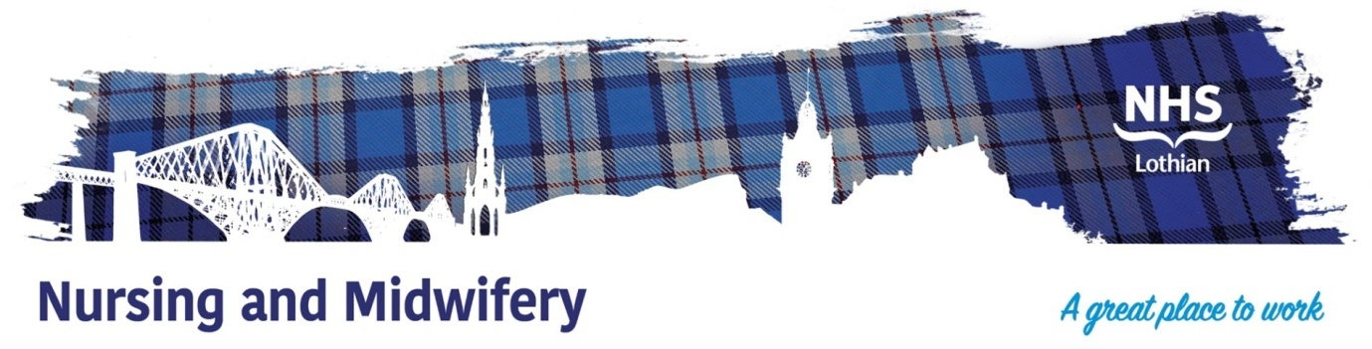

**NHS Lothian East Lothian Primary Care Vaccination Service**

We are excited to offer a fantastic opportunity to be part of our inclusive and welcoming team at the East Lothian Primary Care Vaccination Service. We are looking for **a passionate, caring, and motivated Band 5 Primary Care Nurse** (part-time, 2 days a week) to join our skilled and friendly nursing team.

This is a great chance to contribute to the health and wellbeing of our local communities across East Lothian, working with a supportive team that prioritises collaboration, respect, and kindness.

As part of our team, you will work flexibly and across different environments, from East Lothian Community Hospital to Musselburgh Primary Care Centre, Edington Cottage Hospital, Care homes, people’s own homes and pop-up venues across the county - ensuring that you gain diverse experience in providing vital vaccination services.

Our team is built on the values of inclusivity, teamwork, and excellence. You will have the opportunity to develop your skills and knowledge in a supportive, caring environment, with strong Nursing leadership. Full training will be provided, ensuring you are equipped with all the skills needed to succeed and thrive in this role.

You will also be a key player in fostering positive communication and relationships with colleagues across a variety of disciplines, including managers, clinicians, third sector and voluntary services. Your ability to connect with people, work collaboratively, and deliver high-quality care will be central to your success in this role.

**What we offer:**

* **A welcoming and inclusive team environment**, where everyone is valued.
* **Supportive nursing leadership** to help guide and develop your career.
* **The opportunity to work across multiple locations** in East Lothian, offering variety in your daily work.
* **Full training and ongoing development** to support your professional growth.
* **7-day service**, providing flexibility in your work schedule.

**Post details:**

* Band 5 Primary Care Nurse
* Hours: 18.30 hours a week – 2 days: 7.30am to 5.15pm across seven days.

**Informal Calls and Visits Are Very Welcome!**

We understand that making a career move is an important decision, and we are happy to offer informal calls or visits to the service. This is a great opportunity to meet the team and get a better feel for the work environment before applying.

**For more information or to arrange an informal visit, please contact:**

* **Michelle Wright**, Team Manager michelle.wright@nhs.scot
* **Linda Rankin**, Deputy Team Manager linda.rankin@nhs.scot
* **Morven Connal**, Deputy Team Manager morven.connal@nhs.scot

If you are an enthusiastic and compassionate registered nurse looking to make a real difference in the community, we would love to hear from you.

Come join us and be part of a team that makes NHS Lothian a great place to work!

  