NHS TAYSIDE – AGENDA FOR CHANGE

JOB DESCRIPTION

Sco6 – 5635N

|  |  |  |
| --- | --- | --- |
| 1. JOB IDENTIFICATION | Job Title | **Deputy QA Manager** |
| Department(s)/Location | **Tayside Pharmaceuticals /**  **NHSS PSS** |
| Number of job holders | **1** |

|  |
| --- |
| JOB PURPOSE  * To be responsible for the operational management of the quality assurance section of Tayside Pharmaceuticals (TP)/NHS Scotland Pharmaceutical ‘Specials’ Service (PSS). * To deputise for the QA Manager and advise on quality issues. * To ensure the principles of Good Manufacturing Practice (GMP), Good Laboratory Practice (GLP), Good Clinical Practice (GCP) and Good Distribution Practice (GDP) and other relevant legislation are followed. * To support the implementation and maintenance of the quality management system against requirements of BS EN ISO 9001. * To undertake the acceptance of raw materials for manufacture and the release of batches of finished products. * To support the provision of a pharmaceutical quality assurance service to NHS Tayside (NHST). |

|  |
| --- |
| ORGANISATIONAL POSITION See Appendix 1- Organisational Chart |

|  |
| --- |
| SCOPE AND RANGE PSS/TP produces a range of 700 sterile and non-sterile medicines, selling over 1.6 million units annually with a value of over £10 million. These medicines are not commercially available and are supplied to hospital and community pharmacies throughout the UK and to the Scottish Ambulance Service and include the supply of clinical trial materials. In order to undertake this manufacture, PSS/TP is a licensed pharmaceutical manufacturing facility and is subject to external inspection from the Medicines and Healthcare products Regulatory Agency (MHRA) and is accredited to BS EN ISO 9001:2015.  This involves annually:   * 450 starting materials approved, 4600 batches of medicines released by documentation checks only and 1200 batches of medicines analytically tested * 600 sterility tests and 26000 media plates   A quality assurance service is provided in support of Pharmacy, NHS Tayside. This includes:   * audit of dispensaries, clinical trials, aseptic dispensaries, stores, procurement and medicines information * monitoring of aseptic dispensing environment and personnel * calibration of thermometers and temperature mapping * testing of medical gas pipeline systems * contributing to Clinical Governance Reports * advice on quality matters including regulatory issues, audits, performance indicators, formulation, shelf life, design of new facilities, equipment etc.   Testing is also provided to other customers:   * Sterile Services Departments: environmental monitoring (NHS Tayside) and steam condensate, washer water testing (NHS Tayside and throughout Scotland via Health Facilities Scotland)   **The postholder has the following range of duties:**   * Manages a team of Pharmacists, Laboratory Manager, Validation and Quality Systems Specialist, Senior QA Technicians and Pharmacy Support Workers in approving documentation and testing the environment, starting materials and finished products. * Ensures that QA sections follow the principles of GMP, GLP, GCP and GDP and other   relevant legislation.   * Deputises for the QA Manager in their absence. * Support the implementation and maintenance of the quality management system against   requirements of BS EN ISO 9001.   * Undertakes the acceptance of raw materials for manufacture and the release of batches of   finished products.   * Acts as an authorised signatory for purchase orders, travel and SSTS. * Acts as a Quality Controller of piped medical gases supplied to patients of NHST. * Supports the provision of a comprehensive QA Service to Pharmaceutical Services NHST. |
| MAIN DUTIES/RESPONSIBILITIES **Policy and Planning**   * To assist with the implementation of a strategic plan to deliver a QA service for the national pharmaceutical manufacturing service in PSS, taking account of the transfer of QA activities from TP and PPU. * To support the development and execution of the Validation Programme for PSS in line with MHRA regulatory requirements. * To assist in the development of annual objectives for TP/PSS. * To assist the QA Manager and other senior managers in the determination of policy   and strategic plans for both TP in the short term and PSS in the long term.   * To assist in the development of the quality assurance service provided to NHST Pharmacy.     **Operational Management**   * To be responsible for the Operational Management of the QA section within TP/PSS. * To undertake and manage NHST HR policies such as Grievance, Promoting Attendance at Work and Employee Conduct when required. * To be responsible for the recruitment and selection of staff within QA and to ensure NHST policies on Recruitment and Attendance at Work are adhered to.   **Quality Management System**   * To support the QA Manager in leading the implementation and maintenance of the   quality management system against the requirements of BS EN ISO 9001.   * To assist in representing TP during external audits, ensuring compliance and continued registration. * To prepare and approve procedures and documentation relevant to the quality management system. * To develop the internal audit programme, conduct and participate in audits ensuring deficiencies are addressed. * To liaise with customers on matters relating to quality. * To carryout external audits of suppliers as appropriate or otherwise determine the suitability of suppliers of raw materials and services and produce approved lists of suppliers. * To deal with, analyse and report on customer quality complaints, customer feedback, non-conformance reports, product recalls, deviations from standard practice.   **Quality Assurance TP/PSS**   * To assist in ensuring that the quality assurance facilities and practices, and in conjunction with the Production Manager and Deputy Production Manager, the production facilities and practices, meet the standards of GMP required by the MHRA. * To partake in evaluating quality and production systems to ensure best practice is promoted, be involved in MHRA inspections and assist in developing action plans against deficiencies and ensure they are addressed. * To develop and maintain quality assurance documentation e.g. specifications and standard operating procedures (SOPs) and ensure documentation is reviewed and revised. * To approve production worksheets and SOPs. * To approve clinical trial documentation as part of Qualified Person (Investigational Medicinal Products) duties – includes procedures, worksheets, labels, randomisation, blinding, review of Clinical Trial Authorisation and MHRA Approval. * To support the QA Manager in developing and reviewing TP’s Validation Master Plan. * To develop and approve Annual Product Quality Reviews (regulatory requirement). * To review autoclave process records and test results. * To be responsible for the development of the calibration and validation schedule and ensure equipment and processes are approved as fit for intended purpose. This includes approving validation test results. * To ensure that all relevant legislation e.g. Health and Safety at Work, COSHH etc is applied within quality assurance. * To organise testing and report on the results of the inter-laboratory assessment programme. * Liaise with customers regarding product specifications, product labels and COSHH specifications. * To undertake the approval of starting materials for use in manufacture (or rejection as appropriate). * To undertake the release of batches of medicinal products and extemporaneously prepared products for use in the treatment of NHS patients throughout the UK (or rejection of batches as appropriate with associated investigations, problem solving and documentation).   **Quality Assurance NHST Pharmacy**   * To ensure the environmental monitoring, staff monitoring and validation results for aseptic dispensing in conjunction with the Accountable Pharmacist, Aseptic Dispensing and agree actions required to address any deficiencies. * To participate in external audits of aseptic dispensing services within NHST and in agreeing the action plan provided to the Chief Executive to address deficiencies. * To act as external auditor for aseptic dispensing services throughout NHS Scotland. * To audit Pharmaceutical Services within NHST. * To provide advice on regulatory issues, facilities and equipment, processes, documentation, formulation and shelf life and input into pharmacy, safety and clinical care governance. * To support the approval of the calibration of thermometers, weights, temperature mapping and cold chain monitoring. * To advise on and approve the quality of unlicensed medicines. * To represent Tayside as an active member of the Scottish Pharmaceutical Quality Assurance Group (SPQAG), involving the development and maintenance of national guidelines and audit tools.   **Quality Assurance Other**   * To support the environmental monitoring and steam condensate and washer water testing and provision of reports for Sterile Services Department, NHST. * To provide reports of steam condensate and washer water testing throughout Scotland via Health Facilities Scotland.   **Product and Assay Development**   * To contribute to the formulation, development and validation of unlicensed medicines and clinical trials materials in response to customer requirements. * To take part in the process design and to develop the validation of new and existing products. * To develop assay methods for new products, develop specifications and ensure testing requirements in line with standard methods are carried out.  **Staff Supervision and Training**  * To manage Quality Assurance staff and to monitor their performance in accordance with NHST Employee Appraisal System. * To identify the training needs of quality assurance staff in order to undertake the roles required. * To identify the training needs for staff within PSS. * To participate in the training of all grades of staff as required. * To ensure that GMP competency based training for all staff is developed and maintained and that individual training records for quality assurance staff are complete and up to date.   **Resource Management**   * To assist in identifying the QA manpower requirements for PSS. * To maintain and update the equipment database. * To prepare and maintain a capacity plan for the quality assurance service, including   contingency plans, and ensure that resources and demands are managed accordingly.   * To act as an authorised signatory for purchase orders, travel and SSTS. * To approve suppliers of raw materials.   **Medical Gas Testing - NHST Pharmacy**   * To act as Quality Controller responsible to the Chief Executive for the quality of medical gases in NHST. * To undertake testing of Medical Gas Pipeline Systems (MGPS) in accordance with SHTM2022 and approve the medical gas systems as fit for use in patient care in conjunction with the MGPS authorised person. * To provide advice on testing requirements as required. * To ensure the routine testing of medical air compressors is undertaken. |
| COMMUNICATIONS AND RELATIONSHIPS The postholder will communicate with a wide range of people, both within and outwith the organisation including:  **Internal**   * TP/PSS staff * Pharmacy staff * Estates staff * Authorised Person MGPS, Contractors, Nursing Staff * Senior professional staff from other NHST departments - microbiology, infection control, sterile services department, IT department * Human Resources   **External**   * Scottish Pharmaceutical Quality Assurance Group – senior pharmacy quality assurance staff within Scotland * Aseptic Services Specialist Interest Group – senior pharmacy aseptic dispensing staff within Scotland * MHRA, BSI and other external auditors * Customers – product specifications and certificates of analysis, technical advice, customer complaints and feedback * Suppliers – raw material quality issues * Facilities Maintenance staff in PSS   In order to communicate effectively with the above groups, the following are essential:   * highly developed interpersonal and communication skills, written and verbal, formal and informal, and presentation skills. * ability to convey highly complex information in a form readily understood by a variety of target audiences. * ability to motivate staff and influence change. * ability to use diplomacy, tact and empathy when dealing with difficult situations and opposition. |

|  |
| --- |
| KNOWLEDGE, TRAINING AND EXPERIENCE REQUIRED TO DO THE JOBQualifications – essential  * Master of Pharmacy degree (MPharm) * Competency assessed and examined professional registration (GPhC) * Mandatory CPD to maintain fitness to practice  Qualifications – desirable  * Management qualification * Specialist higher degree (e.g. Masters in Pharmaceutical Technology and Quality Assusrance) * Eligible for registration as a Qualified Person under Directive 2001/83/EC or equivalent experience * Quality Controller for MGPS, HTM2022 * Qualified Person (Investigational Medicinal Products) under Directive 2001/20/EC  Experience – essential  * Extensive post qualification pharmacy practice experience * Considerable post qualification work in a pharmaceutical QA/Manufacturing/Aseptic environment * Operating under a quality management system (e.g. BS EN ISO 9001), including internal audit and documentation control * Staff management  Experience – desirable  * Involvement in MHRA inspection processes * The post holder should have a demonstrated ability to: * deliver and validate staff training * identify and manage risks * manage change * manage the safe handling of hazardous materials  Knowledge Demonstrated knowledge of:   * all aspects of QA, GMP, GLP, GCP and GDP and proven ability to apply this knowledge in practice * technical aspects of manufacturing, sampling, analytical and microbiological techniques * formulation of pharmaceutical products to meet clinical needs of patients * problem solving for difficult and ambiguous problems by advanced reasoning and sound technical judgement * promotion and evaluation of best practice * risks associated with handling hazardous materials and appropriate H&S precautions * medical gas pipeline systems |

|  |
| --- |
| 1. SYSTEMS AND EQUIPMENT      * The post holder has operational responsibility for the systems, facilities and equipment within the Quality Assurance Department and validating the facilities and equipment in Production Departments. * Requires knowledge of highly complex instrumentation used in the analytical testing of medicinal products. * Requires knowledge of the design of pharmaceutical production facilities including air handling plant, filtration systems and laminar flow cabinets and their monitoring and testing. * Requires knowledge to validate pharmaceutical production equipment including distilled water systems, bottle washers, IV bag filling machines etc. and approve testing and validation of sterilisers. * Uses highly complex instrumentation in the testing of Medical Gas Pipeline Systems (oxygen and nitrous oxide analyser, particle counter, Draeger impurity detection tubes). * Requires knowledge of MGPS, gas cylinders, gas manifolds, medical air compressors, VIE. * Requires knowledge of Q-Pulse CAPA software (or equivalent system). * Basic keyboarding skills, knowledge of standard office software including word processing, spreadsheets and databases. Produces correspondence, reports, audits and action plans, specifications and SOPs, collects manipulates and presents data on customer complaints, non-conformances, customer feedback. * Use of equipment (laptop, datashow projector, overhead projector, etc) to give presentations to staff, undergraduate and post graduate students and local and national meetings and conferences. * Use of the internet to source specialised pharmaceutical, analytical and medical information. * Ability to use computerised stock control system to answer stock and supplier enquiries and produce traceability, customer movement, product and raw material reports.   **Responsibility For Records Management**  All records created in the course of the business of NHST are corporate records and are public records under the terms of the Public Records (Scotland) Act 2011. This includes email messages and other electronic records. It is your responsibility to ensure that you keep appropriate records of your work in NHST and manage those records in keeping with the NHST Records Management Policy and with any guidance produced by NHST specific to your employment. |

|  |
| --- |
| PHYSICAL DEMANDS OF THE JOB Physical Effort   * Mainly seated, long periods of VDU use, walking between locations, occasional need to stand for long periods. * Standing to inspect and approve raw materials in QA laboratory or store with occasional need to lift boxes/containers for inspection and move loaded trolleys/pallets. * Occasional need to audit in a clean room environment. * Working in difficult conditions when carrying out medical gas testing throughout NHST including: * carrying gas cylinders * climbing ladders, testing outside, on roofs or in basements, testing in a building site requiring the wearing of hard hat and fluorescent jacket * testing in patient areas * difficulty in reaching the gas sampling point due to other work ongoing in the area  Mental Effort  * Intense concentration is required: * when representing TP/PSS at NHST or national meetings. * daily for periods of up to 4 hours while analysing data, producing reports and releasing products. A high level of accuracy is essential to ensure that products that are released comply with their specification and are fit for their intended purpose in patient treatment. * Intense concentration required to determine if in-process assay results require formulation changes – often working to tight time constraints in order to allow production to continue. * Calculation skills are required to ensure analytical test results have been calculated correctly. * Dealing with out of specification results, abnormal events and validating processes and equipment. * Work is subject to scrutiny from customers (via Certificates of Analysis) and from regulatory authorities. * Subject to constant interruptions due to staff queries. * Operates with limited resources and to tight timescales. * Making decisions on severity of deficiencies when carrying out audits, reporting and discussing deficiencies verbally to staff.   **Emotional Effort**   * Empathy and composure required when conducting investigatory and disciplinary hearings and dealing with staff and customer complaints. |

|  |
| --- |
| DECISIONS AND JUDGEMENTS  * Expected to act decisively and autonomously in a professional and managerial capacity being accountable for their actions without the need to refer to the QA Manager. * Required to manage, analyse and act when faced with difficult problems with minimum reference to line manager. * Required to interpret legislation and national and local protocols for use in quality assurance. * Required to be accountable for own professional actions and outcomes. * Required to decide if a product is fit to be released based on results of analytical and microbiological testing, actions to be taken with non-conformances and approve raw materials for use. * Required to manage own time and prioritise workload within customer, regulatory body or local management deadlines. |

|  |
| --- |
| MOST CHALLENGING/DIFFICULT PARTS OF THE JOB  * Ensuring that Tayside Pharmaceuticals continues to meet the requirements of Good Pharmaceutical Manufacturing Practice and maintains the Manufacturers ‘Specials’ and Investigational Medicinal Products Licences, and the quality management system continues to meet the requirements of BS EN ISO 9001. * Management and motivation of staff whilst maintaining a team approach within QA. * Prioritising the allocation of limited resources (staff and financial) against often conflicting   requirements of customers, management and regulatory authorities.   * Deciding on the action to be taken when products are very close to the specified limits, approving as fit for release for patient treatment. |

TAYSIDE PHARMACEUTICALS/ NHS SCOTLAND PHARMACEUTICAL ‘SPECIALS’ SERVICE – ORGANISATION CHART

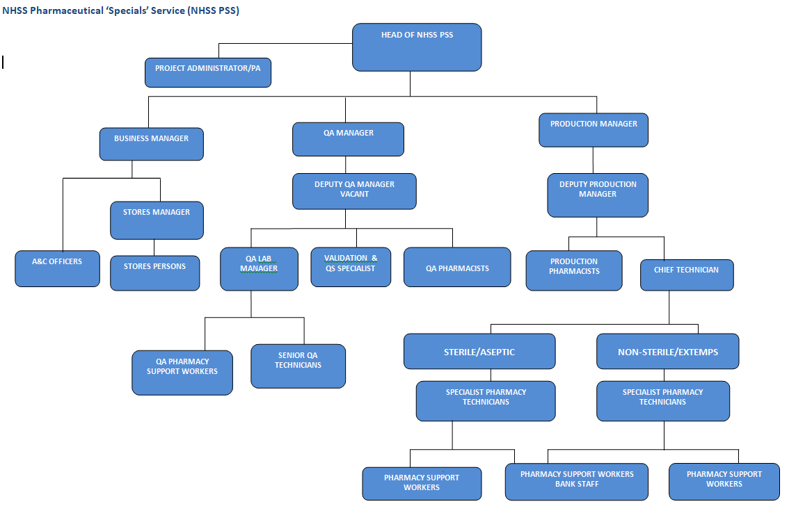Appendix 1