

**EHSCP Care Homes**

Exciting opportunities are available to join EHSCP Care homes within one of the sites across Edinburgh. We have Band 5 positions available for Registered Nurses and we are looking for passionate, caring, motivated people to join our highly skilled nursing teams.

We offer the opportunity to work with talented teams within multidisciplinary environments and impact positively on the lives of our residents and their families.

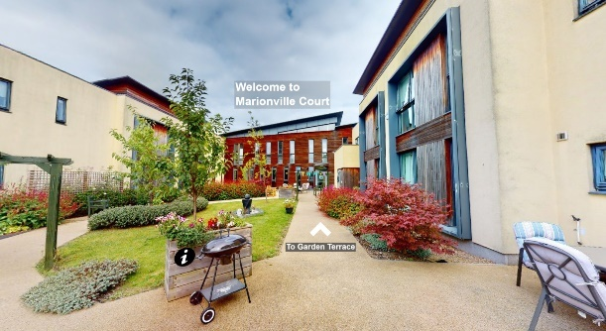

**What We Can Offer You**

We have a range of vacancies for experienced nurses to join our innovative and dynamic teams across NHS Lothian – providing you with the opportunity to gain a breadth of knowledge and exposure to multiple complex physical and mental health issues experienced by our residents. Various training courses available including leadership and management as well as opportunities to progress into these roles.

We provide nursing care for people over the age of 65 years who are frail and have complex care needs. We have dementia units caring for people with mild to severe cognitive impairments.

**Sites**

* Royston Court Care Home
* Marionville Court Care Home (Vacancy Available)
* Inch View Care Home
* Castle Green Care Home (Vacancy Available)
* North Merchiston

  