***Please quote your reference number*** *for quick job identification.*

**IMPORTANT LINKS**

* Jobtrain log-in [page](#)
* [Jobtrain Hiring manager SOPs](#): (short e-learning demo videos)
* [HR Portal](#) (L&D, eESS)
* [NHS Scotland Policies](#)

**MAILBOXES**

* Adverts and Re-adverts: [Recruitment.Vacancies@ggc.scot.nhs.uk](#)
* Shortlisting and Interviews: [Nhsggc.Recruitment@nhs.scot](#)
* Checks and onboarding
  + Nursing and Midwifery: [nursing.recruitment@ggc.scot.nhs.uk](#)
  + Support services- (Estates and [Facilities): agendaforchange.recruitment@ggc.scot.nhs.uk](#)
  + Admin, AHP, Healthcare science etc: [ggc.generalrecruitment@ggc.scot.nhs.uk](#)
* Bank posts: [adminstaffbank@ggc.scot.nhs.uk](#)
* NQN posts: [ggc.nqnrecruitment@ggc.scot.nhs.uk](#)
* Sponsorship queries: [ggc.sponsorship@ggc.scot.nhs.uk](#)
* Retire and return: [ggc.retireandreturn@ggc.scot.nhs.uk](#)
* Redeployment: [transition.advisor@ggc.scot.nhs.uk](#)
* Non-Medical and Dental Honorary contracts: [ggc.honorarycontracts@ggc.scot.nhs.uk](#)

**VACANCY REQUEST AND APPROVAL**

1. Source and complete the relevant [paperwork](#) (Vacancy request form- VRF, Job description-JD, Person specification). Check that you have the correct and most-up-to date version
2. Create your advert text within the VRF
   1. About your department
   2. About the role
   3. Essential criteria
   4. Specific requirements- Registration, licence etc
   5. Informal contact name and email/landline/mobile
3. Identify your recruitment Panel (shortlisters and interviewers) and target schedule for recruitment
4. Please note that
   1. **All relevant signatures from the correct signatories must be on the VRF otherwise this be sent back**
   2. All Nursing & Midwifery or Allied Health Professional posts at Band 8A and above must be approved by the Executive Director of Nursing or the Director of Allied Health Professionals.
   3. All Executive & Senior Manager Grades and all Agenda for Change posts Band 8A and above, will require NHSGGC Chief Executive Approval. Please send these requests directly to: [vacancy.authorisation@ggc.scot.nhs.uk.](#) If approved, posts will directly be sent on to the Recruitment Service
5. Once signed-off, please send your VRF, JD, and Person spec to the Vacancies team.
6. You will receive a notification once your advert has been created. You can also check on you job list if it already available. Requests are processed in order of date when the email (paperwork) was received.
7. Vacancies are directed to a Redeployment check first before they go live, usually 2 days after the advert is created.
8. VRFs for appointing a reserve/additional candidate must be sent to the relevant Processing team direct.

! If you wish to have a specific filter question or assessment question to be added to help with managing applicant volumes and shortlisting, please note down your request on the email or contact us.

**LIVE ADVERT**

* Adverts are made live every Friday of the week and closes on a Sunday, either a week or two weeks depending on the request.
* **! You can already start shortlisting as soon as your advert is live and an app is received.**
* Your calendar event template for the interview schedule is created at the same time as the advert. You can already start discussing your interview date with the rest of the Panel, and drafting your interview questions or format (presentation, exercise, Face to face or Teams etc)

**SHORTLISTING AND CALENDAR**

* A Shortlisting form must be completed for each candidate, checking the application against the Essential and Desirable criteria on your Person spec.
* The Shortlisting process is composed of 1) completing a shortlisting form- comments and scores, 2) updating the candidate status, and 3) completing the calendar event.
* **Job interview guarantee scheme:**
  + The two-ticks icon is the Job interview guarantee scheme: [Disability Confident – Are you disability confident?](#)
  + It means that as long as the candidate meets *ALL of the essential/minimum criteria* for the post, they should be invited for interview. On the Jobtrain shortlisting form, this is a score of 4 and above.
* If you are marking a candidate as *failed* at shortlisting, please make sure that you update the shortlisting form with a robust explanation on what they have missed (criteria) and/or reason for not putting them forward for interview.
* Candidates are not notified of the outcome *until* recruitment changes the status that you set to the **counterpart** recruitment status that contains the email. You can therefore amend comments and status if you need to.
* All Panel members are required to complete a shortlisting form per candidate however, for high volume recruitment, we do accept **consensus shortlisting** where in agreement with all members, one panel member will go in and shortlist for the group. Once completed, they will then go back to the rest of the team to check if they agree- it might require a couple of back and forth discussions before a final interview cohort can be made.

**Shortlisting statuses**

|  |
| --- |
| Recommend failed shortlisting |
| Recommend candidate invite to interview |
| Recommend - Not eligible to apply- External candidate for internal only post) |

**Interview calendars**

* Are created at the same time as your advert
* And are accessible here, top-right of the page: (provided that you are named on the Calendar event, interviewers name taken from the VRF)



* Only update the tabs:
  + Date/Time with venue/date/timings
  + Interviewers with the actual interview Panel members (add and remove)
  + Notes&Attachments for presentation or exercise details or any other instructions.
* MS Teams link is created separately. This can be created by either the Hiring team/manager or Recruitment.
* Always click Save&Continue when adding info on the calendar otherwise it will not save your update.
* For any re-scheduling/agreed change of interview mode, this can be done direct with the candidate out with Jobtrain.

**!** You can notify us once shortlisting AND calendar are completed by clicking the Shortlisting complete button. We will also run a completed calendar report and will automatically pick your recruitment up this way so there is no need to get in touch. If we have any queries, we will contact you.

We will send you an email once your invites are sent and you will also get a notification once your candidates have started booking.

**Certificate of Sponsorship (COS)** there are some posts that could be eligible for sponsorship to allow a candidate to take up a role, if they require a right to work in the UK visa. Please raise your visa queries to the Sponsorship team.

**PRE-INTERVIEW**

1. Finalise your interview questions, prep your venue and equipment (test if required)
2. You will receive an email from Recruitment days before the interview if any of your candidates require reasonable adjustments to attend/complete the interview
3. Get a copy of the Interview paperwork and guidance on Jobtrain
   1. Click the **job title/ reference number** above the list of candidates.  
      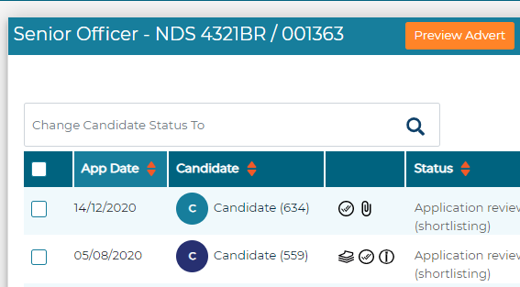
   2. Select the **Approval Form** tab.



* 1. Scroll down the page to the **Approval Attachment** section.

The following documents should be visible, select the **eye icon** to download.

* Interview Assessment Form AfC NHS Scotland (for all AfC posts unless a board has agreed values based recruitment interview paperwork).
* Caring behaviours
* NHS Scotland and ID Verification guide.
* JD and or Person Specification
* VRF

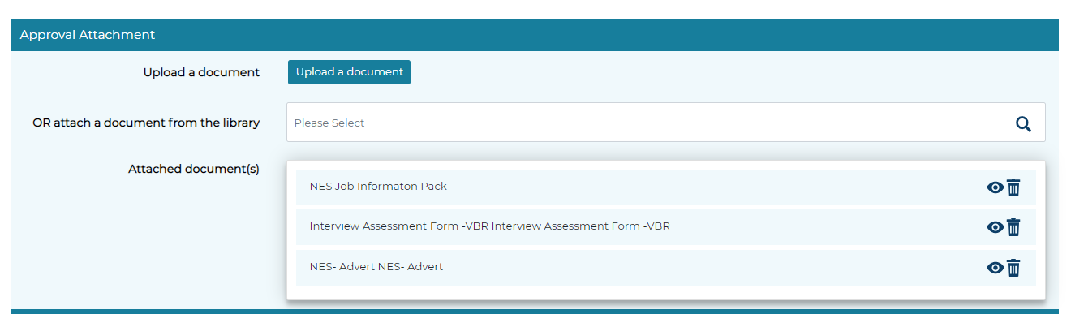

! Recruitment will notify you if we receive a reasonable adjustment request

**POST-INTERVIEW**

The Hiring manager must:

1. Speak to candidates re the outcome- provide feedback, ask and answer questions
2. Upload the interview assessment form of each attendee on their profile

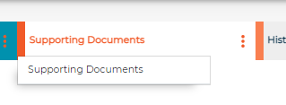

**!** Please scan and save your documents on the lowest but clearest setting/size as Jobtrain has a 2MB limit per document.

1. Update the candidate statuses

|  |
| --- |
| Conditional offer -Preferred candidate |
| Recommend unsuccessful after interview |
| Recommend- Did not attend interview |
| Recommend- Reserve list (use stars to indicate 1st, 2nd etc) |
| *Withdrawn/Declined offer- please contact the recruitment team* |

1. Update the Offer form for the preferred candidate

On their record, please select on the left-hand side options:

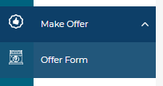

* 1. Update all the items in red
  2. Increment is always 00 and starting salary is the starting amount

Only payroll can confirm the specific/actual increment and starting salary on the employee’s first payslip

*\*if appointing on a higher increment, the Starting salaries guidance must be completed and signed-off. It must be forwarded to the processing team as well as to the eESS team together with the SEF. Pls contact recruitment for a copy of the template.*

**!** Provided that the above items have been completed, this will be captured when we run the daily Conditional offers report.

**!** **Please do not change the preferred candidate/s status after setting it to Conditional offer recommend offer**, until such time that you receive an email from Recruitment that all checks are now complete and a start date/reporting details are now required.

Recruitment must be made aware of any **withdrawn or declined offer/acceptance** before any contact is made with the candidate or update is done on Jobtrain. The Team will do the necessary candidate status update for these instances.

**ONBOARDING**

The relevant processing team (checks and onboarding) will be in touch if there are any queries or updates in relations to checks that requires the Hiring manager input.

You can check the status of the checks via:

1. the candidate status as it can be

* Conditional offer 2nd stage- conditional offer email sent
* Pre-employment checks commenced
* Hiring manager approval- checks complete and start date requested

1. You can also check the Pre-employment checklist:

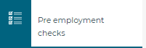

1. For references, it is accessible by clicking the 3 dots beside More and selecting Onboarding/references

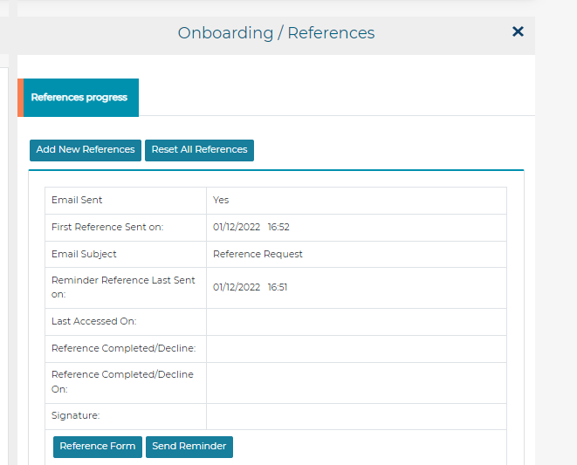

Once all checks are complete, the processing team will be in touch for you to confirm/update the **Offer form with the start date and reporting details**. You will also be provided with the candidate documents so that you can create your **Employee file.** This must be kept by the Service recruiting. \*Please be advised that the contract is still to be issued at this point and thus must be downloaded or requested once it is available.

You will be asked to

1. **Review the references** if they are satisfactory and also confirm the start date agreed with the new starter. Any issues or queries, please get in touch.
2. **Check all the other pre-employment checks**- occupational health, professional registration, PVG etc
3. **Check and Update the candidate’s Offer form** specifically the *Start date agreed* with the candidate and the *Reporting details*.
4. Change the status to **Pre-employment checks- Approved by Hiring manager,** once the above two tasks are complete and you do not have any further queries/concerns.

Once the status has been changed and the relevant info made available, as well as if there are no other issues, the **Contract/Offer letter** can now be issued to the candidate. A report is run daily to capture the contracts to be issued.

**!** Please download a copy of the employee contract to add to your Employee file:

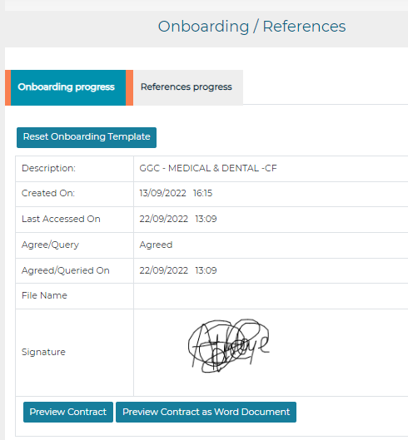

**Other info**

1. **Internal new starters (NHS GGC to NHS GGC employment)- only an Unconditional offer letter** is issued which details the post title, start date, salary range, and reporting details.

Further details of the current employment can be access under eESS (start date, pay number, hours, type of contract, grade band, years of service, employee no., location etc

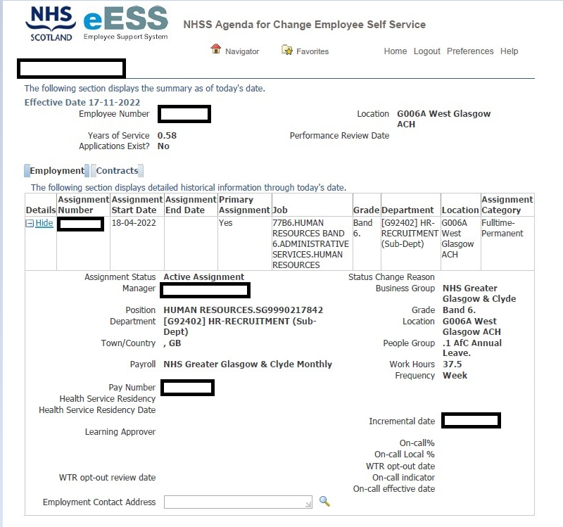

The link is available on MS Edge> NHS GGC favourites> [eESS]("  "https://eess.mhs.scot.nhs.uk/OA_HTML/RF.jsp?function_id=28716&resp_id=-1&resp_appl_id=-1&security_group_id=0&lang_code=US&params=OGMWPo39Xhlzl96OWyF3fDSeCK.nNZrKCvhxH3kZnRH2ErWaJvTHVfMqAIVkwlPNadiZJNJk.dFviJvyuuk.HiyS0t3KVxLNA8.LJ-PrnXRpTA5lr-dKFZXqTEPHtGuIVW62b5kY5YYUBlmKLM5bmAivBxQsVM6UiGmI3c7J7do&oas=A_teWg0t5PIepNGLKwotBw.." \o "https://eess.mhs.scot.nhs.uk/OA_HTML/RF.jsp?function_id=28716&resp_id=-1&resp_appl_id=-1&security_group_id=0&lang_code=US&params=OGMWPo39Xhlzl96OWyF3fDSeCK.nNZrKCvhxH3kZnRH2ErWaJvTHVfMqAIVkwlPNadiZJNJk.dFviJvyuuk.HiyS0t3KVxLNA8.LJ-PrnXRpTA5lr-dKFZXqTEPHtGuIVW62b5kY5YYUBlmKLM5bmAivBxQsVM6UiGmI3c7J7do&oas=A_teWg0t5PIepNGLKwotBw.." \t "_blank).

Any issues in accessing, please contact the eESS team via the [HR portal.](#)

1. On your home page, select the drop-down: *NHSS Agenda for Change Manager* or *Employee Self Service, NHS Greater Glasgow & Clyde*
2. click *My Employee Job Information* or *My Job information*
3. click*SHOW*
4. **Staff Engagement forms** (SEF) can now be downloaded via and must now be submitted to eESS via the [HR Portal](#). If you are not able to log-in, please contact IT via [eHelp]("  "https://nhsscotland.service-now.com/ehealth" \o "https://nhsscotland.service-now.com/ehealth" \t "_blank)

* Once you have successfully logged in, select eESS:

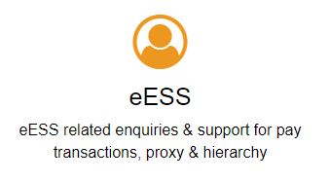

* On the Enquiry type and and category, select the following:

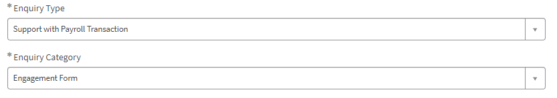

* Provide a description and select the relevant priority level
* By clicking the paperclip icon, you can then attach the SEF

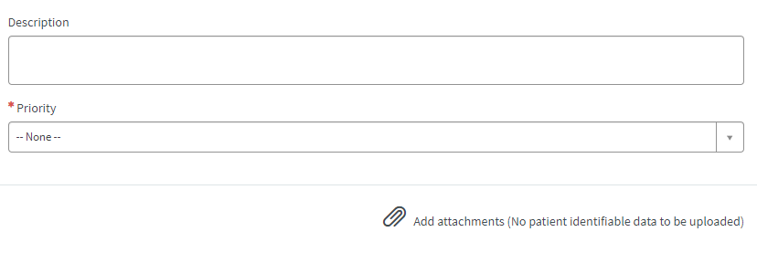

1. **If appointing to a salary higher than the first increment** of the band, please contact Recruitment for the Starting salaries form that must be completed.
2. For new starts, please request for the creation of their profiles
   1. [NHS GGC email address](#) (New accounts)
   2. [LearnPro account](#)