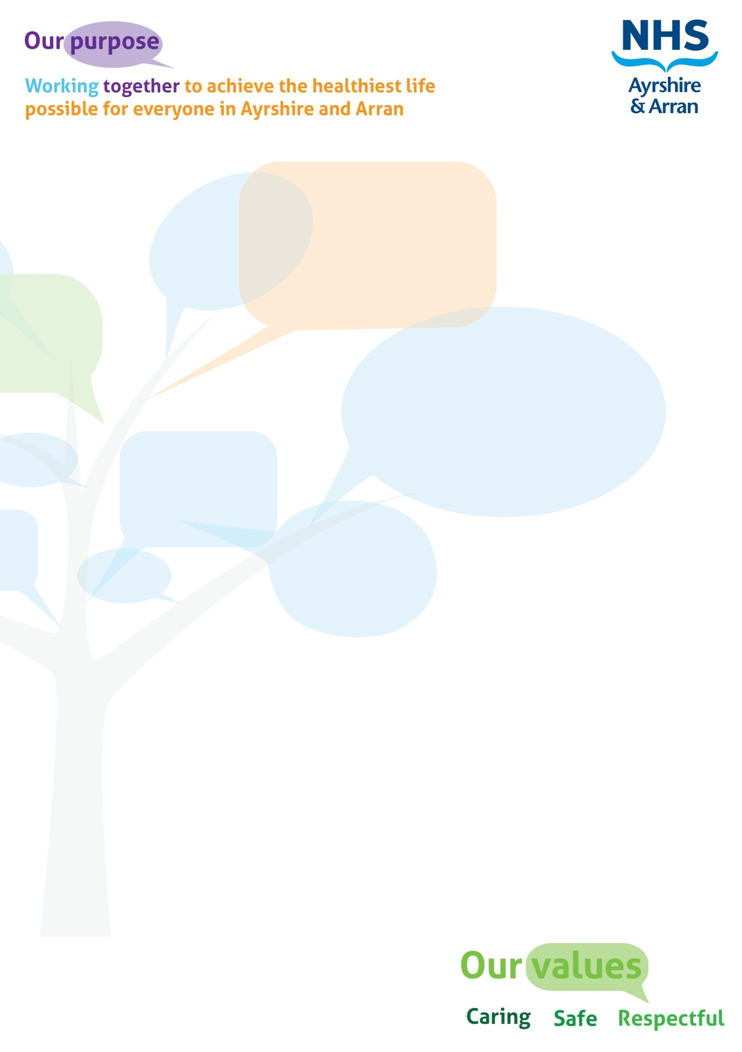

#### **JOB DESCRIPTION**

|  |
| --- |
| JOB IDENTIFICATION |
| **Job Title:** Administration & Clerical Officer  **Responsible to:** Audiology Service Administration & Clerical Manager & PA to Head of Service.  **Department:** Audiology Service  **Directorate:** Surgical  **Operating Division:** Acute  **Job Reference:**  **No of Job Holders:** 2  **Last Update:** 1st April 2023 |

|  |
| --- |
| 2. JOB PURPOSE |
| To participate fully in the delivery of audiology services to the population of Ayrshire & Arran through the provision of reception services and when required, administration and clerical support. The role provides the first point of contact for visitors to the Department including the handling of & telephone enquiries and limited general administration and clerical activity to support professional staff and colleagues in the day-to-day running of the Service. |

|  |
| --- |
| **3. DIMENSIONS** |
| The post holder typically works directly with 7 other administration and clerical colleagues and 22 professional/technical colleagues within the Service.  The postholder has shared responsibility for the efficient use of resources and materials needed to perform their duties.  The post reports directly to the Audiology Service Administration & Clerical Manager (and PA to Head of Service). |



|  |
| --- |
| 4. ORGANISATIONAL POSITION |
|  |
| 5. ROLE OF DEPARTMENT |
| The Audiology Service, part of the Surgical Directorate managed from University Hospital Crosshouse, provides an area wide service.  The Service, is delivered from 2 principle sites, 4 satellite sites and through additional peripheral locations including health centres, nursing homes, schools and domiciliary visits. Staffed by 16 Audiologists, 4 Assistant Technical Officers and 7 Administration and Clerical Officers, the role of the Service is to provide comprehensive diagnostic and rehabilitative audiological care to the people of Ayrshire & Arran, ensuring effective and efficient delivery of services within budget to a wide range of service users with a broad range of clinical conditions on a 5-day a week basis.  To achieve this, the Service:  Provides hospital based specialist investigative and diagnostic services to 6 ENT consultants and their middle and junior grade medical colleagues. This includes complex and non routine electrophysiological measurement testing to assist in the diagnosis of hearing and vestibular disorders associated with ENT/neurological and audiological complaints. Testing is undertaken on an out-patient basis within the Audiology Department and ENT theatre sessions.  Delivers an assessment and rehabilitation tinnitus service to tinnitus sufferers.  On a daily basis provides audiological input to assist in the running of all routine ENT out-patient clinics.  Works in partnership with ENT in the provision and development of the implantable hearing aid service.  Manages the day to day delivery of the Universal Newborn Hearing Screening Programme.  Delivers diagnostic assessment for all infants referred from the Organisation’s Newborn Hearing Screening Programme.  Provides assessment, selection, and prescription fitting of hearing aids to all residents of Ayrshire and Arran from newborns to the elderly to include the development of individual management plans and lifelong support and rehabilitation.  Operates a direct GP referral system for hearing assessment leading to hearing aid provision for older adults. In conjunction with this a patient self referral system operates for existing hearing aid users.  Provides an “open access” walk-in service 5-days a week for hearing aid repair and/or battery exchange from the 2 principle sites to all pre-existing NHS Ayrshire & Arran’s NHS hearing aid users.  Delivers training and education to departments and agencies outwith the Audiology Service i.e. medical & nursing staff, voluntary organisations, public sector staff, business community etc to promote the issues faced by the hearing impaired and provide on occasion practical training in dealing with these and the technical issues associated with the use of hearing aids.  Liaises closely with other professionals within Health, Education and Social Services across the 3 local authorities in addition to the private sector and volunteer groups to maximise the provision of care for the hearing impaired.  The Service is delivered in line with the requirements of the Scottish Government Health Department, the local health plan and national objectives and programmes linked to patient safety, quality and performance. |
|  |

|  |
| --- |
| 6. KEY RESULT AREAS |
| **Reception** (carried out in parallel with the Administration & Clerical activities)  Provide first point of contact for service users and visitors to the Department including telephone enquiries.  Provision of consumables e.g. hearing aid batteries to service users on a drop in and collect basis.  Checking in and greeting of patients/visitors to the Department supported by the use of the Service's patient management system.  Maintenance of patient information within the Service's electronic patient management system.  Managing the receipt and sending of mail.  Contribute to the gathering of activity information for the Service.  **Administration & Clerical**  Maintenance of stationary stock levels requesting resupply when necessary.  Advising colleagues of the need to re-book/reschedule patients and clinics based on information received from Service Users and participates in this activity. |
| 7a. EQUIPMENT AND MACHINERY |
| Standard office equipment that consists of:  Telephone, computer, scanner, photocopier, fax & shredder. |
| **7b. SYSTEMS** |
| **The postholder is required to use the following systems:**  Audiology Service's electronic patient management system (Practice Navigator).  NHS Ayrshire & Arran’s electronic patient management system (Trak Care).  Microsoft Office package.  Manual health record systems – paper based casenotes.  Cash book & receipts - for the sale of consumables within the Service. |

|  |
| --- |
| 8. ASSIGNMENT AND REVIEW OF WORK |
| The majority of the role is demand led work and is generated by patients attending the Service’s drop in “Open Access” sessions. In addition to this, work is also generated via telephone calls, email communications, mail and requests from the Audiology Service’s Clinical staff on a daily basis.  Review is carried out both formally and informally through the use of personal development reviews and on a day-to-day basis by both the Audiology Service Administration and Clerical Manager / Lead Audiologist for the site. |

|  |
| --- |
| **9. DECISIONS AND JUDGEMENTS** |
| The postholder typically manages and prioritises their own workload on a daily basis, revising priorities as necessary throughout the day due to the activity of the Department and under guidance from the Audiology Service Administration and Clerical Manager.  They will make and take decisions when advising both personal callers and telephone callers to the Department regarding general hearing aid queries on use, repair and other associated matters to provide options on how to resolve a problem including when necessary call forwarding to professional staff for more complex and detailed advice. |

|  |
| --- |
| 10. MOST CHALLENGING/DIFFICULT PARTS OF THE JOB |
| The post holder is the first point of contact for members of the public. Patients in particular can be anxious and require time and reassurance. It is a requirement that the post holder has a broad understanding of the referral pathway and patient journey to be able to provide good quality help.  Assisting anxious patients and their families/carers, attempting to satisfy demands and expectations  Communication with patients with complex hearing difficulties and communication problems and at times with physical and/or learning disability.  The ability to switch between disparate tasks quickly due to the demands and needs of service, services users & colleagues at any given time.  Having the personal characteristic and ability to remain calm when under pressure. |

|  |
| --- |
| **11. COMMUNICATIONS AND RELATIONSHIPS** |
| Communication is made in a variety of ways including face-to-face, telephone and email. The range of issues varies as do the contacts themselves which can include:   * Internal – immediate colleagues, other departments, professional, technical, nursing, medical, secretarial staff and patients and their families where there is a requirement to provide information on patient care and general advice. * External – via telephone, email and letter with regard to patient care, appointments, delivery of goods.   Relationships are developed and maintained with the following people:   * Internal - immediate colleagues, other departments, professional, technical, nursing, medical, secretarial staff. * External – patients and their families, other Audiology Services and related health professionals, Social Work & Education Services, Voluntary Sector and Suppliers.   These relationships require to be caring, safe and respectful. |

|  |
| --- |
| **12. PHYSICAL, MENTAL, EMOTIONAL AND ENVIRONMENTAL DEMANDS OF THE JOB** |
| Physical:   * Manual handling of paper records, mail and small parcels. * Bending and stretching to retrieve materials. * Typing.   Mental:   * Concentration and awareness is required when dealing with hearing impaired patients as they may also have speech impairment. * Difficult to concentrate with interruption from the telephone and patients arriving at ‘Open Access’. * Patients have direct access to the Department through Open Access and the post holder can be the first point of contact; therefore unpredictable situations occur on a daily basis requiring the post holder to use initiative and tact.   Emotional:   * Dealing with angry, verbally abusive members of the public / patients and clinical staff face to face or via the telephone.   Environmental:   * Heated environment. |

|  |
| --- |
| 13. KNOWLEDGE, TRAINING AND EXPERIENCE REQUIRED TO DO THE JOB |
| Essential   * An education with evidence of qualification to Standard Grade or equivalent in English & Mathematics. * Excellent spoken and written English. * Competent in the use of Microsoft Office in particular Word, Excel & Outlook. * Proficient in the use of the Internet. * Excellent keyboard skills. * Flexible approach to work and working as part of a team. * Excellent communication and interpersonal skills. * Experience of working with the general public on a routine (daily) basis. * Ability to manage time and prioritise work for self. * Calm empathetic nature and approach to dealing with others in a busy and demanding environment.   Desirable   * A formal IT literacy qualification. * A formal administration & clerical qualification * Experience working in a health care environment and in particular with the general public on a routine (daily) basis. |