**eHealth/Diagnostics Job Pack 2023**

**NHS GREATER GLASGOW AND CLYDE**



**Post: Picture Archiving & Communications System**

**PACS Manager**

**Tenure: Permanent**

**Directorate: Diagnostics/eHealth**

**Grade: Agenda for Change Band 7**

**Salary: £46,244 - £53,789**

**Hours: Full time 37.5 hours per week**

**Location: Royal Alexandra Hospital**

**Closing Date: 24/11/2023**

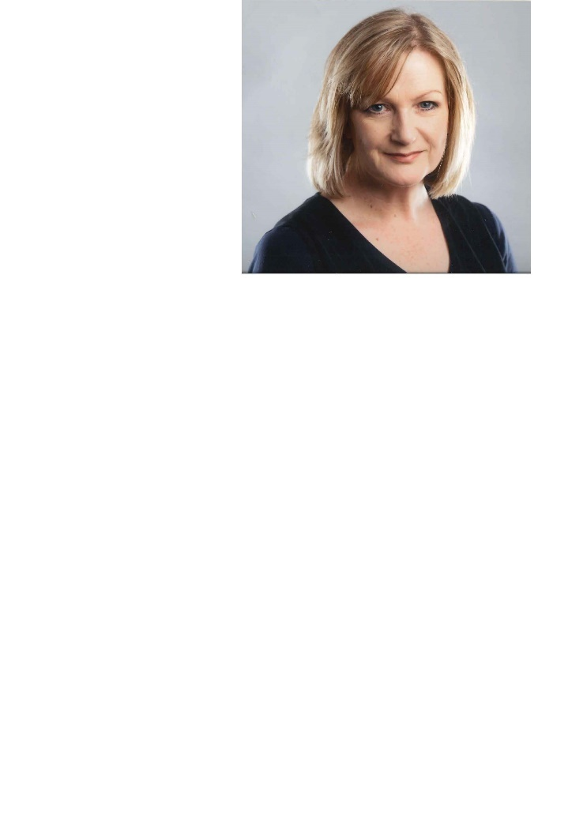**Welcome from Denise Brown, Director of Digital Services**

Thank you for expressing an interest in the role of PACS Manager. NHS Greater Glasgow and Clyde (NHSGGC) has the largest eHealth department in NHS Scotland and is at the forefront of digital transformation across the Health Service in Scotland. This role is an exceptional development opportunity for an experienced and dynamic person to join a highly motivated team whose role it is to support clinical and other staff to deliver the best possible care. NHSGGC is a Board which values and develops its people and joining the team provides many potential opportunities to grow and develop your career over time.

**About NHS Greater Glasgow and Clyde Health Board**

NHSGGC is the largest healthcare provider in Scotland, serving a population of approximately 1.3m, through the provision of a comprehensive range of Acute, Mental Health and Community Care services. The Board also provides cross-border and Regional services.

**About the Directorate**

The eHealth Directorate has 1,640 staff. The Directorate has a revenue budget of approximately £70m (including annual Scottish Government funding), an annual capital budget of circa £7m and other non-recurring budget of approximately £13m.

The Imaging Support Team supports a wide range of deliverables across all the departments detailed below.

The eHealth Directorate comprises of the following departments:

* **Operations** – responsible for the overall IT and Telecommunication service delivery to NHSGGC including the delivery of the underpinning technical infrastructure and applications to support the health and corporate directorates across NHSGGC to agreed KPI’s and SLA’s. In addition, Information security and compliance.
* **Strategy and Programmes** - responsible for the development of the medium to long term eHealth Strategy and the delivery of a large number of highly complex programmes and projects including significant service reconfiguration and System development.
* **Innovations** – responsible for development and delivery of eHealth enabled Innovation Programmes, linking with Innovators such as clinicians, R&D, industry and SME's within NHSGGC, West of Scotland, and the broader Innovation community.
* **Information Management** – responsible for the collection and analysis of information, information governance and delivery of knowledge management services. This service comprises Knowledge Services (Libraries), Clinical Coding and Business Intelligence.
* **Health Records** - delivery of Health Records services across NHSGGC, including provision of outpatient clinics and ward clerk services.
* **Business and Resource Management** – responsible for financial management, procurement & contract management, audit, risk management, Programme Management Office (PMO), Information Governance, FOI responses and overarching aspects of staff governance and organisational development, Health & Safety, general Directorate wide governance and facilities management activities.

The Directorate is fortunate to have in place strong governance structures to enable us to manage and effect change at pace and scale. The success of the Directorate is down to the way that teams work flexibly to deliver the support that’s required. A key element of the progress that we’ve been able to also down to the strong clinical leadership roles which are now embedded within the Directorate structure. Our clinical colleagues are aligned to key programmes and operate as a clinical reference group too.

Additionally, we place a big emphasis on staff development, retention and attracting new talent and we do this through a mature performance development framework, robust workforce and succession planning and role-based training which is pivotal overall.

The job description is enclosed as appendix 1 and the person specification is enclosed as appendix 2.

**Digital Strategy and other Transformation Programmes**

NHSGGC has an ambitious 2023-2028 Digital Strategy (LINK) which sets out all of the strategic themes and programmes. The Imaging Department is pivotal to supporting the delivery of transformational change, with some examples of the key programmes of work the department is involved in, set out below.

|  |  |
| --- | --- |
| **Programme** | **Description** |
| National PACS Reprovisioning and Implementation | Implementation of a new National Picture Archive & Communications System. |

**Moving Forward Together (MFT)**

Launched in 2018, the NHSGGC Moving Forward Together programme is a whole-system approach to planning services covering acute hospital care, community services and primary care in order to improve care and outcomes. The MFT Portfolio of Projects comprises a range of short-, medium- and longer-term initiatives including development of new ways of working which provide safe, effective, and patient-centred care. The Digital Strategy aligns with MFT over the coming five years, making best use of available resources and the opportunities created by innovation and technology. More information on the Moving Forward Together Programme can be found via the LINK.

~~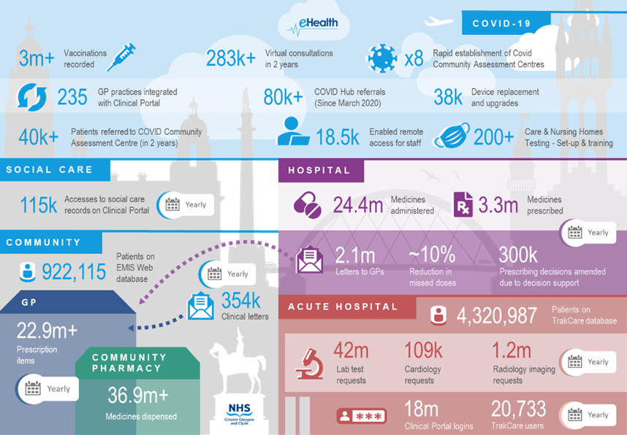~~

**Useful Links and Information**

* NHSGGC Digital on Demand Strategy 2023 – 2028 ~~-~~ LINK & Video
* NHSGGC Twitter - LINK

**Key Strategic Drivers**

* National Digital Health & Care Strategy
* National Workforce Strategy for Health and Social Care in Scotland
* Fairer Scotland Duty
* Meeting the Requirements of Equality Legislation (2020-24)
* NHSGGC Stakeholder Communications and Engagement Strategy (2020-23)
* NHSGGC Healthcare Quality Strategy 2019/2023
* NHSGGC Moving Forward Together (MTF) programme
* NHSGGC “Growing Our Great Community” Workforce Plan 2022-25

**Appendix 1 – Job Description**

|  |
| --- |
| * **JOB IDENTIFICATION**   **Job Title:** Picture Archiving and Communication System (PACS) Manager  **Responsible to:** SDPM - Diagnostics  **Department:** Imaging  **Directorate:** Diagnostics/eHealth |
| **2. JOB PURPOSE** |
| To manage, administer and support the Picture Archiving and Communications System (PACS) across NHS Glasgow and Clyde.Accountable for efficient service delivery in the clinical environment to always ensure continuity of patient care. This includes the development and maintenance of operational policies and procedures, system audit, handling of complaints and ensuring a close liaison with clinical users and with third party suppliers.Responsible for the content, quality and integrity, safe use and security of the data.Maintain effective service delivery through the allocation and management of physical resources and respond to evolving clinical service needs.To be the local expert in all issues relating to and affecting PACS and advise on appropriate prioritisation and allocation of budgetary resources to support service development and improvement.Have highly developed specialist knowledge in RIS, PACS and other Radiology Information Systems and be expert in Imaging IT.Create, organise and deliver training to a wide range of clinical and non-clinical staff with according adjustment. |

|  |
| --- |
| **3. ROLE OF DEPARTMENT** |
| The overall aim of the eHealth Directorate is to deliver and maintain a comprehensive integrated information, technology and record management strategy in order to ensure that the right information is provided in the right place at the right time, to support highest possible levels of diagnosis, treatment and care of patients and clients, to support continuous improvement of the health of the populations we serve and to achieve more effective integration between Health and the care services of our Local Authority partners.    This includes patients’ case notes and other information for clinicians working in the community and primary care, in outpatient clinics, on the point of admission for inpatients/day cases and for review after discharge: it includes developing and supporting electronic information systems for clinical and management use: and it includes collection and analysis of data required by the Scottish Government Health Department, for local monitoring of activity or performance, and for surveillance and protection of the health of our populations.    The eHealth Directorate has approximately 1,480 staff, a revenue budget of approximately £57m (inc. annual Scottish Government ring fenced funding), annual capital budget ranging between £3-5m and non-recurring eHealth budget of approximately £15.8m.  The eHealth Directorate comprises the following departments:   * **Operations** – responsible for the overall IT and Telecommunication service delivery to NHSGGC including the delivery of the underpinning technical infrastructure and applications to support the health and corporate directorates across NHSGGC to agreed KPI’s and SLA’s. * **Strategy and Programmes** - responsible for the development of the medium to long term eHealth Strategy and the delivery of a large number of highly complex programmes and projects including significant service reconfiguration. * **Information Management** – responsible for the collection and analysis of information, information governance and delivery of knowledge management services. This service comprises Knowledge Services (Libraries), Information Governance and Business Intelligence. * **Health Records** – delivery of Health Records services across NHSGGC, including provision of outpatient clinics. * **Business and Resource Management** – responsible for financial management, procurement & contract management, audit & FOI responses and overarching aspects of Human Resource and Organisational Development, Health & Safety, general Directorate wide governance and facilities management activities. |

|  |
| --- |
| **4. ORGANISATIONAL POSITION** |
|  |

|  |
| --- |
| **5. SCOPE AND RANGE** |
| The PACS is a highly complex computerised system designed to store, display and distribute the entire results of the clinical radiology service, allowing images to be available at the point of need 24 hours a day for clinical use. Over 300 sophisticated images modalities, including Computed Tomography (CT) and Magnetic Resonance Imaging (MRI) scanners are interfaced with the system. Radiology departments provide a comprehensive diagnostic imaging service to a wide range of patients throughout Glasgow and Clyde and neighbouring health boards**.**  Approximately 1,200,000 examinations are carried out in Glasgow and Clyde each year and the PACS has over 8,000 users in areas such as radiology, accident and emergency, outpatient departments, all wards, intensive, coronary and neonatal care units, orthopaedics and theatres.  While the PACS Managers are responsible for the day-to-day maintenance and organisation of the system they must also respond to, and plan for changes and future developments.  Each PACS Manager is responsible for the delivery of the service locally, but will also be required to provide cross site cover, e.g. for holiday cover, etc. The post holder participates in a 24-hour on call service as part of the system support team. |

|  |
| --- |
| **6. MAIN TASKS, DUTIES AND RESPONSIBILITIES** |
| **Managerial – 25% of time**  Uses detailed knowledge of radiological image production processes and hospital workflow to convey complex information to clinical users on the most efficient use of the resources available.  Establishes the most effective distribution and safe use of available, expensive hardware and licences, taking into account both clinical requirements and value for money.  Supports the PACS Programme Manager in the development of strategic activities for NHS GGC and develops and delivers activities locally.  For all aspects which involve IT equipment and software, works within all IT policies and standards, including IT change control and asset management practice.  Negotiates with the PACS vendor provider to ensure users’ needs are accurately communicated.  Liaises with the PACS supplier and colleagues throughout NHS Glasgow and Clyde to co-ordinate the implementation of system upgrades and patching.  Liaises with the PACS suppliers to ensure outstanding issues are resolved to the satisfaction of the Trust.  Identifies and evaluates new equipment to inform the selection and procurement process.  Liaises with eHealth colleagues and system suppliers in the management of interfaces between PACS and other information systems.  Liaises with IT colleagues to ensure the overall security of the system.  Responsible for developing, implementing and maintaining policies including contingency, data administration protocols, operational policy, disaster recovery and the distribution of images out with NHS Glasgow and Clyde, within agreed NHS GGC eHealth policies and standards.  Responsible for developing and operating a PACS quality assurance and audit programme to optimize the diagnostic potential of the radiological image.  Develops and implements the local strategy for long-term development of the PACS working practices and procedures.  Monitors and reports on PACS supplier performance with regard to their contractual obligations.  Responsible for training and supervising the activity the activity of PACS ‘super-users’.  Produces written and verbal reports on the performance of systems and system problems.  Ensures compliance with the Health and Safety at Work Act and IR(ME)R and all other relevant national and local policies and procedures.  Responsible for developing and maintaining system documentation.  Ensure all new processes and policies are compatible and complement those needed to maintain the GGC Electronic Patient Record system and Radiology Information System (RIS)  Acts as representative for users at forums where PACS is discussed.  Investigates and addresses formal complaints from users. This requires prolonged concentration.  Investigates and researches innovative uses of technology to address evolving patterns of clinical service delivery.  **Educational – 25% of time**  Supports the PACS Programme Manager in the development of strategic activities and develops and delivers the following activities locally.  Creates, organises and delivers training programmes to varying sizes of groups as part of the medical staff rotation or as part of routine training of medical and non-medical staff. Groups can include 60 people or more.  Provides ad hoc training for new employees – this is an ongoing commitment and involves users from a wide range of employment backgrounds.  Acts as source of specialist knowledge and information for a range of PACS applications, procedures and working practices.  Requires a good working knowledge of other software programs to include specialist orthopaedic planning, PowerPoint and other MS products.  Provides ad hoc advice to users of the system on a variety of topics normally via an office telephone or email.  Maintains a good working knowledge of the system software and hardware, whilst keeping abreast of new developments and advancing technology.  Trains and advises consultant and trainee radiologists on optimal use of reporting software to assist accurate diagnosis.  Responsible for liaising between special modality staff, radiologists, clerical staff and PACS equipment suppliers  Works with product specialists and developers to contribute to development and improvement of a worldwide product.  Carries out detailed investigative research work to support system improvement and configuration decisions.  Assesses and advises on radiographic practise to ensure high quality diagnostic images are available for the treatment and management of patients.  Assists clinical/medical staff in the preparation of presentations for multidisciplinary and national meetings.  Maintains own continuous professional development in keeping with state registration and professional requirements.  Contributes to and shares PACS policy development at national and international forums.  Leads visits to sites by other Trusts proposing to replace or upgrade PACS.  Delivers presentations to a variety of groups.  Responsible training of radiography students.  Maintains a personal CPD programme with particular reference to PACS technology and system management.  **Technical – 30% of time**  For all aspects which involve IT equipment and software, works within IT policies and standards, specifies requirements and liaises with eHealth colleagues in the implementation or configuration of hardware or software.  Uses in-depth knowledge to investigate and diagnose problems which can affect several services in the live clinical environment.  Provides on the job advice and training to users of the PACS.  Investigates reasons for system problems and determines best course of action.  Develops and performs system testing to validate the safe and effective implementation of software and hardware upgrades and their compatibility with interfaced systems and modalities.  Escalates system faults and operational issues appropriately.  Responsible for the configuration of reporting workstation software to meet changing demands of radiologists.  Adapts software configuration for clinical users.  Assesses the impact of users’ specific image display requirements in the context of database functionality.  Provides technical support and guidance out of hours for the PACS system to an agreed service level.  Works closely with Radiology Information System team to ensure and maintain consistent accurate data quality.  Collaborates with eHealth colleagues to resolve NHS Glasgow and Clyde hardware, software and OS problems.  Collaborating with large complex groups of interested parties in the planning and implementation of interfacing information systems.  Evaluates new radiology and IT equipment and advises on suitability, together with eHealth colleagues.  Uses test equipment as part of an image quality assurance program and for monitor fault diagnosis.  Undertakes system administration of PACS, according to directorate guidelines, e.g. for management of user ids, etc.  **Administrative – 20% of time**  Uses highly developed specialist knowledge of highly complex imaging equipment, such as Magnetic Resonance, Computed Tomography, Ultrasound, Nuclear Medicine, and Computed Radiography to identify and correct faults in images.  Uses an in-depth experience of the PACS to investigate faults and determine the best course of action, including the exact cause when they are subtle or non-reproducible.  Identifies and rectifies patient identification and database integrity issues thereby minimising clinical risks.  Monitors all parts of the system to ensure image availability is maintained.  Records and documents day-to-day maintenance and faults and determines level of intervention required to minimize downtime.    Identifies relevant legislation, guidelines, security updates and policies that may need to be applied.  Liaises with PACS team to ensure on-call provision to agreed service levels.  Ensures cover for annual leave/sickness is arranged.  Development of job description, evaluation and selection of candidates as part of the recruitment process. |

|  |
| --- |
| **7a. SYSTEMS, EQUIPMENT AND MACHINERY** |
| **Systems**  Responsible for the local operation of the Picture Archiving and Communications System across all NHS GG&C sites.  Ensures compliance with NHS Greater Glasgow and Clyde security policy, including maintenance and control of system access levels, user accounts and passwords.  Accountable for the maintenance and integrity of the centralised image database.  Carries out preventative and curative actions to maintain the quality of the image database.    Ensures privacy of PACS databases.  Protects the PACS databases by ensuring they are secure from physical harm or unauthorised access.  Determines, reviews and applies policy for levels of access to PACS data for a variety of user groups.  Determines need for encryption of sensitive data where necessary.  Examines audit trail logs for unusual activity.  Other systems used include:   * Interfaced specialist image post processing systems * Operative Image Navigation Systems * Radiology department imaging modalities (X-ray and scanning equipment) * Radiology Information System (RIS) for managing records of patients in radiology. * Hospital Information System (PAS) * SCI Store * Service Now   **PACS Hardware**   |  |  | | --- | --- | | **PACS v12.x Servers** | | | **Item / Feature** | **Specification** | | PACS server box | Four Intel® Xeon® Processor X7560 (24M Cache, 2.26 GHz, 6.40 GT/s Intel® QPI)  32GB Memory for 4 CPUs, DDR3, 1066MHz (8x4GB Quad Ranked RDIMMs)  Three x 146GB SAS 6Gbps 10k 2.5" HD Hot Plug  Two Intel® PRO 1000PT Dual Port Server Adapter, Gigabit NIC (In addition to on-board NIC ports)  Two Dual Channel 8GB Optical Fiber Channel HBA PCI-E Card (compliant with the selected RAID),  16X DVD+/-RW Drive SATA  Embedded, 512MB Cache Raid Controller  Remote access module  Rack mountable  High Output Power Supply (2+2 PSU) 1100W, Redundant Full-Power Configuration  OS: Windows server 2008 x64 R2 STD | | PACS server HA | High Availability level managed by Veritas Cluster software.  2 x PACS servers per Hamper  Data Access through Veritas DMP multipath software | | Server / Storage connectivity | Direct Attached Storage FC connection 4GB/sec  Dual HBA FC connection to RAID Storage Processor for redundant data access path. | | UPS/Mains connectivity | 2 x UPS for each Rack for Power redundancy (2 x 32-amp sockets)  2 x mains connectivity (2 x 16-amp sockets)  30-minute UPS autonomous runtime  UPS 🡨🡪 mains automatic failover via Automatic Transfer Switch or equivalent (where required) | | Rack | Standard 38u Maximum Rack Unit, 42u where required.  1U to be allocated to reuse DAP Sun Fire v210/v215 until DC upgrade complete | | RAID disk array (Db and Image) | 2 x Storage Processor 4GB RAM per processor  Raid Controller: Dual Active-Active  Number of drive slots: as required.  System memory cache: 4GB per CPU (minimum)  Host interface: Four 4Gb/s FC (minimum)  Drives: 600GB 15K FC or 600GB 15K SAS  RAID5 RAID group for database, backup and image partitions  1 x SAS Hot Spare Disk per expansion module |  |  | | --- | | **Reporting Workstations** | | **HP Z420 High-end reporting workstations** | | **16GB RAM, SSD** | | **Dual Eizo 3MP diagnostic displays** |   **PACS Software**   |  |  | | --- | --- | | **Feature** | **Software** | | PACS Server Operating System | Windows 2008 x64 R1 after Sep 2010 | | Multipath software | Veritas DMP 5.1 | | CSH software | Carestream PACS v11.x | | Cluster software | Veritas SFW-HA 5.1 | | Database software | Oracle 11.1.0.7.0 database and client | | Web server | Apache HTTP Server 2.2.6 | | User Management | Apache Tomcat 6 (for Carestream) | | Java | Java development kit Java 1.6 for v11.1 | | Scripting | ActivePerl 5.6.1 Build 638, ActivePhiton 2.4.1 |  |  | | --- | | **Other Software** | | HSS CRIS 2.09.10t1i | | Speechmagic 7 and 8 | | Image Exchange Portal | | Carestream PACS Admin Suite | | GGC PACS Amendment System | | CHI 24 | | USD Service Desk Support | | Clinical Portal | | LearnPro Training | | PUMA User Management System | | MS Office application suite |   **Other**  Various models of PC, standard PC monitors and dedicated monochrome and colour reporting monitors and data projectors.  Reporting monitor quality assurance software, measuring instruments and test patterns. |
|  |

|  |
| --- |
| **8. DECISIONS AND JUDGEMENTS** |
| NHS Glasgow and Clyde leads PACS development in Scotland. Policies and procedures are created from first principles and must be continually reviewed in response to changing user demands and expectations. Many problems encountered can be site specific and there may not be any ‘usual’ solution.  Uses judgement to analyse and identify complex user and technical system information while maintaining continued safe and effective system operation.  Assesses and balances information from a variety of sources and to determine the best course of action by comparing a range of options to resolve operational system issues.  Works without supervision at all times, and as an integral member of the local radiology team and distributed team of PACS system managers.  As senior member of the radiology team, most of the work is undertaken at the postholders’ discretion and on their own initiative.  Manages, assesses and prioritises of issues with regard to both clinical risk and financial implications.  Determines technical, practical and economic viability of requests for service provision changes made by users.  Responsible for the management and prioritisation of own workload. |

|  |
| --- |
| **9. COMMUNICATIONS AND RELATIONSHIPS** |
| The post holder is required to communicate with:  Other eHealth Directorate Professionals ensuring models of service delivery are achieved.  NHSGG&C Business and Project Managers, both advising and negotiating the use of new and emerging technologies.  Clinical staff throughout NHSGGC, advising and supporting to resolve issues. Staff from other Health Board areas, in particular when national information events and working groups take place.  Receives highly complex technical and sensitive information from system suppliers and eHealth team. Interprets and communicate highly complex information to diverse multidisciplinary clinical and non-clinical groups.  Uses persuasion and motivational skills as PACS champion to provide reassurance to, and co-operation of, clinical staff.  Acts with tact and diplomacy to maintain good relationships when users expectations cannot be met, sometimes in a highly emotive environment.  Delivers presentations on complex issues to large staff groups on technical, working practise and scientific subjects related to PACS.  Negotiates with and persuades stakeholders and suppliers.  Communicates service-related information to other senior managers.  Delivers formal clinical training to user groups of up to 60 people.  Provides ad hoc clinical training on a one-to-one basis.  Promotes general awareness of the system.  Communication within team for support, assistance and load sharing.    Communication with various staff groups from other Health Boards.  Participation in national forums. |

|  |
| --- |
| **10. PHYSICAL, MENTAL, EMOTIONAL AND ENVIRONMENTAL DEMANDS OF THE JOB** |
| **Physical** Combination of sitting, standing and walking.  Regular manual handling of computer equipment.  Occasional cramped and dusty conditions.  Prolonged VDU exposure. (50 %+)  Prolonged keyboard use. (50 %+)  Driving between clinical sites when required. **Mental** Frequent interruptions from various medical and non-medical staff, either in person, or by phone, pager or e-mail. Frequent interruptions make completing tasks arduous.  Required to respond quickly and efficiently with best course of action.  Frequent, intense concentration required for data analysis, often undertaken under strained conditions.  Managing/anticipating user expectations.  Providing support as required to different sites. **Emotional** Occasional risk of verbal abuse |

|  |
| --- |
| **11. MOST CHALLENGING/DIFFICULT PARTS OF THE JOB** |
| Manage a 24-hour critical care system in an ever-changing IT/Imaging environment ensuring.  the continuing availability to users  System failure can cause severe and sudden disruption to clinical services.  This requires an immediate response to ensure continuity of patient care and  timely treatment.  Participates in a 24/7 on-call cover to agreed service levels to support PACS throughout the Health Board area. Responsibility to maintain the availability of medical images for clinical users is shared with the PACS and eHealth team.  To encourage, motivate and manage multi-disciplinary groups of staff to user.  new technology/developments available and negotiating with and persuading staff to  change working practices.  Management of conflicting resource issues between daily operational and development  projects  To carry out testing of new software releases and develop user documentation while continuing to provide an efficient support service.  Management conflicting requirements of the different disciplines within the departments.  Managing and resolving inter departmental operational issues throughout Greater Glasgow  and Clyde.  Meeting the user's expectation of understanding the wide variety of clinical applications to which the system is put.  Isolated nature of the position within the multi-disciplinary structure.  Requires resilience, self-discipline, and self –motivation.  Multi-disciplinary nature of the environment can lead to difficult inter-personal situations. |

|  |
| --- |
| **12. KNOWLEDGE, TRAINING AND EXPERIENCE REQUIRED TO DO THE JOB** |
| **Essential**   * Educated to Diploma/Degree level in radiography or imaging related subject or equivalent practical experience in this field. * Knowledge of desktop software is also required including Microsoft Office. * Good understanding of Windows platforms. * Experience in using a helpdesk system.   **Desirable**   * Experience of relational databases. * Experience in Unix/Linux. * Experience of using integration engines.   **Experience**  The post holder will have demonstrable practical experience in the support and implementation of clinical and diagnostic applications within a complex environment.   * Ability to prioritise and meet deadlines in a time constrained environment. * Ability to exercise initiative and work independently. * Able to communicate clearly about technical issues and problems with non-technical.   users   * Good interpersonal and negotiating skills allowing post holder to influence decision making. |

**Appendix 2 – Person Specification**

**Job Title: - PACS Manager (AFC 7)**

**Department: - eHealth/Diagnostics Support Team**

|  |  |  |
| --- | --- | --- |
| **Qualifications and Skills** | **Essential** | **Desirable** |
| Educated to degree level in Radiography with a minimum of 3 years postgraduate experience | **✓** |  |
| HCPC registration |  | **✓** |
| Evidence of post diploma or postgraduate study |  | **✓** |
| Post graduate qualification in IT |  | **✓** |
| Understanding of IT network infrastructure and computer hardware. |  | **✓** |
| Knowledge of relevant legislation to include data protection and radiation protection regulations (IR(ME)R) |  | **✓** |
| **Experience** | **Essential** | **Desirable** |
| Detailed working knowledge of clinical processes and Imaging Department workflow | **✓** |  |
| Excellent planning and organisational skills | **✓** |  |
| Excellent communication and interpersonal skills | **✓** |  |
| Experience of Medical Imaging Quality Assurance procedures |  | **✓** |
| **Behavioural Competencies** | **Essential** | **Desirable** |
| An ability to work as part of a multi-disciplinary team | **✓** |  |
| High level of communication and negotiating skills and the ability to diplomatically deal with all levels of users, senior management and clinical staff, allowing post holder to influence decision making with relevant presentation skills | **✓** |  |
| Ability to present to and engage a high level managerial or clinical audience | **✓** |  |
| Ability to prioritise and meet deadlines in a time constrained environment | **✓** |  |
| Organised approach to administration, workloads and prioritisation. Ability to exercise initiative and work independently. | **✓** |  |
| Good interpersonal and negotiating skills allowing post holder to influence decision making | **✓** |  |
| Ability to understand the business aspects of information systems and supported applications. | **✓** |  |
| Intuitive and proven team player | **✓** |  |
| Proactive self-starter, ability to exercise initiative and work independently | **✓** |  |
| Understanding of the business aspects of IT systems and applications | **✓** |  |
| Ensures that technical and complex tasks are completed to a high standard | **✓** |  |
| **Other** | **Essential** | **Desirable** |
| Ability to travel around NHSGG&C and partners sites | **✓** |  |