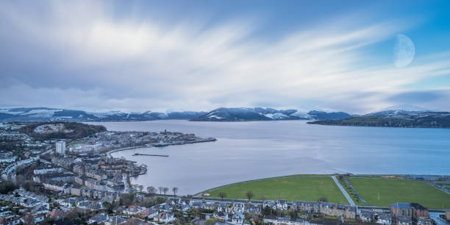

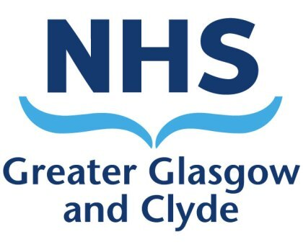

**Candidate Information Pack Consultant in Anaesthesia** Inverclyde Royal Hospital, Inverclyde

West Central Scotland

**Contents**

1. Welcome, How to Apply & Contact Details

2. The Recruitment Advertisement………………………………………………………

**3. Job Information…………………………………………………………………………………..**

* **About NHS Greater Glasgow and Clyde**
* **The Hospital**
* **The Department**
* **The Work**
* **The Job Plan**
* **The Person Specification**

**4. Terms and Conditions of Appointment……………………………………………………….**

5. About the Inverclyde Area

***For further information regarding NHS Greater Glasgow and Clyde and its hospitals, please visit our website*** ***www.nhs.ggc.org.uk***

1. **Welcome**
2. **Introduction**

Thank you for your interest in joining NHS Greater Glasgow and Clyde in the post of Consultant in Anaesthesia at Inverclyde Royal Infirmary.

This candidate information pack contains details about the job including information about the Department, the Job Plan and the Terms and Conditions of Service along with information about the local area.

We hope you will find the information in this pack helpful in considering coming to join our team at Inverclyde Royal Infirmary. We look forward to receiving your application if you decide to apply.

1. **What we can offer you**

Working with NHS Greater Glasgow and Clyde offers a variety of opportunities and benefits:

* Access to the NHS pension scheme
* Assistance relocating to the area
* NHS Greater Glasgow and Clyde is an equal opportunities employer and promotes work-life balance and family-friendly policies
* A beautiful setting to live and work and to take time out after a busy day or week
* Access to a transport network offering easy travel links to the rest of Scotland, the UK and Europe, as well as international options.

1. **How to Apply**

Interested applicants are most welcome to contact the department for additional information and to discuss the specifics of the post. Those shortlisted may wish to organise a visit to the department. We would support any reasonable expenses to facilitate this.

**If you would like to find out more about this role before applying, please contact Dr Duncan Thomson, Consultant Anaesthetist, NHS Greater Glasgow and Clyde on 0141 314 6609 or E-mail:** **Duncan.Thomson@ggc.scot.nhs.uk** **or Dr Fergal Burns, Clinical Director, Clyde, on 0141 3146609, or Email Fergal.Burns@ggc.scot.nhs.uk**

1. **Making your Application**

Candidate applications for this post are being invited via the NHS Scotland recruitment system called **Jobtrain**. We cannot accept CV’s as a form of application and only application forms completed via the Jobtrain recruitment system will be accepted.

For further details on how to apply and to complete the NHS Scotland Online application form visit www.apply.jobs.scot.nhs.uk ***Select Region > Greater Glasgow and Clyde >Job Type Medical and Dental > Job Reference 152172***

# General Information for Candidates

* NHS Greater Glasgow and Clyde encourages applications from all sections of the community. We promote a culture of inclusion across the organisation and are proud of the diverse workforce we have.
* NHS Scotland is exempt from the 1974 Rehabilitation of Offenders Act (Exclusions & Exceptions) (Scotland) Order 2003. As part of any offer of employment in regulated work candidates will be subject to Disclosure Scotland’s Protection of Vulnerable Groups Scheme Membership (PVG).

# NHS Scotland Application Process

# The purpose of an application form is to help evidence that the applicant has all the requirements applicable to carry out the job applied for.

# It is essential to read both the job description and the person specification to gain a full understanding of what the job entails and the minimum criteria required.

# Please note for equal opportunity purposes NHS Greater Glasgow and Clyde do not accept CV’s as a form of application.

# Your personal information will not be sent with the application for shortlisting. The application form will be identified by the candidate number only to ensure that no applicant will be unfairly discriminated against.

# Please complete all sections of the application form. Those sections that are not relevant please indicate ‘not applicable’, do not leave blank.

# Please visit www.apply.jobs.scot.nhs.uk for further details on how to apply

1. **Special Requirements for the Recruitment and Selection process**

To ensure prospective candidates are not disadvantaged in the recruitment and selection process we are fully supportive in making reasonable adjustments in order to support disabled job applicants or applicants with other health conditions. Reasonable adjustments for example may include allowing extra time during assessment exercises or ensuring information is provided in an alternative format such as audio, Braille or large font. If you require any special arrangements to be made in regards your participation in the recruitment selection process, please indicate this by contacting separately: Scott O’Rourke, Senior Recruitment Advisor via E-mail: Scott.O'rourke@ggc.scot.nhs.uk

**The closing date for applications: 13th July 2023**

**Interviews are scheduled for: 28th July 2023**

1. **The Recruitment Advertisement**

**NHS Greater Glasgow and Clyde**

**Clyde Sector – Anaesthetic Department**

**Consultant in Anaesthesia (1 WTE posts)**

**Location: Inverclyde Royal Hospital, Greenock (West Central Scotland)**

**Salary: £91,474 (GBP) to £121,548 (GBP)**

**Hours of work: 40 (10 PAs)**

**Relocation Package available**

**Consultant Opportunities – Inverclyde Royal Hospital, Greenock**

**Applications are invited for the full time post of Consultant in Anaesthesia based at Inverclyde Royal Hospital in Greenock. The posts are suitable for candidates at any stage of their consultant careers.**

A full range of District General Hospital Specialties are delivered from Inverclyde Royal Hospital which has 273 beds and approximately 4,200 General Anaesthetic patients per year. The department is responsible for the delivery of services for a wide range of specialties including Orthopaedics and General Surgery on an emergency and inpatient basis. In addition day surgery is undertaken for Ophthalmology, Gynaecology, Urology, ENT and Dental. There is also a chronic pain service.

**The Post**

These critical replacement posts provide an opportunity to join a small, supportive and friendly department consisting of 9 consultant posts, one middle grade posts and 5 trainees. The successfully appointed candidates, will be part of NHS and academic staff contributing to a 1:9 rota providing senior anaesthetic cover for elective, emergency surgery and critical care stabilisation of level 3 patients before transfer. This is supported by the RAH Intensive Care team.

Applicants with an interest in Orthopaedics or Colorectal surgery would be welcome however both posts offer an opportunity to tailor elements of each to the interests of the successful candidates.

Whilst the posts are based primarily at Inverclyde Royal Infirmary it is also anticipated that one day per week would be at the Royal Alexandra Hospital, Paisley (*the largest acute hospital in the Clyde sector located 15 miles from Inverclyde Royal Hospital*).

We also welcome applications from colleagues who wish to explore flexible or part-time working. Our goal is to enhance our team with the appointment of enthusiastic colleagues who are keen to contribute to the development of our Anaesthetic and Critical Care services.

The scope of surgical practice at Inverclyde Royal Hospital whilst challenging also offers exciting and varied clinical opportunities for consultant anaesthetists and there is continued support for non-clinical professional activities both inside and outside the Board.

The successful candidate will be a true generalist who enjoys a hands on approach to anaesthesia and be able to work flexibly as part of an integrated team and have excellent communication and problem solving skills. With an active interest in teaching and support the successful candidate will be expected to contribute to departmental quality improvement activity and the clinical supervision and training of our postgraduate trainees in Anaesthesia. NHS Greater Glasgow and Clyde is fully committed to continuing medical education for our consultants.

Candidates must be able to demonstrate a high level of clinical experience in all aspects of the essential criteria of the post.

Applicants must have full GMC Registration, a license to practise and eligible for inclusion in the GMC Specialist Register. Those trained in the UK should have evidence of higher specialist training leading to CCT or be within 6 months of confirmed entry from the date of interview. CESR (Certificate of Eligibility for Specialist Registration) route doctors are only eligible to apply for a substantive consultant post once CESR is awarded. Non-UK applicants must demonstrate equivalent training.

The job is offered as a full-time post on a 10 PA basis but applications will be considered from those wishing to work less than full-time. Up to 2 EPA’s may be available to undertake additional outpatient and/or procedure sessions or management activity.

Additional Non DCC (up to 2 PA’s in total – Inclusive of 1 core SPA plus 1 additional non DCC can be negotiated and agreed between the successful candidate and Management depending on the time required to support professional activities and the needs of the service.​​​​​​​​​​​​​​

All newly qualified Consultants are initially offered a minimum of 1 Core Supporting Professional Activity (SPA) which includes CPD, audit, clinical governance, appraisal, revalidation, job planning and management meetings. This will be reviewed within 6 months (or earlier if required) of appointment and revised upwards if additional responsibilities are agreed.

NHS Greater Glasgow and Clyde encourages applications from all sections of the community. We promote a culture of inclusion across the organisation and are proud of the diverse workforce we have.

We very much look forward to receiving your application which will be given careful consideration.

|  |  |  |  |
| --- | --- | --- | --- |
| Canvassing in connection with appointments is not permitted but this does not debar candidates who wish to visit the department/hospital(s) concerned. If you would like to find out more about this post before applying and details of arrangements to visit the department will be welcome by: | | | |
| **Name** | **Job Title** | **E-mail** | **Telephone** |
| **Dr Duncan Thomson** | **Consultant Anaesthetics, Inverclyde Royal Hospital.** | **Duncan.thomson@ggc.scot.nhs.uk** | **0141 314 6609** |

For more information about NHS Greater Glasgow and Clyde please refer to the additional information pack entitled ‘About NHS Greater Glasgow and Clyde’

**Job Information**

1. **NHS Greater Glasgow and Clyde**

* NHS Greater Glasgow and Clyde has the largest Acute Services delivery model in Scotland covering a range of diverse services from local ambulatory care sites to the largest and some of the most modern health service facilities in the UK. A range of Acute services are also provided for the West of Scotland on a national basis.
* Our Acute Services has a workforce of 21,457 staff and an annual revenue budget of approximately £1.5 billion. Acute services are delivered through three Acute Sectors at North Glasgow, South Glasgow and Clyde (Renfrewshire, Inverclyde & West Dunbartonshire) and three Directorates with cross site responsibilities covering Women and Children’s Services, Regional Services, Diagnostic Imaging and a range of support functions.
* With responsibility for 3 Acute sites the **Clyde sector** is distinct from the other NHS Greater Glasgow and Clyde sectors. A full range of District General Hospital Specialties with excellent support facilities are delivered from **Inverclyde Royal Infirmary (Greenock), Vale of Leven Hospital (Dunbartonshire) and the largest Clyde sector acute hospital - Royal Alexandra Hospital (Paisley).**
* Located in the West of Scotland, near Glasgow, the Clyde sector has an annual budget of around £198m with 3,240 whole time equivalent (wte) staff and is recognised as a substantial part of NHS Greater Glasgow and Clyde’s Acute services. The sector has 1,416 inpatient beds and approximately 64, 200 inpatient cases, 34,000 day cases and 120,000 ED attendances annually.
* Serving a large urban and rural catchment area across Renfrewshire, Inverclyde & West Dunbartonshire including parts of Argyll and Bute our hospitals are recognised as being at the heart of the community and we’re investing in the future by creating sustainable clinical services. Work is already underway to develop and implement the models of care flowing from our Moving Forward Together Strategy and steering the Clyde sector through the effects of the COVID-19 pandemic whilst ensuring services continue to respond to the increased demands of a changing population and deliver against key national performance targets including Access and Waiting Times.

# The Hospital

**Inverclyde Royal Hospital** is a District General Hospital situated in Greenock. It is part of the Clyde sector of the Acute Services Division of NHS Greater Glasgow and Clyde. Approximately 30 minutes from Glasgow, Inverclyde Royal Infirmary serves a mixed population (125,000) of the local towns together with an extensive rural population extending down the Clyde Estuary to Ayrshire together with the Islands of Bute and Cumbrae and the Cowal peninsula in Argyll.

Inverclyde Royal Hospital has 273 beds and approximately 4,200 General Anaesthetic patients per year with 17,000 in-patient cases, 10,000 day cases, 67,000 out-patient, 38,000 nurse led out-patient attendances, 112,000 AHP and other out-patient attendances and 33,000 ED attendances.

The hospital provides a range of services including inpatient beds, General Medical and Surgical specialties, Orthopaedics, Ophthalmology, a Community Maternity Unit and Accident & Emergency.

Inverclyde Royal Hospital is relatively modern and well equipped. There is a rolling programme of replacement for equipment which is limited by available resources, nonetheless the Association’s minimal monitoring standards are met in all theatre areas.

The Inpatient Theatre Suite comprises 6 theatres, reception and recovery. The Day Surgery Unit comprises 1 theatre, a treatment room and pain suite.

There is a Postgraduate Education Centre within the hospital, with full library facilities, lecture and seminar rooms.

The Anaesthetic Department has its own collection of “bench-books” and computing facilities.

Inverclyde Royal Hospital has shown significant success despite COVID-19 pressures over the past 18 months, including achieving Investors in People recognition. Melanie McColgan, Director Clyde Sector said*: “This recognition underlines the investment we have made in our workforce at Inverclyde Royal Hospital. We are delighted to achieve accreditation by Investors in People. We have such a great community spirit amongst staff at the Inverclyde Royal Hospital and we hope these positive changes will further enhance that’’.*

1. **The Department**

There are currently 8 Consultants, based at Inverclyde Royal Hospital.

Dr Fergal Burns is the Clinical Director for Anaesthetics for the Clyde Sector

John Kennedy is the General Manager Surgery & Anaesthetics for the Clyde Sector

**Consultant Anaesthetists Inverclyde Royal Infirmary**

**Consultants Special Interests**

Dr Duncan Thomson

Dr Lew Chin Chee

Dr Manfred Staber

Dr Fiona Munro

Dr Artur Pryn

Dr Grant Tong

Dr Martin Shwab

Dr Saman Jayathilaka (locumn Consultant)

The out of hours rota is further supported by a Substantitive Consultant from QEUH Dr Malcolm Watson

**Non Career Grade Medical Staff**

2 specialty doctors/ clinical fellows and 5 Trainee anaesthetists

1. **The Work**

**Main Duties and Responsibilities**

The Base hospital will be Inverclyde Royal Infirmary, Greenock.

The Anaesthetic Department is responsible for the delivery of services for a wide range of specialties, including Orthopaedics and General Surgery, on an emergency and elective basis. In addition day surgery is undertaken for Ophthalmology, Gynaecology, Urology, ENT and Dental.  The anaesthetic department run an acute and chronic pain service.

**Provide high quality care to patients:**

* Maintain GMC specialist registration and hold a licence to practice
* Develop and maintain the competencies required to carry out the duties of the post
* Ensure patients are involved in decisions about their care and respond to their views
* Where possible to collaborate with academic and clinical colleagues to enhance NHS Greater Glasgow and Clyde’s research portfolio, at all times meeting the full requirements of Research Governance
* To provide high quality teaching to medical undergraduates and members of other health care professions as required by the Clinical Director
* To act as educational supervisor and appraiser as delegated by the Clinical Director to ensure external accreditation of training posts with an appropriate allocation of SPA time for these roles

**Medical Staff Management:**

* To work with colleagues to ensure junior doctors’ hours are compliant in line with EWTD and New Deal
* To ensure that adequate systems and procedures are in place to control and monitor leave for junior medical staff and to ensure that there is appropriate cover within the clinical areas, including on-call commitments
* To participate in the recruitment of junior medical staff as and when required
* To participate in team objective setting as part of the annual job planning process

**Governance:**

* Participate in clinical audit and quality improvement, incident reporting and analysis and to ensure resulting actions are implemented
* Ensure clinical guidelines and protocols are adhered to by doctors in training and updated on a regular basis
* Keep fully informed about best practice in the specialty areas and ensure implications for practice changes are discussed with the Clinical Director
* Role model good practice for infection control to all members of the multidisciplinary team Strategy and Business Planning:
* To participate in the clinical and non-clinical objective setting process for the directorate

**Leadership and Team Working:**

* To demonstrate excellent leadership skills with regard to individual performance, clinical teams and NHS Greater Glasgow and Clyde and when participating in national or local initiatives
* To work collaboratively with all members of the team
* To resolve conflict and difficult situations through negotiation and discussion, involving appropriate parties
* Adhere to NHS Greater Glasgow and Clyde’s and departmental guidelines on leave including reporting absence

# Education

The Anaesthetic Department is proud of its reputation for training and has developed an enviable success rate in the College exams. The training provided includes induction, mentoring and regular assessment and appraisal as well as a comprehensive programme of in-house tutorials.

All members of the Department take part in the monthly afternoon meetings which act as a forum for discussion and presentation of audit, interesting case reports, morbidity and mortality, critical incidents, current journal articles and reports of recent meetings. A short divisional meeting is held where reports are gathered from the various interest groups (e.g. training, pain, anaesthetic assistance) and matters of concern can be raised.

The Postgraduate Education Department, headed by an audit and resource manager, to support audit and research activity.

Consultants are expected to ensure that they fulfil the requirements of the Royal College of Anaesthetists for continuing professional development.

Study leave is provided.

# Anaesthetic Assistance

We have a full complement of skilled anaesthetic and recovery nurses.

The post of consultant is normally a full-time post. Full consideration will, however, be given to any individual who wishes to make an application on a part-time basis.

Arrangements for leave and other absences must be approved by the rota manager.

# Indictive Job Plan

This post is 10 Programmed Activities (PAs), of which 8 are Direct Clinical Care (DCC) and 2 Special Programmed Activities (PA) (the SPA time is flexible).

* The day time working week will consist of an average of 5 clinical sessions which will be finalised to balance the interests of the successful applicants and the needs of the service.
* Two clinical sessions will be based at the Royal Alexandra Hospital, Paisley covering trauma on a Thursday, the other 3 clinical sessions will be based at Inverclyde Royal Hospital.
* If changes to this job plan are required this will be by negotiation in accordance with nationally agreed terms and conditions.  Extra Programmed Activities (EPAs) may be available for the successful candidate.  EPAs will be discussed after appointment.

* On call duties are at Inverclyde Royal Hospital covering theatre work and stabilisation of Level 3 critical care patients before transfer.  The consultant will take part on the on call rota on a 1 in 9 basis.
* This job plan is negotiable and will be agreed between the successful applicant and the Clinical Director. The precise allocation of SPA time and associated objectives will be agreed with the successful applicant and will be reviewed at annual job planning. SPA time allocated is expected to cover internal Continued Professional Development, attendance at departmental management and audit meetings, appraisal, clinical supervisor role and annual job plan review.
* Out of hours duties are at IRH covering the theatre work and stabilisation of critically ill level 3 patients before transfer.

1. **Person Specification**

The appointment will be made by the Board on the recommendation of an Assessment Panel and External Advisor who will conduct the selection process , constituted in terms of the National Health Service (Appointment of Consultants) (Scotland) Regulations, 2009.

|  |  |  |
| --- | --- | --- |
| **NHS Greater Glasgow and Clyde**  **Person Specification**  **Post of Consultant in Anaesthesia**  **Inverclyde Royal Hospital** | | |
| **REQUIREMENTS** | **ESSENTIAL** | **DESIRABLE** |
| **Qualifications** | * MB ChB or equivalent * Fellowship of the Royal College of   Anaesthetists (or equivalent)   * Full Registration with the GMC and a licence to practice * Completion of Higher Training in Anaesthetics and inclusion on the GMC Specialist Register or within six months of CCT or CESR (Anaesthetics) at interview. | * Additional   sub-specialty training |
| **Experience and Skills** | * Broad range of general anaesthetic knowledge. * Confidence in managing acute medical and surgical emergencies and stabilising major trauma * Wide experience is all aspects of anaesthetic practice. * Training/experience to be competent and confident to cover critical care with consultant support during both in and out of hours. | * Special interest applicable * to the needs of the hospital. * Publications relevant to anaesthesia, pain or critical care medicine |
| **Specific Aptitudes, Ability, Attributes & Interpersonal Skills** | * Leadership qualities. * Team working skills. Enjoys working in a multidisciplinary team environment. * Enthusiastic and well-motivated .Be able to participate effectively as a member of a   clinical team. Willing to work flexibly within the confines of a small clinical team including specialist nursing staff.   * Must have good communication skills. * Ability to communicate easily with patients, carers and colleagues across the disciplines. Fluency in English to enable effective communication with patients, carers and colleagues * Flexible approach to service delivery. * Commitment to personal development * Motivated to develop service * Time management skills. | * Evidence of ability to initiate projects * Experience of people management/   management skills/training   * Able to demonstrate   leadership abilities |
| **Research and Audit** | * Be able to demonstrate evidence of involvement in on-going clinical audit and committed to lifelong learning and demonstrate on-going medical education * Experience of teaching junior medical staff * Experience in performing and teaching quality improvement projects * Knowledge of basic research methods and ability to guide junior doctors to conduct their research projects | * Experience working at national level in quality improvement or national audit. * Evidence of publications in peer reviewed journals |
| **Management Ability** | * Involvement in project management. * Working Knowledge of NHS management system and current developments. * An understanding of clinical governance |  |
| **Teaching and supervision** | * Interest in teaching and supervising both undergraduate and postgraduate trainees. | * Evidence of having organised seminars or educational meetings. * Evidence of supervision or mentorship of other team members. |

**4. Terms and Conditions of Appointment**

Terms and Conditions of Service are those determined by the Terms and Conditions of the New Consultant Grade (Scotland) as amended from time to time. For an overview of the terms and conditions visit **http://www.msg.scot.nhs.uk/pay/medical**

|  |  |
| --- | --- |
| **TYPE OF CONTRACT** | **Permanent** |
| **GRADE AND SALARY** | **Consultant**  The whole-time salary will be a starting salary of:-  £91,474 - £121,548 per annum (pro rata if applicable)  Progression of salary is related to experience.  New Entrants to the NHS will normally commence on the minimum point of the salary scale, (dependent on qualifications and experience). Salary is paid monthly by Bank Credit Transfer. |
| **HOURS OF WORK** | **Full-Time** |
| **SUPERANNUATION** | New entrants to NHS Greater Glasgow and Clyde who are aged sixteen but under seventy five will be enrolled automatically into membership of the NHS Pension Scheme.  Should you choose to "opt out" arrangements can be made to do this via: www.sppa.gov.uk |
| **REMOVAL EXPENSES** | Assistance with removal and associated expenses may be given and would be discussed and agreed prior to appointment. |
| **EXPENSES OF CANDIDATES FOR APPOINTMENT** | Candidates who are requested to attend an interview will be given assistance with appropriate travelling expenses. Re-imbursement shall not normally be made to employees who withdraw their application or refuse an offer of appointment. |
| **SMOKEFREE POLICY** | NHS Greater Glasgow and Clyde operate a No Smoking Policy in all premises and grounds. |
| **DISCLOSURE SCOTLAND** | This post is considered to be in the category of “Regulated Work” and therefore requires a Disclosure Scotland Protection of Vulnerable Groups Scheme (PVG) Membership. |
| **CONFIRMATION OF ELIGIBILITY TO WORK IN THE UK** | NHS Greater Glasgow and Clyde (NHSGGC) has a legal obligation to ensure that it’s employees, both EEA and non EEA nationals are legally entitled to work in the United Kingdom. Before any person can commence employment within NHSGGC they will need to provide documentation to prove that they are eligible to work in the UK. Non EEA nationals will be required to show evidence that either Entry Clearance or Leave to Remain in the UK has been granted for the work which they are applying to do. Where an individual is subject to immigration control under no circumstances will they be allowed to commence until the right to work in the UK has been verified.. You will be required provide appropriate documentation prior to any appointment being made. |
| **REHABILITATION OF OFFENDERS ACT 1974** | The rehabilitation of Offenders act 1974 allows people who have been convicted of certain criminal offences to regard their convictions as “spent” after the lapse of a period of years. However, due to the nature of work for which you are applying this post is exempt from the provisions of Section 4 of the Rehabilitation of Offenders Act 1974 by virtue of the Rehabilitation of Offenders Act 1974 (Exceptions Orders 1975 and 1986). Therefore, applicants are required to disclose information about convictions which for other purposes are “spent” under the provision of the act in the event of employment, failure to disclose such convictions could result in dismissal or disciplinary action by NHS Greater Glasgow and Clyde. Any information given will be completely confidential. |
| **DISABLED APPLICANTS** | Job Interview Guarantee Scheme  As a Disability Symbol user, we recognise the contribution all individuals can make to the organisation regardless of their abilities. As part of our ongoing commitment to extending employment opportunities, all applicants who are disabled and who meet the minimum criteria expressed in the job description will be guaranteed an interview. A disability or health problems does not preclude full consideration for the job and applications from people with disabilities are welcome. All information will be treated as confidential. You will note on our application form that we ask for relevant information with regard to your disability. This is simply to ensure that we can assist you, if you are called for interview, to have every opportunity to present your application in full. We may call you to discuss your needs in more detail if you are selected for interview. |
| **FLEXIBLE WORKING** | NHS Greater Glasgow and Clyde operates flexible staffing arrangements whereby all appointments are to a grade within a department. The duties of an officer may be varied from an initial set of duties to any other set, which are commensurate with the grade of the officer. The enhanced experience resulting from this is considered to be in the best interest of both NHS Greater Glasgow and Clyde and the individual. |
| **EQUAL OPPORTUNITIES** | The postholder will undertake their duties in strict accordance with NHS Greater Glasgow and Clyde’s Equal Opportunities Policy. |
| **NOTICE** | **The employment is subject to 3 months’ notice on either side, subject to appeal against dismissal.** |
| **MEDICAL NEGLIGENCE** | In terms of NHS Circular 1989 (PCS) 32 dealing with Medical Negligence the Health Board does not require you to subscribe to a Medical Defence Organisation. Health Board indemnity will cover only Health Board responsibilities. It may, however, be in your interest to subscribe to a defence organisation in order to ensure you are covered for any work, which does not fall within the scope of the indemnity scheme. |

**Contd.**

# About the Inverclyde Area

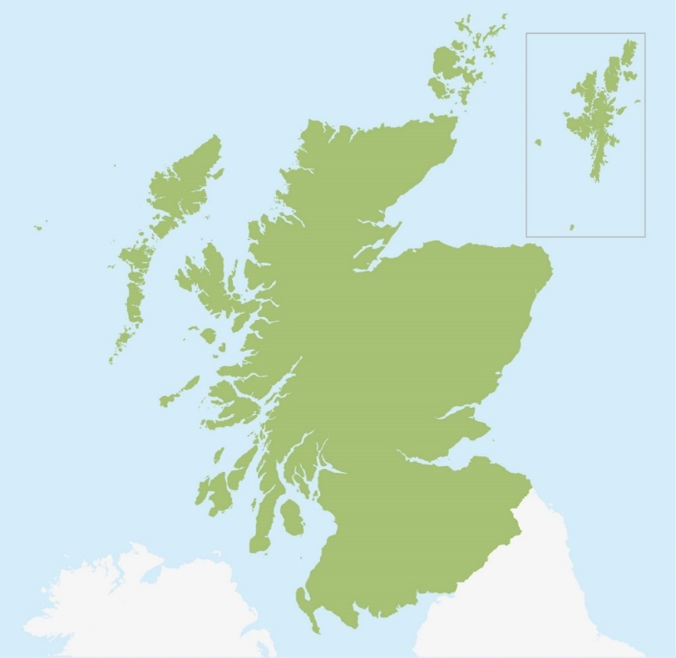

**Inverclyde is located on the west coast of Scotland**

It is one of the most attractive places in Scotland to live, work and visit, with breath-taking scenery, excellent transport links to Glasgow and Edinburgh, a wide range of sporting and leisure opportunities and one of the best school estates in Scotland.

The area includes the main towns of Greenock, Port Glasgow, Gourock, Inverkip and Wemyss Bay, and the rural villages of Kilmacolm and Quarrier’s Village. Offering spectacular views and scenery, unique waterfront sporting and leisure opportunities all accessible easily by car, rail, ferry and air links from the city of Glasgow and beyond.

The area has a history and heritage rich in shipbuilding and seafaring dating back to the 1500’s which has left its mark throughout the region.

These days, it offers a broad range of sports and leisure facilities, both indoors and outdoors, a great variety of arts and culture activities and wide open spaces to enjoy and explore.

There are many recreational activities; for lovers of the outdoors, with excellent local golf courses, sailing in the Clyde, hill walking and mountain biking in Argyll & Bute. There are 6 golf courses alone in the area with outstanding views of the Firth of Clyde.  Wild swimming, sailing and rowing are all popular activities. This makes the area is an attractive one to live in. It offers good access to the Highlands and to Glasgow with its many cultural and recreational attractions. Glasgow airport is 30 minutes away and there are excellent road and rail links to Scotland and the rest of the UK.

Inverclyde’s estimated population in 2017 was 78,760, which is 1.5% of the total population of Scotland. 52% of the population are female and 48% male.

87% of the population live in the towns of Greenock, Port Glasgow and Gourock with the remainder of the population living in the villages of Inverkip, Wemyss Bay, Kilmacolm and Quarriers Village.

* 16.2% of Inverclyde’s population is aged 16 years or younger,
* 20.46% is aged 65 years or older.
* 63.3% of Inverclyde’s population is aged between 16 and 64 years old.

Despite the attractiveness of many parts of Inverclyde there are a number of communities, similar to other parts of the West of Scotland, in Inverclyde that continue to suffer from high levels of poverty and disadvantage. The areas suffering from the highest levels of deprivation include parts of Greenock and Port Glasgow. Within Greenock in particular, there are communities that have consistently been placed amongst the top 5% most deprived in Scotland since 2004. This has manifested itself in poorer health, lower levels of employment, higher levels of child poverty, lower levels of attainment and higher levels of drug and alcohol misuse in these areas.

The differences in social and economic circumstances in communities across Inverclyde mean that tackling inequalities is key priority for NHS Greater Glasgow and Clyde .

**Education**

In Inverclyde there are currently 6 Secondary Schools, 20 Primary Schools along with Early Years Establishments and Additional Support needs units.

**Secondary State Schools:** State schools for boys and girls aged from 12 to 18.

* *Clydeview Academy**, Burnside Road, Gourock, PA19 1UX.* *Inverclyde Academy**, Cumberland Road, Greenock, PA16 0FB.*
* *Notre Dame High School**, Dunlop Street, Greenock, PA15 4NW.*
* *Port Glasgow High School**, Port Glasgow Community Campus, Kilmacolm Road, Port Glasgow , PA14 6PP.*
* *St Columba's High School**, Fletcher Avenue, Gourock, PA19 1TN.*
* *St Stephen's High School**, Port Glasgow Community Campus, Kilmacolm Road, Port Glasgow , PA14 6PP.*

**Independent Schools**

* *Cedars School of Excellence**, 31 Ardgowan Square, Greenock, PA16 8NJ. An independent school for boys and girls aged from 12 to 18.*
* *St Columba's School**, Duchal Road, Kilmacolm, Inverclyde, PA13 4AU. An independent school for boys and girls aged from 3 to 18.*

**Primary State Schools** State schools for boys and girls aged from 3 to 12.

* *Aileymill Primary School**, Norfolk Road, GREENOCK, PA16 0JG.*
* *All Saints Primary School**, Blairmore Road, GREENOCK, PA15 3JS.*
* *Ardgowan Primary School**, Newton Street, Greenock, PA16 8SN.*
* *Gourock Primary School**, Davidson Drive, Gourock, PA19 1QD.*
* *Highlanders Academy Primary School**, 24 Mount Pleasant Street, Greenock, Greenock, PA15 4DP.*
* *Inverkip Primary School**, Station Road, Inverkip, PA16 0AY.*
* *Kilmacolm Primary School**, Churchill Road, Kilmacolm, PA13 4LH.*
* *King's Oak Primary School**, 35 East Crawford Street, Greenock, PA15 2DX.*
* *Lady Alice Primary School**, Inverkip Road, Greenock, PA16 9EH.*
* *Moorfoot Primary School**, Moorfoot Drive, Gourock, PA19 1ES.*
* *Newark Primary School**, Bridgend Avenue, Port Glasgow, PA14 5SU.*
* *Overton Primary School**, Peat Road, Greenock, Greenock, PA15 4JW.*
* *St Andrew's Primary School**, Chester Road, Greenock, PA16 0TT.*
* *St Francis' Primary School**, East Barmoss Avenue, Port Glasgow, PA14 6HX.*
* *St John's Primary School**, Mary Street, Port Glasgow, PA14 5AL.*
* *St Joseph's Primary School**, Wren Road, Greenock, PA16 7NH.*
* *St Mary's Primary School**, Patrick Street, Greenock, PA16 8PH.*
* *St Michael's Primary School**, Bridgend Avenue, Port Glasgow, PA14 5SU.*
* *St Ninian's Primary School**, Staffa Street, Gourock, PA19 1SL.*
* *St Patrick's Primary School**, Broomhill Street, Greenock, PA15 4HL.*
* *Wemyss Bay Primary School**, Ardgowan Road, Wemyss Bay, PA18 6AT.*
* *Whinhill Primary School**, Drumfrochar Road, Greenock, PA15 4EQ.*

Find out more about schools in Inverclyde via www.inverclyde.gov.uk/education-and-learning/schools

# More About the Greater Glasgow and Clyde Area

As a place to live, the Greater Glasgow and Clyde area has many attractions. The West of Scotland combines cosmopolitan charm, lush countryside and soothing seaside. Culturally diverse, architecturally stunning and historically rich, this vibrant region is home to innovation, celebration and the largest city in Scotland – Glasgow.

As Scotland’s most populous region, the West of Scotland is home to approximately two million people. In addition to the city of Glasgow, East and West Dunbartonshire, Inverclyde, Ayrshire, North and South Lanarkshire, Renfrewshire and East Renfrewshire make up this captivating and eclectic part of the country.

This is a region of striking contrast. Larger areas like Glasgow are within easy reach of picturesque towns, villages and some of Scotland’s most scenic beaches, captivating wildlife and tranquil countryside.

## Glasgow

Multicultural, magnificent and brimming with personality, Scotland’s largest city is home to nearly 600,000 people. Discover rich history, stunning architecture and the best shopping in the UK outside London. Glasgow is one of the highest ranking cities in the UK for quality of life. (source: Mercer survey, 2012)

This aptly-named ‘Dear Green Place’ blends the best of urban-living with the splendour of lush gardens and parks. Impressively, the city boasts more green space per square mile than any other UK city. With some of the biggest and brightest businesses Scotland has to offer, in addition to enjoying the scenery, you can explore the many great career opportunities the city offers.

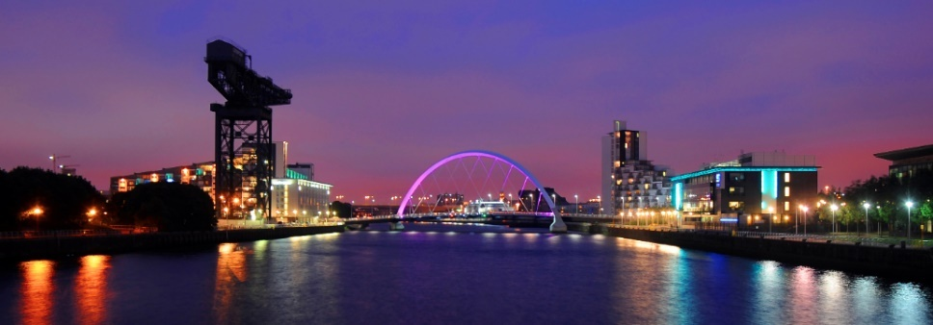Offering the best of both worlds, Glasgow is close to breath-taking countryside offering up nearby hill walking, sailing, and cycling. Some of the world’s greatest golf courses are all within an hour’s drive of the city. And this bustling city’s arts and culture, nightlife and food are hard to surpass.

Home to over 133,000 students from around the world, this vibrant city has five world-renowned universities and seven colleges.

## Lots to see and do

No matter what your age or interest, the West has something for you. Be dazzled by Charles Rennie Mackintosh’s iconic architecture in Glasgow or satisfy your appetite with mouth-watering produce at the farmers’ markets in Renfrewshire and Inverclyde.

You also have your choice of impressive year-round events and festivals, attractions or some of the best leisure facilities in the country. And as a UNESCO City of Music, Glasgow offers an impressive range of musical delights.

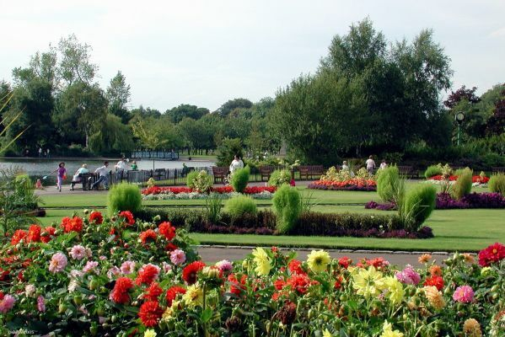Experience the award-winning wonder of Kelvingrove Art Gallery and Museum and the awe-inspiring Glasgow Science Centre, or enjoy international musicians, sporting events and more at the city’s last addition, the 12,000 seat SSE Hydro Arena.

This year’s Mercer’s Quality of Living survey sees Glasgow beat the likes of Rome, Prague, and Dubai to be named as one of the best cities in the world to live.

The West loves its sports – evident in its numerous outstanding leisure centres and facilities. Glasgow is one of the world’s top 10 destinations for sports events and in 2014, Glasgow hosted the 20th Commonwealth Games. The newly built Commonwealth Arena and adjoining Sir Chris Hoy Velodrome in the East End of Glasgow hosted badminton and cycling events for the 2014 games.

In Ayrshire you can celebrate the national poet at the Burns and a' that Festival, admire the spectacular scenery at the Ayr Flower show or try your luck at the races at the Scottish Grand National.

## Housing

Whether you are renting or buying, Glasgow offers a superb selection of housing. Here you’ll have your choice of apartments on the River Clyde, spacious Victorian flats in the West End and family homes in leafy suburbs conveniently located near to schools.

## 

## Getting around

The region’s excellent transport links mean you’re connected to the rest of the UK - and the world.

The M8 motorway connects the West with the rest of Scotland, taking just under an hour to drive between the country’s major cities Glasgow and Edinburgh, a well-used commuter’s route.

The bus is an effortless way to get around because it’s inexpensive and widely available across the region – even in remote locations. Glasgow has the UK’s largest suburban rail network outside London.

An abundance of stations and travel times makes exploring the region by train an easy option. The rail network links both rural areas and cities with the rest of Scotland and the wider UK.

From Ardrossan, Gourock and Wemyss Bay you can also travel by ferry to many of Scotland’s islands, or further afield from one of the cruise ships that dock at Greenock harbour.

Glasgow’s two international airports connect the region with the rest of the UK and beyond. Pre Covid there were approximately 200 flights per day from Glasgow international airport alone, ready to fly you to over 90 destinations like London, Dubai and New York.

The best of the city-living, magnificent countryside and an opportunity to work in some of Scotland’s most exciting industries means this region is a hugely popular place to live, play and work.

## Further information

To find more information about living and working in Scotland please visit:

www.visitscotland.com

www.scotland.org

www.talentscotland.com

www.moverdb.com/moving-to-glasgow