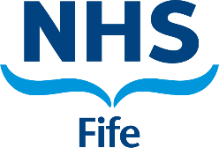

Specialist Doctor in Addiction Psychiatry

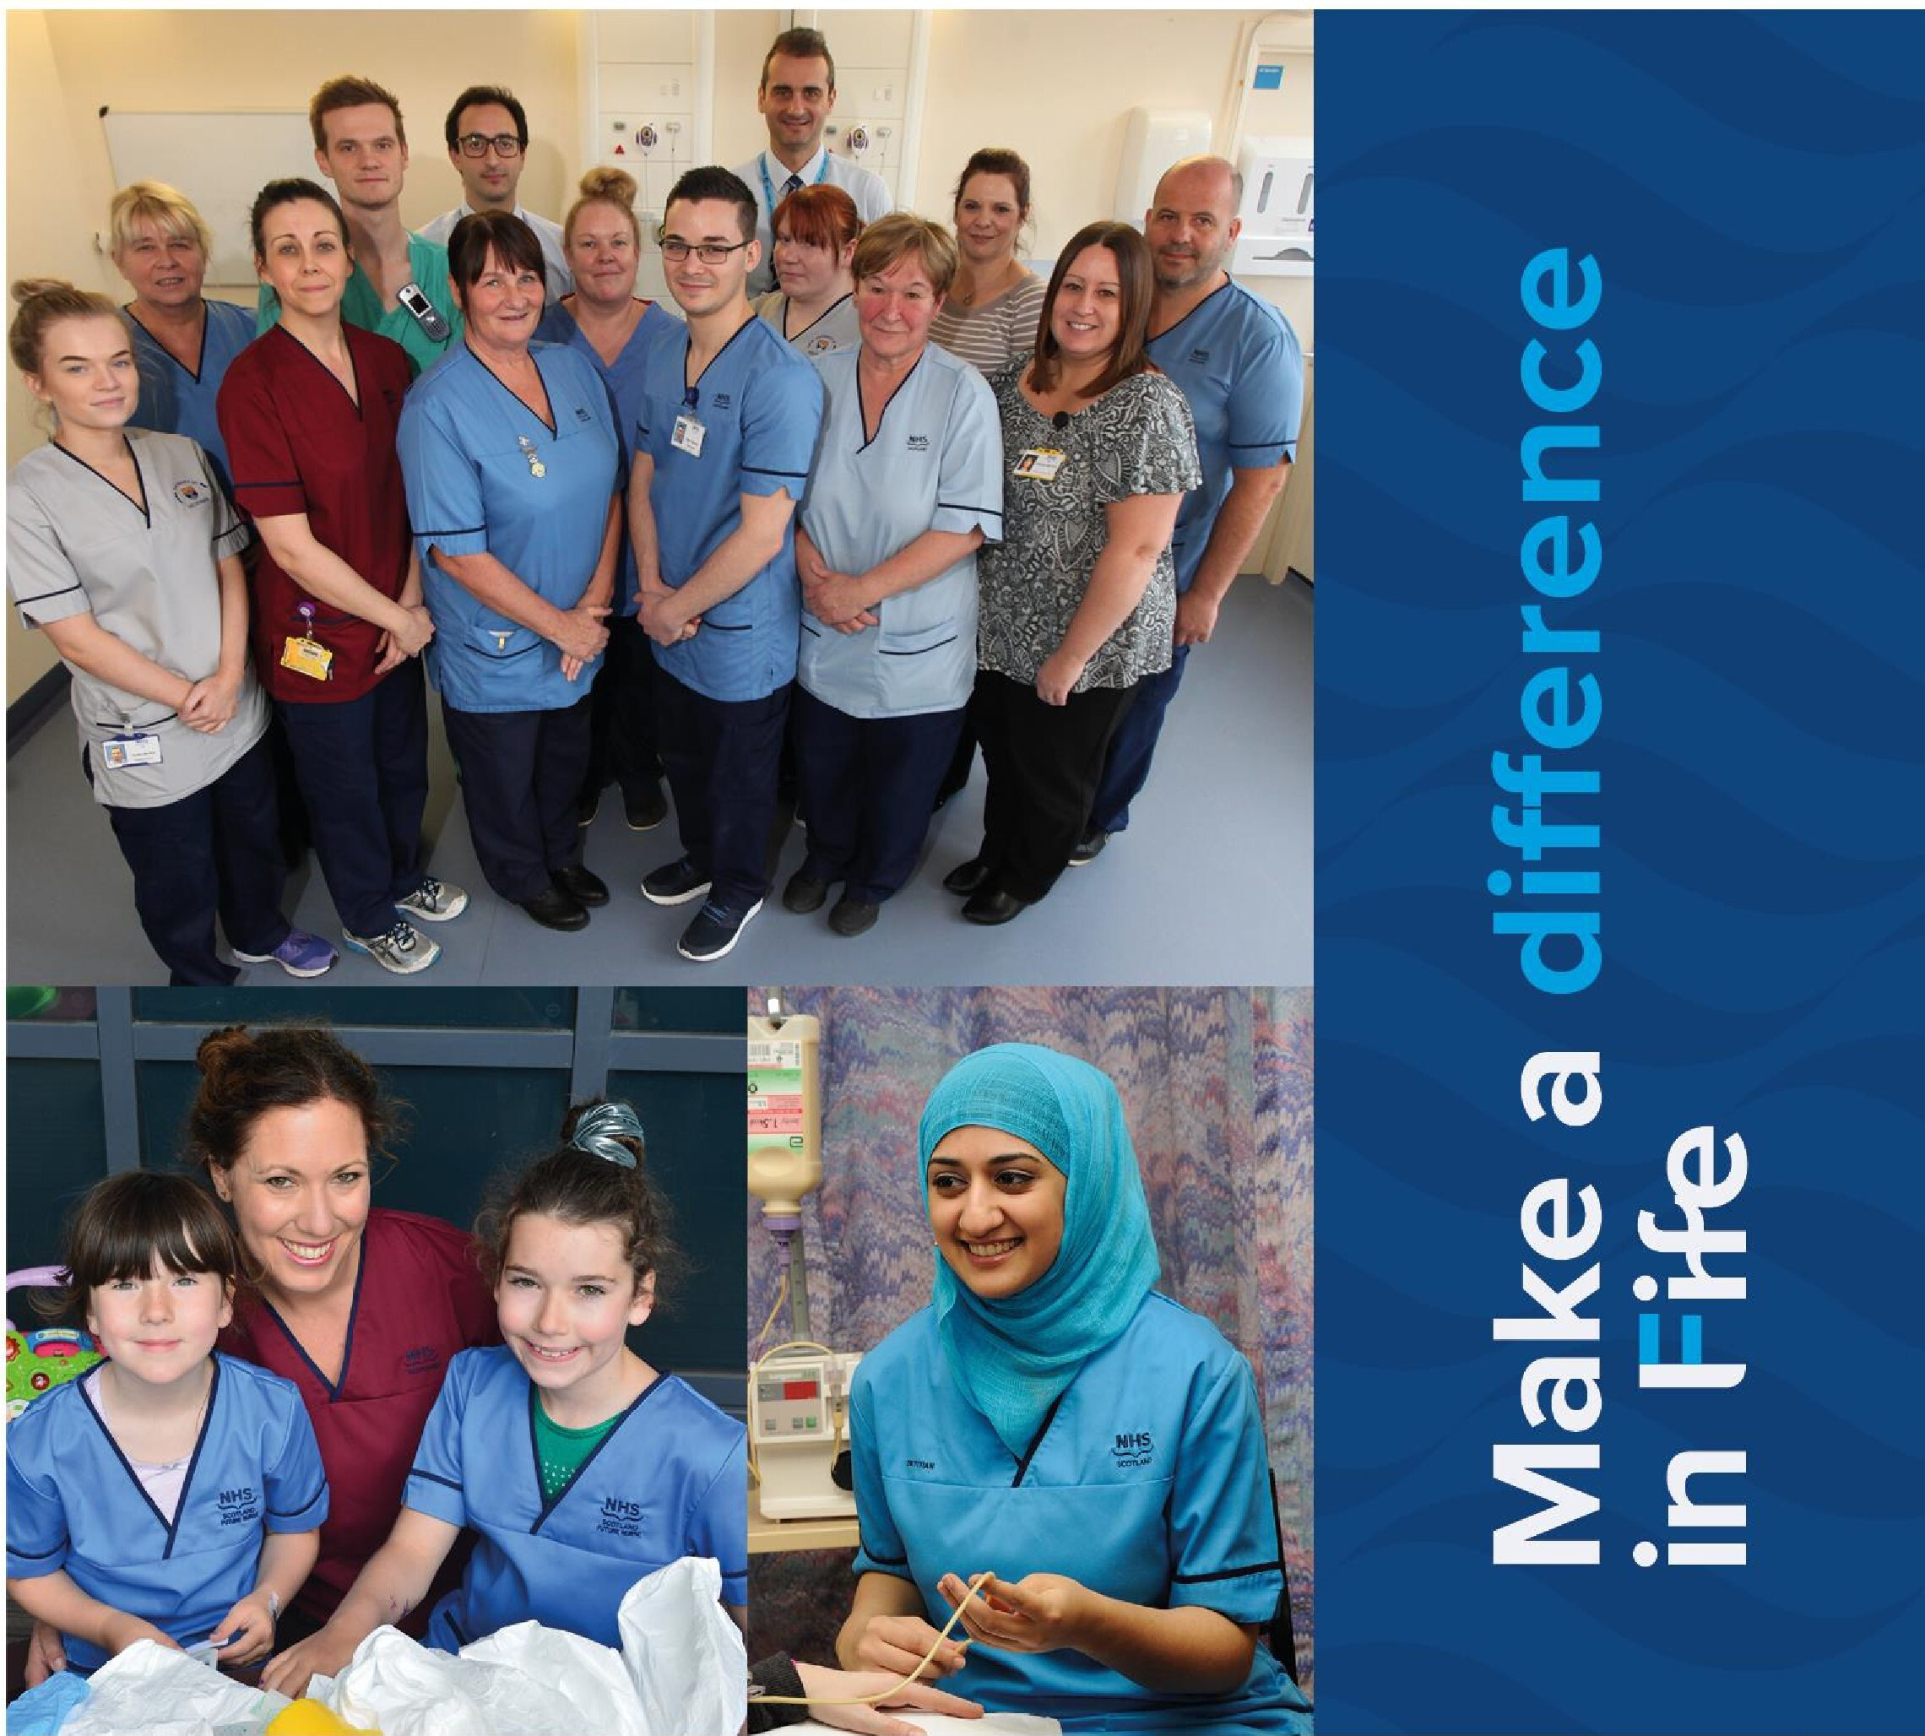



**© NHS Fife 2021 Published: March 2021**

This document is licensed under the Creative Commons Attribution- Non commercial-No Derivatives 4.0 International Licence. This allows for the copy and redistribution of this document as long as NHS Fife is fully acknowledged and given credit. The material must not be remixed, transformed or built upon in any way. To view a copy of this licence, visit https://creativecommons.org/licenses/by-nc-nd/4.0/

**www.nhsfife.org**

**Contents**



**Section 1: Personal Specification Section 2: Introduction to Appointment**

**Section 3: Departmental and Directorate Information Section 4: Main Duties & Responsibilities**

**Section 5: Indicative Job Plan Section 6: Contact Information**

# Section 1: PERSONAL SPECIFICATION

**Position: SPECIALIST DOCTOR IN ADDICTION PSYCHIATRY Department: NHS FIFE, ADDICTION SERVICES**

**Base: ADDICTION SERVICES SITES (Cameron Hospital / Whyteman’s Brae Hospital / Lynebank Hospital)**

|  |  |  |
| --- | --- | --- |
| **CONSULTANT ADDICTIONS** | | |
| **REQUIREMENTS** | **ESSENTIAL** | **DESIRABLE** |
| **Qualifications** | MBBS or equivalent medical qualification.  Full registration with the GMC at time of appointment with a current Licence to Practice.  Evidence of achievement GMC standards as outlined in *Good Medical Practice* including:  • good clinical care  • maintaining good medical practice  • good relationships and communication with patients  • good working relationships with colleagues  • good teaching and training  • professional behaviour and probity  • delivery of good acute clinical care  Relevant specialty clinical knowledge: capacity to apply sound clinical knowledge relevant to the job.  All applicants to have demonstrable skills in written and spoken English that are adequate to enable effective communication about medical topics with patients and colleagues. | Additional post-graduate qualifications, e.g. MD/ PhD/MSc related to Addictions.  Section 22 approval under the Mental Health (Care and Treatment) (Scotland) Act 2003 |
| **Clinical Skills and Experience** | Experience in addiction medicine & addiction psychiatry.  Working in community settings  Clinical judgement: experience in making clinical decisions and managing risk.  IT literacy | Evidence of leading team meetings and other examples of clinical leadership.  Experience of undertaking Mental Health Act assessments in the community |
| **Teaching** | Formal and informal teaching and training of trainee doctors, medical students and other clinical staff.  Learning and continuing professional development | Ability to deliver high quality teaching & supervision |
| **Audit** | Evidence of commitment to clinical audit | Completed audit leading to change in practice  Experience of designing audits |
| **Research and Publication** | Supportive of research activity | Evidence of research and publications in peer reviewed journal |
| **Management** | Ability to take full responsibility for independent management of patients.  Ability to communicate effectively and clearly with patients and team members | Evidence of complex case management  Evidence of service development and quality improvement. |
| **General Attributes** | Evidence of commitment to patient-focused care  Continuous professional development and life-long learning  Effective and efficient use of resources  Ability to organise time efficiently and effectively  Reliability  Excellent communication skills | Experience of involvement in service development projects  Clear commitment to developing role in relation to community services  Ability to motivate colleagues Leadership training  Good liaison and negotiation skills |

# Section 2: INTRODUCTION TO APPOINTMENT

**Job Title: SPECIALIST DOCTOR IN ADDICTION PSYCHIATRY Department: NHS FIFE, ADDICTION SERVICES**

**Base: ADDICTION SERVICES SITES (Cameron Hospital / Whyteman’s Brae Hospital / Lynebank Hospital)**

**Hours: Full time / part time – up to 40 hours per week**

**Post Summary:**

NHS Fife Addiction Services operate from three main sites Cameron Hospital / Whyteman’s Brae Hospital / Lynebank Hospital). The post is full time 10 session (40hrs/week) post in Addiction Psychiatry. A request for part-time position will be considered. Job share will be considered. The post holder will be working within the Addiction Services sites (one or more).

The post holder will have responsibility for providing a comprehensive range of services in conjunction with the multi-disciplinary team to patients with addiction problems. The main role is in assessment, diagnosis and management of substance use problems within a multiagency partnership; to provide clinical support to the addictions multidisciplinary team; and to engage in strategic initiatives linked with provision of healthcare for addictions.

Addiction Services in Fife are community based with in-reach to general hospital beds. The postholder will be expected to lead and engage in a number of outpatient clinics – including rapid access clinics, review clinics, alcohol (including alcohol brain damage) clinics, benzodiazepine clinics, buvidal clinics, review clinics and high and complex needs clinics.

The post holder will be expected to cover for colleagues during absences in line with local arrangements.

# Section 3: DEPARTMENTAL & DIRECTORATE INFORMATION

## NHS FIFE ADDICTION SERVICES

The NHS Fife Addiction Services provide specialist treatment for people with drug and/or alcohol problems across the Fife region. The services provide treatment in conjunction with other statutory and non-statutory addiction treatment providers, within the Fife Alcohol and Drug Partnership. The services form part of the Mental Health, Learning Disabilities and Addictions Service, Complex and Critical Care Service, HSCP. The services are delivered from three main localities – Whyteman’s Brae Hospital, Cameron Hospital and Lynebank Hospital – providing treatment to the Fife-wide population – Central Fife (population of 147,370); North East Fife (population of 74,180); and, West Fife (population of 126,840).

NHS Fife Addiction Services deliver a range of person-centred treatment options that are largely classified as Tier 3 modalities of treatment. These include specialist comprehensive assessment; home alcohol, opioid and benzodiazepine detoxification programmes; home stabilisation and maintenance prescribing programmes; prescribing of other medications as indicated for multimorbidity; harm reduction interventions; relapse prevention interventions; psychological interventions; hospital liaison services; and, alcohol brain damage treatment interventions. The services employ psychiatrists, nurses, psychologists and drug counsellors to deliver treatment. Provision is largely community-based and engages individuals with moderate to severe drug and/or alcohol problems and/or those with high and complex needs.

The Services function through a clinical governance structure that ensures ongoing quality improvement processes and initiatives aimed at achieving best outcomes and patient experience of treatment. Overall the services meet expected targets with delivery aligned with corporate NHS strategic goals and strategic goals set by the Alcohol and Drug Partnership.

Addiction services employ 65 full-time and 25 part-time staff and currently provides treatment to 2400 patients – an increase of more than 50% since 2016/17 (National Statistics Scotland, 2018) – and continues to receive approximately 80 referrals per month. Patient appointments tend to be one-to-one, last between 30 mins and 1 hour, and until the recent Covid-19 outbreak, occurred mostly in-person within the clinic localities. The services are community- based and provide treatment for patients with high and complex needs.

NHS addiction services deliver evidence-based treatment; have developed quality systems, policies and procedures; have responded to Government initiatives; and, have worked collaboratively with other providers and universities to improve addiction treatment in Fife.

### Organisational structure

|  |  |
| --- | --- |
|  | Director Fife NHS Fife Medical Health & Social Director  Care Partnership  Associate Medical Director Health & Social Care  General Manager Partnership  Fife Wide Services  Health & social  Care Partnership Fife Wide Services Clinical Director  Senior Manager Mental Health Service  Clinical Services Clinical Lead in  Manager in Addictions  Addictions  All other Addiction Consultant in  Clinical and Admin Addictions - **THIS**  Staff **POST**  Line management accountability Professional accountability |
|  |
|  |

**Medical Staff Resource**

The current medical resource consists of 3 Consultant Psychiatrists (2 full-time and 1 part- time), 2 (full-time) Specialty Doctors in Addictions Psychiatry, 1 (full-time) Specialist Doctor in Addiction Medicine (this post), and 2 (part-time) GPs with special interest in Addiction Medicine.

### Innovation projects

NHS Fife Addiction Services are involved in a number of innovative initiatives aimed at addressing addiction healthcare challenges in Fife. Services are engaged in efficient, effective and meaningful implementation of Medication Assisted Treatment Standards, and (together with the innovation team) in the innovation challenge of reducing drug deaths. Other current initiatives include: working with vulnerable populations, in-reach to mental health units and outreach to primary care.

## FIFE MENTAL HEALTH DIRECTORATE

NHS Fife Addiction Services is part of Fife Mental Health Service.

The NHS Fife Mental Health Service is a Fife wide service delivering the full range of inpatient and community care and treatment for patients of all ages experiencing mental illness and a range of mental health problems, including alcohol and drug dependency. The service operates as a distinct, Fife wide service managed and governed within and by Fife Wide Division of Fife Health & Social Care Partnership.

It is a large and complex service organised into operational and functional service units in order to provide secondary, tertiary and specialist services, and to link with primary care and the Acute Division. The service is geographically organised to provide inpatient and community general adult and elderly psychiatric care, and functionally organised to provide general and specialist community services for children and young people, and those with addiction problems.

The Adult Psychiatric Service in Fife is divided into three sectors, with inpatient and outpatient care being delivered by a nominated sector consultant:

**West Sector** (approx population 149,357) Based in Queen Margaret Hospital, Dunfermline **Central Fife** (approx population 153,909)

Kirkcaldy & Levenmouth Sectors: Based in Whyteman’s Brae Hospital, Kirkcaldy Glenrothes Sector: In-patients based in Stratheden Hospital, Cupar

Day Hospital and Gemini Team based in Whyteman’s Brae Hospital, Kirkcaldy

### North East Sector

Based in Stratheden Hospital, Cupar (approx population 75,997)

### In-patient services

In-patient services are at Queen Margaret Hospital, Dunfermline, Whyteman’s Brae Hospital, Kirkcaldy, and at Stratheden Hospital, Cupar. There are three general adult acute wards, one on each site. Ward 2 at Queen Margaret hospital, Dunfermline has 30 beds, Ravenscraig Ward in Whyteman’s Brae Hospital, Kirkcaldy has 29 beds, Lomond Ward in Stratheden Hospital Cupar has a further 30 beds.

There is a newly built eight bedded IPCU based on the Stratheden site, offering both male and female inpatient intensive care for the whole of Fife.

### Supporting Adult Mental Health Services:

**Community Mental Health Teams**

There are two CMHTs in West Fife, three in Central Fife and one in North East Fife. Teams comprise of community psychiatric nursing staff, psychology, psychiatry and attendance at meetings by occupational therapy. Teams broadly follow the GP clusters. Multidisciplinary care planning and key working are in place.

Weekly multidisciplinary meetings occur in the team bases. Team lead posts are in the process of appointment and links with the newly created GP clusters are being established.

Newly created primary care community nursing triage posts have recently been established. The self referral Access Therapies for Fife complements primary care initiatives and includes a range of interventions from self help psychoeducational materials to therapy groups.

Developments are progressing with local area coordinators, community hubs, peer support cafes and expanding the third sector trauma informed project, Better the Well and employability initiatives.

### Community Resources

There is an additional multidisciplinary community rehabilitation team in West Fife ( WFCOT) and a recently developed community rehabilitation team for East Fife covering some of the supported accommodations and patients discharged from the rehabilitation wards.

There are three day hospitals, one for each site, Hillview at Queen Margaret, Dunikier Day Hospital at Whyteman’s Brae, and Weston Day Hospital in Cupar, offering a range of nurse delivered psychological therapies, both individual and group based, in addition to running Clozapine clinics. There are plans in place to expand physical health monitoring within the day hospitals.

The Fife wide Occupational Therapy Service covers the 3 sectors in Fife and provides a service to acute, rehabilitation and community for both over and under 65 year old patients. The service includes assessment of functional capacity and deficits, therapeutic activity, specific evidence based interventions and discharge planning.

The department of Clinical Psychology is led by the Area Head of Psychology Services based at Lynebank Hospital and Stratheden Hospital. There is a comprehensive range of services providing primary mental health psychological care in addition to secondary care provision.

Social Work Department (Fife Council). Currently the Social Work Service is being reorganised but we relate at present mainly to the Mental Health Officer team and community care team. The Social Work Department commissions supporting care from a number of providers.

Specialist Pharmacy Services. Specialist mental health pharmacy managers work closely with clinicians, provide information to patients and carers and work on local protocols. There is regular attendance at ward clinical meetings.

### Specialist Services

|  |  |
| --- | --- |
| **Unscheduled Care Assessment Team** | This is a 24 hour nurse led team with medical input from duty trainee doctors. It is a Fife wide service and is based at Whyteman’s Brae Hospital. It provides urgent assessments, management and signposting for unscheduled presentations including A&E at the Victoria Hospital Kirkcaldy and has close links with the sector teams. It provides a bed management role to the acute wards. |
| **Old Age Psychiatry** | Whyteman’s Brae Hospital (Day Hospital only), Kirkcaldy Stratheden Hospital, Cupar  Queen Margaret Hospital, Dunfermline |
| **Rehabilitation** | Stratheden Hospital, Cupar (Fife wide) |
| **Intensive Psychiatric Care Unit** | Stratheden Hospital, Cupar (Fife wide) |
| **Addictions** | Cameron Hospital, Windygates, Leven Whyteman’s Brae Hospital, Kirkcaldy Lynebank Hospital, Dunfermline |
| **Child and Adolescent** | Playfield House, Stratheden Hospital, Cupar (Fife wide) |
| **Learning Disabilities** | Lynebank hospital, Dunfermline (Fife wide) |
| **Forensic** | Forensic Community Mental Health Team, Lynebank Hospital, Dunfermline  Radernie Low Secure Unit, Stratheden Hospital, Cupar |
| **ANITT** | Drumcarrow Lodge Stratheden |

**Non statutory/Voluntary Organisations**

Fife has many such organisations, which include:-

|  |  |
| --- | --- |
| **Scottish Association for Mental Health** | Evergreen Project, Kirkcaldy (Horticulture)  SAMH’s Pantry, Dalgety Bay (Catering).  SAMs Café, Kirkcaldy, offering out of hours social contact |
| **National Schizophrenia Fellowship Scotland** | Fife Families Support Project (carers) Fife Hearing Voices Network. |
| **Supporting People Initiative** | Independent providers commissioned by Social Work  Housing Associations e.g. Richmond Fellowship, Penumbra, Barony etc. |
| **Substance misuse** | DAPL (Drugs and Alcohol Psychotherapies Limited) ADAPT / FASS (ADAPT Substance Recovery)  FIRST (Fife Intensive Rehabilitation & Substance Misuse Team) We Are With You (Harm reduction service)  Barnardo’s CAPSM (Children affected by parental substance  misuse service)  Clued up Project (Youth service) Frontline Fife (Homelessness services) Phoenix Futures  Restoration  Scottish Families Affected by Alcohol & Drugs |
| **Day Centre** | Contact Point in Kirkcaldy and Buckhaven (Barony) |
| **Vocational Training / Employment** | FEAT (Fife Employment Access Trust)  FACET (Fife ARTS & Crafts Enterprise Training) Castle Furniture Project  Individual Placement and Support |
| **Activities** | Boomerang Project, Glenrothes |
| **Miscellaneous** | Kingdom Abuse Survivors Project Express Group (Fife) Relationships Scotland  CRUSE, Bereavement Care, Scotland.  Fife One Stop Shop for Autism |

## SOUTH EAST SCOTLAND PSYCHIATRIC TRAINING SCHEME

Fife is part of the South East of Scotland Psychiatric Training scheme. Trainees rotate throughout the whole region, between Lothian, The Borders and Fife. Trainees spend one half day each week during the academic year attending the MRCPsych course in Edinburgh and an additional half day of postgraduate training in Fife. They also attend psychotherapy training. There are also GPSTs and FY2s on rotation with the service. In total there are 19 trainee doctor posts.

## ARRANGMENTS FOR MEDICAL REPRESENTATION

There is an active Local Negotiating Committee with Primary Care Division representation. Consultants, Specialist and specialty doctors are members of Fife Division of Psychiatry.

# Section 4: MAIN DUTIES & RESPONSIBILITIES

The main duties and responsibilities for the post/s include the following:

The successful applicant will provide clinical support, advice and supervision to NHS Fife Addiction Services in order to deliver care and promote a multi-disciplinary/multi- agency approach.

This post helps support the delivery and ongoing development of an effective and safe NHS Fife Addiction Service within the Health and Social Care Partnership in Fife. The postholder will take responsibility for the clinical care of individuals referred to the service within a designated area/s.

The post is a 10PA job, to be worked over five days. This will comprise 8 DCC and 2 SPA and flexibility to be subtracted from the DCC’s. The post reports to the Clinical Service Manager and the Clinical Lead of the Service.

This post will complement the medical workforce within a multidisciplinary service that provides an evidence based and clinically governed approach to individual and population level interventions to meet the needs of substance dependent individuals in Fife. The successful applicant will be involved in the delivery of a recovery oriented approach to complex and multi- morbidity cases using a consultancy model.

## DUTIES AND RESPONSIBILITIES

### Clinical

* + To provide clinical support to the care of individual patients as well as the care of patients within the assigned clinical patch.
  + To give expert advice on clinical issues relating to substance misuse to the clinical teams within Addiction Services and Mental Health.
  + To assess, treat and arrange appropriate care for people with substance misuse problems on an outpatient basis and to provide such care as part of a multi- disciplinary team.
  + To undertake psychiatric, medical and risk assessments, and treatment planning in conjunction with the multi-disciplinary team.
  + To coordinate complex multiple morbidity clinical scenarios

### Managerial

* + To assist with successful achievement of set targets such as the HEAT A:11 waiting time to treatment target.
  + To take a special interest lead, the nature of which is to be agreed between the post holder and Clinical Lead.

### Clinical Audit, Data Management and Clinical Governance

* + To work with GPs and other clinicians and support staff to develop Fife wide policies for the assessment and management of drug and alcohol users.
  + To liaise with the existing geographically based Psychiatry and other medical specialties’ services to develop protocols for the care of patients with multiple morbidities.
  + To develop, in partnership with other agencies, alternatives to hospital admission for detoxification and/or rehabilitation.
  + To set up substitute prescribing clinics across Fife, working closely with the Health and Social Care Partnerships and Fife Alcohol and Drug Partnership (ADP)
  + To work closely with a wide range of statutory and voluntary agencies active within Fife to ensure a multi-agency approach in the provision of services for people with substance misuse problems and associated multiple morbidities.
  + To work closely with Primary and Secondary Care services in the provision of a timely and effective treatment plan.

### Leave

* + Annual leave allowances and public holidays are combined 40 days per annum for a full time appointment.

### Research

* + Research and audit will be encouraged. Honorary Senior Clinical Teacher and/or Honorary Senior Lectureship status may be available to an appropriately qualified applicant with St Andrews University Medical School. NHS Fife Addiction Services is active within the NHS Fife Research and Development Programme of research

activities. NHS Fife also participates in the teaching and research activities organised by Universities of Dundee, St Andrews and Edinburgh.

* + To uphold, support and/or initiate research and innovation related activities

### Teaching

* + To participate in the training and development of junior medical staff and medical students, including individual and educational supervision.
  + To support and coordinate addiction related placements for Universities of Edinburgh, Dundee and St Andrews undergraduate medical training

### Continuous professional development

* + To engage actively in local and national Continuing Professional Development

# Section 5: INDICATIVE JOB PLAN

### Contract: Full-time or Part-Time

### Programmed Activities: 10

### Managerially Responsible to: Clinical Service Manager, Angela Swift Professional accountability to: Addictions Clinical Lead, Dr Susanna Galea-Singer

### Job Plan Review

The Job Plan is provisional and still to be finalised. In particular, you may be asked to consider extra programmed activities of direct clinical care. Your job plan will be subject to review once a year by you, your Clinical Service Manager in Addiction Services and the Clinical Lead in Addictions / Clinical Director, as laid out in the terms & conditions of the new Specialist Doctor contract.

In the event of any significant changes in the circumstances affecting this job plan, it is agreed that it will be renegotiated jointly in collaboration with consultant colleagues.

The Specialist Doctor in Addictions position will translate to 8:2 split, comprising 10

programmed activities. A draft job plan is shown below:

|  |  |  |  |
| --- | --- | --- | --- |
| **Day** | **Hospital/Other Location** | **Type of Work** | **PA’S** |
| Monday am | Cameron Hospital | Clinically related meetings | DCC (4hrs) |
| Monday pm | Cameron Hospital | Benzodiazepine Clinic | DCC (4hrs) |
| Tuesday am | Cameron Hospital | Review Clinic | DCC (4hrs) |
| Tuesday pm | Cameron Hospital | Clinical Meetings | DCC (4hrs) |
| Wednesday am | Cameron Hospital | Review Clinic | DCC (4hrs) |
| Wednesday pm | Cameron Hospital | High & Complex clinic | DCC (4hrs) |
| Thursday am | Cameron Hospital | Alcohol clinic | DCC (4hrs) |
| Thursday pm | Cameron Hospital | Clinical Meetings | DCC (4hrs) |

|  |  |  |  |
| --- | --- | --- | --- |
| Friday am | Cameron | SPA | SPA (4hrs) |
| Friday pm | Cameron | CPD | SPA (4hrs) |

The above plan is provisional and is negotiable.

### Cover for Colleagues

Annual/Study Leave - You will be required to provide emergency cover for colleagues during absence on annual or study leave.

### General provisions

You will be expected to work with local managers and professional colleagues in the efficient running of services and will share with colleagues in the medical contribution to management. Subject to the provision of the Terms and Conditions, you are expected to observe the Directorate’s agreed policies and procedures, drawn up in consultation with the profession on clinical matters, and to follow the standing orders and financial instruction of NHS Fife. In particular, where you manage employees, you will be expected to follow the local and national employment and HR policies and procedures. You will be expected to make sure that there are adequate arrangements for hospital staff involved in the care of your patients to be able to contact you when necessary.

# Section 6: CONTACT INFORMATION

# Dr Jacqueline Drummond, Clinical Director on 01592543355 ext 46966 and/or

# Dr Susanna Galea-Singer, Clinical Lead and Consultant Psychiatrist, NHS Fife Addictions Service on 07977033524.

**NHS Fife** Hayfield House Hayfield Road

Kirkcaldy, KY2 5AH

**www.nhsfife.org**

facebook.com/nhsfife @nhsfife youtube.com/nhsfife @nhsfife

