

**NHS Lothian Care Homes**

Exciting opportunities are available to join Care homes within one of the sites across NHS Lothian. We have multiple Band 5 positions available for Registered Nurses and we are looking for passionate, caring, motivated people to join our highly skilled nursing teams.

We offer the opportunity to work with talented teams within multidisciplinary environments and impact positively on the lives of thousands of patients and their families.

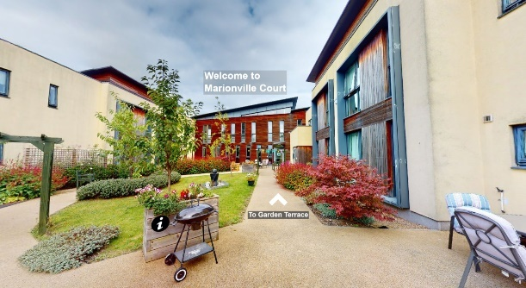

**What We Can Offer You**

We have a range of vacancies for experienced and newly qualified nurses to join our innovative and dynamic teams across NHS Lothian – providing you with the opportunity to gain a breadth of knowledge and exposure to multiple specialties.

We provide nursing care for people over the age of 65 years who are frail and have complex care needs. We have dementia units caring for people with mild to severe cognitive impairments.

**Sites**

* Royston Court Care Home
* Marionville Court Care Home
* Inch View Care Home
* North Merchiston Care Home
* Castle Green Care Home

  