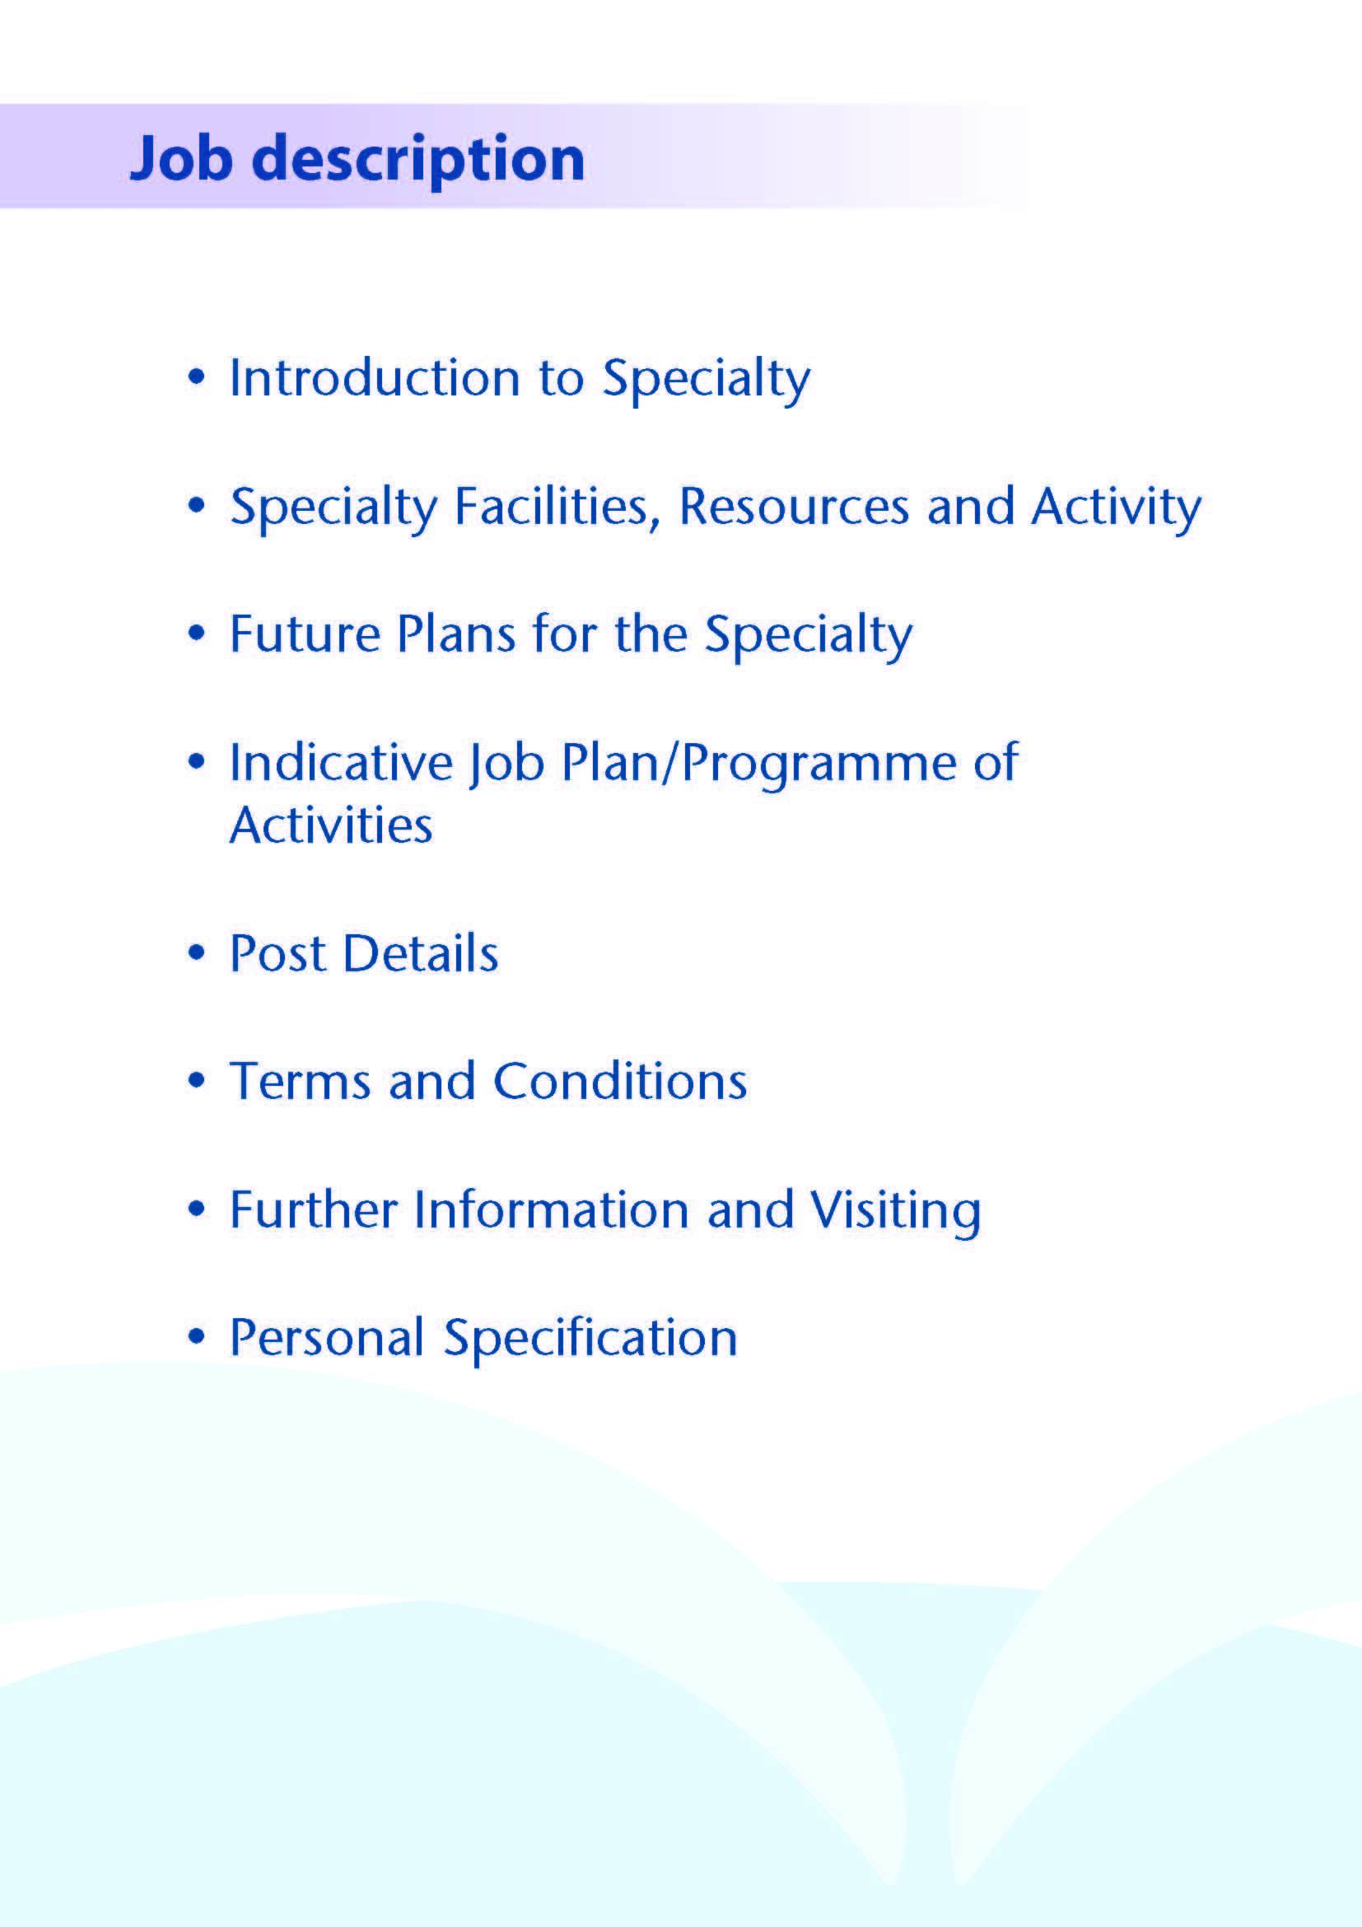



An exciting opportunity has arisen for an enthusiastic and motivated individual to join our expanding team as a Locum Ear, Nose and Throat (ENT) Consultant.

The successful applicant for this post will have an interest in General Adult and Paediatric ENT, joining a team of six established Consultants.

NHS Ayrshire & Arran has two principle District General Hospitals; University Hospital, Crosshouse and University Hospital, Ayr. The ENT Department forms part of the Head & Neck Directorate, alongside Oral and Maxillofacial Surgery, Orthodontics (complex IOTN and Orthognathic cases) and Restorative Dentistry (oral cancer rehabilitation, hypodontia and trauma). The Directorate is part of the Surgical Division.

Adult and Paediatric Emergency and elective ENT services are provided to the Ayrshire & Arran catchment population of 375,000 residents and the department also hosts the National Cochlear Implant Service.

The main base for this post is University Hospital Crosshouse where ENT in-patient and day-case services are located. Out-patient Clinics are provided at University Hospital Crosshouse and University Hospital Ayr. Specialist clinics include a middle ear implant clinic, neck lump and head and neck oncology clinics, cochlear clinic and balance clinic. The post holder will participate on the consultant on-call rota (currently1:6 with prospective cover, will be 1:8). On call duties are supported by a middle grade tier.

The successful candidate will play an active role within the ENT Service. The post holder will also contribute to service development, clinical audit and research.



# Inpatient Beds

The Head and Neck Directorate operates primarily from one inpatient ward. There is a well-equipped treatment room available and rooms for counselling. There is a suite of ENT offices located at University Hospital, Crosshouse. The Consultant will have shared office accommodation. There are currently 4 medical secretaries within the ENT department to help with any administrative duties at University Hospital Crosshouse and 2 secretaries supporting the ENT department at University Hospital Ayr.

# Clinics

At University Hospital Crosshouse the main outpatient department comprises some 50 consulting rooms. There is a dedicated fully equipped area for the ENT clinics.

At University Hospital Ayr outpatient services are provided from both a dedicated area and some rooms shared with other specialties.

#### Theatres and Day Surgery

Theatre services supporting the ENT department are provided at University Hospital Crosshouse. There are 11 main theatres in the theatre complex and one treatment theatre in OMFS Outpatient department.

#### Diagnostics

Crosshouse also has a full supporting diagnostic facility including two spiral CT scanners with 3D reconstruction and a new MRI scanner. There are also new CT and MRI scanners at University Hospital Ayr.

# Oral and Facial Laboratory

There is a fully equipped oral and facial laboratory. Both intraoral and craniofacial prostheses are made at University Hospital Crosshouse.

**Scottish Cochlear Implant Programme for Adults and Paediatrics**

Based at the Raj Singh Cochlear Implant Unit at University Hospital Crosshouse, the Scottish Cochlear Implant Programme is a national service for severe-to-profoundly deaf adults and children from across Scotland. It provides a comprehensive cochlear implant service for the population of Scotland and is delivered by a dedicated multidisciplinary team consisting of medical, scientific, rehabilitation and support staff. Currently, over 1700 cochlear implant recipients are being supported by the service. Approximately 100 new patients undergo cochlear implantation per annum.

**Audiology**

The Audiology Service is delivered on both sites where it has sound-proofed and sound-treated facilities along with additional peripheral facilities (dedicated and shared) at a number of locations around Ayrshire providing a broad range of audiology services to patients of all ages.

###### Education Facilities

Both hospitals have extensive facilities for educational support. The MacDonald Education Centre on the Ayr site and the Alexander Fleming Centre at University Hospital have an auditorium, tutorial rooms and up-to-date audio-visual facilities.

Both Education Centres house well stocked libraries which include good IT facilities offering access to Medline and the Internet.

**Medical Staff Resources**

The staffing of the Head & Neck Directorate is as follows:

|  |  |  |
| --- | --- | --- |
| **Consultant Staff** | **Base** | **Specialist Interest** |
| Miss Deborah Boyd | Crosshouse | Oral and Maxillofacial /Orthognathic/Facial Deformity/ Trauma; Clinical Director for Head and Neck and Dermatology |
| Mr Roger Currie | Crosshouse | Oral and Maxillofacial /Skin Cancer/Associate Medical Director, Surgery |
| Mr Ewen Thomson | Crosshouse | Oral and Maxillofacial /Head and Neck Oncology |
| Miss Mhairi Little | Crosshouse | Oral and Maxillofacial /Orthognathic/Facial Deformity/Trauma |
|  | | |
| Ms Lorna Langstaff | Crosshouse | General ENT/Head & Neck Oncology/ Clinical Lead ENT |
| Mr Andrew Whymark | Crosshouse | General ENT/Rhinology/ Otology |
| Mr Richard Townsley | Crosshouse | General ENT/Head & Neck Oncology |
| Ms Lyndsay Fraser | Crosshouse | General ENT/Paediatrics & Cochlear Implant |
| Ms Natasha Grimmond | Crosshouse | General ENT/Paediatrics & Cochlear Implant |
| Mr Paul Sooby | Crosshouse | General ENT/Paediatrics & Cochlear Implant |
|  | | |
| Mr Andrew McInnes | Crosshouse | Restorative Dentistry (visiting) |
| Mr Philip Benington | Crosshouse | Consultant Orthodontics |

|  |  |  |
| --- | --- | --- |
| **Speciality Doctor ENT** | **Base** | **Specialist Interest** |
| Dr Stuart Benzie | Crosshouse | ENT |
| Dr Giovanni Sambiagio | Crosshouse | ENT |
|  |  |  |
| **Speciality Doctor OMFS** | **Base** | **Specialist Interest** |
| Ms Louisa McCaffrey | Crosshouse | Oral and Maxillofacial (F/T) |
| Ms Xixi Zhu | Crosshouse | Oral and Maxillofacial (F/T) |
| Dr Ryan McSorley | Crosshouse | Oral and Maxillofacial (F/T) Locum |

The ENT department is currently staffed by 6 consultants, 2 specialty doctors, 2 ENT specialist trainees on the West of Scotland training programme, one FY2 and 2 GP trainees. The ward is staffed by the junior trainees during the day and Hospital at Night rota overnight. The ENT Department is also supported by ENT Advanced Nurse Practitioner services who support nasal fracture care and tracheostomy work. There are two Head and Neck oncology nurses.

**Activity (average per annum):**

|  |  |  |  |
| --- | --- | --- | --- |
|  | **In-patient Admissions** | **Day Case Admissions** | **New Out-patient Appointments** |
| Maxillofacial Department | 182 | 1206 | 2959 |
| ENT Department | 518 | 815 | 7317 |
| Orthodontics | 0 | 0 | 231 |



The ENT department / SCIP is very forward thinking and has been at the forefront of many innovations. The department is open to innovation and new ways of working and will support the successful candidate to develop services that benefit the population of Ayrshire and Arran.

The successful candidate will be supported to develop a complementary interest to the current consultants and expand the opportunities for team working.



# Proposed Weekly Programme

The proposed weekly programme is shown below. Activities with current fixed time commitments will be carried out as detailed in the work programme e.g. clinics. Other DCC and SPA activities are shown with indicative timings within the weekly programme and will be discussed with the appointee. Some weekend working is required to enable delivery of the service objectives in relation to patient waiting times and to meet the Scottish Government Treatment Time Guarantee targets. **This element of the weekly programme is still under review as the service develops and the job plan shown below is indicative.**

**Notes on the Programme:**

**Patient Administration**. This activity covers the management of individual patients including outpatient administration, results reporting, letters/phone calls to patients, carers, GP’s and members of the wider multidisciplinary team involved in the patients care.

**Ward Rounds**: the time allocated is indicative and will be discussed with the appointee. Ward work will include teaching ward rounds as required.

**Travel:** Any travel allocation will be included within the Total Programmed Activities and will be determined by location at which Direct Clinical Care and Supporting Professional activities are carried out.

**On call arrangements:** The successful candidate will partake in the ENT on call rota covering Adults and Children. This is currently a 1:6 with prospective cover and is under review, likely to increase to 1:8 with recruitment.

**Supporting Professional Activities**: NHS Ayrshire and Arran recognise the important role Job Planning has in ensuring consultants are supported in delivering high quality, safe, sustainable clinical care to patients. It is therefore important to ensure there is an adequate balance between direct clinical care activities and activities which support both the personal and professional development of the consultant workforce and facilitates agreed contribution to activities including:

* Under and post graduate teaching/training
* Clinical Governance
* Quality and Patient Safety
* Research and Innovation
* Service management and planning
* Work with professional bodies

All consultants will have 1 SPA as a minimum to support job planning, appraisal and revalidation. However the final balance of SPA and DCC activity will be agreed between the appointee and clinical manager prior to contracts being agreed.

There may be a requirement to vary the DCC outlined in the indicative timetable below when the final balance of DCC and SPA is subsequently agreed. There may also be opportunities to contract for Extra Programmed Activities opportunities subject to service requirements and in accordance with national terms and conditions of service.

If the post-holder will be responsible for the formal training and supervision of post-graduates and under-graduates, a suitable additional allocation of SPA time will be made in accordance with national guidance.

**Job Plan Review**

New appointees will discuss the indicative job plan with the Clinical Director, prior to commencement and will at that time review the balance of activities. Where it is possible to agree a revision to the indicative plan in advance of commencement, this will be acted upon. In any event however, there must be an interim Job Plan review conducted at 3 months post commencement to agree and finalise the Job Plan. The consultant at time of induction should ask for an interim review date to be scheduled. The agreed job plan will include all the consultant’s professional duties and commitments, including agreed Supporting Professional Activities.    Thereafter Job Planning will be carried out annually as part of the Boards Job Planning process.

**Private Practice:** If the post-holder wishes to undertake any private practice, they are obliged to inform their employer at the time of appointment of their intentions to do so. This should be submitted in writing to the Clinical Director. The conduct of private practice will be in accordance with the Consultant Contract (Scotland) Terms and Conditions.

The post-holder shall be free to undertake private practice without approval provided such work is undertaken outside the time agreed in the job plan for programmed activities. (Refer Section 6 of the New Consultant Contract).

**Proposed Weekly Programme**

|  |  |
| --- | --- |
| **Proposed timetable (subject to revision as service plans are developed)** | |
|  | **Description** |
| **Mon a.m.** | Ward Round  Admin / Vetting |
| **Mon pm** | Outpatient clinic |
| **Tues am** | Ward Round / SPA |
| **Tues pm** | Outpatient clinic |
| **Wed am** | Outpatient clinic |
| **Wed pm** | Ward Round / Admin / Vetting |
| **Thurs am** | Outpatient clinic |
| **Thurs pm** | Outpatient clinic |
| **Fri am** | Nominal day off if theatre week (approximately 1 in 3 tbc)  Or  SPA |
| **Fri pm** | Nominal day off if theatre week (approximately 1 in 3 tbc  Or  Departmental meeting and education events |
| **Sat am** | Day Off |
| **Sat pm** | Day Off |
| **Sun am** | Day Off  or  Nominal Theatre (approximately 1 in 3 tbc) |
| **Sun pm** | Day Off  or  Nominal Theatre (approximately 1 in 3 tbc) |



The postholder will be accountable to the Clinical Director who will agree the Job Plan.

He/she will be expected to work with local managers and professional colleagues in the efficient running of services and will share with Consultant colleagues in the medical contribution to management. Subject to the provisions of the Terms and Conditions of Service, he/she is expected to observe NHS Ayrshire and Arran’s agreed policies and procedures, drawn up in consultation with the profession on clinical matters, and to follow the standing orders and financial instructions of NHS Ayrshire & Arran.

In particular, where he/she formally manages employees of NHS Ayrshire and Arran, the postholder will be expected to follow the Local and National Employment and Personnel Policies and Procedures.

He/she will be expected to make sure that there are adequate arrangements for hospital staff involved in the care of patients to be able to make contact with the postholder when necessary.

The postholder is required to comply with NHS Ayrshire and Arran’s Health and Safety Policies.

He/she will be responsible for the training and supervision of Junior Medical Staff who work with the postholder and will be expected to devote time to this activity on a regular basis. In addition, he/she will be expected to ensure that Junior Staff have access to advice and counselling. If appropriate, the postholder will be named in the Contracts of Doctors in training grades as the person responsible for overseeing their training, and as the initial source of advice to such Doctors on their career.

**Resources**

The staff resources of the Directorate are listed elsewhere. The postholder will have access to such general administrative support as is required for the discharge of his/her duties and responsibilities.

This will include the provision of adequate secretarial and clerical support and the availability of accommodation, equipment etc.

The postholder will receive support from such other professional staff as are employed within NHS Ayrshire and Arran and are deployed to his/her area of patient care.

**Duties and Responsibilities**

The main duties and responsibilities of the post include:

* Responsibility for the care of patients in his/her care and for the proper functioning of the Department.
* Administrative duties associated with the care of his/her patients.
* Opportunities to undertake clinical audit and to be an active participant in the regular educational meetings within the department.
* The postholder will be required to comply with Organisational Policies on Clinical Governance.
* Responsibilities for carrying out teaching, accreditation and examination duties as required, and for contributing to undergraduate andpostgraduate medical education.
* The postholder will be expected to comply with College recommendations on Continuing Medical Education.
* The postholder will be required to comply with NHS Ayrshire and Arran’s Policies on Clinical Governance.
* Opportunities to participate in research and to develop a relevant subspecialty interest, subject to resources and local priorities.
* Managerial, including budgetary, responsibilities (where appropriate).

## Annual Appraisal & Job Planning

The successful candidate will also be required to participate in annual appraisal. Job planning is linked closely with, but is separate to, the agreed appraisal scheme for consultants. The job plan review will take into account the outcome of the appraisal discussion and reflect the agreed personal development plan.



The Terms and Conditions of Service are those determined by the Terms and Conditions of the New Consultant Grade (Scotland) as amended from time to time. The distance that a consultant can reside from the principal base hospital, where travel time is seen as more important than mileage, is subject to the agreement of the Executive Medical Director, but it is usually anticipated that a journey that takes no more than 30 minutes for any emergency situation would be acceptable.



Applicants wishing further information about the post are invited to contact Miss Lorna Langstaff, ENT and Head and Neck Oncology Consultant / ENT Clinical Lead on elizabeth.langstaff@aapct.scot.nhs.uk with whom visiting arrangements can also be made. You may also contact Miss Debbie Boyd, Clinical Director for Head and Neck and Dermatology on 01563 827176



**Post of**: Locum Consultant in ENT

**Location**: University Hospital Crosshouse

|  |  |  |
| --- | --- | --- |
| REQUIREMENTS | ESSENTIAL | DESIRABLE |
| GMC **Post-graduate qualifications** | Full GMC Registration  * Intercollegiate Fellowship of the Royal College of Surgeons in ORL-HNS |  |
| **Specialist Register** | * Inclusion on the GMC Specialist Register for Otolaryngology Head and Neck Surgery * Certificate of Completion of Training (CCT)   (or evidence of Higher Speciality Training leading to CCT or  be within 6 months of confirmed entry to the Specialist Register from date of interview) |  |

**SKILLS/KNOWLEDGE/COMPETENCE**

|  |  |  |
| --- | --- | --- |
| **REQUIREMENTS** | **ESSENTIAL** | **DESIRABLE** |
| **General Experience** | * Broad experience in both adult and paediatric outpatient management and ENT surgery |  |
| **Team Working** | * Effective team player who can display evidence of working with others |  |
| **Development** | * Evidence of audit and involvement in clinical improvement activity |  |
| **Teaching & Training** | * Experience in teaching * Desire to promote education for training grade staff, team members and medical students | * Proven ability to deliver high quality teaching * Interest in and knowledge of advances in medical education and training |
| **Research & Publications** |  | * Evidence of publication(s) in a peer-reviewed journal |
| **Clinical Audit** | * Evidence of previous clinical audit activity | * Peer reviewed publications and presentations |
| **Management & administration** | * Commitment to effective departmental management and the organisation/ management of a multidisciplinary team. * Understanding of resource management and quality assurance * Proven organisational skills | * Proven ability to lead a clinical team * Proven management experience |
| **Personal & Interpersonal Skills** | * Effective communicator and negotiator * Demonstrate effective team leadership * Show willingness to develop special interests which conform to the needs of NHS Ayrshire and Arran * The ability to work flexibly and constructively with a team of colleagues. * A willingness to accept flexibility to meet the changing needs of the NHS in Scotland | * Knowledge of recent changes in the NHS in Scotland |