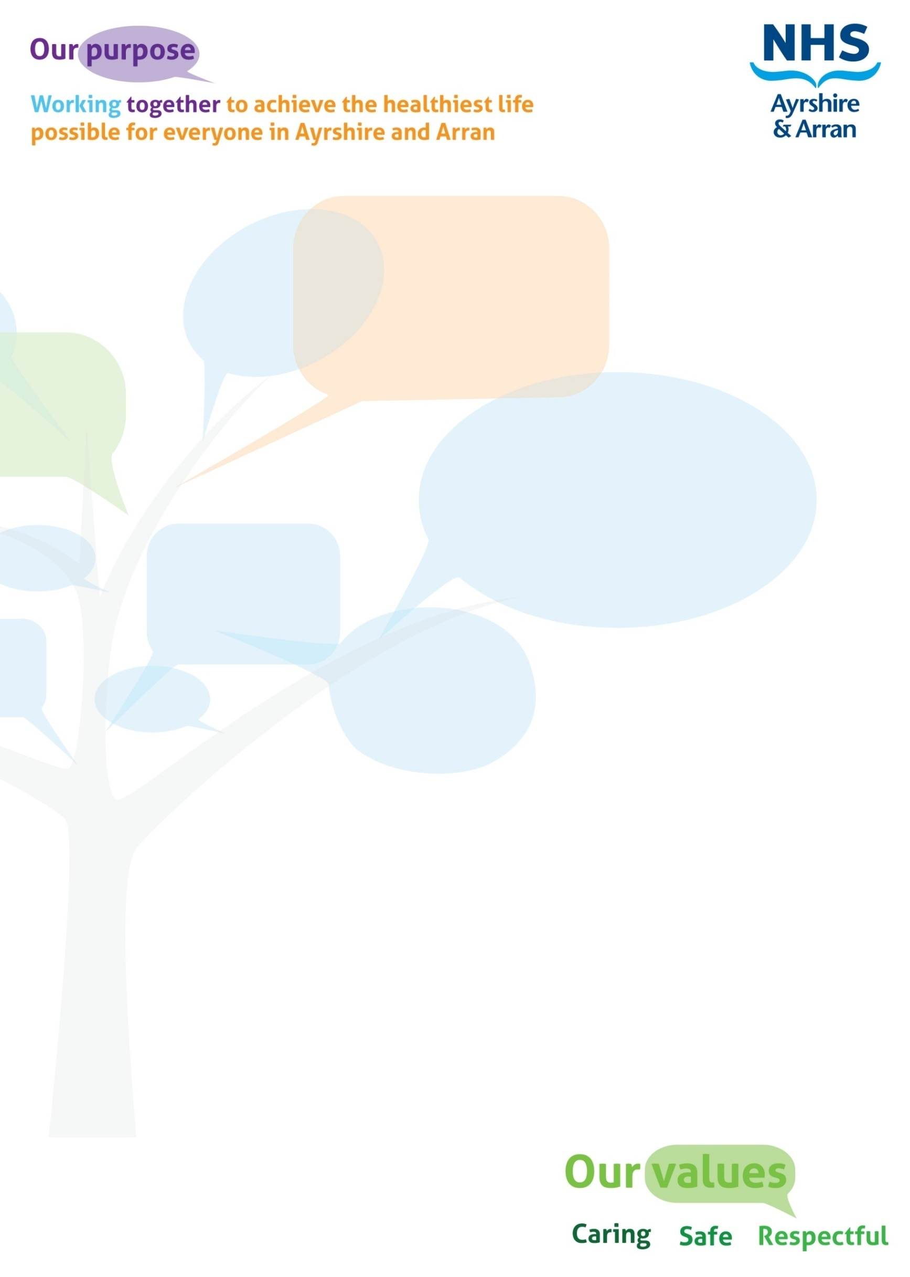

|  |
| --- |
| JOB IDENTIFICATION |
| Job Title: Administrator  Responsible to: Admin Team Manager  Department(s): Ayrshire Urgent Care Service (AUCS)  Directorate: East Ayrshire Health and Social Care Partnership  Operating Division: Primary Care and Out of Hours Community Response Service  Job Reference: 083287  No of Job Holders: 3  Last Update : 18/11/2024 |

|  |
| --- |
| 2. JOB PURPOSE |
| The post holder will contribute to providing a high level of clerical, administrative and operational support service in all aspects of the NHS AUCS daytime Administration and the Out of Hours Operational Services.  Assisting in managing clinical and non-clinical Rotas to ensure the service can run efficiently and effectively.  Upholding the high quality and standards of the NHS AUCS service provision to the Ayrshire public. |

|  |
| --- |
| **3 DIMENSIONS** |
| You will be part of the Ayrshire Urgent Care Service administration team. You will provide support and work in partnership with the Senior Management Team to develop and deliver high quality care to all service users.  NHS AUCS serves circa 375,000 patients within mainland Ayrshire during the Out of Hours period plus 10 public holidays.  NHS AUCS has circa 95,000 patient contacts per annum and daily working interaction with 55 mainland Surgeries, 255 General Practitioners and practice staff and close working links with NHS24, A&E, SAS and other internal and external partners and agencies.  The NHS AUCS Administration is the conduit linking the daytime Primary Care service provision and the Out of Hours Primary Care service provision enabling a seamless transition for the population of Ayrshire’s continuing health care. |

|  |
| --- |
| ORGANISATIONAL POSITION |
|  |

|  |
| --- |
| **5. ROLE OF DEPARTMENT** |
| The service aims to provide a high quality, safe and effective clinical and social care service for unscheduled care to the population of Ayrshire.  The Service is responsible for the delivery of urgent community healthcare provision to the population of Ayrshire and Arran. The service provides an accessible urgent care service locally delivered primarily by a multi-disciplinary team of General Practitioners, ANPs, District Nurses, Social Work and Mental Health professionals. The service covers the whole of Ayrshire which incorporates North, South and East Ayrshire local authorities. |

|  |  |  |
| --- | --- | --- |
| 6. KEY RESULT AREAS | | |
| **Bespoke AUCS IT Data Bases & Web Rotas**   * Responsible for ensuring that all NHS AUCS Clinicians/Doctors have the relevant up  to date documentation such as GMC, Performers List, Full Indemnity and NMC certification * Ensure that NHS AUCS doctors are processed into the correct working group such  as Preferred or Permitted according to NHS AUCS protocol * Responsible for monitoring ST1’s and ST3’s induction process ensuring accuracy  of paperwork and coordinating clinical supervision for the trainees during shifts undertaken * Document all ST1 & ST3’s work undertaken during the out of hours period, to evidence their compliance with their OOH training requirement * Responsible to input all staff rotas and updated information into the NHS AUCS bespoke   Patient Management IT system, Adastra and maintaining accurate databases   * Responsible for the accurate maintenance of all operational & driving staff rotas; including updating internal workforce management circa100 staff * Ensuring that Administrators are fully employed within their sphere of accountability such as, daily tasks, annual inspection of all IT data bases, personnel files, this list is not exhaustive   **General Administration**   * Ensuring that all work within the AUCS administration in completed accurately and timeously and met within set deadlines such as missed triage investigation support, monthly statistical analysis provision to each of the 55 GP practices * Responsible to ensure that all stock ordering and control is undertaken timeously and with no deficits * Responsible to ensure that all types of Special Patient Notes are input into the local and national IT systems * Ability to communicate sensitively and efficiently with the public/colleagues, wishing to lodge complaints or comments regarding the service provision, in line with the organisations complaints procedures * To take responsibility for their own training and development needs, attending meetings, annual appraisal and training courses that are deemed to form an integral part of their duties | | |
| 7a. EQUIPMENT AND MACHINERY | |
| * PC, Monitor & Mouse * Photocopier, Scanner, Fax & Printer * Laminator, Binder & Shredder * Telephones &Voice Recording Equipment * Paper Cutter & Edger | * **Diagnostic sets** * **Defibrillator** * **Oxygen cylinder** * **Oxygen concentrator** * **Nebuliser** |
| All the above equipment is used for training purposes and as part of the daily operational function of the service. The medical equipment (**in Bold**) must be recognisable to the employee and its functionality known. | |

|  |
| --- |
| **7b. SYSTEMS** |
| Adastra Patient Management System  Microsoft Office Packages such as Microsoft Teams, Word, Excel & Powerpoint  IT SYTEMS - various  RotaMaster  SSTS Payroll System  TURAS  Datix |

|  |
| --- |
| 8. ASSIGNMENT AND REVIEW OF WORK |
| The post holder is accountable to and is directly managed by the Admin Team Manager.  The post holder works independently and autonomously whilst carrying out tasks with periodic direction from the Team Manager.  Work is of a complex nature where independent decision making is required.  The post holder is expected to assess and deal with issues, escalating those that require senior intervention.  The Team Manager will carry out Annual Reviews and one to one meetings will be held at regular intervals to discuss results/outcomes. |

|  |
| --- |
| **9. DECISIONS AND JUDGEMENTS** |
| The post holder uses own initiative to make decisions regarding workload priorities in line with preset systems & deadlines, accuracy of work and general enquiries will be self-regulated.  The line manager is available for support with challenging or complex issues. |

|  |
| --- |
| 10. MOST CHALLENGING/DIFFICULT PARTS OF THE JOB |
| * Working within a multi-disciplinary environment * Manage time effectively and efficiently * Prioritisation of workload * The ability to work under pressure to meet deadlines * Recording and maintaining accurate information systems * Direct patient/public contact that may be defensive or challenging * Diplomacy in sensitive or confrontational situations Staff/Clinicians |

|  |  |
| --- | --- |
| **11. COMMUNICATIONS AND WORKING RELATIONSHIPS** | |
| Effective communication skills are an essential component of the job. Communication is face to face (individual and group), written (reports, email and letters) and telephone. | |
| ***Internal***   * General Practitioners * District Nursing Staff * AUCS Management Team * AUCS ANP Team * AUCS Administration Team * AUCS Operational Delivery Teams * Quality Improvement * Pharmacy * A&A IT Department * HR Department * Integrated Care Teams and the   CRISIS service | ***External***   * NHS 24 * GP Practices * Social Services * Scottish Ambulance Service * Community Pharmacy service * Police Scotland * Voluntary and Third Sector Representatives * Various Suppliers * Patients/General Public |
| **12. PHYSICAL, MENTAL, EMOTIONAL AND ENVIRONMENTAL DEMANDS OF THE JOB** | |
| **Physical Effort/Skills**   * Combination of sitting, standing and walking * Bending and lifting stock, boxes, drug cases/bags into and out of the car boots * Standing filing records * Manual dexterity required for keyboards * Visual dexterity requires reading such as medicine labels, patient’s case notes and staff correspondence   **Mental Effort/Skills**   * Meeting deadlines * Frequent periods of concentration required for keyboard skills ensuring accuracy of information * Occasional challenging situations with clinicians/public/staff * Long periods of VDU working where accuracy is essential to impart information * Frequent interruptions, requiring the post holder to multi task * Filling short notice clinical and non clinical rota cancellations, requiring persuasive and negotiating skills to ensure continuous safe service provision     **Emotional Effort/Skills**   * Meeting many deadlines; Rotas, SSTS, statistical information required by other work colleagues * Frequent lengthy periods of concentration required ensuring accuracy of information and systems * Frequent exposure to distressing clinical patient information such as palliative care, end of life, DNACPR, violence & aggression, mental health and child protection issues * Extensive use of VDU equipment, almost continuously, as most tasks keyboard based * Work in a calm and rational manner at all times setting the highest example of working standards and procedures   **Environmental Working Conditions**   * Primarily working within an office environment * Occasional visits to the other two Primary Care Treatment Centres | |

|  |
| --- |
| 13. KNOWLEDGE, TRAINING AND EXPERIENCE REQUIRED TO DO THE JOB |
| **Essential Skills**   * Good working knowledge of all Microsoft Packages & Computer Literate * Excellent communication and inter personnel skills including excellent telephone manner * Capable of working under own initiative, autonomously and as part of a multi-disciplinary team * Capable of working under pressure meeting tight deadlines whilst maintaining status quo * Excellent Planning and Organising Skills * Experience working in an admin environment * Capable of working under pressure and meeting tight deadlines * Experience of independent decision making and escalating when appropriate   **Desirable Skills**   * ECDL * Car Driver & Full Licence * Knowledge of Adastra Patient Management IT Software |