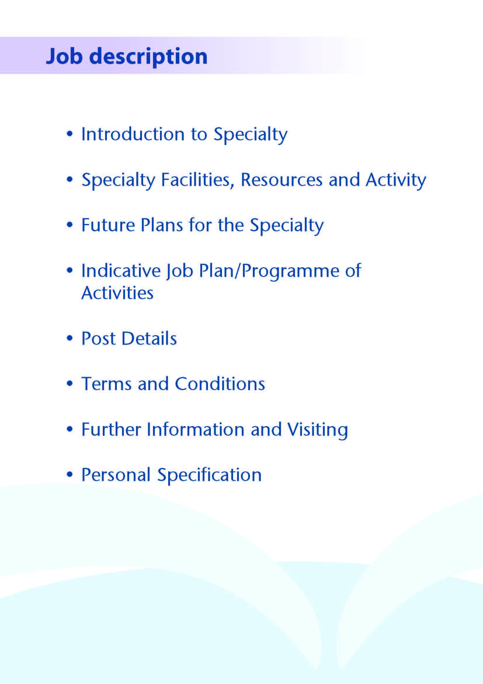



This Consultant post is available to support the Orthodontic Team within NHS Ayrshire & Arran and replaces a retired colleague. This post is one of two based the Department of Orthodontics, NHS Ayrshire & Arran, delivering services from two district general hospitals at University Hospital Crosshouse (UHC) near Kilmarnock and also from University Hospital Ayr (UHA), with some clinics at Ayrshire Central Hospital, Irvine.

Ayrshire has a beautiful rural and sea-side landscape and excellent recreational facilities, wonderful opportunities for sailing, walking, cycling - and many golf courses. There are excellent road and rail links to Glasgow, Central Scotland, and the Western Highlands and beyond. There are domestic and international flight connections at Glasgow Airport, south and west side of the city.



NHS Ayrshire & Arran has a population of approximately 388,000 residents stretching from Skelmorlie on the Clyde coast to Ballantrae in the rural South. The Health Board boundary is co-terminus with North, South and East Ayrshire health and Social Care Partnerships and councils.

The Orthodontic Department forms part of the Head & Neck Directorate alongside Oral & Maxillofacial Surgery, Restorative Dentistry, Maxillofacial laboratories, Ear Nose and Throat, Audiology and the Cochlear Implant Service. UHC is the Scottish national centre for cochlear implant surgery.

**Facilities**

University Hospital Crosshouse, Kilmarnock is the main base for the Orthodontic department. Currently clinics are partially displaced owing to the pandemic but remobilisation is ongoing as part of a return to full service. The office facilities, secretarial services and the Oral-Facial Laboratory are located in UHC. All in-patient and day-case maxillofacial/oral surgery is carried out at UHC. Both University Hospital Crosshouse and University Hospital Ayr have full x-ray imaging facilities including MR and CT imaging with three dimensional reconstruction capabilities and at UHC, there is a first class Medical Illustration and Photographic suite. We also have Cone Beam CT imaging.

The Orthodontic and Maxillofacial Department at University Hospital Crosshouse shares six dental surgeries and two consulting rooms, with two of the dental surgeries dedicated to Orthodontic use. There are two surgeries at University Hospital Ayr. Outreach treatment clinics are held at Ayrshire Central Hospital.

The UHC Oral Facial Laboratory provides excellent technical support. There are six Maxillofacial/Orthodontic Technicians who manufacture all orthodontic appliances in house and carry out the orthognathic surgery model planning. The Laboratory provides facial and ocular prostheses and a camouflage cosmetic service. 3D printing and scanning is available on site.

**Medical Staff Resources**

The staffing of the Head & Neck Directorate is as follows:

|  |  |  |
| --- | --- | --- |
| Consultant Staff | Base | Specialist Interest |
| Ms Deborah Boyd (Clinical Director Head and Neck) | Crosshouse | Oral Maxillofacial/Orthognathic/Facial Deformity/ Trauma |
| Mr Roger Currie (Associate Medical Director, Surgery) | Crosshouse | Oral and Maxillofacial /Skin Cancer/ Orthognathic |
| Mr Ewen Thomson | Crosshouse | Oral and Maxillofacial /Head and Neck Oncology |
| Vacancy | Crosshouse | Oral Maxillofacial/Orthognathic/Facial Deformity/ Trauma |
| Ms Lorna Langstaff (Clinical Lead ENT) | Crosshouse | General ENT/Head & Neck Oncology |
| Mr Andrew Whymark | Crosshouse | General ENT/Rhinology |
| Mr Richard Townsley | Crosshouse | General ENT/Head & Neck Oncology |
| Ms Lyndsay Fraser | Crosshouse | General ENT/Paediatrics & Cochlear Implant |
| Mr Peter Wardrop | Crosshouse | General ENT/Cochlear Implant |
| Ms Natasha Grimmond | Crosshouse | General ENT/Cochlear Implant |
| Mr Padraig Ferry | Crosshouse | Locum Consultant Orthodontics |
| Ms Sue Thomas | Crosshouse | Locum Consultant Orthodontics |
| Mr Andrew McInnes | Crosshouse | Consultant Restorative Dentistry (visiting) |

|  |  |  |
| --- | --- | --- |
| **Speciality Doctor** | **Base** | **Specialist Interest** |
| Dr Julie Cross | Crosshouse | Oral and Maxillofacial (P/T) |
| Dr Alison Murray | Crosshouse | Oral and Maxillofacial (P/T) |
| Dr Louisa McCaffrey | Crosshouse | Oral and Maxillofacial (F/T) |
| Dr Xixi Zhu | Crosshouse | Oral and Maxillofacial (F/T) |

The department is supported by junior staff as part of the Pan Scotland StR Training Programme 1 Dual qualified StR on rotation. Four DCT2’s, one DCT1, and 4 Specialty Doctors.

The department is part of the Scottish NES Post CCST training programme and periodically recruits a ST4 level trainee post shared with Glasgow Dental Hospital.

**Supporting Staff in the Orthodontic department**

|  |  |
| --- | --- |
| Orthodontic Therapists | 0.8 |
| Orthodontic Nurses | 5.6 WTE |
| Nursing Auxiliaries | 1.6 |
| Secretary | 1 |
| Oral facial laboratory | 5.5 WTE |



The patient care provided by the NHS Ayrshire and Arran Hospital Orthodontic service has evolved as the provision of specialist orthodontic primary care treatment has increased over the last 10 years. The Unit delivers treatment for complex cases and those requiring multidisciplinary care. The successful candidate will be expected to carry out a wide range orthodontic treatment appropriate to the work of the department. Specialist interests or skills will be welcomed and encouraged.

At present, the Department has expertise in Orthognathic Surgery, Cleft lip and Palate, Surgical and Orthodontic management of impacted teeth, hypodontia and non-surgical management of sleep apnoea. We also have a newly established Joint Orthodontic Paediatric clinic with a Specialist in Paediatric Dentistry who is employed by the Public Dental Service. Although currently paused there are usually regular joint orthognathic and dento-alveolar clinics held with maxillofacial colleagues and joint clinics with Restorative Consultant colleague.

There are currently quarterly local MDT Cleft care clinics with full support from Plastic Surgery, Speech and Language Therapy, ENT, Psychology, Paediatric Dentistry and Orthodontics.

Additional MDT working is being developed virtually with bone grafting clinics online.

Now that our CBCT machine is in place, it is hoped to develop 3D imaging/model printing and a digital study model system.

New orthognathic planning software has been purchased to facilitate the recommencement of the orthognathic surgical service.

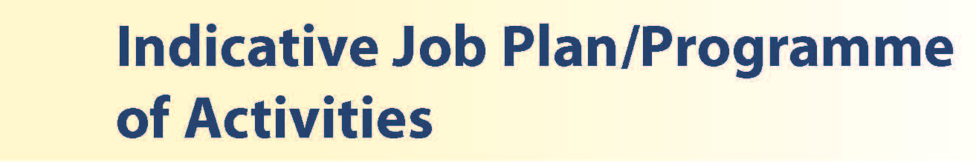

# Proposed Weekly Programme

Activities with current fixed time commitments will be carried out to include new patient clinics, treatment/review clinics and multi-disciplinary clinics. Other DCC and SPA activities with indicative timings within the weekly programme will be discussed with the appointee.

**Patient Administration/Laboratory**. This activity covers the management of individual patients including Out Patient administration, treatment planning, ceph tracing, liaising with the laboratory, letters/phone calls to patients, carers, GDP’s and members of the wider multidisciplinary team involved in the patients care.

**Travel:** Any travel allocation will be included within the Total Programmed Activities and will be determined by location at which Direct Clinical Care and Supporting Professional activities are carried out.

**On call arrangements:** There is no on-call associated with this post.

**Supporting Professional Activities**: NHS Ayrshire and Arran recognise the important role Job Planning has in ensuring Consultants are supported in delivering high quality, safe, sustainable clinical care to patients. It is therefore important to ensure there is an adequate balance between direct clinical care activities and activities which support both the personal and professional development of the consultant workforce and facilitates agreed contribution to activities including:

* Under- and postgraduate teaching/training
* Clinical Governance
* Quality and Patient Safety
* Research and Innovation
* Service management and planning
* Work with professional bodies

All consultants will have 1 SPA as a minimum to support job planning, appraisal and revalidation. However the final balance of SPA and DCC activity will be agreed between the appointee and Clinical Director prior to contracts being agreed.

There may be a requirement to vary the DCC when the final balance of DCC and SPA is subsequently agreed. There may also be opportunities to contract for Extra Programmed activities Opportunities subject to service requirements and in accordance with national terms and conditions of service.

If the post-holder is responsible for the formal training and supervision of trainees, a suitable additional allocation of SPA time will be made in accordance with national guidance.

**Job Plan Review**

New appointees will discuss the indicative job plan with the Clinical Director, prior to commencement and will at that time review the balance of activities. Where it is possible to agree revisions to the indicative plan in advance of commencement this will be acted upon. In any event however, there must be an interim Job Plan review conducted at 3 months post commencement to agree and finalise the Job Plan. The consultant at time of induction should ask for an interim review date to be scheduled. The agreed job plan will include all professional duties and commitments, including agreed Supporting Professional Activities.  Thereafter Job Planning will be carried out annually as part of the Board’s Job Planning process.

**Private Practice:** If the post-holder wishes to undertake any private practice, they are obliged to inform their employer at the time of appointment of their intentions to do so. This should be submitted in writing to the Clinical Director. The conduct of private practice will be in accordance with the Consultant Contract (Scotland) Terms and Conditions.

The post-holder shall be free to undertake private practice without approval provided such work is undertaken outside the time agreed in the job plan for programmed activities. (Refer Section 6 of the New Consultant Contract).



The postholder will be accountable to the Clinical Director who will agree the Job Plan.

He/she will be expected to work with local managers and professional colleagues in the efficient running of services and will share with Consultant colleagues the medical contribution to management. Subject to the provisions of the Terms and Conditions of Service, he/she is expected to observe NHS Ayrshire and Arran’s agreed policies and procedures, drawn up in consultation with the profession on clinical matters, and to follow the standing orders and financial instructions of NHS Ayrshire & Arran.

In particular, where he/she formally manages employees of NHS Ayrshire and Arran, the postholder will be expected to follow the Local and National Employment and Personnel Policies and Procedures.

He/she will be expected to make sure that there are adequate arrangements for hospital staff involved in the care of patients to be able to make contact with the postholder when necessary.

The postholder is required to comply with NHS Ayrshire and Arran’s Health and Safety Policies.

He/she will be responsible for the training and supervision of Junior Dental Staff who work with the postholder and will be expected to devote time to this activity on a regular basis. In addition, he/she will be expected to ensure that Junior Staff have access to advice and counselling. If appropriate, the postholder will be named in the Contracts of Dentists in training grades as the person responsible for overseeing their training, and as the initial source of advice to such Dentists on their career.

**Resources**

The postholder will have access to such general administrative support as is required for the discharge of his/her duties and responsibilities. This will include the provision of adequate secretarial and clerical support and the availability of accommodation, equipment etc.

The postholder will receive support from such other professional staff as are employed within NHS Ayrshire and Arran and are deployed to his/her area of patient care.

**Duties and Responsibilities**

The main duties and responsibilities of the post include:

* Responsibility for the treatment of patients under his/her care and associated patient administration
* Share in the responsibility of administration for the proper functioning of the Orthodontic department
* The postholder will be required to comply with NHS Ayrshire and Arran’s Policies on Clinical Governance.
* Requirements to participate in clinical audit and in continuing professional education.

**Annual Appraisal & Job Planning**

You shall also be required to participate in annual appraisal. Job planning is linked closely with, but is separate to, the agreed appraisal scheme for consultants. The job plan review will take into account the outcome of the appraisal discussion and reflect the agreed personal development plan.



The Terms and Conditions of Service are those determined by the Terms and Conditions of the New Consultant Grade (Scotland) as amended from time to time. The distance that a consultant can reside from the principal base hospital, where travel time is seen as more important than mileage, is subject to the agreement of the Executive Medical Director, but it is usually anticipated that a journey that takes no more than 30 minutes for any emergency situation would be acceptable.



Applicants wishing further information about the post are invited to contact Ms Sue Thomas (01563 827291) sue.thomas@aapct.scot.nhs.uk or Mr Padraig Ferry (01563 827291) Padraig.ferry@aapct.scot.nhs.uk with whom visiting arrangements can also be made. In addition, you may contact Ms Debbie Boyd, Clinical Director on (01563 27300) debbie.boyd2@aapct.scot.nhs.uk



**POST OF: CONSULTANT ORTHODONTIST, NHS AYRSHIRE AND ARRAN**

## QUALIFICATIONS:

|  |  |  |
| --- | --- | --- |
| REQUIREMENTS | ESSENTIAL | DESIRABLE |
| GDC  Qualifications | Full GDC Registration  GDC Specialist List for Orthodontics  Primary Dental Degree (BDS)  Membership in Orthodontics (M.Orth.)  Intercollegiate Speciality Fellowship Exit examination in Orthodontics (ISFE), before commencing post | Higher degree in orthodontics, e.g. D.Clin.Dent/MSc  Postgraduate dental diplomas e.g. other Royal College memberships or fellowships |
| Training and experience | Successful completion of a SAC-approved 2-year minimum training programme in a Fixed Term Training Appointment (FTTA) in Orthodontics, or within 6 months of completion of training, or equivalent.  Experience of a broad range of malocclusions and treatment modalities to an advanced level or have already held a post at consultant level. | Additional post CCST training and experience in the management of complex surgical orthodontics, hypodontia etc. |

**SKILLS/KNOWLEDGE/COMPETENCE**

|  |  |  |
| --- | --- | --- |
| **REQUIREMENTS** | **ESSENTIAL** | **DESIRABLE** |
| General and Specialist Experience: | Broad experience in all aspects of dental practice.  A high level of competence in all aspects of Orthodontics and evidence of an ability to develop new skills. | Area of special interest in orthodontics |
| Team Working | Effective Team Player  Evidence of working with other dental and medical specialties e.g. OMFS/Restorative/ ENT/Paediatrics |  |
| Development | Evidence of audit and involvement in clinical improvement activity. |  |
| Teaching & Training | Experience in teaching  Desire to promote education for training grade staff | Teaching undergraduates and postgraduates |
| Research & Publications | Knowledge of current orthodontic literature | Research degree, evidence of publications |
| Clinical Governance and Audit | Evidence of previous audit activity and involvement in clinical governance | Peer reviewed publications and presentations |
| Management and Administration | Commitment to effective departmental management and the organisation and management of a multidisciplinary team. | Proven ability to lead a clinical team.  Proven management experience.  Understanding of resource management and quality assurance.  Proven organisational skills |
| Personal and Interpersonal Skills | Effective communicator and negotiator.  Demonstrate effective team leadership.  A willingness to develop special interests which conform to the needs of NHS Ayrshire and Arran.  Ability to operate on a variety of different levels  The ability to work flexibly and constructively with a team of colleagues.  Reliable. | Knowledge of recent changes in the NHS in Scotland  A willingness to accept flexibility to meet the changing needs of the NHS in Scotland.  Self-motivation to act proactively |
| Other | Car driver with full Driving License. | Innovative, enthusiastic and ability to inspire others |