# JOB DETAILS

**Job Title:** Programme Management Office Admin Assistant

**Responsible to:** Programme Management Team

**Department:** Programme Management Office

**Directorate:** Corporate Services

# JOB PURPOSE

The overall aim of the Programme Management Office’s (PMO) is to manage and deliver on all the requirements aligned to the Corporate Services & Governance. The PMO delivers a professional, responsive and accurate service, to ensure that NHSGGC is minimising risk, and giving a clear, fair and transparent account of processes, timelines and accounts.  The PMO therefore must have meticulous record keeping, manage various systems, and have robust quality controls and reporting measures in place.

This post contributes to the development and delivery of the Programme Management Office’s (PMO) objectives include co-ordinating, facilitating and supporting the PMO to deliver activities across multiple programme/project work streams.

A key element of this post is the ability to work within a multi-disciplinary team, to liaise with and co-ordinate activities with Senior Managers, external contacts (including Scottish Government colleagues) and a diverse range of internal staff throughout NHS Greater Glasgow and Clyde and external stakeholders

The post-holder is expected to recognise the high-profile nature of the work and will be accessing confidential information to allow for the provision of wider administrative support, all administrative service provided must be to a high standard, effective and efficient and confidentiality must be retained at all times.

# ORGANISATIONAL POSITION

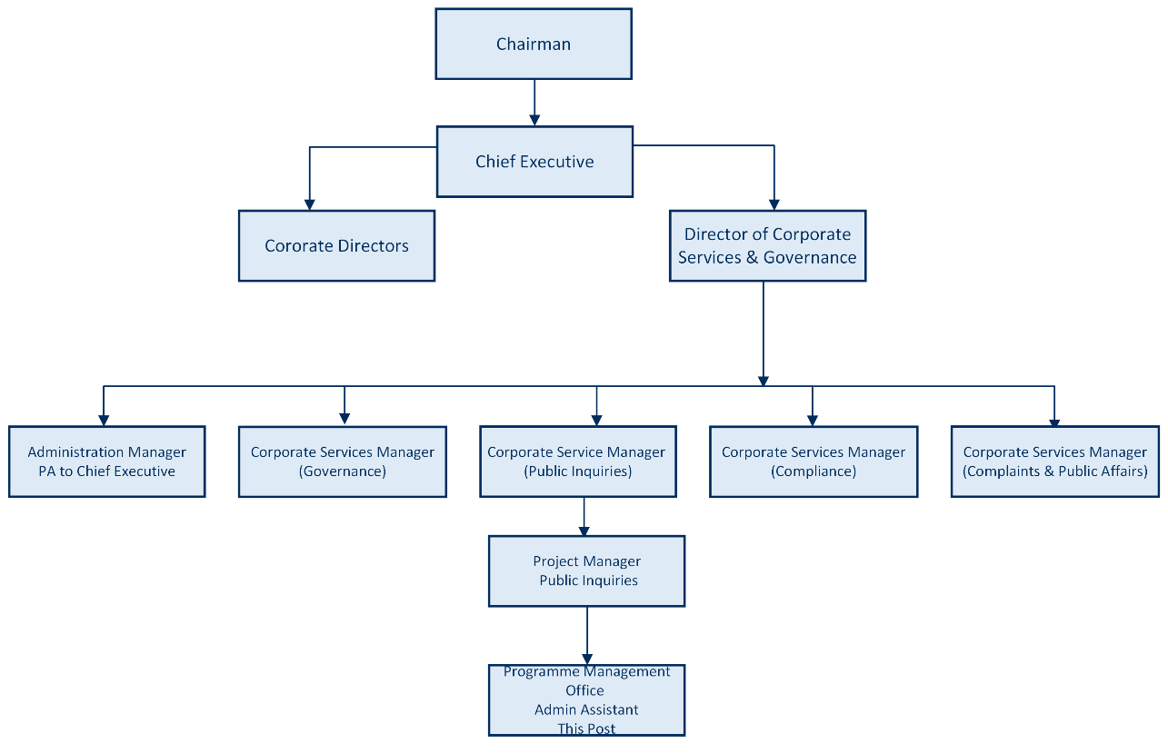

# SCOPE AND RANGE

The post holder will provide a comprehensive administrative service to the PMO and wider Directorate acting as a key contact within the team. This position requires an effective network of contacts to be formed and maintained with a broad range of Directors, staff, managers and clinicians across NHS Greater Glasgow and Clyde and related organisations as well as external organisations promoting a positive image of the organisation.

As a valued member of the team the post holder will be expected to use their initiative and effectively use available resources to meet expectations, while, exercising confidentiality, diplomacy and tact combined with a high degree of accuracy and contribute to the effective achievement of the team’s overall objectives.

There will often be times when the person has to respond to competing demands from the Programme Management Teams members whilst managing a varied personal workload in support of the activities of the team.

# MAIN TASKS, DUTIES AND RESPONSIBILITIES

1. Management of several mailboxes, ensuring messages are prioritised and responded to in the interim as appropriate on behalf of PMO Manager(s), or draft more complex correspondence. Ensure that matters receive attention on a timely basis and that outstanding replies to correspondence are progressed
2. Assist with telephone and face to face enquiries or complaints from all staff groups, patients, relatives and carers, providing information as required, redirecting to other staff where appropriate or arranging for accurate and timely messages to be conveyed to designate Programme Management Team members.
3. Manage designated Programme Management Team diaries proficiently, by forward planning of diary commitments, liaising with Internal and external stakeholders to ensure the effective use of time, resolving conflicting demands within a busy schedule of meeting commitments
4. Assist in arranging a variety of meetings, events and conferences under direction. Organise diary commitments by arranging meetings, suitable venues, hospitality and equipment where appropriate. Also manage attendance at seminars/courses, etc by ensuring necessary paperwork is completed and approved and travel arrangements/accommodation are booked.
5. Responsible for booking travel and accommodation arrangements as authorised by the Programme Manager(s). Including liaising directly with internal and external stakeholder, through the procurement department procedures. Maintaining accurate records of associate costs and ensuring costs are apportioned to the correct cost centre, to allow for accurate financial reporting.
6. Ensure that all necessary arrangements for meeting are made including booking venue, arranging room layout, notifying participants, issuing of agenda and supporting papers, writing up of minutes, their circulation, and ensuring follow up action is taken timeously with the relevant person, and status reported for next meeting
7. Acknowledgement of customer requests for Freedom of Information (FOI), dealing with very sensitive and high profile information in a professional manner
8. Undertake data input activities accurately and in a timely manner to allow for the preparation and production of reports for member of the Programme Management Team..
9. Assist with the coordination and administration of complaints for Programme Management team as directed, liaising with the Complaints Department, helping ensure deadlines are met for complaints to be signed by the Chief Executive.
10. Type a variety of documents (correspondence, reports, statistical and financial data, and presentations) using various processing systems and tools from a variety of sources (including audio) with a high degree of accuracy. This includes extraction of information from spreadsheets and/or production of complex reports and presentations, collating and summarising information from a variety of sources.
11. Maintain and keep under review relevant filing systems (including, where appropriate, electronic database systems and electronic distribution systems relevant to work areas) within protocols and standing working practises for the relevant Programme Manager maintaining confidentiality at all times
12. Attend high level strategic or operational meetings and events and ensure that all relevant papers for meetings are received and submitted on a timely basis.
13. Exhibit a high level of sensitivity and political awareness ensuring the important nature of the work for the Programme Management Team is maintained at all times.
14. Build collaborative relationships, with other Administration staff across the organisations and externally and, where appropriate, liaise directly with the offices of the NHS Board Chief Executives, Chairs, and Executive Directors, other health organisations, partner agencies, CLO, trade union representatives and members of the public ensuring that a customer and performance focus promotes a positive image of the organisation.

# SYSTEMS AND EQUIPMENT

* + - * Personal Computers, Laptop or Tablet Devices
      * Printer, Scanner, Photocopier or Multi Function Devices
      * Telephone
      * Audio transcription equipment
      * Overhead Projectors and other Audio/Video equipment
      * Conference Call equipment
      * All Microsoft Office applications (keeping abreast of updates and new functionality), including Word, Excel, PowerPoint, MS Visio, MS Project, MS Outlook (e-mail) and Teams
      * Adobe Acrobat Reader and Writer
      * StaffNet (or other Intranet Technology)
      * Cedar/Pecos for Stationery and Sundry Ordering
      * HI&T related Service Desk/User Requests Management Tools
      * Any National or Local Staff Management tools, such as, SSTS, eExpenses, ePayroll, eEES, eKSF and LearnPro
      * Any other Information Management Systems pertinent to the role and department

# Decisions and Judgements

The post-holder is required to exercise a high level of judgement including being aware of specific sensitivities when dealing with the Programme Management Team members, Directors, other Senior Managers, Scottish Government Heath Directorates Office and Cabinet Secretary’s Office, MSPs/MPs/MEPs and Elected Representatives, other health organisations, partner agencies, trade union representative and members of the public.

The post-holder manages their own workload and works independently, autonomously and uses their initiative on a daily basis.

The post-holder takes responsibility for:

* + - * Maintaining confidentiality at all times.
      * Screening e-mails and general correspondence, preparing responses or redirecting as appropriate.
      * Providing advice and direction to the Programme Management Team in the appropriate use of departmental tools and systems for managing staff, for example, SSTS, eExpenses, ePayroll, eEES, eKSF and location of organisation policy and departmental procedures.
      * Responding to conflicting demand from Programme Management Team members, and specifically competing workload demands at the request of Managers to whom they are aligned with.
      * In the absence of manager(s), the post-holder will use their own initiative to make decisions ensuring appropriate action is taken.
      * Working proactively within general principles set by the designated Programme Management Team.
      * In line with agreed protocols, prioritise daily workload with little requirement to refer back to line manager on a regular basis.
      * Determining from exercise of their own judgement those matters which should be brought to the attention of the line manager and those which can be progressed independently.

# COMMUNICATIONS AND WORKING RELATIONSHIPS

The post holder requires to have very well developed verbal/ written communication and interpersonal skills coupled with the ability to maintain excellent working relations with staff within NHS Greater Glasgow and Clyde and external partners, dealing with sensitive and confidential information, developing effective working relationships and promoting team working. At all times the post-holder has to be aware of the need to maintain the corporate identity of NHS Greater Glasgow and Clyde in any communication that they have.

**Verbal**

* + - * Face to face or via telephone to answer basic queries, take messages and arrange meetings for the Programme Management team and/or Senior Manager at all levels within the division and with external agencies.

**Written**

* + - * By email, drafting letters in response to queries, collating reports, minute taking and a variety of written communications.

**Relationships**

* + - * Effective working relationships are required to achieve the Programme Management Team objectives by maintaining co-operation and support from all the NHS Greater Glasgow and Clyde staff groups involved in the programmes of work and wok streams

# DEMANDS OF THE JOB

**Physical**:

* + - * Required to spend a high percentage of the day sitting at desk using PC or similar equipment for prolonged periods of time i.e. word processing, Microsoft Teams, minute taking.
      * Fast and accurate advanced keyboard skills to produce documentation to tight deadlines.

# Mental:

* + - * High degree of intense concentration on the production of work recognising the need for a high level of accuracy at all times, particularly around minute taking and ability to meet demanding workloads to tight deadlines on a daily basis.
      * Dealing with frequent interruptions often associated with potentially serious, sensitive or contentious issues.
      * Ability to multi-task and be proactive in actions.
      * Patience, with the ability to recognise that their own priorities may not match those of the Manager or other Programme Management Team members, and manage those conflicts.

# Emotional:

* + - * Well-developed diplomatic skills.
      * Constant change of priorities and competing demands.
      * On occasions, required to react sensitively to distressed staff or public, including receiving complaints.
      * Exposure to written information related to clinical, sensitive or disciplinary issues.

# Environmental:

* + Generally within standard office environment, however, travel to other locations may be required e.g. for meeting or events.

# MOST CHALLENGING/DIFFICULT PART OF POST

The post-holder must have the ability to manage a highly complex and demanding workload, to meet tight deadlines, have a high degree of confidentiality and have a very flexible approach to work patters. As primary point of contact with Directors, senior managers and staff within NHS Greater Glasgow and Clyde, the wider NHS family and external partners this requires highly developed judgement skills when confidential, sensitive or contentious issues arise. The post-holder must also have an awareness of potentially sensitive political issues and the high profile nature of the work of the department.

Tactfully and with discretion, dealing with the number, range and complexity of relationships to be managed both internally and externally through influencing and persuasion.

* + - Ability to quickly adapt to changes in demand using effective time management and prioritising workload.
    - Maintaining high quality personal assistance and administrative service to designated Programme Management Team members, as well as to their line manager, which may involve resolving conflicting demands and interruptions to planned activity.
    - Exercising influence over staff whom the individual has no direct managerial authority.

# KNOWLEDGE, TRAINING AND EXPERIENCE REQUIRED TO DO THE JOB

* + - Recognised qualification in Administration equivalent to HNC in Secretarial Studies or Business Administration, or SVQ in Administration at Level 4, or significant relevant equivalent practical experience.
    - Significant previous experience working at Senior/Director level within a large and complex organisation.
    - High degree of organisational ability, together with excellent analytical, written and oral communication skills, with good command of the English language.
    - Ability to handle and prioritise a diverse workload, including matters of a highly confidential and sensitive nature with diplomacy.
    - The ability to engage with Executives, Directors and Corporate staff in all disciplines, foster team working and high standards in an environment of rapidly changing priorities and tight deadlines is essential.
    - Conversant with office procedures and systems and able to demonstrate prior experience in working in a secretarial or administrative role. Such experience is unlikely to have been achieved in less than 3 years’ related secretarial/administrative experience at a more junior level through which a thorough understanding of office procedures has been obtained.
    - Must show competence in the use of range of computer packages evidenced by experience in use of standard software systems e.g. MS Outlook or similar e-mail systems, MS Word, MS Excel, MS PowerPoint and Teams and be able to demonstrate advanced keyboard skills.
    - Knowledge of the NHS environment is desirable, together with an understanding of the full range of organisational policies and procedures governing the role of the Board, its Executive and Non-Executive Directors and Corporate Managers.
    - Understanding of Technical and Medical terminology; knowledge of Policies & Procedures related to eHealth e.g. Data Protection, Access to Health Records and E-mail Policy.
    - Prepared to work additional hours on occasion and be flexible.
    - Provide support and cover for colleagues and on taking on new or different requirements as appropriate to role.