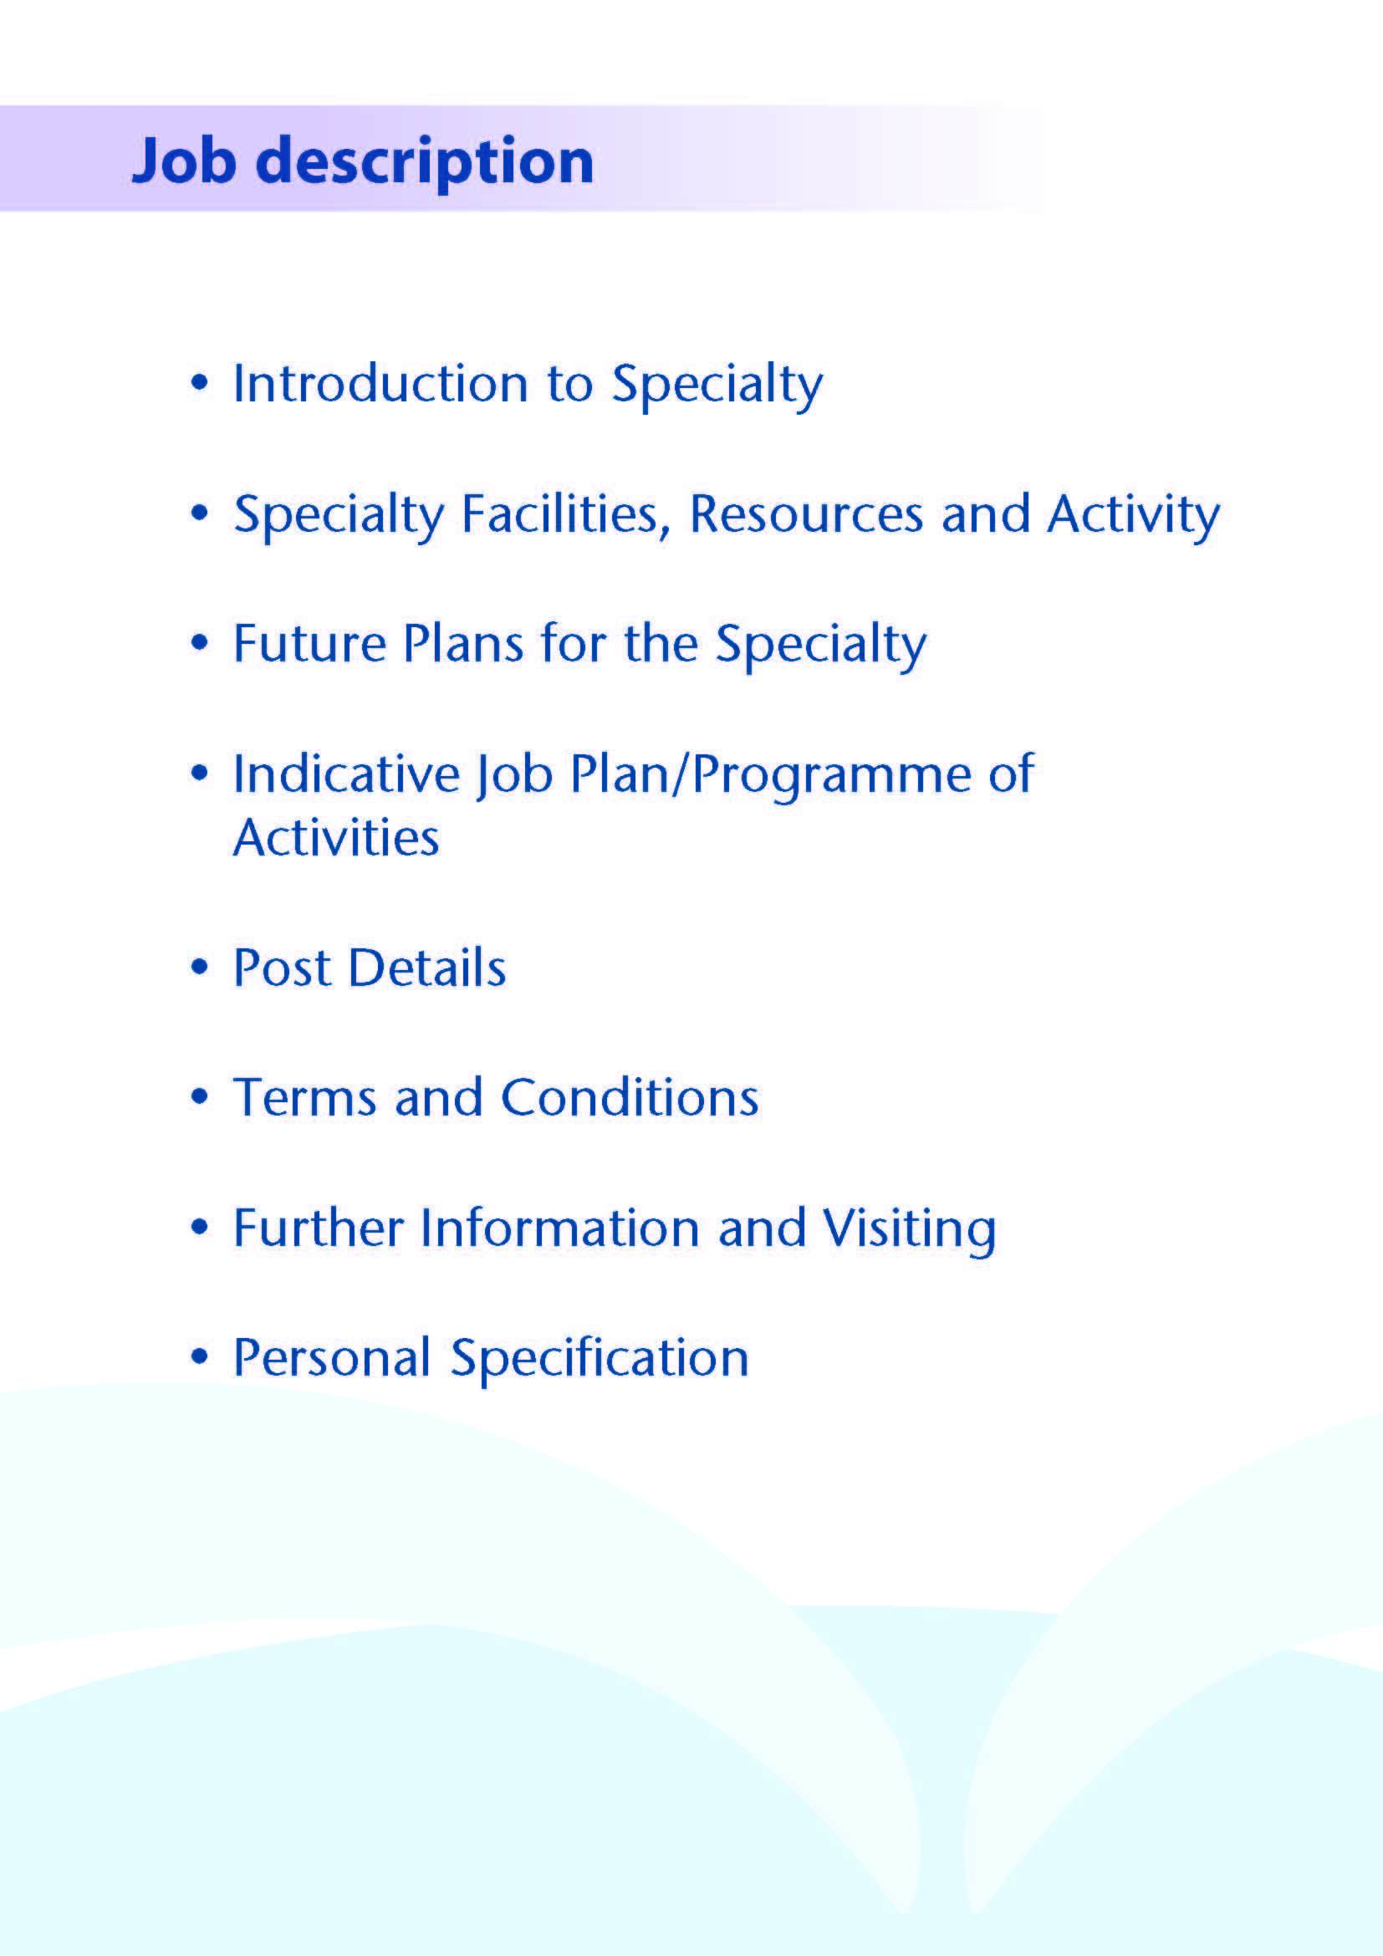



NHS Ayrshire and Arran has invested significantly in mental health service development over recent years. All acute psychiatric beds are now sited in our purpose-built inpatient unit, Woodland View, which opened on the Ayrshire Central Hospital campus in Irvine in 2016. This includes an IPCU, low secure unit and an open forensic rehabilitation ward. The development of an Early Intervention in Psychosis Service is a new and exciting opportunity following Ayrshire and Arran being put forward as a pathfinding site by the Scottish Government.

We are currently looking to recruit one part time (0.2 WTE) enthusiastic and motivated Consultant in General Adult Psychiatry to support the development of a new Early intervention in Psychosis (EIP) service, and to play a key role in supporting these exciting new developments. The Role is advertised on a fixed term contract as part of a scoping and pilot project.

The post holder would provide the sole consultant psychiatric input into the development of the new EIP service, providing medical expertise and leadership to the team. They will support other members of the MDT to develop an EIP Service within Ayrshire and Arran as part of a Pathfinding Project. The successful candidate will support the development of EIP clinical pathways.

The role will also provide opportunity for the direct clinical care of patients with first episode psychotic presentations, including assessment and management of this patient group.

Other members of the team include a band 7 team leader and a clinical psychologist.



The Early Intervention in Psychosis (EIP) Service is intended for patients with a First Episode psychosis to improve longer term outcome. Some patients will have other co-morbidities. The team will cover the three Ayrshire HSCPs. It would accept referrals of individuals with established psychosis as well as those with possible prodromal symptoms of psychosis (such as low or short lived psychotic symptoms or reduced functioning and family history of psychosis).

The EIP team will be expected to assess current models of care for the FEP patient cohort and identify how the new EIP service can link in with existing care pathways and community teams to support the existing resource for manging patients with FEP and also identifying new clinical pathways to support this patient cohort.

The Team will be expected to establish referral criteria, care pathways and develop a best practice for case management. The team will also be involved in managing the clinical care of patients with FEP. The proposed model of care is that the EIP service will manage patients with FEP for up to three years. After three years care would be transferred back to the appropriate adult team or patients would be discharged.

The team would be community based. The Consultant Psychiatrist would be the RMO for inpatients and the team would continue to provide care for patients during periods of inpatient admission.

The team would operate in office hours

The new Early Intervention Services will managed and Supported by clinical and management leads within unscheduled care and Perinatal services. The postholder, along with the other multidisciplinary members of the EIP team will have the role of developing new pathways for patients with first episode psychosis (FEP).

**Medical Staff Resources**

**Consultant Grade:**

**ADULT**

***East Locality***

**Dr Morag Henderson**

**Dr Aileen Guthrie (East Community Clinical Director)**

**Dr Yasmin Nalci**

**Dr Pamela Swift**

***North Locality***

**Dr Everett Julyan**

**Dr Alison MacRae (North Community Clinical Director)**

**Dr Alex McLean**

**Dr Eilidh Orr**

***South Locality***

**Vacancy**

**Dr Tim Johnston**

**Dr Adrian Nitu**

**Dr Jacqui Scott (South Community Clinical Director)**

***Rehabilitation***

**Dr Krzysztof Tyczynski**

***Liaison/Perinatal***

**Dr Malcolm Cameron**

**Dr Ben Chetcuti (Clinical Director)**

**Dr Kim Newlands**

***Psychotherapy***

**Dr Steve Moorhead**

***Forensic***

**Dr Dawn Carson (Clinical Director, Inpatients, Rehab & Forensic)**

**Dr Gillian Howieson**

**Dr Ishbel MacFarlane**

**This post**

***Elderly***

**Dr Debbie Browne (Associate Medical Director, Mental Health)**

**Dr Stephanie Cowan**

**Dr Mark Luty (Clinical Director)**

**Dr Susan Maxwell**

**Dr Joseph Sharkey**

**Dr Alan Spratt**

**Dr Gillian Scott**

***CAMHS***

**Dr Helen Smith (Clinical Director)**

**Dr Tahir Ali**

**Vacancy**

***Learning Disability***

**Dr Claire Hughes (Clinical Director)**

**Dr Douglas Paterson**

**Dr Omer Rashid**

***Addictions***

**Dr Clare Duncan**

**Dr Karthik Kessavelou**

**Dr Beinn Wilson (Clinical Director)**

**Dr Caroline Woolston**

**Non Consultant Grade:**

The consultant posts are supported by 5 Specialty Grade Doctors, approximately 28 junior trainees (FY2/ST1-3) and a varying number of Higher Trainees in Psychiatry (ST4-6). The post holder would be encouraged to become a trainer.

**Admin Support**

The post holder will be supported by a medical secretary.

**Education**

Woodland View has its own library and training facilities on site for local Postgraduate teaching. Crosshouse and Ayr Hospitals have the Alexander Fleming Education Centre and MacDonald Education Centre, respectively. These facilities have well stocked libraries with good electronic facilities, a lecture theatre with state-of-the-art equipment and meeting rooms.

The post holder will be invited to participate in the local postgraduate psychiatric training programme and can be involved in the teaching of medical undergraduates.



This post is part of ongoing exciting developments within the Ayrshire Early Intervention in Psychosis Service.



The post will consist of 2 programmed activities. The nature and timing of activities shown in the timetable are indicative only and the precise nature of the duties will be agreed with the successful candidate at a job planning meeting with the Clinical Director. Timetables may be adapted to meet the changing needs of the service and personal requirements. The current vacancy had been flexible working and an example is below.

|  |  |  |
| --- | --- | --- |
| **DAY** | **HOSPITAL/ LOCATION** | **ACTIVITY** |
| **FROM / TO** |
| **Monday** |  |  |
| AM | Woodland View/Other clinical areas | Service Development and Pathway development meetings / SPA |
| PM | Woodland View/Other | EIP assessments/ DCC |
| **Tuesday** |  |  |
| AM |  |  |
| PM |  |  |
| **Wednesday** |  |  |
| AM |  |  |
| PM |  |  |
| **Thursday** |  |  |
| AM |  |  |
| PM |  |  |
| **Friday** |  |  |
| 9am – 1pm |  |  |
|  |  |  |

**Proposed Weekly Programme**

**Supporting Professional Activities and Job Plan Review**:

NHS Ayrshire and Arran recognise the important role Job Planning has in ensuring consultants are supported in delivering high quality, safe, sustainable clinical care to patients. It is therefore important to ensure there is an adequate balance between direct clinical care activities and those activities which support both the personal and professional development of the consultant workforce and facilitates agreed contribution to activities including:

* Under- and post-graduate teaching/training
* Clinical Governance
* Quality and Patient Safety
* Research and Innovation
* Service management and planning
* Work with professional bodies

1 SPA is provided within the post to support with service management, planning and pathway development .

There may be a requirement to vary the DCC outlined in the indicative timetable when the final balance of DCC and SPA is subsequently agreed. There may also be opportunities to contract for Extra Programmed activities Opportunities subject to service requirements and in accordance with national terms and conditions of service.

If a post-holder will be responsible for the formal training and supervision of post-graduates and undergraduates, a suitable additional allocation of SPA time will be made in accordance with national guidance.

**Job Plan Review**

New appointees will have an interim Job Plan review conducted at 3 months post commencement to review the balance previously agreed. The agreed job plans will include all the consultants’ professional duties and commitments, including agreed Supporting Professional Activities.    Thereafter Job Planning will be carried out annually as part of the Board’s Job Planning process.

Research: Research is encouraged and supported by an active Research and Development Committee. Appointees will be encouraged to develop research interests associated with their specialist interest.



The main duties and responsibilities of the posts include:

* Providing consultant leadership within the EIP team.
* Providing medical support to the EIP team.
* Liaising with mental health colleagues across all disciplines and with health and social care partners in support of comprehensive patient care
* Liaising with GPs and third sector agencies
* Providing Consultant level assessment, diagnosis and treatment of new and existing patients presenting to services
* Acting as RMO for patients subject to mental health legislation
* Undertaking domiciliary visits and emergency assessments where appropriate
* Undertaking Mental Health Act/Adults with Incapacity Act work
* Participation in the local psychiatric training programme
* Involvement in teaching and supervision of medical students and junior doctors (subject to job plan negotiation)
* Participation in medical audit and continuing professional development
* Compliance with NHS Ayrshire & Arran Clinical Governance policies
* Involvement in appraisal and job planning.



Terms and Conditions of Service are those determined by the Terms and Conditions of the New Consultant Grade (Scotland) as amended from time to time. The distance that a consultant can reside from the principal base hospital, where travel time is seen as more important than mileage, is subject to the agreement of the Medical Director.



For further information or to arrange an informal visit please contact Dr Ben Chetcuti on 01563826121 or Dr Debbie Browne, Associate Medical Director, on 01294 323514.



**POST OF : CONSULTANT IN EARLY INTERVENTION IN PSYCHOSIS (0.2 WTE)**

## LOCATION : AYRSHIRE CENTRAL HOSPITAL / COMMUNITY

## QUALIFICATIONS:

|  |  |
| --- | --- |
| ESSENTIAL | DESIRABLE |
| Full GMC Registration (with Licence to Practice) | Experience in working in EIP service |
| Inclusion on the GMC Specialist Register for General Adult Psychiatry (or will achieve this within 6 months of interview date). | Section 22 approval under the Mental Health (Care and Treatment)(Scotland) Act 2003 |
| MRCPsych (or equivalent) |  |
| Full Driving Licence |  |

|  |  |  |
| --- | --- | --- |
| **SKILLS/**  **KNOWLEDGE/**  **COMPETENCE** | **ESSENTIAL** | **DESIRABLE** |
| **General Experience** | Broad experience and knowledge in the field of psychiatry |  |
|  | Ability to communicate effectively with all levels of staff and patients |  |
|  | Ability to work efficiently with good time management |  |
|  | IT literacy |  |
|  | Good record keeping skills |  |
| **Team Working** | Commitment to being an effective team player, establishing and maintaining patient-centred collaborative relationships |  |
|  | Ability to recognise value of and develop working relationships with partnership agencies |  |
|  | Willingness to contribute to development and clinical leadership of the multidisciplinary partnership |  |
| **CPD** | Evidence of relevant Continuing Professional Development |  |
| **Teaching and Training** | Engagement with teaching and training | Interest in and knowledge of advances in medical education and training |
| **Research and Publications** |  | Evidence of publications in peer reviewed journals |
| **Clinical Audit** | Participation in regular medical audit |  |
| **Management and Administration** | Proven organisational skills |  |
| **Personal and Interpersonal Skills** | Flexibility to meet the changing needs of the service |  |
|  | Effective communicator and negotiator |  |
|  | Open and non-confrontational |  |
| **Professional values and practice** | Committed to practicing according to the GMC’s Good Medical Practice, and the RCPsych’s Good Psychiatric Practice |  |