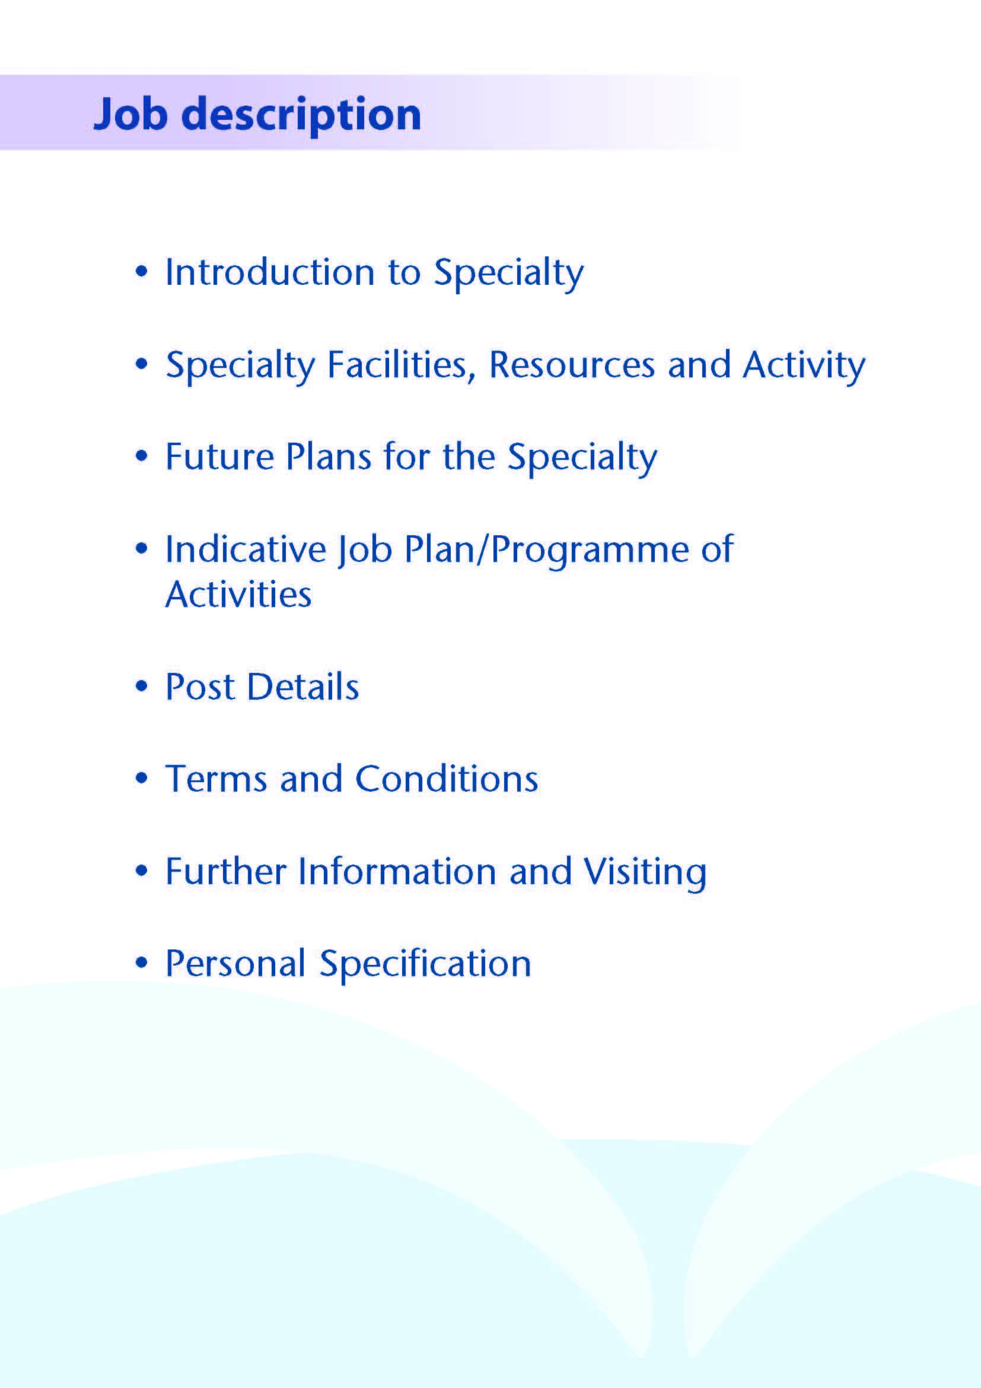



NHS Ayrshire and Arran has invested significantly in mental health service development over recent years following a major strategic review, and this has resulted in the creation of a 24 hour crisis service, expansion of primary care mental health services and new services for eating disorders. All acute psychiatric beds are now sited in our purpose-built inpatient unit, Woodland View, which opened on the Ayrshire Central Hospital campus in Irvine in 2016.

A vacancy has arisen for a dynamic Speciality Doctor in General Adult Psychiatry to join our Community Mental Health Team within the South Ayrshire Health & Social Care Partnership. The post involves impatient and community clinical work.

The successful candidate will work closely with the 3.0 WTE Consultant Psychiatrists and other members of the multidisciplinary team to provide high quality care and treatment to adults residing within South Ayrshire, encompassing both urban and rural settings.

The post holder will provide up to 10 programmed activities with responsibilities including in-patient and community assessment and treatment. The role will also include assessing and reviewing inpatients, outpatients via clinics, home visits if required, providing mental health and incapacity assessments and reports and contributing to under-and post-graduate teaching and training, as well as quality improvement and clinical governance activities. Continuing professional development and appraisal will be supported, in addition to candidates wishing to work towards a Certificate of Eligibility for Specialist Registration (CESR). The post holder requires a minimum of four years post-graduate psychiatry experience, in order to be able to be Section 22 approved for mental health act assessments.



Adult inpatient mental health services in Ayrshire are provided within our purpose built community hospital, Woodland View, with general adult (acute), elderly, continuing care, rehabilitation, IPCU and alcohol rehabilitation wards. There is a smaller unit providing elderly and rehabilitative services based on the Ailsa Hospital site in South Ayrshire.

There are three General Adult Community Mental Health Teams (CMHTs) in Ayrshire: North, East and South.

The North Ayrshire CMHT is based at the Three Towns Resource Centre in Saltcoats, and consists of:

5.0 Consultants

2-3 Core/GPST/F2 trainees

1 Higher Trainee

1 Nursing Team Leader

8.7 WTE Charge Nurses

11.6 WTE staff nurses

1 WTE Health Assistant

4.4 WTE Occupational Therapy

4.8 WTE Psychologists

9.21 WTE Admin staff

**Medical Staff Resources**

**Consultant Grade:**

**ADULT**

**North Locality**

Dr Anna Ulanova

Dr Everett Julyan

Dr Alison MacRae (North Community Clinical Director)

Dr Eilidh Orr

Dr McLean

**East Locality**

Dr Aileen Guthrie (East Community Clinical Director)

Dr Morag Henderson

Dr Y Nalci

Dr Swift

**South Locality**

Dr Adrian Nitu

Dr Tim Johnston

Dr Jacqui Scott (South Community Clinical Director)

**Rehabilitation**

Dr Kris

**Liaison**

Dr Debbie Brown (AMD)

Dr Malcolm Cameron

Dr Kim Newlands

**Psychotherapy**

Dr Steve Moorhead

**Forensic/IPCU**

Dr I McFarlane

Dr Dawn Carson

**Elderly**

Dr Susan Maxwell

Dr Dominic Gallagher

Dr Mark Luty (Clinical Director)

**CAMHS**

Dr Vytas Blazys (Clinical Director)

Dr Helen Smith (Clinical Director)

**Learning Disability**

Dr Claire Hughes (Clinical Director)

Dr Douglas Paterson

Dr Omer Rashid

**Addictions**

Dr Clare Duncan

Dr Karthik Kessavelou

Dr Beinn Wilson (Clinical Director)

Dr Caroline Woolston

**Non-consultant Grade:**

The consultant posts are supported by 6 Specialty Grade Doctors, approximately 14 junior trainees (FY2/ST1-3) and a varying number of Higher Trainees in Psychiatry (ST4-6)

**Administrative Support**

The post holder will have access to such general administrative support as is required for the discharge of his/her duties.

**Education**

Woodland View has its own library and training facilities on site for local Postgraduate teaching. Crosshouse and Ayr Hospitals have the Alexander Fleming Education Centre and MacDonald Education Centre, respectively. These facilities have well stocked libraries with good electronic facilities, a lecture theatre with state-of-the-art equipment and meeting rooms.

The post holder will be expected to participate in the local postgraduate psychiatric training programme and to be involved in the teaching of medical undergraduates.



A new national medium secure adolescent unit will be opening within the Woodland View Site.



The post will consist of 8 programmed activities. The nature and timing of activities shown in the timetable are indicative and the precise nature of the duties will be agreed with the successful candidate at a job planning meeting with the Clinical Director. Timetables will be reviewed to meet the changing needs of the service and post-holder, subject to discussion and job planning.

Flexible working (i.e. compressed hours) can also be considered for the suitable candidate.

|  |  |  |  |  |  |
| --- | --- | --- | --- | --- | --- |
|  | Mon | Tues | Wed | Thur | Fri |
| am | Clinical admin / In-patient reviews - ward round attendance | Clinical admin / MDT | Woodland View hospital – Ward round attendance | SPA / teaching | Woodland View review inpatients |
| pm | In-Patient reviews – Ward round attendance | CLINIC | CLINIC | Team Base | Woodland View / Admin |

* Option with agreement with CD for remote clinics

**Proposed Weekly Programme**

The proposed weekly programme is illustrated above (but flexible for change). Activities with current fixed time commitments will be carried out as detailed in the work programme, e.g. ward reviews and clinics.

In-patient role will require when suitability able to attend mental health act tribunals on behalf of the relevant RMO.

Clinical supervision will be provided by Consultant Psychiatrists when required, and educational supervision is timetabled. Details of other activities will be agreed with the post holder.

The job plan incorporates all the professional duties and commitments, including agreed Supporting Professional Activities.

Opportunities may exist for other activities to be undertaken subject to service requirements and the post-holder’s individual professional needs and preferences.

Administration: This activity covers the management of individual patients including outpatient administration, results reporting, letters/phone calls to patients, carers, GPs and members of the wider multidisciplinary team involved in patient care as well as medico-legal documents.

Travel: Any travel allocation will be included within the Total Programmed Activities and will be determined by location at which Direct Clinical Care and Supporting Professional Activities are carried out.

**Supporting professional activities and job plan review**

NHS Ayrshire and Arran recognise the important role job planning has in ensuring Speciality Doctors are supported in delivering high quality, safe, sustainable clinical care to patients. It is important, therefore, to ensure there is an adequate balance between direct clinical care activities and those activities which support both the personal and professional development of the consultant workforce and facilitates agreed contribution to activities including:

* Under- and post-graduate teaching and training
* Clinical Governance
* Quality Improvement and Patient Safety
* Research and innovation
* Service management and planning
* Work with professional bodies

All Speciality Doctors will have 1 SPA as a minimum to support CPD, job planning, appraisal and revalidation. However, the final balance of SPA and DCC activity will be agreed between the appointee and clinical manager prior to contracts being agreed.

There may be a requirement to vary the DCC outlined in the indicative timetable when the final balance of DCC and SPA is subsequently agreed. There may also be opportunities to contract for additional programmed activities subject to service requirements and in accordance with national terms and conditions of service.

If the post holder will be responsible for the formal training and supervision of post-graduates and undergraduates, a suitable additional allocation of SPA time will be made in accordance with national guidance.

Job plan review: New appointees will have an interim job plan review 3 months post commencement to review the balance previously agreed. The agreed job plans will include all the consultants’ professional duties and commitments, including agreed Supporting Professional Activities.    Thereafter job planning will be carried out annually as part of the Board’s job planning process.

Research: Research is encouraged and supported by an active Research and Development Committee. Appointees will be supported to develop research interests associated with their specialist interest.



The main duties and responsibilities of the posts include:

* Providing review and management of inpatients in collaboration with the relevant Consultant.
* Providing assessment, diagnosis and treatment of new and existing patients presenting to services as part of community clinics.
* Providing medical input to the multidisciplinary team as and when required
* Liaising with mental health colleagues across disciplines and with health and social care partners in support of comprehensive patient care
* Liaising with GPs and third sector agencies
* Acting as RMO for patients subject to mental health legislation
* Undertaking domiciliary visits and emergency assessments where appropriate
* Undertaking Mental Health Act/Adults with Incapacity Act work
* Providing medical input to the South Ayrshire Crisis Resolution Team
* Participation in the local psychiatric training programme
* Involvement in teaching and supervision of medical students and junior doctors (subject to job plan negotiation)
* Participation in medical audit and continuing professional development
* Compliance with NHS Ayrshire & Arran Clinical Governance policies
* Involvement in appraisal and job planning.



Terms and Conditions of Service are those determined by the Terms and Conditions of the New Consultant Grade (Scotland) as amended from time to time. The distance that a consultant can reside from the principal base hospital, where travel time is seen as more important than mileage, is subject to the agreement of the Medical Director.



For further information or to arrange an informal visit please contact **Dr Jacqueline Scott**, Clinical Director on **01292 513028**;



**POST OF : SPECIALITY DOCTOR IN GENERAL ADULT PSYCHIATRY**

## LOCATION : SOUTH AYRSHIRE CMHT (Ailsa, AYR)

## QUALIFICATIONS:

|  |  |
| --- | --- |
| ESSENTIAL | DESIRABLE |
| Full GMC Registration (with Licence to Practice) |  |
| A minimum of At least 4 years of post-graduation experience in psychiatry. | MRCPsych  (or part/equivalent) |
| Full Driving Licence | Section 22 approval under the Mental Health (Care and Treatment)(Scotland) Act 2003 – however must be eligible to apply |

|  |  |  |
| --- | --- | --- |
| **SKILLS/**  **KNOWLEDGE/**  **COMPETENCE** | **ESSENTIAL** | **DESIRABLE** |
| **General Experience** | Broad experience and knowledge in the field of psychiatry | Experienced in General Adult Psychiatry |
|  | Ability to communicate effectively with all levels of staff and patients | Training in a relevant psychotherapy, e.g. CBT, EMDR, DBT or MBT |
|  | Ability to work efficiently with good time management |  |
|  | IT literacy |  |
|  | Good record keeping skills |  |
| **Team Working** | Commitment to being an effective team player, establishing and maintaining patient-centred collaborative relationships |  |
|  | Ability to recognise value of and develop working relationships with partnership agencies |  |
|  | Willingness to contribute to development of the multidisciplinary partnership |  |
| **CPD** | Evidence of relevant Continuing Professional Development |  |
| **Teaching and Training** | Engagement with teaching and training | Interest in and knowledge of advances in medical education and training |
| **Research and Publications** |  | Evidence of publications in peer reviewed journals |
| **Clinical Audit** | Participation in regular medical audit |  |
| **Management and Administration** | Appropriate organisational skills |  |
| **Personal and Interpersonal Skills** | Flexibility to meet the changing needs of the service |  |
|  | Effective communicator and negotiator |  |
|  | Open and non-confrontational |  |
| **Professional values and practice** | Committed to practicing according to the GMC’s Good Medical Practice, and the RCPsych’s Good Psychiatric Practice |  |