

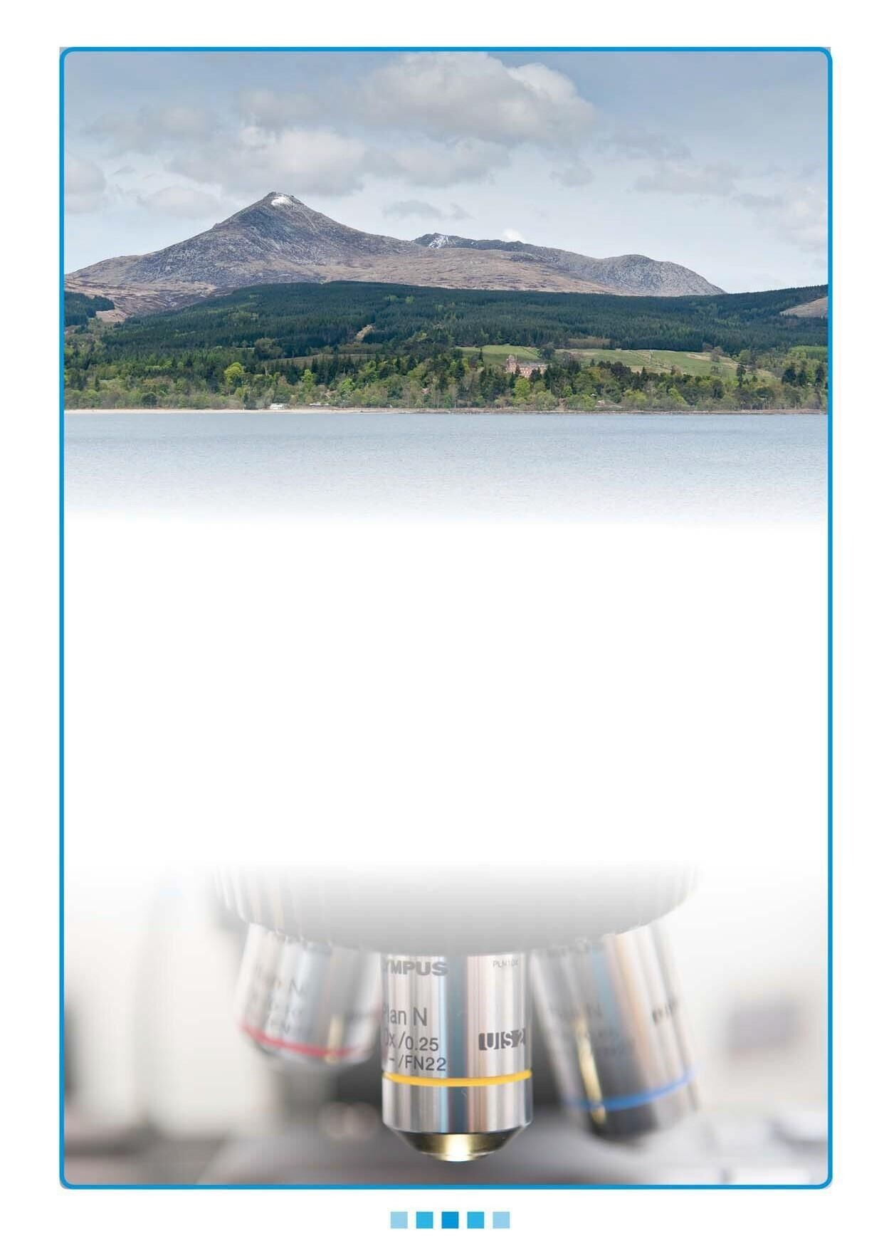

**Permanent**

**Consultant**

**Histopathologist**

**NHS Ayrshire & Arran**

**Permanent Consultant in Histopathology**

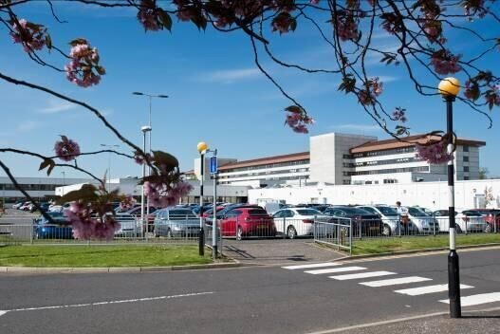

1. **Introduction**

Applications are invited for the post of Consultant Histopathologist based at the Area Laboratories, University Hospital Crosshouse, Kilmarnock.

We are looking for dynamic and enthusiastic individuals to join our friendly team of consultant histopathologists. Successful candidates will be able to report cases from a wide range of general surgical pathology practice including diagnostic cytology, although a degree of subspecialisation has also been introduced.

The role includes:

* Contribution to a consultant-led histopathology service.
* Participation in multi-disciplinary team meetings.
* Ensuring that the service continues to meet UKAS standards.

Our service has a reputation for being innovative and forward thinking. The post will appeal to suitably qualified persons who are enthusiastic and are looking for a stimulating and challenging career. We offer a professional environment where staff are encouraged to contribute and supported to develop services that put patient quality and safety first. Portfolio pathway formerly known as CESR (Certificate of Eligibility for Specialist Registration)route doctors are only eligible to apply for a permanent consultant post if they are registered on the GMC’s specialist register.

Any candidate who is unable for personal reasons to work full time will be eligible to be considered for the post. If such a person is appointed, modification of the job content will be discussed on a personal basis with the organisation in consultation with consultant colleagues.

Applications from UK, EU and non-EU candidates will be welcomed. If you are an international doctor from outside of the UK and Republic of Ireland, you can apply for medical posts that may qualify for sponsorship under a skilled worker visa.  A health and care worker visa allows health and care professionals to come to the UK to do an eligible job within the NHS. If you require a work visa, please seek further guidance on current immigration rules, which can be found on the UK government home office website.



**2. Living in the Area**

Situated in the South West of Scotland on the Firth of Clyde, Ayrshire is a scenic area with 80 miles of varied coastline. We are ideally placed, offering easy access to Glasgow, the national motorway network via the M77 and ferry services to West Coast Islands. There are excellent rail and bus links to Glasgow and elsewhere. Glasgow and Prestwick International airports are close by, providing access to the rest of the UK and beyond.

Ayrshire offers a variety of living environments. There are three main towns, Kilmarnock, Irvine and

Ayr, which provide plentiful shopping and leisure amenities and affordable housing. There are also many picturesque villages close to the hospital which offer a more relaxed rural environment. Nearby coastal Troon is a popular place to live. There are high quality state and private schools.

The area offers a wide variety of leisure opportunities. There are over 50 quality golf courses, including Turnberry and Royal Troon, the latter being the venue for the 2016 Open Golf Championship. There is access to sailing on the West Coast and islands. There are several fine beaches and abundant pleasant countryside for walking and cycling (see below). There are many good restaurants, country inns and hotels in the area, with high quality seafood a speciality.

The ferry port of Ardrossan, which is a twenty minute drive from University Hospital Crosshouse, is the departure site for the regular CalMac ferries to the Isle of Arran, a 55 minute crossing. This picturesque island is a popular weekend and holiday destination for walking, cycling, golfing and relaxing in beautiful surroundings. There are also ferries to Kintyre from Ardrossan and to Cumbrae from Largs.



Take a walk along the coast, find out more about our National Bard and see how it’s made. There are plenty of great things to do in Ayrshire & Arran, here are just a few of them:

* Culzean Castle & Country Park
* Dundonald Castle
* Dean Castle & Country Park
* Brodick Castle & Country Park
* Kelburn Castle & Country Estate
* Burns Monument Centre / Birthplace Museum / Burns Cottage / Souter Johnnies Cottage
* Crossraguel Abbey
* Dumfries House
* Vikingar
* The Isle of Arran Distillery & Visitor Centre
* The Scottish Maritime Museum
* Ayr Race Course
* Heads of Ayr Farm Park
* Dark Sky Observatory
* Walking – Ayrshire Coastal Path, The River Ayr Way, Ayr Gorge, The Smugglers Trail, Goat Fell
* Cycling -National Cycling Network Routes – 7, N73 / Mountain Bike Trails
* Regional Sports Facilities

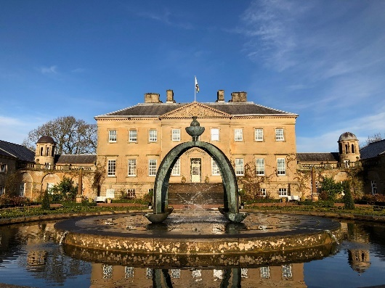

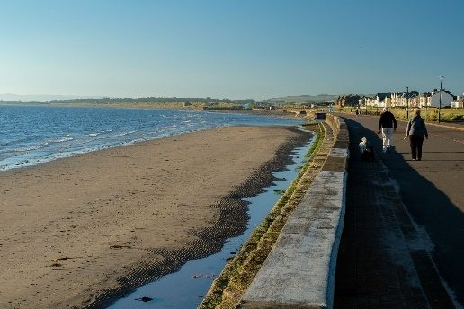

Find out more at: https://www.visitscotland.com/destinations-maps/ayrshire-arran/

https://www.visitscotland.com/ebrochures/en/what-to-see-and-do/ayrshireandarran/ http://www.exploreayrshire-arran.com/ http://whatsonayrshire.com/

http://www.visitsouthernscotland.co.uk/folder-21-ayrshire-and-arran http://www.craftscotland.org/visit-craft/ayrshire-arran/

For a more city-based lifestyle many staff choose to commute to Kilmarnock from the southern fringes of Glasgow and neighbouring East Renfrewshire. From these areas the hospital is a pleasant, approximately 30 minute motorway drive. This is usually relatively quiet against the busier traffic flow direction. There is also a direct bus service. South Glasgow and East Renfrewshire offer high quality housing, education and leisure facilities and easy access to nearby Silverburn shopping centre. There is easy access by road and public transport to Glasgow city centre, with all its cultural, shopping and sporting attractions. East Renfrewshire has the top-performing state schools in Scotland.

**3. Specialty Facilities, Resources and Activity**



**Laboratory Services**

The cellular pathology department is part of the area laboratory services for NHS Ayrshire and Arran and sits within the women, children and diagnostics directorate. This includes all laboratory disciplines in addition to medical imaging and medical physics. The directorate sits within the acute services division.

The management team is as follows –

Acute Services Director Medical Director

Acute site DirectorAssociate Medical Director

General Manager – Diagnostics Clinical Director for Laboratories

Cellular Pathology Lab Manager Head of Pathology Department

In addition, the laboratories have a quality manager.

NHS Ayrshire and Arran provides a comprehensive range of high quality health care services to a population of around 367,000. This is provided through General Practitioners, two acute hospital sites and a number of community hospitals.

**The Pathology Department**

The department has full UKAS accreditation and complies with ISO 15189 Standards. The service is delivered entirely from the main pathology laboratory in University Hospital Crosshouse. The department provides diagnostic histopathology, andrology, diagnostic cytology and autopsy services to the hospitals, community and Procurator Fiscal. The department also provides pathology services for the West of Scotland breast screening service and bowel cancer screening programme, as well as scientific support for the Intrauterine Insemination (IUI) service, which is HFEA licensed.

The workload includes a wide range of surgical and endoscopic specimens from all major specialties and consultant staff are actively involved in multidisciplinary team meetings in all the major cancer sites including breast, lung, upper GI, colorectal, urology, gynaecology, H&N and skin.

The department is currently using a workload allocation system based on the Warwick points- based system.

Small biopsies, skin specimens, etc are placed in a general pool from which they are allocated to consultants in sequence and according to available points, ensuring a good mix of small cases for pathologists. This aspect of work is not sub-specialised, with the exception of breast and colorectal screening specimens.

The role of Biomedical Scientist (BMS) staff in specimen dissection has been extensively developed and the service has a team of 5 fully trained and qualified dissectors, including two advanced practitioners. The role of the advanced practitioner includes triaging of specimen requests (urgent/routine/suitable for BMS dissection) and allocation of cases to pathologists. The team of BMS with dissection roles deal with 80% of specimens requiring any trimming; including orientated complex skin cancer excisions, breast cancer mastectomies, sentinel lymph nodes and hysterectomies. They also deal with sampling of fresh lymph nodes for molecular studies and preliminary handling of gastrointestinal and gynaecological malignancies.

The dissection team is highly motivated and enthusiastic. An excellent team spirit exists with the consultant staff and the dissection team are continually seeking development possibilities to assist the consultants.

The development of BMS dissection has led to a significant release of consultant pathologist time, which has allowed concentration on more challenging aspects of cases. This has changed the working practices of all levels of staff within the department, creating excellent teamwork, improved working relationships and ultimately providing the best possible service for our patients. Our advanced practitioners are part of a Scottish short life working group in the development of BMS dissection across the country. BMS staff from other areas have been seconded to University Hospital Crosshouse for dissection training.

The laboratory information management system uses Clinisys WinPath and the department utilises Q-Pulse as the Quality Management / document control system. Laboratory services have a working eHealth committee and have good working relations with the organisation’s Digital Services team. The laboratory has successfully implemented digital pathology using Philips Intellisite system. Currently, the department has three scanners with one of them for Mega slides.

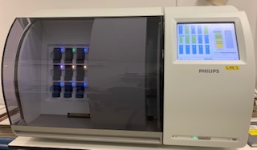

Each consultant has a workstation with two monitors, including HP Monitor EliteDisplay E273 27" and a 3d connexions mouse.

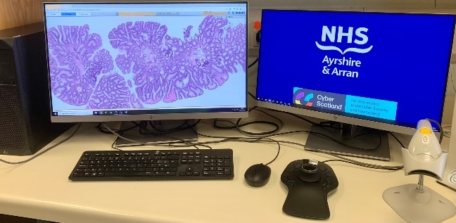

For remote working each consultant has a laptop with docking station, 3D connexions mouse and HP Elite display monitor. Established remote working guidelines are in place. The mortuary, consulting rooms, secretarial area and dissection room are all linked by a PC-based ‘hands-free’ dictation system using organisation wide ‘WinScribe’ software. Dragon voice recognition software is also widely in use by consultants. To support a move to paperlight working all request forms are scanned and available to view digitally with folding space. Microsoft teams is used widely throughout the organisation.

The histopathology laboratory is well equipped, with Peloris Tissue Processors, Leica embedding centres, Staining machines, Sakura Tissue –Tek Film automated cover-slipper and various microtomes.

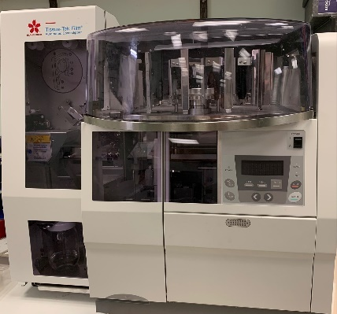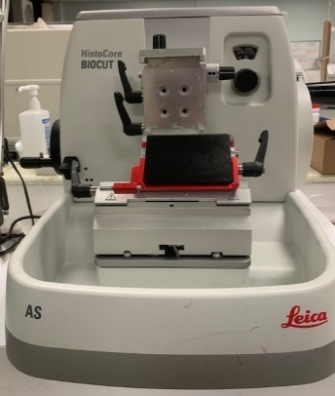

The department is able to process, cut and routinely stain large tissue blocks (mega-blocks) and digitally scan mega slides when needed.

The department has a dedicated modern dissection laboratory with adjustable height dissection tables and digital imaging system for photography of macroscopic specimens (Macropath).

There is a comprehensive repertoire of immunohistochemistry antibodies available with dedicated staff providing a high quality service. The department has three fully automated immunostainers, provided through a managed service contract. Immunofluorescence is performed on inflammatory skin biopsies and equipment for in-situ hybridisation is also available.

There is a full range of diagnostic cytology and seminal fluid examination. The diagnostic cytology service is currently undertaken by a team of five pathologists.

Adult autopsies are currently undertaken in the mortuary at University Hospital Crosshouse. In addition, NHS Ayrshire and Arran has a contract with the Crown Office to provide an adult autopsy service to the local Procurator Fiscal.

Molecular, paediatric pathology, electron microscopy, haematopathology and neuropathology services are provided on a regional basis in Glasgow.

There is a laboratory conference room with colour monitors, microscope projection system, digital projector and large screen facilities for meetings. Digital cameras are also available for macro- and micro-photography. There are modern teleconferencing facilities in this room and these are used extensively in both local and regional multidisciplinary team meetings. There are two multi-headed microscopes for departmental case consultation and teaching. The departmental library contains excellent selection of regularly updated text books. A spacious common room and kitchen facilities are available.

**Departmental workload in 2023/2024**

|  |  |
| --- | --- |
| **Nature of workload** | **Number of** |
| Surgical biopsies | 28,741 |
| Autopsies | 321 adult autopsies |
| Diagnostic cytology | 3083 |

**Consultant office accommodation and equipment**

There is ample office accommodation and secretarial support. Each office has appropriate furnishings, microscope and computer facilities. Each consultant has a work station with two monitors, including HP Monitor EliteDisplay E273 27", and a 3d connexions mouse.

**Staffing Establishment**

* 9 consultant pathologists
* 2 Advanced clinical pathology practitioner
* 17 whole time equivalent biomedical scientists
* 6.6 whole time equivalent MLA staff
* 2 APT
* 5 A&C staff

**4. Future Plans for the Speciality**

* The department plans to continue to develop BMS role extension.
* The department continues to develop the use of digital pathology and supports the validation

and routine clinical use of digital pathology for consultants.

* The department supports pathologists to spend some of their time reporting remotely.

* Pathologists within the department have been involved in AI research.

**5. Indicative Job Plan/Programme of Activities**



**Proposed weekly programme**

The proposed indicative weekly programme is shown below. Direct clinical care (DCC) and supporting professional activity (SPA) sessions are shown with indicative timings within the weekly programme but these will be discussed in detail with the individual appointee. The department recognises changing work-life balance desires of medical staff and has adopted a flexible approach to working time.

Job plan will be reviewed with the successful candidate no later than 3 months following appointment and where possible discussion may take place in advance of appointment. Job plan review thereafter will be no less frequent than annually. Agreed job plan will include all the consultant’s professional duties and commitments, including agreed SPA. Opportunities may arise for Extra Programmed Activities to be undertaken subject to service requirements and in accordance with national terms and conditions of service.

**Specialty:** Histopathology

**Principal place of work:** Pathology Department, University Hospital Crosshouse

**Contract:** Full time

**Total no. of programmed activities**: 10

Please see below an example of job plan.

|  |  |  |  |
| --- | --- | --- | --- |
| **Day** | **Hospital/Location** | **Activity** | **Total Hours per Activity** |
| Monday  09:00 – 13:00 | Pathology Department | DCC | 4 |
| 13:00 – 17:00 |  | DCC | 4 |
| Tuesday  09:00 – 13:00  13:00 – 17:00 | Pathology Department | SPA  DCC | 4  4 |
|  |  |  |  |
| Wednesday 09:00 – 13:00  13:00 – 17:00 | Pathology Department | DCC  DCC | 4  4 |
|  |  |  |  |
| Thursday  09:00 – 13:00 | Pathology Department | SPA | 4 |
| 13:00 – 17:00 |  | DCC | 4 |
| Friday  09:00 – 13:00  13:00 – 17:00 | Pathology Department | DCC  DCC | 4  4 |
|  |  |  |  |

The DCC activity comprises:-

Examination, reporting and authorisation of surgical biopsies including, as appropriate, specimen dissection; supervision of the work of biomedical scientific staff involved in specimen dissection; liaising in a timely manner with hospital staff and general practitioners in the diagnosis and management of patients; frozen section service provision at University Hospital Crosshouse; involvement in multidisciplinary team meetings as appropriate.

**Notes on the Programme**

**Travel:** Any travel allocation will be included within the Total Programmed Activities and will be determined by location at which DCC and SPA are carried out.

**On-call arrangement**: This post does not include an on-call commitment.

**Supporting Professional Activities (SPAs)**: NHS Ayrshire and Arran recognises the important role job planning has in ensuring consultants are supported in delivering high quality, safe, sustainable care to patients. It is therefore important to ensure there is an adequate balance between direct clinical care activities and activities which support both the personal and professional development of the consultant workforce and service development. These activities include: • Job planning, appraisal, revalidation, continuing professional development (CPD​) • Under and post graduate teaching/training. • Clinical Governance. • Research and innovation. • Service management and planning. • Work with professional bodies. 2 SPAs can be provided flexibly and will be agreed between the appointee and the Clinical Director/Associate Medical Director prior to contracts being agreed.

**Research**: Research is encouraged and supported by an active Research and Development Committee. The appointee will be encouraged to develop research interests associated with their specialist interest.

**Private Practice**: If the post holder wishes to undertake any private practice, he/she is obliged to inform their employer at the time of appointment of their intention to do so. This should be submitted in writing to the Medical Director. The post holder shall be free to undertake private practice without approval provided such work is undertaken outside the time agreed in the job plan for programmed activities. (Refer Section 6 of the New Consultant Contract).

**6. The Post- Consultant Histopathologist**



The post holder will be accountable to the Clinical Director who will agree the job plan.

They will be expected to work with local managers and professional colleagues in the efficient running of services and will share with consultant colleagues in the medical contribution to management. Subject to the provisions of the Terms and Conditions of Service, they will be expected to observe NHS Ayrshire and Arran’s agreed policies and procedures, drawn up in consultation with the profession on clinical matters, and to follow the standing orders and financial instructions of NHS Ayrshire and Arran. In particular, where the post holder formally manages employees of NHS Ayrshire and Arran, they will be expected to follow the Local and National Employment and Personnel Policies and Procedures. The post holder is required to comply with NHS Ayrshire and Arran’s Health and Safety Policies.

**Qualifications and experience**

Applicants must hold full GMC registration, including a current licence to practice. Applicants must also be on the specialist register of the GMC or be within 6 months of the anticipated award of a CCT in histopathology at the time of interview. CESR route doctors are only eligible to apply for a permanent consultant post once CESR is awarded.

**Duties and responsibilities**

The appointee will, together with other consultant colleagues, be responsible for the provision of a comprehensive and efficient diagnostic pathology service to the organisation and other users of the service.

**Laboratory:**

All consultants will be expected to contribute to the following:

* Day-to-day supervision of diagnostic methods and examination of specimens.
* Authorisation and interpretation of results.
* Involvement in policy and Standard Operating Procedure (SOP) preparation.
* Quality assurance performance within the department, including taking part in all relevant

national external quality assurance (NEQAS) programmes.

* Achieving and maintaining full accreditation with UKAS.
* Business planning, including the assessment and introduction of new methods, and forward

planning for staff and equipment requirements.

* The appointee should comply with health and safety and security requirements and with agreed

SOPs and investigational algorithms.

**Clinical Governance and Audit**

The appointee will be expected to participate in pathology and multidisciplinary clinical audit, clinical governance meetings and relevant national quality assurance programmes.

**Teaching and training**

The department participates in the West of Scotland training programme for pathology trainees. Currently, two pathology trainees rotate every six months at University Hospital Crosshouse. There is a dedicated room for trainees which includes similar facilities to the consultants including microscope, computer and work station with two monitors, including HP Monitor EliteDisplay E273 27" and a 3d connexions mouse for each trainee. The department is also accredited for training of BMS staff. There is an in-service CPD programme for all BMS staff in the department. There is an opportunity to participate in undergraduate teaching for medical students, Glasgow University.

**Research and development**

There are multiple opportunities for developing R&D within the department.

**Professional**

The appointee will be expected to be registered for CPD with The Royal College of Pathologists (or equivalent body,) and to fulfil requirements for annual certification and for appropriate revalidation. Participation in relevant EQA schemes will be expected. Time, facilities and financial support for study leave and CPD are available.

**Annual appraisal and job planning**

The post holder will be required to participate in annual appraisal. Job planning is linked closely with, but is separate from, the agreed appraisal scheme for consultants. The job plan review will take into account the outcome of the appraisal discussion and include objectives which reflect the agreed personal development plan.



**7. Terms and Conditions of Service**

Are those determined by the Terms and Conditions of the New Consultant Grade (Scotland) as amended from time to time. The distance that a consultant can reside from the principal base Hospital, where travel time is seen as more important than mileage, is subject in principle to the agreement of the Medical Director.

Applicants wishing further information about the post are invited to contact:



**8. Further Information and Visiting**

* Dr Maha Elgoweini, Head of pathology department

(maha.elgoweini@aapct.scot.nhs.uk), tel: 01563 827432.

* The Joint clinical directors:

Dr Lorna Cottrell (lorna.cottrell@aapct.scot.nhs.uk), tel: 01563 827432

Dr Scott Blackwell (scott.blackwell@aapct.scot.nhs.uk), tel: 01563 827409.

* Dr Suzanne MacKenzie, Associate medical director

(suzanne.mackenzie@aapct.scot.nhs.uk), tel: 01563 827401.

* Debbi McEwan, General manager – Diagnostics

(debbi.mcewan@aapct.scot.nhs.uk), tel: 01563 826174.

Visits (Virtual or in person) to the department to meet the team and discuss the post are

welcomed and encouraged.

**Post: Permanent Consultant in Histopathology**

**Location: University Hospital Crosshouse**

**Qualifications**

|  |  |
| --- | --- |
| **Essential** | **Desirable** |
| Full GMC registration with a current licence to practice. | FRCPath |
| Existing Consultants: On the GMC Specialist Register (Histopathology).    New Consultants:  On the Specialist Register or be within 6 months of the  anticipated award of a CCT in Histopathology at the time of interview for the post.  Portfolio pathway formerly known as CESR (Certificate of Eligibility for Specialist Registration) route doctors are only eligible to apply for a permanent consultant post if they are registered on the GMC’s specialist register. |  |

**Skills/Knowledge/Competence**

|  |  |  |  |
| --- | --- | --- | --- |
| **Requirements** | **Essential** | | **Desirable** |
| **General**  **Histopathology**  **Experience** | • Broad based experience in Histopathology.    • Experience in dealing with excision/resection specimens from one or more of the following key diagnostic areas – breast, colorectal, urology, skin, H&N and gynaecology.  • Ability to work efficiently and  timeously to facilitate effective  patient management. | | • Possession of, or capability to develop, a specialist interest to complement the existing areas of expertise within the department.  • Higher Autopsy Training (CHAT) or equivalent. |
| **Team Working** | • Ability to work in a multidisciplinary team environment.  • Ability to work effectively and cooperatively within a pathology consultants’ team. | |  |
| **Teaching & Training** |  | • Ability to deliver high quality  Teaching. | • Interest in medical  education and training. | |
| **Research & Publications** |  |  | • Evidence of publications  relating to specialty. | |
| **Clinical Audit** | • | Evidence of interest and experience in medical audit. |  | |
| **Management &**  **Administration** | • | Commitment to effective departmental management in conjunction with department colleagues. |  | |
|  | • | Good organisational skills. |  | |
| **Personal & Interpersonal**  **skills** | • | Willingness to accept flexibility to meet the changing needs of the NHS in Scotland. |  | |
|  | • | Ability to communicate effectively with clinical colleagues, scientific staff and secretarial staff. |  | |
|  |  |  |  | |