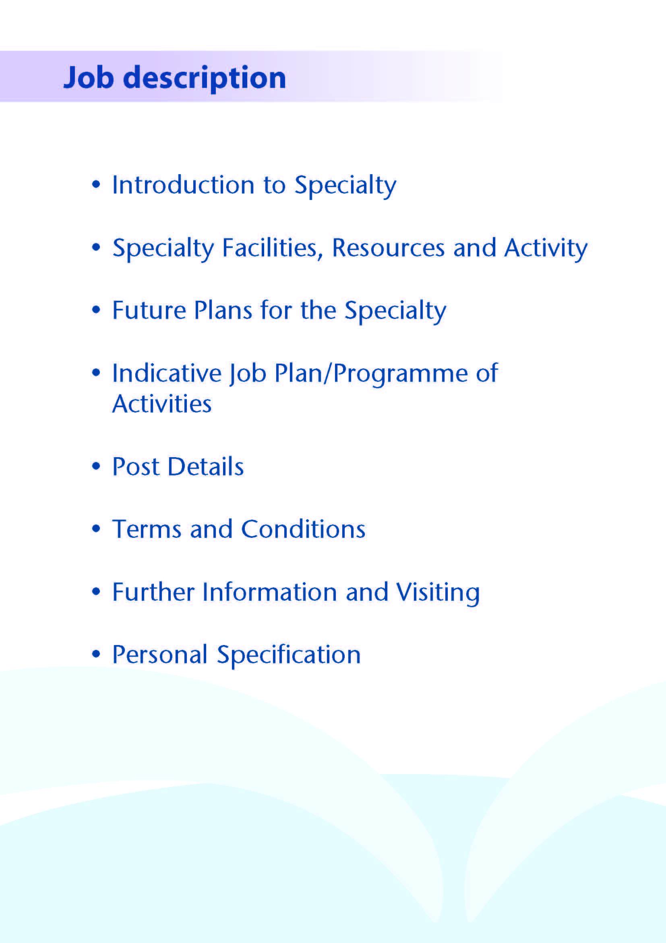



This post will complement the current team of 8 Consultant Haematologists, 1 speciality registrar, 4 clinical fellows and 3 FY1/FY2 doctors to support the delivery and development of clinical and laboratory Haematology services within Ayrshire.

The post is based within both Surgical and Diagnostic Services of NHS Ayrshire & Arran at University Hospital Crosshouse (UHC), near Kilmarnock. The successful candidate will work with consultant colleagues between UHC, and the Kyle Unit at University Hospital Ayr (UHA). The Haematology Department provides an area-wide clinical and laboratory service to all inpatient areas, primary care and community services. The population of Ayrshire is approximately 388,000.

This is a new post created due to increasing demands on the Haematology service. The post will involve all aspects of clinical haematology with the majority of the work load malignant. Career development will be supported. There is potential to develop a sub-speciality interest to complement those already offered within the department.

**Area Laboratory Service**

The Area Laboratory Service is based within UHC in a large integrated laboratory complex providing Pathology, Biochemistry, and Microbiology services in addition to Haematology and Blood Transfusion.

The Haematology and Blood Transfusion Departments provide a wide range of services including routine haematology, coagulation studies, bioassays, blood transfusion and blood products. UHC is a large District General Hospital of over 400 beds with a comprehensive range of medical and surgical services including an area renal service, ICU, and modern Emergency Department with an adjacent 46 bed Combined Assessment Unit. There is also an on-site maternity and neonatal unit at UHC with approximately 5000 deliveries per year. Paediatric services, head and neck, acute stroke and orthopaedic trauma are centralised on the University Hospital Crosshouse site.

There is also a busy satellite laboratory at UHA (18 miles south) providing general haematology, coagulation, and blood transfusion services. UHA is also a busy DGH with over 250 beds, again providing comprehensive medical and surgical services, and a modern Emergency Department with an adjacent Combined Assessment Unit.

The laboratory participates in all relevant NEQAS schemes and is fully accredited by UKAS. The department is also accredited for higher medical training in haematology and generally has one or two specialist registrars on rotation from the West of Scotland Deanery. Close links are maintained with tertiary referral centres and specialist departments through links with the NHS Greater Glasgow teaching hospitals and the Regional Blood Transfusion Service.



**Clinical Haematology Services**

Clinical Haematology services are provided both at UHC for North and East Ayrshire and at University Hospital Ayr (UHA) for South Ayrshire. It is expected that the appointee would work principally from the UHC site although some duties (outpatient/day-case) may be covered on both sites.

Inpatient beds are available on the UHC site, and both hospitals run general Haematology, and Haemato-Oncology outpatient clinics. UHC has a combined Oncology / Haematology inpatient unit with 14 beds and a busy day-case unit. New off-site facilities are also provided at UHA for low risk/supportive treatments, this was developed as a response to the Covid19 pandemic to ensure safe patient flow outwith the acute site. Both sites are large busy District General Hospitals providing a comprehensive range of services requiring frequent clinical haematological input.

Clinical Haematology services are organised from within the Surgical Directorate from where the budget is managed. Junior medical support consists an FY1 and FY2 at UHC who take part in Acute Medical receiving, a Clinical Teaching Fellow and Clinical Development Fellow in Haematology on each site. A Specialist Doctor in oncology is also available at UHC. NHS Greater Glasgow provide consultant oncologist support for breast, urology, lung and colorectal/upper GI tumour types. Anticoagulant clinics are held daily at various locations delivered by anticoagulant pharmacists and nurses, utilising the Dawn management system

Weekly Multidisciplinary Team Meetings (MDT) include all consultant Haematologists supported by Consultant Pathologist and Radiologists. The department participates in the West of Scotland regional MDT via teleconference on a weekly basis. This is now followed by the National CAR-T MDT. The Haemato-Oncology service is supported by 3 full-time haematology clinical nurse specialists who works across both sites, and by dedicated pharmacy and AHP services. There are also close links with the palliative care service, based at the Ayrshire Hospice.

UHC receives medical students (years 1-5) from The University of Glasgow Medical School, and the postholder would be expected to devote some of his / her SPA time to undergraduate teaching activities. Postgraduate teaching is coordinated by Dr Hugh Neil, Director of Medical Education.

There is a Haematology education meeting on a Friday lunch time where all grades of doctor participate. We have recently invested money in a new multi-header microscope and TV monitor to aid laboratory teaching.

**Medical Staff Resources**

The staffing of the Haematology Department is as follows:

|  |  |
| --- | --- |
| *Consultant* | *Departmental responsibility* |
| Dr Peter Maclean | Clinical Director, Cancer Services |
| Dr Fiona Cutler | SACT Lead - local and regional clinical lead |
| Dr Fiona Nicholson | Clinical Lead Haematology |
| Dr William Gordon | Education lead |
| Dr Ian Devanny | Anticoagulation and training lead |
| Samantha Duncan | Transfusion lead |
| Dr Dean Smyth | Laboratory lead |
| Vacancy |  |

Biomedical scientist staffing consists of:

Haematology Lab Manager                                                   1.0 WTE

Lead Scientist Haematology 1.0 WTE

Lead Scientist Blood Transfusion                                           1.0 WTE

Chief BMS Special Haematology/Immunology 1.0 WTE

Senior BMS 7.6 WTE

Specialist BMS   16.3 WTE

BMS/Trainee BMS                                               7.0 WTE

Quality manager (multidisciplinary)       0.25 WTE

MLA                                                            14.3 WTE

Administrative staff                        6.5 WTE

**Clinical Activity**

Clinical Haematology is managed by the Surgical Directorate which includes Cancer Services. There is considerable activity in all areas with recent workload figures shown below:

|  |  |  |  |  |  |
| --- | --- | --- | --- | --- | --- |
| Haematology Activity | **2016/17** | **2017/18** | **2018/19** | **2019/20** | **2020/21**  **(**Pandemic**)** |
| Outpatients attendances | 29433 | 23970 | 23543 | 31737 | 42577 |
| New Outpatients | 821 | 674 | 651 | 696 | 383 |
| Day Cases | 4047 | 4741 | 4928 | 5642 | 4074 |
| Inpatients | 263 | 155 | 197 | 129 | 82 |

Laboratory Haematology and Blood Transfusion are part of the Women, Children and Diagnostics Directorate and the laboratory budget is managed by them.



The Haematology Department is a participant in a wider review of Chemotherapy Services within the West of Scotland Cancer Network. The Health Board has approved a WoSCAN review recommendation to reorganise chemotherapy services such that there will be one primary site for chemotherapy prescribing, complex chemotherapy delivery and inpatient Haematology inpatient services, while at least one other site will provide low risk day case SACT delivery. The specific configuration of the future service is still to be confirmed, but work is in progress to take this forward. This reorganisation is an excellent opportunity to develop a suite of inpatient and day-case facilities to match ongoing developments in the safe and effective delivery of chemotherapy. The department has pioneered online methods for pre-chemotherapy clinical assessment within Haematology with plans to extend this to other tumour types.



# Clinical activity within the post

Clinical duties will include outpatient clinics, on treatment clinics, haematology day unit cover and hospital liaison. The appointee will also be expected to participate in the bone marrow lists on a rotational basis. Training will be given to those not competent in this skill. Some clinical activities may be based at the Kyle Unit Ailsa Hospital, Ayr. This would not be expected to comprise more than 20% of the role.

# Proposed Weekly Programme

The job plan will initially be balanced at 9 DCC to 1 SPA.

As this is a new post the exact job plan will be agreed with the successful candidate.

A 10 PA contract this will approximately equate to the following;

7 clinical sessions comprising clinics, on treatment clinics, bone marrow biopsy list, day unit cover and hospital liaison

1 session for MDT

1 clinical administration

1 session for supporting professional activity

**Template Job plan**

Based on Monday to Friday 9-5pm

|  |  |  |
| --- | --- | --- |
| **Day** | **AM** | **PM** |
| Monday | Admin | Clinical duty |
| Tuesday | MDT | Clinical duty |
| Wednesday | Clinical duty | Clinical duty |
| Thursday | Clinical duty | Clinical duty |
| Friday | Clinical duty | SPA |

The job plan will be reviewed with the successful candidate no later than 3 months following appointment and where possible discussion may take place in advance of appointment. Job plan review thereafter will be no less frequent than annually.

The agreed job plan will include all the appointee’s professional duties and commitments, including agreed Supporting Professional Activity.

**Notes on the Programme**

**Patient Administration**. This activity covers the management of individual patients including Out Patient administration, results reporting, letters/phone calls to patients, carers, GP’S and members of the wider multidisciplinary team involved in the patients care.

**Travel:** Any travel allocation will be included within the Total Programmed Activities and will be determined by location at which Direct Clinical Care and Supporting Professional activities are carried out.

**Supporting Professional Activities**: NHS Ayrshire and Arran recognise the important role Job Planning has in ensuring doctors are supported in delivering high quality, safe, sustainable clinical care to patients. It is therefore important to ensure there is an adequate balance between direct clinical care activities and activities which support both the personal and professional development of the medical workforce and facilitates agreed contribution to activities including:

* Under and post graduate teaching/training
* Clinical Governance
* Quality and Patient Safety
* Research and Innovation
* Service management and planning
* Work with professional bodies

All specialty doctors will have 1 SPA as a minimum to support job planning, appraisal and revalidation. However the final balance of SPA and DCC activity will be agreed between the appointee and clinical manager prior to contracts being agreed.

There may be a requirement to vary the DCC outlined in the indicative timetable at section 4 when the final balance of DCC and SPA is subsequently agreed.



**Duties and Responsibilities**

The main duties and responsibilities of the post include:

* Carrying out teaching as required, and for contributing to undergraduate andpostgraduate medical education. The post holder will be expected to comply with College recommendations on Continuing Medical Education.
* The post holder will be required to comply with NHS Ayrshire and Arran’s Policies on Clinical Governance.
* The successful applicant will be encouraged to participate in research and to develop a relevant subspecialty interest, subject to resources and local priorities.
* Requirements to participate in medical audit and in continuing medical education.
* Managerial responsibilities (where appropriate).

You shall integrate with other middle grade staff in the day-to-day service and commitments of the department. Accordingly, the duties would be flexible and rotate between team members.

All members of the department participate in weekly meetings which may combine audit review or case discussions with our radiological and pathological colleagues.

You will be accountable to the Clinical Director who will agree the weekly timetable.

**Annual Appraisal**

You shall be required to participate in annual appraisal and agree a personal development plan.



The terms and conditions of service applicable to this appointment are the Specialty Doctor Terms and Conditions of Service (Scotland) 2008 as amended from time to time. NHS Ayrshire & Arran will require the post holder to agree with the Lead Clinician and General Manager, a job plan of fixed and other commitments, which will be reviewed on an annual basis and revised as necessary to meet the requirements of the local and national service issues.

Specialty Doctors will be required to participate in an annual appraisal. Formal appointment to this post will be conditional upon satisfactory completion of all pre-employment checks, including satisfactory medical screening.

On commencement of employment, salary will be determined in accordance with Schedule 14 of the terms and conditions of service. This appointment will be superannuable under the NHS Superannuation Scheme. New employees will automatically be enrolled in the scheme unless they opt out. For further information, please contact the Scottish Public Pensions Agency (SPPA) on 01896 893100 or visit www.sppa.gov.uk.

The employment is subject to three calendar months’ notice on either side.



Applicants wishing further information about the post are invited to contact Dr Peter MacLean, Clinical Director peter.maclean@aapct.scot.nhs.uk or Dr Fiona Nicholson fiona.nicholson@aapct.scot.nhs.uk with whom visiting arrangements can also be made.



**Post of**: Specialty Doctor in Haematology

**Location**: University Hospital Crosshouse

**Qualifications:**

|  |  |
| --- | --- |
| **Essential** | **Desirable** |
| * MBChB/MBBS or equivalent medical qualification | * MRCP or equivalent |
| * Full GMC Registration with a Licence to Practice at time of appointment * Evidence of achievement of Foundation competences by time of appointment in line with GMC standards/ Good Medical Practice including:   + Good clinical care   + Maintaining good medical practice   + Good relationships and communication with patients   + Good working relationships with colleagues   + Good teaching and training   + Professional behaviour and probity   + Delivery of good acute clinical care * Completion of a minimum of 4 years full-time postgraduate training (or its equivalent gained on a less than full-time or flexible basis) at least two of which will be in a specialty training programme or specialty registrar locum appointment for training (LAT); or shall have equivalent training, experience or competencies, either in the UK or overseas. * Eligibility to work in the UK | * Previous experience in clinical Haematology . |

**Skills/Knowledge/Competence**

|  |  |  |
| --- | --- | --- |
| **Requirements** | **Essential** | **Desirable** |
| **General Experience:**   * Expertise in generalist field | * Strong basic medical and haematological knowledge commensurate with completion of general medical training * Ability to deal with acute medical problems with indirect supervision * Ability to communicate effectively with all levels of staff and patients * Ability to work efficiently and timeously * IT literacy | * Specialist knowledge of Haematology |
| **Team Working** | * Effective Team Player |  |
| **Development** | * Evidence of relevant Continuing Professional Development * Ability to provide a complete employment history * Evidence of satisfactory career progression * No unexplained career breaks |  |
| **Teaching & Training** |  | * Experience of small group teaching of undergraduates |
| **Research & Publications** |  | * Evidence of publications. |
| **Clinical Audit** | * Evidence of participation in audit |  |
| **Management and Administration** | * Proven organisational skills   All applicants to have demonstrable skills in written and spoken English adequate to enable effective communication about medical topics with patients and colleagues demonstrated by one of the following:   * + a) that applicants have undertaken undergraduate medical training in English; or   + b) have the following scores in the academic lnternational English Language Testing System (IELTS) – Overall 7, Speaking 7, Listening 6, Reading 6, Writing 6. * If applicants believe they have adequate communication skills but do not fit into one of these examples they must provide supporting evidence | * Understanding of resource management and quality assurance. |
| **Personal and Interpersonal Skills** | * A willingness to accept flexibility to meet the changing needs of the NHS in Scotland * Effective communicator * Open and non-confrontational | * Knowledge of recent changes in the NHS in Scotland |