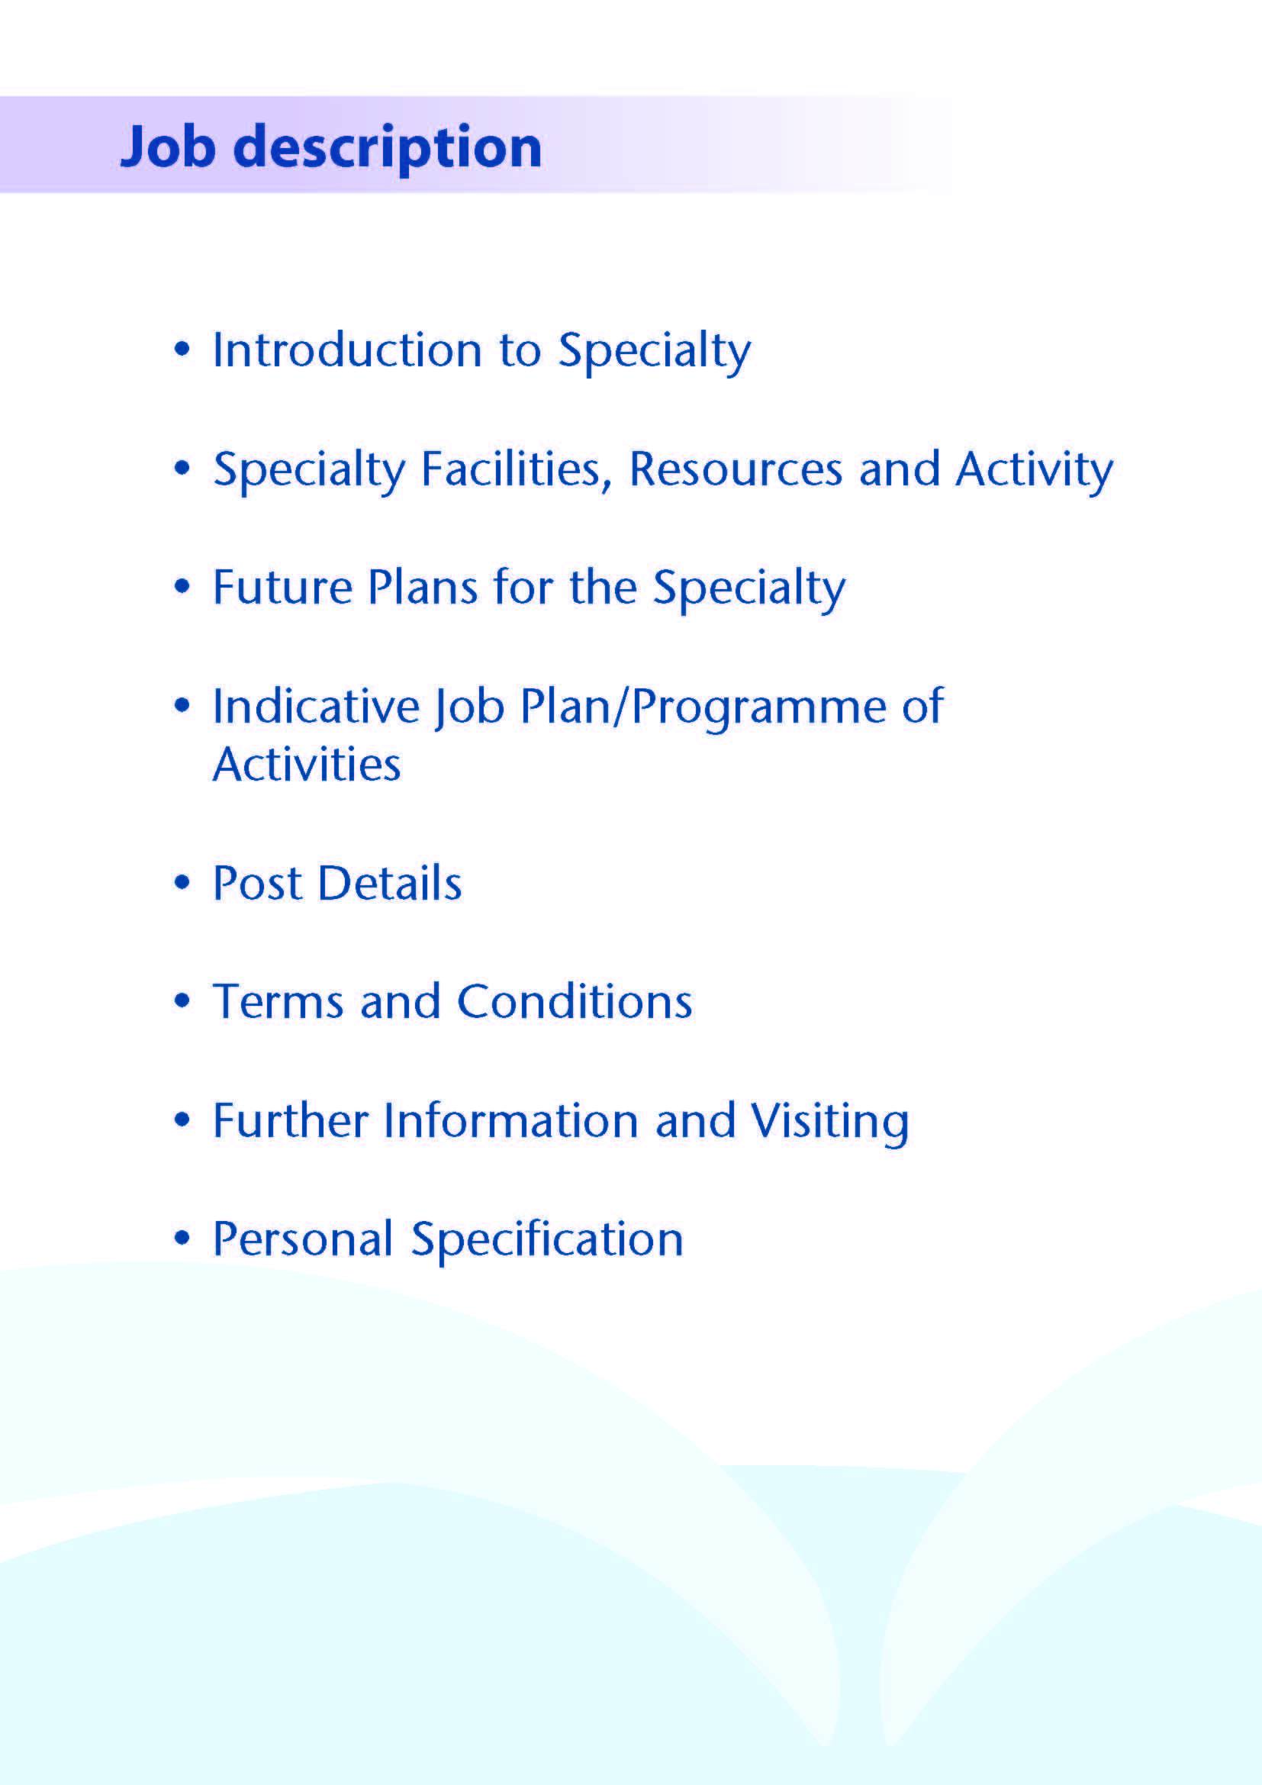



We are excited to advertise this consultant with expertise in robotic surgery post within NHS Ayrshire and Arran’s (NHSAA) Urology Directorate at University Hospital Ayr (UHA). The post will a central role in developing robotic urological surgery in NHSAA whilst supporting the overall urology workload in the Board. The successful candidate will join the team of five other consultant urologists, two Specialty Doctors, two Specialist Registrars, two CT trainees and a Clinical Development Fellow. We have plans to recruit to the full complement of 7 WTE consultants within the next 12-18 months.

UHA is a relatively new general hospital, opened in 1991 and has a range of laboratory and investigative facilities. The hospital provides care in elective orthopaedics, elective and emergency general surgery, limited elective vascular surgery and ophthalmology. Inpatient urology care for NHSAA is currently centralised at UHA although some inpatient care will be provided at University Hospital Crosshouse (UHC) in future as a result of the development of the robotic assisted surgery programme. The medical directorate provides care in all aspects of general medicine and cardiology. There is a 24-hour Emergency Department with care led by consultants in emergency medicine.

The Urology Unit has 23 adult beds and access to the rapid assessment area and combined access unit for emergency admissions. The service serves NHSAA’s population of 367,000.

The appointee will participate in the on-call urology rota on a one in seven basis with prospective cover, supported by a middle grade on call rota, and hospital at night team. On call work is very manageable, and all elective work is cancelled during on call commitments. We have a consultant of the week system for on call work and ward cover, on a one in seven basis.

NHSAA have recently purchased a dual console robotic assistant surgical system. This system is based at University Hospital Crosshouse and will be used for urology (upper tract and pelvic oncology), colorectal and gynaecology patients and is an exciting addition to our services.



**Facilities**

University Hospital Ayr has five main theatres largely dedicated to inpatient care, one interventional theatre and one further theatre which is equipped for both interventional and general surgical procedures. There are an additional three theatres within the Day Surgery Unit. The Ballochmyle Suite is a separate diagnostic suite, which is predominantly used by urology services. The following is a breakdown of the bed complement.

|  |  |
| --- | --- |
| Combined Assessment Unit including Medical High Care | 29 |
| ICU / HDU | 8 |
| Cardiology | 24 |
| General Medicine | 96 |
| General Surgery | 39 |
| Geriatric Medicine | 24 |
| Haematology | 3 |
| Ophthalmology | 2 |
| Elective Orthopaedics | 22 |
| Urology | 23 |

In addition there is a Day Surgery Unit which operates until 8pm, Monday to Friday.

***University Hospital Ayr has excellent support facilities, which include:***

# Imaging

The facilities in the department include CT and MRI scanning, Nuclear Medicine including radio-isotope facilities and digital subtraction angiography. The radiology Service also provides a full range of interventional uro-radiology

A mobile DSA imaging machine and image intensification is also available in theatre.

**Theatre Suite**

The theatre suite at present contains five theatres largely dedicated to inpatient care. In addition there is one interventional theatre dedicated solely to interventional work with one further theatre equipped for both interventional and general surgical procedures. There is also a purpose built Day Surgery Unit which contains an additional three theatres.

**Ballochmyle Suite**

The Ballochmyle Suite which is used predominantly by the urology team and offers outpatient and diagnostic facilities. Outpatient diagnostic clinics are held, offering patients a ‘one stop visit’ to the hospital.

# Emergency Department

This ED is staffed by a team of consultants in Emergency Medicine, which is supported by a full hierarchy of junior staff and a multi-disciplinary team.

# The Macdonald Education Centre

This is an excellent postgraduate education facility with a full size lecture theatre, classrooms and a number of tutorial rooms. The facilities are supported with modern audio visual and information technology and the centre incorporates an excellent up-to-date library.

# Medical photography

The Medical Illustrations Department can provide a full service for clinical photography, preparation of slides, PowerPoint etc, for lecture purposes.

# Nurse Specialist Services

There are a number of Urology Specialist Nurses including three in uro-oncology, and three in continence care and two job share physiotherapists.

**Advanced Nurse Practitioners**

The Department has three ANPs delivering routine haematuria assessments and flexible cystoscopy work, in addition to procedures such as stent removal, botox injections and TRUS biopsy.

**Medical Staff Resources**

|  |  |  |
| --- | --- | --- |
| **Consultant Staff - Urology** | **Base** | **Sub Specialty Interest** |
| Miss Jennifer Jones | University Hospital Ayr | Pelvic oncology, female and reconstructive urology |
| Mr B Little | University Hospital Ayr | Lap renal surgery, laser prostate surgery and prostate diagnostics |
| Mr R Clark | University Hospital Ayr | Lap renal surgery, stones and prostate diagnostics |
| Ms H Bekarma | University Hospital Ayr | Female Urology |
| Mrs Lynne Kerr | University Hospital Ayr | Stone Disease |
| Vacancy (This Post) | University Hospital Ayr | Robotic pelvic oncology |
| Vacancy | University Hospital Ayr | TBC |

|  |  |
| --- | --- |
| **Specialty Doctor** | **Base** |
| 1.00 wte | University Hospital Ayr |

|  |  |
| --- | --- |
| **Specialty Trainees** |  |
| 2 Specialty Trainees from the West of Scotland Training Programme in Urology | University Hospital Ayr |

|  |  |
| --- | --- |
| **SHOs** | **Base** |
| 2 CT Trainees | University Hospital Ayr |
| I Clinical Development Fellow | University Hospital Ayr |

**Activity (average per annum):**

|  |  |
| --- | --- |
| **Inpatients**  **Day cases** | 2166 per annum  2795 per annum |
| Outpatients New  Return | 5,202  13,448 (includes all nurse led work) |



The Urology Unit in NHSAA is proactive and forward thinking and accommodates colleagues with a number of subspecialty interests.

We offer Artemis diagnostic prostate biopsy work, subspecialty female urology work, laser surgery for BPH and of course the full range of core urological procedures. We offer a full range of treatments for stone disease and are keen to establish a metabolic stone service moving forward.

The successful candidate will be the lead surgeon for robotic assisted pelvic oncology for the urology department in NHSAA and will work with other specialties (colorectal and gynaecology) as we grow the robotic assisted surgical program.

Going forward, the unit is fully engaged in the West of Scotland regional planning group, and the provision urology services within the region and the development of collaborative working with other units.



# Proposed Weekly Programme

The proposed weekly programme is shown below. Activities with current fixed time commitments will be carried out as detailed in the work programme e.g. clinics. Other DCC and SPA activities are shown with indicative timings within the weekly programme and will be discussed with the appointee.

**Notes on the Programme**

**Patient Administration**: This activity covers the management of individual patients including Out Patient administration, results reporting, letters/phone calls to patients, carers, GP’S and members of the wider multidisciplinary team involved in the patients care.

**Ward Rounds**: The time allocated is indicative and will be discussed with the appointee. Ward work will include teaching ward rounds as required.

**Travel:** Any travel allocation will be included within the Total Programmed Activities and will be determined by location at which Direct Clinical Care and Supporting Professional activities are carried out.

**On call arrangements:** The postholder will participate in the Urology on-call rota on a 1:7 basis with prospective cover. Clinical commitments are cancelled during on call periods.

5 hours per week have been included within the allocation of DCC to recognise the predictable and unpredictable hours of work associated with the provision of emergency care. An availability supplement of 5% will be paid.

**Supporting Professional Activities**: NHS Ayrshire and Arran recognise the important role Job Planning has in ensuring consultants are supported in delivering high quality, safe, sustainable clinical care to patients. It is therefore important to ensure there is an adequate balance between direct clinical care activities and activities which support both the personal and professional development of the consultant workforce and facilitates agreed contribution to activities including:

* Under and post graduate teaching/training
* Clinical Governance
* Quality and Patient Safety
* Research and Innovation
* Service management and planning
* Work with professional bodies

All consultants will have 1 SPA as a minimum to support job planning, appraisal and revalidation. However the final balance of SPA and DCC activity will be agreed between the appointee and clinical manager prior to contracts being agreed.

There may be a requirement to vary the DCC outlined in the indicative timetable below when the final balance of DCC and SPA is subsequently agreed. There may also be opportunities to contract for Extra Programmed activities Opportunities subject to service requirements and in accordance with national terms and conditions of service.

If the post-holder will be responsible for the formal training and supervision of post-graduates and under-graduates, a suitable additional allocation of SPA time will be made in accordance with national guidance.

**Job Plan Review**

New appointees will discuss the indicative job plan with the Clinical Director, prior to commencement and will at that time review the balance of activities. Where it is possible to agree a revisions to the indicative plan in advance of commencement this will be acted upon. In any event however, there must be an interim Job Plan review conducted at 3 months post commencement to agree and finalise the Job Plan. The consultant at time of induction should ask for an interim review date to be scheduled. The agreed job plan will include all the consultant’s professional duties and commitments, including agreed Supporting Professional Activities.    Thereafter Job Planning will be carried out annually as part of the Boards Job Planning process.

**Private Practice:** If the post-holder wishes to undertake any private practice, they are obliged to inform their employer at the time of appointment of their intentions to do so. This should be submitted in writing to the Clinical Director. The conduct of private practice will be in accordance with the Consultant Contract (Scotland) Terms and Conditions.

The post-holder shall be free to undertake private practice without approval provided such work is undertaken outside the time agreed in the job plan for programmed activities. (Refer Section 6 of the New Consultant Contract).

**Proposed Weekly Programme**

|  |  |  |  |  |  |  |  |  |  |  |  |  |  |
| --- | --- | --- | --- | --- | --- | --- | --- | --- | --- | --- | --- | --- | --- |
| **Work Timetable – Post 1** | | **Direct Clinical Care (hours)** | | | | |  | **Supporting Professional Activities (hours)** | | | | | |
|  | Description | On-  Call | Theatre | OPC | Admin | Ward  Work | **Total** | Teaching | Audit | CPD | Research | Other | **Total** |
| Mon am | Admin  SPA |  |  |  | 2 |  | **2** |  | 2 | 2 |  |  | **4** |
| Mon pm | DSU 3 UHA |  | 4 |  |  |  | **4** |  |  |  |  |  |  |
| Tues am | RAS Theatre UHC |  | 4 |  |  |  | **4** |  |  |  |  |  |  |
| Tues pm | RAS Theatre UHC |  | 4 |  |  |  | **4** |  |  |  |  |  |  |
| Wed am | OPC UHC |  |  | 4 |  |  | **4** |  |  |  |  |  |  |
| Wed pm | Post-op care  Admin |  |  |  | 2 | 2 | **2**  **2** |  |  |  |  |  |  |
| Thurs am | Ballochmyle Suite one stop clinic |  |  | 4 |  |  | **4** |  |  |  |  |  |  |
| Thurs pm | Admin |  |  |  | 2 |  | **2** |  |  |  |  |  |  |
| Fri am | MDT  Pre-op |  |  | 2 | 1 |  | **1**  **2** |  |  |  |  |  |  |
| Fri pm | SPA (to be negotiated) |  |  |  |  |  |  | 2 |  |  |  | 2  (development of RAS service) | **4** |
| On call | On call is 1:7 | 5 |  |  |  |  | **5** |  |  |  |  |  |  |
| **TOTALS** |  | 5 | 12 | 10 | 7 | 2 | **36** |  |  |  |  |  | **8** |

5 hours are allocated for on call

The job plan above is indicative of a typical job plan during non on call weeks.



The post holder will be accountable to the Clinical Director who will agree the Job Plan.

He/she will be expected to work with local managers and professional colleagues in the efficient running of services and will share with Consultant colleagues in the medical contribution to management. Subject to the provisions of the Terms and Conditions of Service, he/she is expected to observe NHS Ayrshire and Arran’s agreed policies and procedures, drawn up in consultation with the profession on clinical matters, and to follow the standing orders and financial instructions of NHS Ayrshire & Arran.

In particular, where he/she formally manages employees of NHS Ayrshire and Arran, the post holder will be expected to follow the Local and National Employment and Personnel Policies and Procedures.

He/she will be expected to make sure that there are adequate arrangements for hospital staff involved in the care of patients to be able to make contact with the post holder when necessary.

The post holder is required to comply with NHS Ayrshire & Arran’s Health and Safety Policies.

He/she will be responsible for the training and supervision of Junior Medical Staff who work with the post holder and will be expected to devote time to this activity on a regular basis. In addition, he/she will be expected to ensure that Junior Staff have access to advice and counselling. If appropriate, the post holder will be named in the Contracts of Doctors in training grades as the person responsible for educational supervision, and as the initial source of advice to such Doctors on their career.

**Resources:**

The staff resources of the Directorate are listed elsewhere. The postholder will have access to such general administrative support as is required for the discharge of his/her duties and responsibilities.

This will include the provision of adequate secretarial and clerical support and the availability of accommodation, equipment etc.

The post holder will receive support from such other professional staff as are employed within NHS Ayrshire and Arran and are deployed to his/her area of patient care.

**Duties and Responsibilities:**

The main duties and responsibilities of the post include:

* Responsibility for day case, inpatient and outpatient care at The University Hospital Ayr including participation in the on-call rota that covers the Accident and Emergency Department at University Hospital Ayr.
* Provision of cover for consultant colleagues during periods of annual and study leave.
* Professional supervision and management of Junior Medical Staff.
* Responsibilities for carrying out teaching, accreditation and examination duties as required, and for contributing to undergraduate andpostgraduate medical education. The post holder will be expected to comply with College recommendations on Continuing Medical Education.
* The post holder will be required to comply with NHS Ayrshire and Arran Policies on Clinical Governance.
* The successful applicant will be encouraged to participate in research and to develop a relevant subspecialty interest, subject to resources and local priorities.
* Requirements to participate in medical audit and in continuing medical education.
* Managerial, including budgetary, responsibilities (where appropriate).

**Annual Appraisal and Job Planning:**

You shall also be required to participate in annual appraisal, revalidation and ne licensed by the GMC. Job Planning is linked closely with, but is separate to, the agreed appraisal scheme for consultants. The job plan review will take into account the outcome of the appraisal discussion and reflect the agreed personal development plan.



The Terms and Conditions of Service are those determined by the Terms and Conditions of the New Consultant Grade (Scotland) as amended from time to time. The distance that a consultant can reside from the principal base hospital, where travel time is seen as more important than mileage, is subject to the agreement of the Executive Medical Director, but it is usually anticipated that a journey that takes no more than 30 minutes for any emergency situation would be acceptable.



Applicants wishing further information about the post are invited to contact Mr Ross Clark, Clinical Director. Telephone 01292 610555 ext 14750 with whom visiting arrangements can be made.

Applicants may also wish to contact Mr Roger Currie, Associate Medical Director – 01563 825478 - and Cameron Sharkey, Divisional General Manager – 01292 616899.

The last date for application is



**Post of**: Consultant Urologist

**Location**: University Hospital Ayr

## Qualifications:

|  |  |
| --- | --- |
| Essential | Desirable |
| Full GMC Registration with a current Licence to Practice | FRCS (Urol) |
| **Existing Consultants**: Inclusion on the GMC Specialist Register    **New Consultants**: Be within 6 months of the anticipated award of a CCT or CESR at the time of interview. |  |

**Skills/Knowledge/Competence**

|  |  |  |
| --- | --- | --- |
| **Requirements** | **Essential** | **Desirable** |
| General Experience: | * *Expertise in generalist field* * *Expertise in robotic assisted surgery* * *Knowledge of and skill relevant to the management of patients.* * *Ability to communicate effectively with all levels of staff and patients* * *Ability to work efficiently and timeously* * *IT literacy* | * *Ability to develop and maintain a database of clinical practice* |
| Teaching & Training | * *Proven ability to deliver high quality teaching* | * *Interest in and knowledge of advances in medical education and training.* |
| Team Working | * *Ability to lead others, think strategically* * *Effective Team Player* |  |
| Development | * *Evidence of relevant Continuing Professional Development* * *Evidence of satisfactory compliance with appraisal requirements* |  |
| Research & Publications | * *Evidence of publications of a high standard relating to specialty* |  |
| Clinical Audit | * *Evidence of interest and depth of experience in medical audit* |  |
| Management and Administration | * *Proven ability to lead a clinical team* * *Commitment to effective departmental management and management of a multidisciplinary group* * *Proven organisational skills* | * *Proven management experience* * *Understanding of resource management and quality assurance.* |
| Personal and Interpersonal  Skills | * *A willingness to accept flexibility to meet the changing needs of the NHS in Scotland* * *Effective communicator and negotiator* * *Demonstrate effective leadership* * *A willingness to develop special interests which conform to the needs of NHS Ayrshire and Arran* * *Ability to operate on a variety of different levels* * *Open and non-confrontational* | * *Knowledge of recent changes in the NHS in Scotland* |