

**Job Description**

**Specialty Doctor**

**University Hospital Crosshouse Emergency Department**

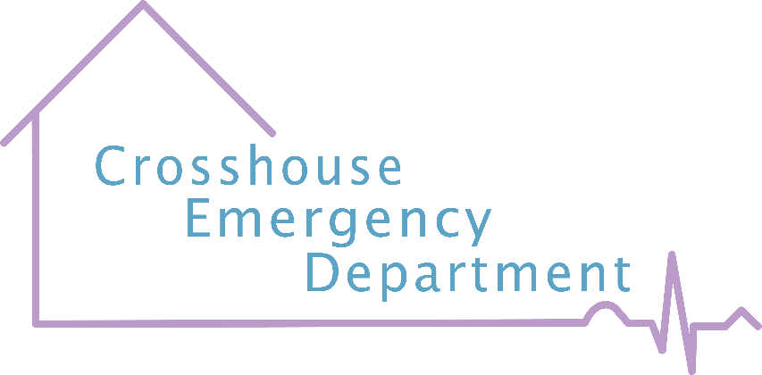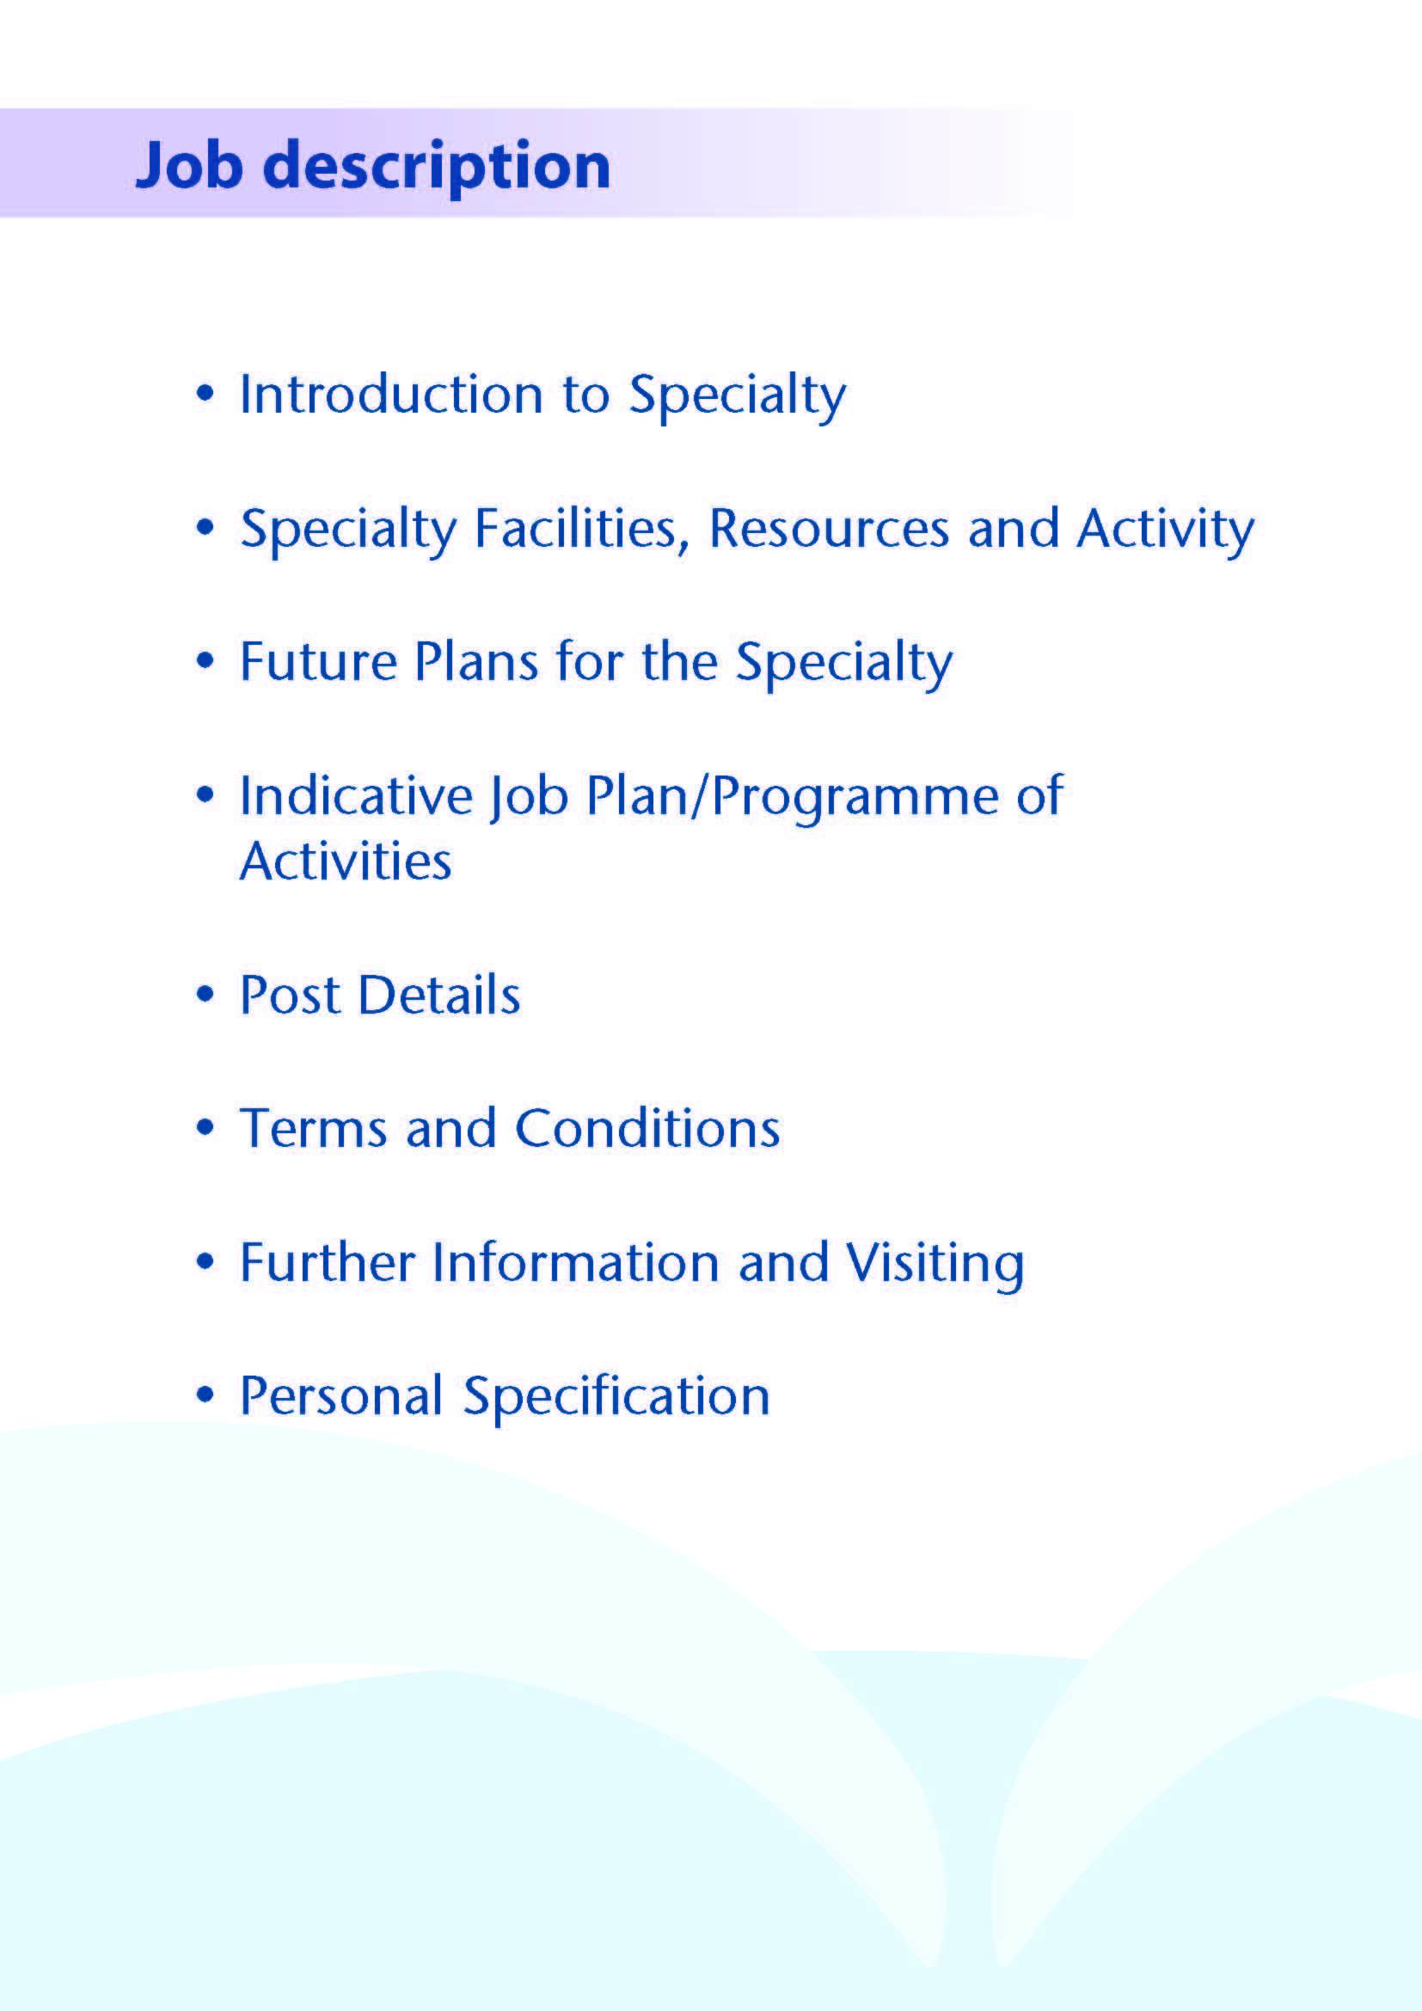

We are delighted that you are interested in applying for a Specialty Doctor post within Emergency Medicine in University Hospital Crosshouse, NHS Ayrshire & Arran. Ayrshire is a wonderful location to work with beautiful islands and beaches yet still an easy distance to Glasgow City and surrounding areas. We have world class outdoor pursuits on our doorstep and excellent local schools. We serve a population of 370,000.

We are committed to providing an enjoyable and rewarding working experience through supporting and developing our medical workforce to achieve their ambitions and support our ambition to build the best medical workforce that supports an outstanding training environment.

This is exciting opportunity to join the Emergency Department team at University Hospital Crosshouse as a Specialty Doctor on a permanent basis. You will contribute to the middle grade tier in a department seeing around 200 new patients per day of which 20-25% are paediatric attendances. The consultants provide extended hours cover (midnight at weekends) and the ST4-6 trainees provide full 24 hour cover. There is regularly scheduled supported professional activity time to pursue quality improvement projects as well as continued professional development.



**University Hospital Crosshouse** is a modern 626 bedded Acute District General Hospital located in the outskirts of Kilmarnock, easily commutable from Glasgow. It is responsible for the provision of secondary health care services for approximately 221,600 people living in North & East Ayrshire as well as the Islands of Arran & Cumbrae. Our front door has been recently expanded to accommodate a Combined Assessment and Ambulatory Care Unit, which take all of the Primary Care medical referrals.

The Emergency Department has 4 Resuscitation Bays, 15 Majors Bays, and a specially equipped ENT / eye room as well as a minor operations room. There is also a 5 bedded MIU operating 9am-10pm. During the daytime and evening, we have a dedicated paediatric area, with separate waiting room and 4 bays. We have 24 hour diagnostics cover, with in-department radiology and close CT support. Crosshouse takes paediatric ambulance and Primary Care referrals from all of Ayrshire, resulting in 20-25% of all patients being under 16 years of age. Crosshouse is also the acute receiving site for Stroke, Obstetrics & Gynaecology, Maxillofacial and ENT for Ayrshire. In the future Crosshouse will be designated as Ayrshire’s Trauma Unit due to commence in August 2021.

We have recently had an expansion in Teaching and Development Fellows, and continue to proudly focus on the training of both medical students and nursing students. We have had great success with support for the whole process of quality improvement projects, culminating in recent prizes at international conferences and many poster presentations nationally. UHC ED was also voted the top ED for training in the UK in the GMC survey in 2019.

We have a well-established clinical governance structure with quarterly clinical governance meetings and M&M meetings.

**Staffing At University Hospital Crosshouse**

Dr J Adams, Clinical Director NHS A&A EM & Consultant in Emergency Medicine (Whole-time)

Dr J McLaren, Clinical Lead UHC ED & Consultant in Emergency Medicine (Whole-time)

Dr C McGuffie, Medical Director, Acute Care & EM Consultant (Part-time)

Dr T Hopkins, Consultant in Emergency Medicine (Whole-time)

Mr J Stevenson, Consultant in Emergency Medicine (Whole-time)

Mr David Chung, Consultant in Emergency Medicine (Whole-time)

Dr J Mulligan, Consultant in Emergency Medicine (Part-time)

Dr J Gordon, PEM Consultant in Emergency Medicine (Part-time)

Dr Y Moulds, Consultant in Emergency Medicine (Whole-time)

Dr L Black, Consultant in Emergency Medicine (Whole-time)

Dr C McRoberts, Consultant in Emergency Medicine (Whole-time)

Dr M Draegebo, Consultant in Emergency Medicine (Whole-time)

Dr L Brown, Consultant in Emergency Medicine (Whole-time)

Dr E McKenzie, Consultant in Emergency Medicine (Whole-time)

Dr Rita Das, Consultant in Emergency Medicine (Part-time)

Dr Daniel Graham, Consultant in Emergency Medicine (Part-time)

Dr Alastair Stevenson, Consultant in Emergency Medicine based in UHA ED

Dr Alan Krichell, Clinical Lead UHA ED & Consultant in Emergency Medicine based in UHA ED

4.0 wte HST Emergency Medicine

3.8 wte Specialty Doctors in Emergency Medicine

18.0 wte Junior Grades

6 ENPs



The Emergency Department at University Hospital Crosshouse is actively engaging in the wider NHS Ayrshire & Arran Transformational Change programme. We are pursuing the goal of keeping a career as a Specialty Doctor in Emergency Medicine rewarding and stimulating whilst enhancing the sustainability of the post. We regard the Emergency Department as ideally situated to implement innovative ways of resolving the many challenges faced by the NHS in Scotland, and the voice of the ED middle grade doctor helps to shape these changes.

The ED has capitalised on the expansion in Clinical Fellows over the past years by supporting meaningful input in quality improvement projects, benefiting both our own department and the wider health board. The ED middle grade tier has been instrumental in the success of this, and will continue to support future projects.

We are proud of our support for the individual Specialty Doctor’s training needs. One of our Specialty Doctors has recently gained their Certificate of Eligibility for Specialist Registration (CESR) in Emergency Medicine after the EDs support via secondments in addition to ongoing in-house educational opportunities. They went on to successfully gain a consultant post in the West of Scotland. 2 of our current specialty doctors are working towards CESR. We are happy to support any future specialty doctors on this path if desired. 

# Proposed Weekly Programme

The proposed weekly programme is shown below. It is an indication of the spread of hours currently worked by the majority of the Specialty Doctors, but should be viewed as a basis upon which to discuss tailoring it to the suitability of both individual and department.

**Supporting Professional Activities**: NHS Ayrshire and Arran recognise the important role Job Planning has in ensuring Specialty Doctors are supported in delivering high quality, safe, sustainable clinical care to patients. It is therefore important to ensure there is an adequate balance between direct clinical care activities and activities which support both the personal and professional development of the medical workforce and facilitates agreed contribution to activities including:

* Under and post graduate teaching/training
* Clinical Governance
* Quality Improvement
* Service management and planning
* Work with professional bodies

One session for Supported Professional Activities is included with this post.

If the post-holder will be responsible for the formal training and supervision of post-graduates and under-graduates, a suitable additional allocation of SPA time will be made in accordance with national guidance.

**Job Plan Review**

New appointees will discuss the indicative job plan with the Clinical Director, prior to commencement and will at that time review the balance of activities. Where it is possible to agree a revisions to the indicative plan in advance of commencement this will be acted upon. In any event however, there must be an interim Job Plan review conducted at 3 months post commencement to agree and finalise the Job Plan. The specialty doctor at time of induction should ask for an interim review date to be scheduled. The agreed job plan will include all the specialty doctor’s professional duties and commitments, including agreed Supporting Professional Activities.    Thereafter Job Planning will be carried out annually as part of the Board’s Job Planning process.

**Proposed Weekly Programme**

Example given is based on 12 sessions a week. Current Speciality Doctors in the department work between 10 and 12 sessions a week. The successful candidate would have a job plan agreement bespoke to them prior to commencing and review said job plan 3 months after commencement.

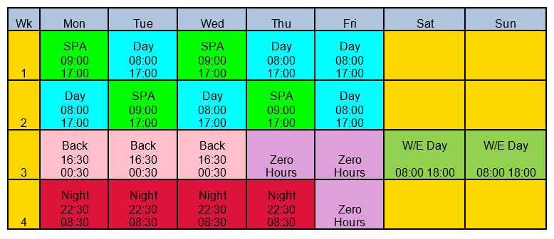



The post is a full-time Specialty Doctor in Emergency Medicine, governed by a standard nationally-agreed contract. It includes an average of one Supported Professional Activity per week. There may be scope to extend this depending on responsibility streams in the department.

All of the clinical and non-clinical commitments will be delivered at University Hospital Crosshouse. As a middle grade clinician in the Emergency Department, the post holder will be expected to manage the undifferentiated patient in need of urgent care. An understanding of the local arrangements for primary and secondary care will need to be rapidly developed to optimise their ongoing management. Engagement with learning, both planned and informal, is required both for and from the post holder. There are both undergraduate and post graduate trainees in our department at most times, and the post holder will need to facilitate any learning opportunities that become available.

The Specialty Doctor will need to demonstrate successful annual appraisal and adherence to the General Medical Council’s guidance on Good Clinical Practice. The post holder is expected to adhere to all of NHS Ayrshire & Arran’s Health and Safety guidance, including proactive engagement with Occupational Health when required.



Are those determined by the Terms and Conditions of the New Specialty Doctor grade (Scotland) as amended from time to time.



Please contact Dr Jayne McLaren, Clinical Lead for Emergency Medicine, on 01563 827751, jayne.mclaren@aapct.scot.nhs.uk for either an informal discussion or to arrange a visit. Kilmarnock is an easy journey away from Glasgow, yet a handy distance from the beautiful Ayrshire coast.



**Post of**: Specialty Doctor in Emergency Medicine

**Location**: Emergency Department, University Hospital Crosshouse

## Qualifications:

|  |  |
| --- | --- |
| Essential | Desirable |
| Full GMC Registration with a current Licence to Practice |  |
| * A minimum of 4 years full-time postgraduate training, at least 2 years of which will have been within Emergency Medicine  Primary exam for Fellowship of Royal College of Emergency Medicine | Intermediate exam for Fellowship of Royal College of Emergency Medicine |

**Skills/Knowledge/Competence**

|  |  |  |
| --- | --- | --- |
| **Requirements** | **Essential** | **Desirable** |
| General Experience: | •   Knowledge of and skill relevant to the management of undifferentiated emergency presentations of all ages  •   Ability to communicate effectively with all levels of staff and patients  •   Ability to work efficiently  •   IT literacy  • Child Protection training | •   Ability to develop and maintain a database of clinical practice  • Current ALS, ATLS and APLS provider status |
| Teaching & Training | •   Proven ability to deliver high quality teaching | •   Interest in and knowledge of advances in medical education and training |
| Team Working | •   Demonstrate ability to work with colleagues constructively | •   Ability to lead others & think strategically |
| Development | •  Evidence of relevant Continuing Professional Development |  |
| Research & Publications |  | •   Ability to appraise publications and apply to clinical practice  •   Demonstrate current training in Good Clinical Practice |
| Quality Improvement |  | •   Evidence of interest and depth of experience in Quality Improvement |
| Management and Administration |  | •   Proven organisational  skills |
| Personal and Interpersonal  Skills | •   A willingness to accept flexibility to meet the changing needs of the NHS in Scotland  •   Effective communicator and negotiator |  |

**If there is any reason why a disabled person should not be considered suitable for this** **post, please provide details**: The post requires physical dexterity. Uncorrected visual or hearing defects would be incompatible with the nature of the work. The post does require contribution in unsocial hours and the post holder must be able to demonstrate an ability to perform their duties at weekends and during the night if required.

