Working in NHS Fife

Specialty Doctor (Adults with Intellectual Disability)

Closing date: Job Ref:

Interview Date: Interview Date:

**Closing date: Friday 6 July 2018**

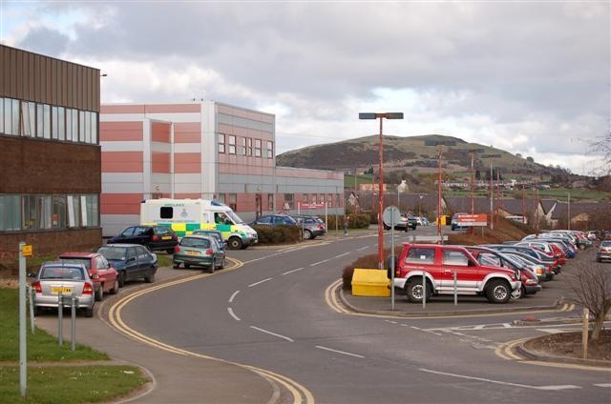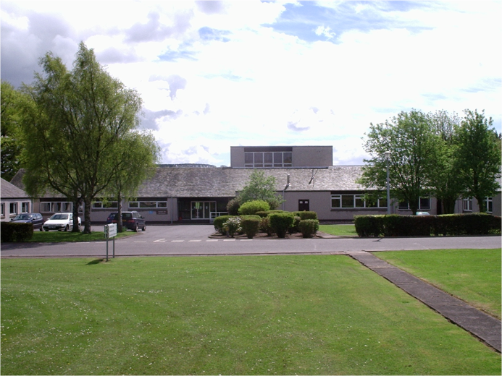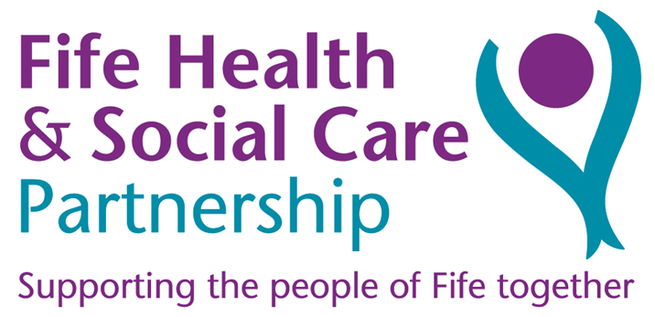

**Contents**

|  |  |
| --- | --- |
| Contacts | 2 |
| Overview of post | 3 |
| Departmental and Directorate Information | 4 |
| Person specification – Specialty Doctor, Adults with Intellectual Disability | 6 |
| Additional post information | 8 |
| NHS Fife Strategic Framework | 11 |

**Unfortunately we cannot accept CVs as a form of application and only application forms completed via the Jobtrain system will be accepted. Please visit https://apply.jobs.scot.nhs.uk for further details on how to apply.**

**You will receive a response acknowledging receipt of your application.**

|  |
| --- |
| **This post requires the post holder to have a PVG Scheme membership/record. If the successful applicant is not a current PVG member for the required regulatory group i.e. child and/or adult, then an application will need to be made to Disclosure Scotland and deemed satisfactory before the successful post holder can commence work.** |

**All NHS Scotland and NHS Fife Medical vacancies are advertised on our medical jobs microsite: www.medicaljobs.scot.nhs.uk**

**Who to contact about the post**

For more details about the post and application information, please contact:

**Dr Swaraj Alkanti**, Consultant Psychiatrist, Clinical Lead, Intellectual Disability Service, Lynebank Hospital, Dunfermline

Fife KY11 4UW. Tel: 01383 565245. Email: swaraj.alkanti@nhs.scot

**Fraser Ross**, Interim Clinical Services Manager, Intellectual Disability and Specialist Mental Health Services, Lynebank Hospital, Dunfermline. Fife KY11 4UW. Tel: 01383 35266. Email: alison.mcpherson4@nhs.scot



To find out more about Fife, local psychiatry services, and the latest opportunities, please visit:

**Overview of post**

**The post**: Specialty Doctor, Adults with Intellectual Disabilities

**Sessions:** 10 sessions

**Department**: NHS Fife Adult Intellectual Disability Service

**Base:** Lynebank Hospital, Dunfermline. Fife. KY11 4UW.

**Post Summary: This full-time post has become available for a Specialty Doctor to be part of a well developed and progressive service for adults with a learning disability within Fife.**

**The post is a 10 session post, based at Lynebank Hospital, which consists of 8 Clinical and 2 SPA sessions per week.**

**The post sits within the Fife Learning Disability Service**

The Region of Fife is bounded in the north by the Firth of Tay, in the east by the North Sea and in the south by the Firth of Forth. The Region spans an area of 130,700 hectares and has a population of approximately 360,000. There is a highly developed agricultural part in east and north-east Fife, and in the west there is an extensive cross-section of highly skilled and scientifically orientated industry. The largest towns are Dunfermline, Kirkcaldy and Glenrothes. The cathedral city of St Andrews is the seat of Scotland’s oldest university and the UK’s third oldest university.

Fife is an area of considerable scenic and historical interest. The usual range of sporting facilities are available locally including golf, swimming, fishing, curling, football, rugby, sailing, motor sport and gliding. The Cairngorm Mountains are within easy reach providing access to skiing, mountaineering, orienteering and salmon fishing. Wide ranges of cultural activities are available in Fife, and in the cultural centres of Edinburgh and Glasgow. The main urban and leisure centres of central Scotland are within easy reach and there are excellent air, rail and motorway links to the major centres in the UK. Edinburgh Airport is within easy reach by road.

Fife has a rising birth rate and overall population increase particularly in the west. This is mainly due to the expansion of businesses around Edinburgh and an increasing commuter belt.

**Departmental and Directorate Information**

**NHS Fife**

NHS Fife provides primary, community, mental health and hospital services. Ms Carol Potter is Chief Executive and Dr Christopher McKenna is Medical Director. Dr Helen Hellewell is Associate Medical Director in the Fife Integrated Health & Social Care Partnership.

The NHS Fife Board is situated at Hayfield House, Victoria Hospital, Kirkcaldy. The Director of Public Health is Dona Milne.

**Fife Health & Social Care Partnership**

The NHS Fife Intellectual Disability Service is operationally managed within the Fife-Wide Division of the Fife Health and Social Care Partnership following integration of Health and Social Care services.

Ms Nicky Connor is Director of the Fife Health and Social Care Partnership and Ms Rona Laskowski is the Head of Complex and Critical Care Services for Fife HSCP.

**Adult Intellectual Disability Services in Fife**

The Intellectual Disability Service in NHS Fife has undergone a period of significant change following the completion of the discharge programme from the traditionally long stay inpatient model of care to the development of community based services supported by an Assessment and Treatment Facility and a local forensic unit.

The Service has well established Community Intellectual Disability Teams (East and West Fife CLDTs) and an area wide Forensic Team (FFLDS). In addition, the Service has a 10 bedded Acute Assessment & Treatment Unit (Mayfield) and a 2 bedded unit (Tayview) which supports Fife patients with forensic needs and / or challenging behaviour. In addition, the Service also manages the SE Regional Specialist ID Low Secure Forensic Service (Daleview) for patients with Intellectual Disability from the health boards in the Managed CareNetwork (MCN) area (Fife, Lothian,Forth Valley and Borders). All these inpatient services are based on the Lynebank Hospital site.

The NHS Fife Intellectual Disability Service has a lead clinician and medical care is currently provided by consultants (4.7 wte) and two specialty doctors (1.6 wte), with support from a core psychiatry trainee, a full time Clinical Fellow and intermittently a higher trainee in Psychiatry of Intellectual Disability, delivering the services to Lynebank Hospital and the community in Fife.

There are also close working relationships with colleagues within both Social Work and various care agencies and the Care Programme Approach is widely used to ensure consistency of care.

All substantive Consultant Psychiatry staff in the department are employed as part of the South East Scotland Intellectual Disability Managed Care Network (MCN) hosted by NHS Lothian, which allows for sharing of resources, peer support and Continuing Professional Development for medical staff in the service. The MCN was set up to share resources regarding those adults with Intellectual disability with additional Forensic problems, ‘challenging behaviour’ and Autism Spectrum Disorder. The focus of the Fife Intellectual Disability Service is on the mental health, behavioural and forensic needs of the patients although provision of an appropriate level of physical healthcare to inpatients is also included in the service.

**General Community Intellectual Disability Services for Adults**

The general Intellectual Disability Service in Fife in the community is divided into two sectors – West Fife (Dunfermline and Kirkcaldy) and East Fife (Glenrothes and North East Fife). Each sector has a multidisciplinary Community Intellectual Disability Team comprising professionals working in psychiatry, nursing, psychology, occupational therapy, speech and language therapy, physiotherapy, dietetics, podiatry and pharmacy.

Each Community Intellectual Disability Team provides specialist, high quality healthcare services for people with Intellectual disability. In providing such specialist care, each team aims to:

* Deliver effective, specialist healthcare using evidence based practices
* Support General Practitioners and Primary Healthcare teams to identify and meet the health needs of people with Intellectual disability
* Work with Community Health Partnerships and Social Services to provide co-ordinated services
* Facilitate access to primary and secondary healthcare services
* Encourage and facilitate a healthy lifestyle
* Provide education and advice to clients, their families, carers and other professionals.

The Fife Intellectual Disability Service also employs a number of senior specialist nurses in the fields of Challenging Behaviour, Acute Services and Primary Care Liaison, Epilepsy and Child to Adult Transition.

**Forensic Intellectual Disability Services**

The Fife Forensic Learning Disability Service (FFLDS) provides a Fife-wide service to adults with Intellectual Disability and forensic issues. The FFLDS is multi-agency and multidisciplinary and forms part of the NHS Fife Intellectual Disability Service. The service includes professionals working in psychiatry, nursing, psychology, occupational therapy, speech and language therapy, physiotherapy, dietetics and podiatry. The service liaises closely with social work and social care services providing support to service users (currently employed by Fife Council and TRFS).

The FFLDS objectives include:

* Assessment and management of risk with promotion of defensible decision making in forensic contexts
* Provision of treatment, support and care to individuals with Intellectual disability and forensic needs, reflecting the nature of risks identified
* Promotion of individual rights, social inclusion and quality of life whilst recognising the importance of community safety
* Promotion of inter-agency and inter-disciplinary co-operation in the management of risk

The FFLDS aims to achieve these objectives via:

* Comprehensive risk assessment, risk management and review
* Commissioning, supporting and monitoring care packages
* Therapeutic interventions (including offence focussed interventions)
* Identifying, supporting and monitoring relevant structured occupational and leisure activities
* Consultancy and advice
* Liaison with other agencies including via Multi-Agency Public Protection Arrangements

**Services for Children with an Intellectual Disability in NHS Fife**

NHS Fife employs a ‘tiered stepped approach’ to service provision allowing children to be referred to Specialist Services when needed and ensuring professionals work together in providing co-ordinated care for children. There is a Core Community Team which accepts referrals for children with Intellectual Disability and additional persistent social, behavioural, mood and developmental difficulties which are causing concern and interfering with daily living / access to usual activities. The team can also provide advice and additional / intensive consultation, assessment, intervention and support for those children and adolescents with more complex needs and/or challenging behaviours.

**Medical Staff**

**Consultants:**

Dr Swaraj Alkanti (Clinical Lead) 1.0 wte (Mayfield & EST)

Dr Karthik Bommu 1.0 wte (Kirkcaldy & FFLDS)

Dr Fergus Douds 0.6 wte (Daleview and restricted patients)

Dr Fionnuala Williams 0.7 wte (Dunfermline)

Dr Fiona Alexander 0.6 wte (Glenrothes)

Vacancy 1 0.8 wte (North East Fife & Tayview)

**Specialty Doctors:**

Dr Rosalind Vallance (Specialty Doctor) 0.6 wte (West Fife Community Team)

**Vacancy (this post)** 1.0 wte (Inpatient Forensic LD, East Fife Community Team and Multi Disciplinary Epilepsy Team)

**Trainee Posts:**

Clinical Fellow (Vacancy) 1.0 wte (Glenrothes @ Inpatients)

Core Trainee (CT2/3) 1.0 wte (Inpatients and Dunfermline)

**Person specification – Speciality Doctor, NHS Fife Adult Learning Disability Service.**

|  |  |  |
| --- | --- | --- |
| Requirements | **ESSENTIAL** | **DESIRABLE** |
| Qualifications | MB ChB or equivalent medical qualification. | MRCPsych |
| **Eligibility and Training** | Eligibility to work in the UK.  Eligible for full registration and License to Practice with the GMC at time of appointment.  Evidence of achievement of Foundation competencies by time of appointment in line with GMC standards in *Good Medical* *Practice*  At least four years of post registration experience with at least six months in hospital or community psychiatry.  Evidence of Continuing Professional Development. | 6 months or more experience in the Psychiatry of Learning Disability in a core Psychiatry placement or Specialty Doctor / SAS doctor placement, or other Specialty Training in Psychiatry of Learning Disability.  Previous experience rendering eligible for Approval under Section 22 of the Mental Health (Care and Treatment) (Scotland) Act (2003). If not already approved, the post holder will be expected to undertake appropriate training and to gain such approval following appointment and gaining of necessary experience. |
| **Fitness to Practise** | Applicant’s knowledge is up to date and is fit to practice safely. |  |
| **Language Skills** | All applicants to have demonstrable skills in written and spoken English that are adequate to enable effective communication about medical topics with patients, carers and colleagues, which could be demonstrated by one of the following:  • Applicants have undertaken undergraduate medical training in English.  • Applicants have required scores in the International English Language Testing System (IELTS) or equivalent. |  |
| **Health** | Meets professional health requirements (in line with GMC standards in *Good Medical* *Practice*). |  |
| **Experience** | Sound knowledge of general medicine.  Proven ability to work effectively in different clinical settings required in the post.  Demonstrates awareness of good decision making. Aware of own limitations. Track record of engaging in clinical governance: reporting errors, learning from errors.  Evidence of active participation in audit. | Experience working with people with a Learning Disability.  Familiarity and experience with relevant legislation including the Mental Health (Care and Treatment) (Scotland) Act (2003) and Adults with Incapacity (Scotland) Act (2000).  Participation in research and experience in teaching.  Willing to be involved in teaching. |
| **Disposition** | Service orientated.  Committed to clinical patient care and service development.  A commitment to quality of service.  Empathy and sensitivity: capacity to listen and take in others’ perspectives.  Evidence of good team-working: experience of working in teams and values the input of other professionals. Capacity to work effectively in multi-professional teams and demonstrate leadership when appropriate.  Able to work effectively with Primary Care, Statutory and Voluntary Agencies.  Coping with pressure: capacity to operate under pressure. Demonstrates initiative and resilience to cope with setbacks and adapt to rapidly changing circumstances.  Problem solving and decision making: capacity to use logical/lateral thinking to solve problems and make decisions.  Organisation and planning: capacity to organise oneself and prioritise own work.  Demonstrates punctuality, preparation and self-discipline. Understands importance of information technology.  Flexible approach to work: able to adapt and work with employers to deliver improved patient care.  Demonstrates a willingness to engage fully in appraisal. Self-awareness and ability to accept and learn from feedback.  Equality and diversity: promotes equality and values diversity. | Leadership qualities. |
| **Other** | Occupational Health clearance and Enhanced Disclosure clearance under the Protection of Vulnerable Groups scheme.  Ability to fulfil travel requirements of the post.  Learning and personal development: demonstrates interest in Learning Disability Psychiatry. Demonstrates a commitment to maintaining professional skills and knowledge relevant to the post. | Evidence of interest in the post.  Valid UK Driving Licence. |

**Additional Post Information – Main duties and responsibilities**

The post available is for 10 programmed activities as a Specialty Doctor in Intellectual Disability Psychiatry and will be based at Lynebank Hospital, Dunfermline, where suitable accommodation, IT access and administrative support will be provided.

There are three components to the job:-

**Forensic LD:**

3 sessions per week will be spent working in ‘Daleview’ low secure ward for male patients with an intellectual disability. This 10-bedded ward is used as a step-down ward for people coming from medium- and high-security environments as well as an assessment facility for people coming from courts and/or prison.

Supervision and guidance will be provided of Dr Fergus Douds, Consultant Psychiatrist at Lynebank Hospital.

This will involve attending MDT and review/enhanced CPA meetings and undertaking both clinical and administrative tasks following on from these as well as the review of patients on a regular basis to undertake both mental state and physical health examinations.

The successful applicant will be involved in the preparation of a variety of reports and risk assessments relating to all aspects of the patients’ care and will be part of the well-resourced multidisciplinary team. The post holder will be encouraged to undertake Advanced Medical Practitioner training to enable them to be able to use the Mental Health (Care & Treatment) (Scotland) Act 2003. Other training will be provided so that the post holder can undertake capacity assessments and complete relevant paperwork/reports under the Adults with Incapacity (Scotland) Act 2000.

**Community LD Team:**

2 sessions per week working with the East Fife Community Learning Disability Team in particular in the North East region of Fife in the assessment and treatment of those with an intellectual disability and major mental health problems and/or problematic behaviours under the regular supervision of a Consultant Psychiatrist.

The SD will attend the weekly community LD team meetings (over MS Teams) and undertake regular clinics under the supervision of a Consultant Psychiatrist as well as in liaison with members of the team including Community Nursing, Clinical Psychology, Speech and Language Therapy, Occupational Therapy, Physiotherapy and Clinical Pharmacy amongst others.

Regular clinics are already in place; these will be ongoing and there will be the opportunity to also undertake home visits where appropriate.

There is also an expectation that the Specialty Doctor will provide emergency/urgent cover to the East LD team for emergency/urgent mental health assessments when required during the week and liaise with relevant others.

The specialty doctor will gain an understanding of and experience in the Positive Behavioural Support approach in managing those with intellectual disability, mental health concerns and behavioural problems in the community alongside communication guidelines and activity timetables.

They will also be involved in chairing and potentially minuting review and Care Programme Approach meetings where relevant.

**LD Epilepsy Service:**

3 sessions per week:

The SD will be involved in reviewing patients with epilepsy in the Kirkcaldy area of the West Fife CLDT and, Glenrothes and North East Fife areas of the East Fife CLDT, at dedicated clinics or individually via home visits together with colleagues from the Learning Disability Epilepsy Service including an epilepsy specialist nurse (band 7), a band 5 epilepsy nurse as well as a senior Clinical Pharmacist. An experienced Specialty Doctor, who has been working with the epilepsy service for many years covering the West Fife patch, would also be able to offer support and supervision.

There will be opportunities for education and training in the assessment and management of those with learning disability who have epilepsy, to enable the post holder to be proficient to a silver standard as per the Royal College of Psychiatrists Good Practice Guidance CR203: Management of epilepsy in adults with an intellectual disability college-report-cr203.pdf (rcpsych.ac.uk)

**Supporting Professional Activities**:

1 session per week will be for Supporting Professional Activities for the purpose of undertaking Continuing Professional Development) (as per Study Leave Guidelines), appraisal, revalidation etc.

The post holder will have the opportunity to attend the fortnightly Journal Clubs and Case Conferences, organized and run SE Scotland Managed Clinical Network (by MS Teams). In addition, there will also be opportunities to attend local teaching within mental health services in Fife.

A Personal Development Plan will be part of the annual NHS Specialty Doctor appraisal process.

There will also be an additional SPA to attend additional training and / or gain clinical experience to build up the essential portfolio leading to Specialist Registration through the Portfolio pathway route (CESR route).

**Teaching and Training opportunities:**

The post holder would have the opportunity to be involved in teaching opportunities with various groups/disciplines within the Learning Disability Service as well as to the various community support services.

**On-call:**

This post does **not** come with an on-call component. From time to time however, locum shifts do become available on the Fife Psychiatry Unscheduled Care and Assessment Team on-call rota due to the unpredicted absence of FY2, GPSTs or CTs in Psychiatry. Undertaking these can be of help in gaining experience in the management of a range of patients presenting with mental health concerns out-of hours.

The out of hours on-call Psychiatry arrangement for adults with Learning Disability in Fife is provided by junior psychiatry doctors on the Unscheduled Care Assessment Team with senior supervision available from Learning Disability Consultants and senior Learning Disability Psychiatry trainees on a regional South-East Scotland MCN on-call rota.

**Cover:**

There will also be an expectation that the post holder will cross cover for the Core Trainee and Clinical Fellow during periods of absence should direct emergency or urgent medical/psychiatric issues arise either in the hospital or the community.

The medical cover of patients whilst on annual/study leave is to be arranged with colleagues within the adult Learning Disability service.

**Supervision and support:**

The post holder will work closely with and be clinically accountable to the Consultants in Learning Disability Psychiatry. They will be responsible (within their own job plans) for providing appropriate supervision of clinical duties. Professional accountability is to the Consultants with whom the post holder will be working and the Clinical Lead of the service; managerial accountability is to the relevant Clinical Service Manager for the service.

Duties will be wholly related to the work of the Fife Learning Disability Service, and the post holder may be required to work within any part of the Service.

A detailed Job Plan outlining the duties required will be reviewed and agreed, as a minimum, annually. The post holder will participate in the job planning process, and in annual professional Appraisal.

The post holder will be required to keep adequate records (written and electronic) in accordance with good professional practice and to undertake such correspondence and administrative duties as required in a timely fashion, including production of patient discharge summaries.

The post holder will be required to communicate and liaise effectively with General Practitioners, social work and clinical colleagues in connection with patients.

The post holder will be expected to attend and contribute to other professional meetings e.g. teaching, training, management and audit, as appropriate to clinical duties.

**Clinical Commitments**

Clinical duties will be as detailed in the agreed Job Plan. Duties will be in the Psychiatry of Learning Disability, and may include, but are not limited to, those in the following list:

* Contribution to the psychiatric management of inpatients at Daleview.
* Contribution to the psychiatric management of community patients for the East Fife Community Learning Disability team.
* Contribution to the psychiatric management of patients with a learning disability in other wards or in the community as arranged or when necessary.
* Providing cover for emergency psychiatric assessments for people with a learning disability when necessary.
* Support for the Consultant and participation in the procedures associated with Mental Health (Care and Treatment) (Scotland) Act (2003), Adults with Incapacity (Scotland) Act (2000), and any other relevant procedures.

Appraisal and Job Planning:

Appraisal will be undertaken by a Consultant Colleague within the adult Learning Disability Service in Fife. Job planning will also take place on an annual basis together with both Clinical and Service Managers.

Secretarial support and office facilities:

The post holder will have an office at Lynebank Hospital with a computer with e-mail and internet access (as per NHS Fife policy) and will be able to access other facilities for clinics/team meetings etc. together with other members of the Team. A mobile phone and a laptop will also be provided. Electronic record systems will be via MORSE and TRAK and digital dictation is available.

Dedicated secretarial support will be provided.

Clinical Governance:

The post holder will be expected to have commitment to Clinical Governance and improving quality of patient care. Participation in Clinical Audit is encouraged as is participation in service/team evaluation and the planning of future service developments.

**Other duties:**

From time to time it may be necessary for the post holder to carry out such other duties as may be assigned, with agreement, by the Dunfermline & West Fife CHP/NHS Fife. It is expected that the post holder will not unreasonably withhold agreement to any reasonable proposed changes which the CHP/NHS Fife might make.

The post holder will be expected to reside within reasonable travelling distance of all areas of responsibility and to provide, on a pro rata basis, reciprocal cover for colleagues during periods of annual, professional and sick leave.

The appointee will have the option of being superannuable under the terms of the Scottish Health Service Scheme.

**Provisional Time table**

|  |  |  |  |  |
| --- | --- | --- | --- | --- |
| **Monday** | **Tuesday** | **Wednesday** | **Thursday** | **Friday** |
| **AM** | **AM** | **AM** | **AM** | **AM** |
| **NE Fife CLDT** | **Daleview** | **CESR SPA** | **NE Fife CLDT** | **SPA** |
| **PM** | **PM** | **PM** | **PM** | **PM** |
| **Epilepsy** | **Epilepsy** | **Daleview** | **Epilepsy** | **Daleview** |

**NHS Fife Strategic Framework**

***Our Vision***

The people of Fife live long and healthy lives

***Our Mission***

Transforming health and care in Fife to be the best

***Our Values***

Safety First

Dignity & Respect

Care & Compassion

Excellence

Fairness & Transparency

**We aspire to be Person-Centred**

*Our Objectives - we will:*

* listen to what matters to you and treat you as an individual
* design services in partnership with service users, carers and communities
* give you choices and information
* create environments that encourage caring and positive outcomes for all
* develop and redesign services that put patients first, supporting independent living and self-management of health through the integration of health and social care

**We aspire to be an Exemplar Employer**

*Our Objectives - we will:*

* create time and space for continuous Intellectual
* listen to and involve staff at all levels of the organisation
* give staff the skills, resources and equipment needed to do their jobs
* encourage and expect all staff to take appropriate decisions
* encourage staff to be ambassadors for health and social care in Fife
* create high performing multi-professional clinical teams through clinical education and development
* equip people to be the best leaders

**We aspire to be Clinically Excellent**

*Our Objectives - we will:*

* work with you to ensure you receive the best possible care
* ensure there is no avoidable harm
* achieve and maintain recognised quality standards
* ensure that NHS Fife’s environment is clean, tidy, well maintained, safe and something to be proud of
* embed patient safety consistently across all aspects of healthcare provision
* support research, innovation and quality improvement which will see NHS Fife as a centre of excellence

**We aspire to be Sustainable**

*Our Objectives - we will:*

* ensure the maximum impact of our resources in the promotion of health and wellbeing
* increase efficiency and reduce waste
* ensure that our activities are cost effective and within budget
* ensure that all service redesign and development makes the most effective use of resources and avoids waste and unwarranted variation
* develop, in collaboration with our partners, our property and assets to meet the changing needs of health and social care provision