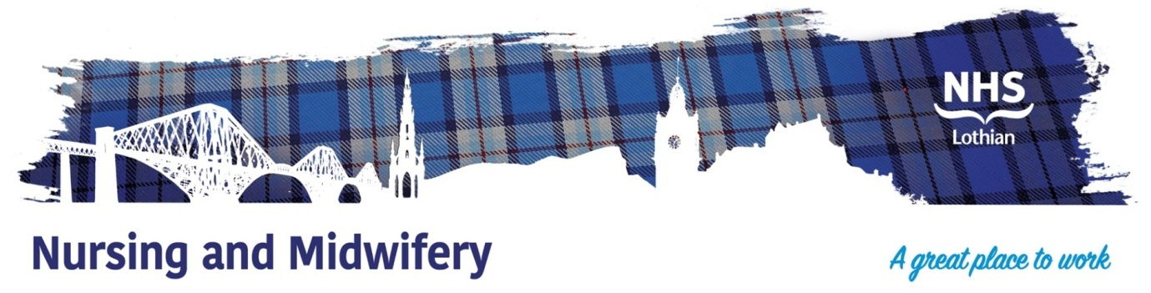

**NHS Lothian Belhaven Hospital Ward 1 Blossom House**

Exciting opportunities are available to join Belhaven Hospital Ward 1 Blossom House within one of the hospital sites across NHS Lothian. We have multiple Band 5 positions available for Registered Nurses and we are looking for passionate, caring, motivated people to join our highly skilled nursing teams.

Blossom House is an 11 bedded cottage hospital, offering long-term nursing care to our frail residents.

All residents require assistance to maintain holistic independent living, whilst offering nurses opportunities to advance is dementia care specialising in the categories of dementia and Alzheimer’s. Extended roles offered, nurse in charge, wound care advancements. Weekly MDT, care planning & social work assessments.

We offer the opportunity to work with talented teams within multidisciplinary environments and impact positively on the lives of thousands of patients and their families.

Find out what our staff say about working in NHS Lothian at https://careers.nhslothian.scot/acute-specialist-nurses/who-we-are/

**What We Can Offer You**

We have a range of vacancies for experienced and newly qualified nurses to join our innovative and dynamic teams across NHS Lothian – providing you with the opportunity to gain a breadth of knowledge and exposure to multiple specialties.

**Roles**

* Staff Nurse - BAND 5 full time post
* MOE Elderly Nursing care
* Nurse in Charge role - medication rounds, care plans, weekly MDT, wound care, social work assessments and meetings.

**Salary**

* Band 5 Range £30,229 – £37,664 (pro rata) per annum

**Benefits**

* A minimum of five weeks annual leave increasing with length of service
* A range of supportive employment policies including Flexible Working
* Full or part time hours considered
* We provide an extensive induction programme and excellent professional training and development opportunities.
* Access to the NHS Pension Scheme and Staff Benefits

