

**NHS Lothian Daybed Suite, Western General Hospital**

Exciting opportunities are available to join the Daybed Suite Team at the Western General Hospital, NHS Lothian. We have multiple Band 5 positions available for Registered Nurses and we are looking for passionate, caring, motivated people to join our highly skilled nursing teams.

We offer the opportunity to work with talented teams within multidisciplinary environments and impact positively on the lives of thousands of patients and their families.

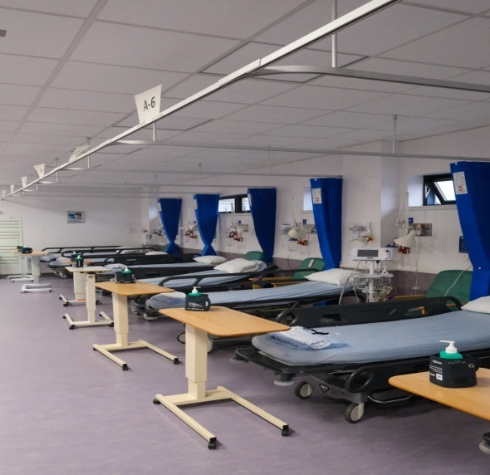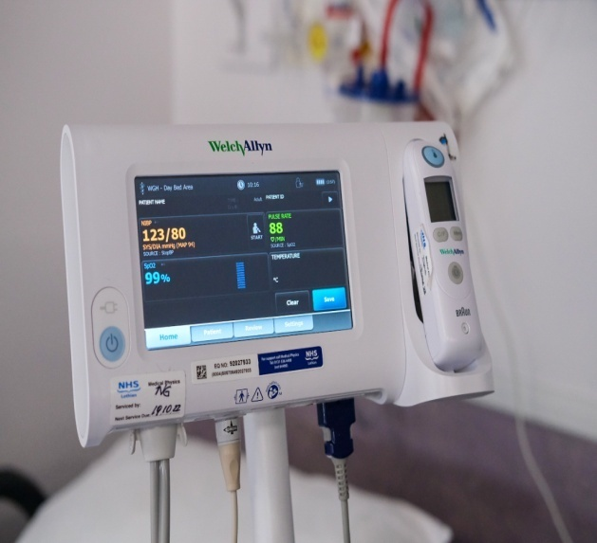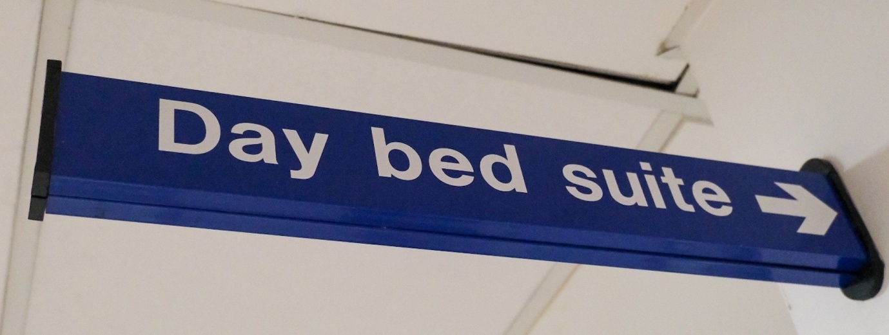

**What We Can Offer You**

Daybed Suite is a Nurse Led Unit based on the ground floor of the Anne Ferguson Building, WGH.

We care for a wide range of patients undergoing Daycase procedures including Endoscopy, Bronchoscopy, Elective Colo-rectal and Urology Day Surgery patients, Flexible Cystoscopies, Botox Injections and Urology 1 Stop clinics, Prostatic Biopsies and the patients undergoing CT or ultra sound guided biopsies. Daybed Suite is often a very busy unit.

Daybed Suite is open Monday-Thursday 0730-2000 and Friday 0730-1900.

The unit is closed at night, weekends & Public Holidays.

Staff work a 4 day week.

Staff interested in working part time will be considered.

Teaching and education is encouraged to ensure that staff are competent and knowledgeable regarding the care of the patients in Daybed Suite. Staff are supported to attend study days and complete the associated competencies; training often takes place in-house in addition to study days.

To ensure new staff feel comfortable and supported in their new role in Daybed Suite, we offer a buddy system to all new staff to support them through their induction period and beyond.

**Roles**

* Band 2 Clinical Support Worker

**Salary**

* Band 2 Range £23,362 – £25,368 (pro rata) per annum

**Benefits**

* A minimum of five weeks annual leave increasing with length of service
* A range of supportive employment policies including Flexible Working
* Full or part time hours considered
* We provide an extensive induction programme and excellent professional training and development opportunities.
* Access to the NHS Pension Scheme and Staff Benefits

We would love to meet you and are happy to show interested people around Daybed Suite or answer any questions you may have.

For further information please contact –

Senior Charge Nurse – Karin Cunningham,

karin.cunningham@nhslothian.scot.nhs.uk

Deputy Charge Nurses – Dianne Garvie

Dianne.garvie@nhslothian.scot.nhs.uk

Kerry Rennie

Kerry.rennie@nhslothian.scot.nhs.uk

Or phone Daybed Suite on 0131 5371327



  