**JOB DESCRIPTION**

**Job description reference:** JD564

**Title of post:** Associate Director of Workforce

**Band:**  AfC Band 8C

**Reporting to:**  Director of Workforce

**Location:** Initially remote working with potential to ultimately work from Glasgow or Edinburghon a hybrid basis.

1. **Job purpose**

As Associate Director of Workforce, the post holder will directly operationally manage the performance and direction of the People and Workplace Directorate. The Directorate currently comprises of Human Resources, Recruitment, Organisational Development and Learning, and Facilities services for Healthcare Improvement Scotland

Key responsibilities will include leading, with the support of the Director of Workforce, the engagement and performance of the People and Workplace Directorate. With this it is vital that the post holder will demonstrate, promote and encourage an organisational culture that supports effective behaviours and ways of working that demonstrate a clear commitment to the organisation’s values. This will include embedding good Human Resources practice and raising managerial capability and accountability for people management.

The Associate Director of Workforce will also play a key role in developing the organisational culture, ways of working and operational planning for the People and Workforce Directorate to ensure that function is proactive in building relationships and in delivering high quality advisory and corporate support services.

**2 Job dimensions**

* + Delegated budget authority up to £9,000
  + Responsible for workforce of *circa* 17 staff covering HR, Organisational Development and Learning, Health & Safety, and Facilities and the associated budget.
  + Leading contribution to setting, analysis & monitoring of workforce budgets totalling *circa* £26m.

**3 Organisational Position - organisational chart attached**

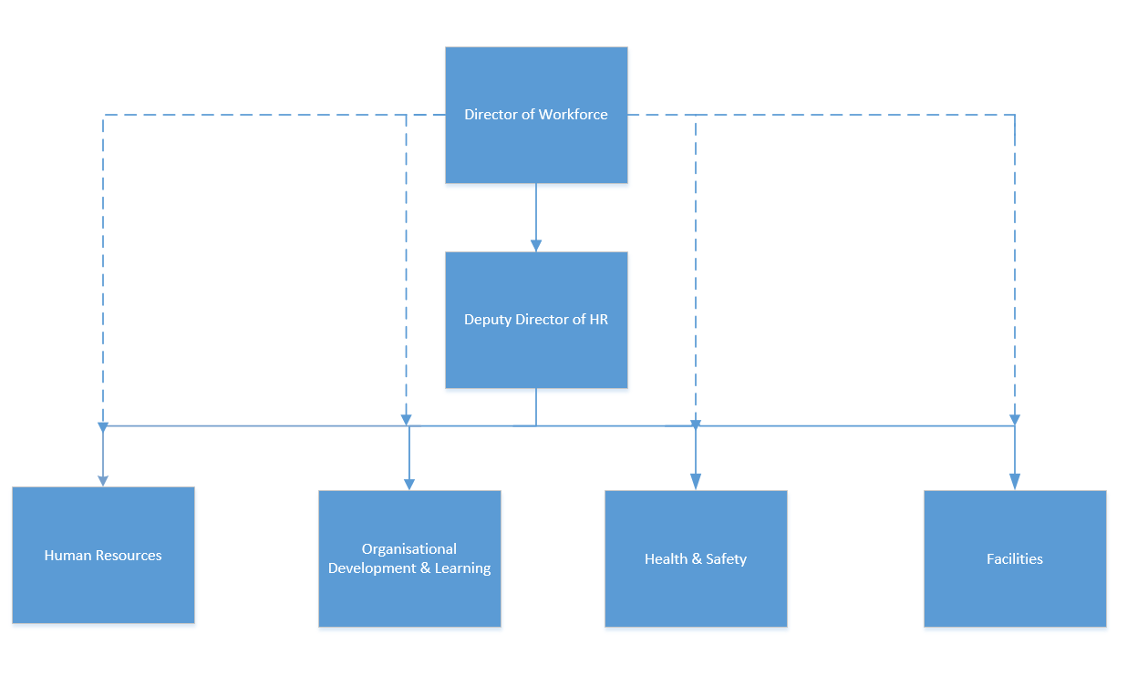

**Role of People and Workforce Directorate**

The People and Workforce Directorate provides centralised professional Human Resources, Organisational Development Learning & Education, Health & Safety, and Facilities services for all directorates within the organisation.

The work is currently managed in a number of teams,

* **Human Resources** – workforce strategy & policy (including employment legislation), workforce planning, workforce equalities, recruitment & selection, employee relations, employee welfare, partnership development & employee engagement, and HR administration.
* **Organisational Development Learning & Education** – specialist workforce skills development, PDR & KSF monitoring and development, learning and organisational improvement activity and learning & education administration.
* **Health & Safety** – provision of all required Health and Safety advice and monitoring across the organisation, including overview of current Fire Safety SLA arrangements**.**
* **Facilities** – workplace environment strategy & policy, workplace environment planning, facilities & consumables budget setting & management, and facilities administration.

**4 Key result areas – Specific to Role**

1. Operational management of the performance and direction of the People and Workplace Directorate. This will include day to day interaction and management of directly managed staff and also to maintain an overview and operational management of all Directorate Service Teams. The post holder will be accountable to the Director of Workforce for the operational performance and delivery of these teams.
2. Provide senior management and professional leadership to the People and Workplace Directorate, working with the team to develop, implement and monitor delivery of Directorate plans, strategies and also cross-organisational activities. This will include the provision of expert professional leadership and guidance to the planning, prioritisation and allocation of resources to support effective delivery of activity across the range of priorities across the Directorate. The post holder also contributes to the development and delivery of the organisation’s strategic and key corporate objectives.
3. Ensure oversight and delivery of a comprehensive Organisational Development and Learning strategy for the organisation which operates on a cross-organisational basis and supports service priorities.
4. Ensure the development, implementation and review of the organisational resourcing strategy for the organisation to ensure effective and responsive recruitment arrangements are in place, based on a consistent policy approach.
5. Ensure comprehensive oversight of the HR service, including employee relations, employment law and discipline and grievance to ensure compliance with legislation, policy and best practice. This will include a requirement to interpret and implement organisational and national strategies, frameworks and policies or legislation in relation to their relevance and impact on the work of the People and Workplace Directorate.
6. On behalf of the Director of Workforce, champion best practice, influencing leaders and managers to ensure the effective management of staff through the fair and consistent application of the Staff Governance Standard; Board Policies, Once for Scotland/ PIN Policies and terms and conditions of service
7. Provide senior professional advice on people-related matters to the Executive and wider senior leadership team and work across Healthcare Improvement Scotland to ensure the work of the Directorate is appropriately embedded into wider programmes of work.
8. Lead a systematic approach to the review and design of the human resource policies and procedures, and ensure mechanisms for their consistent application, including management skills, and measurement of their impact.
9. Ensure HR information systems are developed and organised to achieve delivery of comprehensive and timely management information to ensure that the provision of ‘people’ data is responsive, accurately and in line with the ‘digital first’ approach for Healthcare Improvement Scotland. This will include considering requirements for digital knowledge and expertise within the team including interpretation and analysis, identification of trends and modelling and scenario planning to inform decision making
10. Research and contribute to the development of an embedded Workforce Planning approach, taking account of legal compliance, available technology and systems and organisational priorities and strategy. From this work, ensure that the HR Strategy and Workforce Plan for Healthcare Improvement Scotland are developed in conjunction with wider HIS Directorate and partnership colleagues to represent the organisational requirements going forward, and reviewed and updated regularly.
11. Ensure the Directorate operates within Healthcare Improvement Scotland’s strategic framework and to contribute as a member of the Directorate Management Team and other senior management groups across the organisation.
12. Support the Director of Workforce in the development of the HR function with a focus on leading and managing taking forward a programme of organisational change for the Directorate. Assist the Director Workforce with the development of plans and budgets required for the HR team
13. Contribute to maintaining and promoting productive Trade Union consultation and partnership working ensuring effective engagement. Embed a culture of staff engagement within the service ensuring there are robust arrangements in place which facilitate employee involvement and partnership working, enabling input from staff and their representatives to inform planning and service improvements.

**Key Result Areas – generic**

1. The post holder will work closely with the fellow Associate Director colleagues across Healthcare Improvement Scotland to ensure effective integration and interfaces between the People and Workforce Directorate priorities and the organisations wider multidisciplinary programmes.
2. Operate on behalf of the Director of Workforce, working closely with equivalent external key officers, ensuring development and implement of effective synergies/ joint working and national approaches.
3. Provide strategic and operational management support to the Director to deliver the Directorate’s objectives, assuming a lead role for a core portfolio of work as agreed with the Director of Workforce
4. Contribute significantly to the planning and strategic direction of the organisation as part of the Directorate Management Team and other senior management groups across the organisation.
5. Responsible for identifying and actively managing potential risks to delivery of the work of the portfolio by carrying out regular risk analysis. Where there may be an impact on successful delivery of the programme, the post holder is expected to actively identify and implement solutions to ensure successful delivery
6. The post holder will be expected to represent the Directorate and wider organisation at a senior management level in a variety of situations. This involves making decisions on behalf of the Director and judgements, interpretation and analysis of complex information such as UK and Scottish legislation and national policy.

**5 Equipment & machinery**

Use of the following electronic equipment & software:

* Personal laptop computer
* Printer
* Microsoft Word, Powerpoint, Excel
* Intranet and internet
* Office equipment – photocopier, telephone
* Audio-visual equipment for presentations & training
* Mobile phone

**6 Systems**

The post-holder participates in systems as follows:

* + eESS workforce information system
  + TURAS and Learnpro
  + SSTS – workforce recording system
  + Scottish Workforce Information Standard System (‘SWISS’)
  + National Recruitment System - Jobtrain
  + Preparing invitations to tender and making recommendations for awarding tenders in line with standing financial instructions
  + Complying with audit requirements
  + Meeting the requirements of partnership working

**7 Decisions & judgements**

* 1. Professional & authoritative strategic advice to the Director and Executive Team members on workforce matters including highly complex matters of legislation, policy or national guidance.
  2. Decisions on the development and implementation of the organisational change processes for the People and Workplace Directorate, ensuring consideration of Directorate and organisational impact.
  3. Objectives are agreed annually with Director taking account of key workforce objectives from the Board agreed through the Director of Workforce. Performance is subject to informal and formal appraisal through the Director but within a broad remit. The post holder is responsible for planning the delivery of objectives and targets. Much of the work is self-directed and requires a high level of initiative and self-motivation.
  4. The post holder will be informed by the organisation’s strategic aims and policy drivers and must be able to provide a range of solutions and interventions to achieve this for their area.
  5. The post holder is guided in the main by employment legislation and organisational policies. The post holder will often be expected to advise on decisions where no precedent exists or where there may be conflicts of opinion e.g. when advising on complex employee relations cases or in circumstances where industrial action is threatened and disruption to service delivery is a possibility.
  6. The post holder will be expected to analyse and advise on changes to terms and conditions of service which may have significant financial impact.
  7. The post holder will play an integral part in analysing workforce data and will be accountable for the development of plans to meet service challenges including workforce change initiatives, efficiency savings plans, succession planning etc.
  8. The post holder will identify service improvement opportunities for their area of responsibility and/or the wider Human Resources function. This requires researching best-practice HR, in the NHS and other sectors, and conducting regular activity audits to gather evidence of current practice and performance against operational standards,. HR Analytics and workforce information reports will be commissioned by the post holder and used in these reviews to support service improvements.

**8 Communications & working relationships**

The ability to communicate in a way which inspires, motivates and engages colleagues and staff is critical to the success of this role.

The highest level of persuasive and influencing skills will be needed to promote and develop an organisational culture that embeds effective ways of working and positive behaviours, and to show leadership and a behavioural approach which will promote the principles of dignity and respect for all.

This role will support and deliver a significant departmental organisational change process, along with other organisational change processes across Healthcare Improvement Scotland as necessary.

As such it is anticipated that the post holder will be able to deal with strongly opposing views and if the changes will be viewed as potentially being highly contentious. Any proposed organisational changes will require constant and consistent communication with the Directorate staff involved in the change process. The role will also be required to maintain service delivery and departmental working relationships during any period of upheaval and change.

The post holder will be required to negotiate and present organisational change plans and the implementation of new ways of working where they are likely to encounter significant resistance and for which the highest level of communication skills will be needed to achieve acceptance.

The post holder will provide consistent Employee Relations advice in circumstances where the subject matter is complex (such as at Employment Tribunals), highly sensitive or highly emotive.

The post holder will be required to communicate effectively with a wide range of internal and external stakeholders recognising that they are representing the organisation and reflecting its culture and values:

**Internal**

* Senior Officers of the NHS Board, including Executive & Non-Executive Directors
* Director of Workforce and Director colleagues across the organisation
* Managers and Clinical Leaders
* Clinical and non-clinical staff
* Senior Members of their management team
* Local trade union and partnership representatives

**External**

* Senior Officers in partner organisations
* Senior Officers in Scottish Government and other NHS Boards
* Central Legal Office
* MP

Communication will be face to face, electronic or in writing and range from individual to large groups.

**9 Assignment & review of work**

The post-holder is expected to exercise high levels of autonomy and judgement as to the interpretation of matters regarding strategic opportunity, organisational reputation and performance with respect to their designated functions.

There are monthly review meetings with the Director of Workforce, and regular directorate management team meetings to plan & review strategy and work plans, with more regular or *ad hoc* updates as necessary.

Annual performance review is carried out, objectives set and personal development plan agreed with the Director of Workforce as part of appraisal and on-going development review.

**10 Physical, mental & emotional demands of the job**

The post holder will be required to work flexibly and be agile. There will be a requirement for travel across the central belt. The post holder will use a computer/laptop for the production of documents, emails and for research.

Physical effort

* Inputting at keyboard to respond to email, write reports, prepare presentations and enter data (can be for extended periods of time, and on a daily basis).

Mental effort

* Frequent intense concentration for varying periods of time, for example to interpret complex policy documents or legislative documents, or prepare papers & reports required for internal and / or external professional audiences when required.
* The post holder will frequently be required to produce reports, often involving analysis of a range of complex data where a high level of concentration is required e.g. analysing workforce data.
* Responding to unpredictable demands; dealing with frequent interruptions; meeting tight deadlines; being alert for long periods; frequently changing from one activity to another; managing complex workloads; dealing with rapidly emerging and often conflicting priorities.
* The post holder will be involved in meetings where intense concentration and significant attention to detail is required e.g., complex directorate management discussions, senior management team meetings, partnership negotiations. Typically this will occur at least weekly
* The post holder often encounters frequent interruptions where advice is required to resolve emerging employee relations issues.
* Chair or present at internal or external meetings and other types of events.
* Liaise directly with Board members, senior policy leads in Scottish Government, and a very broad range of other external agencies to advise, influence, and to account for the delivery of agreed objectives.

Emotional effort

* Be sensitive to and juggle a wide range of differing viewpoints and agendas from different stakeholders within a climate of limited resource, conflicting priorities and change.
* The post holder will frequently deal with sensitive, distressing or emotional issues. These can on occasion be highly distressing or emotional and will frequently be involved in discussions involving discipline, grievance, attendance, capability and redeployment.
* The post holder is required to be resilient to meet the range of demands
* Feedback to others (not within line management responsibility) on quality of work such as reports for business performance and to ask for work from others often within tight timeframes.
* Give responses to internal colleagues and external agencies (e.g. deliver responses to consultations on policies) who have an equally strong sense of their own priority or business need.
* Motivate & engage colleagues across the organisation with respect to the post-holder’s designated functions, encountering & proposing solutions and compromises to conflicting priorities and differing viewpoints.
* Responsible for line management and appraisal of employees including recruitment & performance management.
* Provide leadership & support at a senior level with more challenging situations involving upset & emotional employees.

Working conditions

* Continuous use of laptop computer and mobile communications equipment when preparing written reports or responding to a series of detailed emails.
* Regular travel between Delta House and Gyle Square offices and occasional travel to Community Engagement local offices across Scotland.
* Such travel necessitates use of road, rail and occasionally air transportation, depending on the meeting location).

**11 Most challenging parts of the job**

Identifying and ensuring provision of solutions which meet the current and future workforce needs across the diverse and complex services which operates within Healthcare Improvement Scotland as a National Board. This is in the context of increasing financial pressure and rising public and patient expectation.

Transforming the stakeholder view of Human Resources provision by enhancing leadership capacity and managerial capability and accountability for people management.

The role requires constant assessment and re-assessment of priorities while managing a wide range of activities that present considerable demands on time management, problem solving and decision making skills.

Ensuring that all people and working environment strategies, policies, processes and services effectively support the delivery of the organisation’s strategic & operational objectives over the short, medium and longer terms.

In particular, developing, implementing and evaluating an organisational approach to workforce capacity & capability that ensures we have the right people with the right skills in the right places across the organisation at the right time.

Motivating and managing all designated functions to achieve the right balance between the demands of day-to-day operational service demands within on-going & meaningful customer engagement and the highest level of quality & flexibility is achieved to ensure that employee experience is positive, and a healthy working environment is recognised and maintained.

**12 Knowledge, training & experience required to do the job**

1. Educated or studying towards a post-graduate Masters level qualification in a related discipline or equivalent relevant experience.
2. Membership of Chartered Institute of Personnel and Development (CIPD).
3. Substantial Human Resources experience at a senior level in the NHS or another large, complex multi-professional organisation including experience of strategy development, workforce modernisation and advising at Director/Senior Manager level.
4. Demonstrable experience in influencing large scale workforce change/efficiency programmes including evidence of effective partnership working.
5. Proven communication skills, particularly written and oral communication to a range of stakeholders.
6. Experience of successfully leading and delivering on Human Resource Projects.
7. A proven track record of achievement in strategy and policy development and implementation.
8. Proven Ability to prioritise, meet deadlines and make best use of limited resources.
9. Knowledge of the current Human Resources agenda in the NHS.
10. Ability to demonstrate integrity and effective leadership and management skills.
11. A high level of analytical skills