NHS FIFE

SENIOR DENTAL OFFICER – SPECIAL CARE

###### JOB DESCRIPTION

# Details of Post

**Job Title:** Senior Dental Officer – Special Care

**Grade:** Senior Dental Officer

**Responsible to:** Clinical Director, Public Dental Service

**Accountable to:** Clinical Director, PDS

**Period:** Permanent

Job Purpose

To provide comprehensive dental care for patients with a broad range of ‘Special Care Needs’. This will include individuals with a physical, sensory, intellectual, mental, medical, emotional or social impairment or disability (including patients with extreme dental anxiety).

To assist the Clinical Director and Specialist in Special Care Dentistry in the development, co-ordination and management of clinical services to high priority groups.

**NHS Fife**

NHS Fife is an integrated NHS Board in Scotland providing primary, community, mental health and hospital services.

The NHS Board determines strategy, allocates resources and provides governance across the health system. Services are delivered by an operational division and 3 community health partnerships as well as a primary care directorial.

NHS Fife serves a population of 380,000.

**Department Information**

Fife Public Dental Service (PDS) is a Fife wide department that provides primary care dental services which are not or cannot be provided within the General Dental Service (GDS). It effectively operates as a “Safety Net” service and our key aim within Fife is to operate in a complementary manner to both the GDS and the Hospital Dental Service (HDS).

**Objectives of the service**

The role of the Fife Public Dental Service is to:

* Provide dental services, including specialist services, for all those who cannot obtain this from general dental practice.
* Promote oral health
* Monitor the oral health of the population of Fife
* Inspect selected populations for oral disease
* Provide training for all members of the dental team both pre and post qualification
* Provide care for anyone with a physical or learning disability who has difficulty accessing care in general dental practice
* Anyone with a medically compromising condition who has difficulty accessing care in the general dental service
* Anyone with a drug or alcohol abuse problem whose condition makes it difficult for them to access the general dental service
* Any child whose family cannot access regular dental care in the GDS
* Anyone with mental illness who has difficulty accessing care in the general dental practice
* Any patient in hospital
* Anyone in a care home who has difficulty accessing care in general dental practice
* Anyone whose fear of dentistry discourages them from seeking dental treatment
* Homeless people who have difficulty accessing care in general dental practice

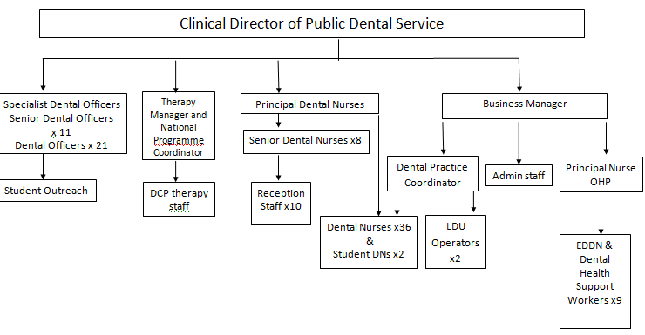

**Key Result Areas**

1. Provide high quality dental care for the most challenging individuals with impairment or disability that is physical, sensory, intellectual, mental, medical, emotional or social.
2. Provide training and support for colleagues including, Primary Care Dental Practitionersand specialist trainees in special care dentistry.
3. Provide a comprehensive Service for dentally anxious adults.

This will include:

* Personally providing inhalation, intravenous and Working with anaesthetists to provide comprehensive dental care under sedation and general anaesthesia.

1. Contribute to the ongoing development of services for those with ‘Special’ dental needs.
2. Undertake routine clinical duties covering the full range of client groups, as required.
3. Share responsibility with other senior staff for monitoring/managing the weekend ‘Out of Hours’ service (rotational).
4. Undertake a high quality clinical workload with further development of his/her areas of clinical expertise.
5. Keep up to date in advancements in clinical techniques and train others, if required.
6. Actively maintain and develop high quality clinical care through audit and service review in conjunction with colleagues.
7. Regularly review and monitor the service in conjunction with colleagues to ensure that waiting times are minimised.
8. Teach and train a variety of professional staff including the dental team, Primary Care Dental Practitioners, Specialist trainees.
9. Lead and participate in research to improve the quality of clinical and non-clinical care.
10. Undertake continuing professional development including the development of non-clinical skills and expertise.
11. Play a full part in the clinical management team for the Public Dental Service.
12. The SDO will undertake other duties appropriate to the post and grade as determined by the Clinical Director of the Public Dental Service.
13. To undertake domiciliary visits where necessary.
14. To maintain treatment records.
15. To participate in future research programmes and epidemiological studies, as required, and assist in DHE programme.
16. To participate in providing dental treatment as required under the terms of GDS regulations, including provision of Emergency Dental Services, as provided within NHS Fife.
17. To undertake the supervision of the dental nurses and help with training.
18. To be responsible for the ordering of materials and maintenance of equipment in base surgery.
19. To participate in clinical governance, audit and department meetings.
20. To work with Oral health educators and dental therapists as required providing high quality oral health care to patients.
21. To follow Fife Primary Care and departmental guidelines to ensure quality of service

**Communications**

The Senior Dental Officer (Special Care) will be part of the Clinical Management Team of Fife Public Dental Service and will play a full part in its work.

The SDO will liaise and collaborate with all members of the dental and Healthcare professions in Fife and with colleagues in NHS Fife Board to facilitate both professional and service development.

The SDO will liaise and collaborate with all members of external Agencies/Professions such as Education, Care Commission and Social Work to facilitate the service and programme development.

**Experience/Qualifications**

The Senior Dental Officer must be a dental graduate and be currently fully registered with the General Dental Council (GDC).

In addition, the SDO should have relevant and appropriate experience & training in special care dentistry.

Possession of a postgraduate qualification relevant to the post is essential.

**Continuing Education**

Fife has good access to opportunities for CPD. The Public Dental Service will expect the Senior Dental Officer to take part in the established Personal Development and Performance Review scheme, which includes agreement of a job plan and annual appraisal.

This job description will be subject to discussion and review on an annual basis within the appraisal process.