NHS Grampian

Job Description

SECTION 1
Job Title: | Highly Specialist Cardiac Physiologist (Echocardiography) Band 7
Department(s): | Cardiology
Location: | Aberdeen Royal Infirmary and community clinics
Hours: | 37.5 hours per week
Salary: | Band 7 (£39,300 - £46,006)
Contract: | Permanent
Job Reference: | NW029019

SECTION 2
Job Purpose
The post holder works as part of a team of Cardiac Clinical Physiologists (CCP) providing support to the Echocardiography Service based within the Department of Cardiology at Aberdeen Royal Infirmary.
The post holder is highly skilled and experienced in performing and reporting Echocardiograms.
At this level of post the post holder will have previous experience in a wide range of specialised areas of Cardiology techniques and will have chosen to specialise in the more complex and skilled areas of Echocardiography. In addition to the specialist tasks associated with this post the post holder will, on occasion, be required to work in general areas cardiac physiology, such as ambulatory ECGs, ETTs and cardiac cath labs. There may be a requirement to participate in the on-call rota for the cath labs.
On a day to day basis the post holder will work under the direction of the Echo Service Manager but will perform and report echo independently at ARI, outlying Cardiology Clinics including the Balfour Hospital, Orkney.
As well as performing a clinical role the post holder will be heavily involved in training and supervision of CCP and medical staff undergoing echo training.
Organisational Chart

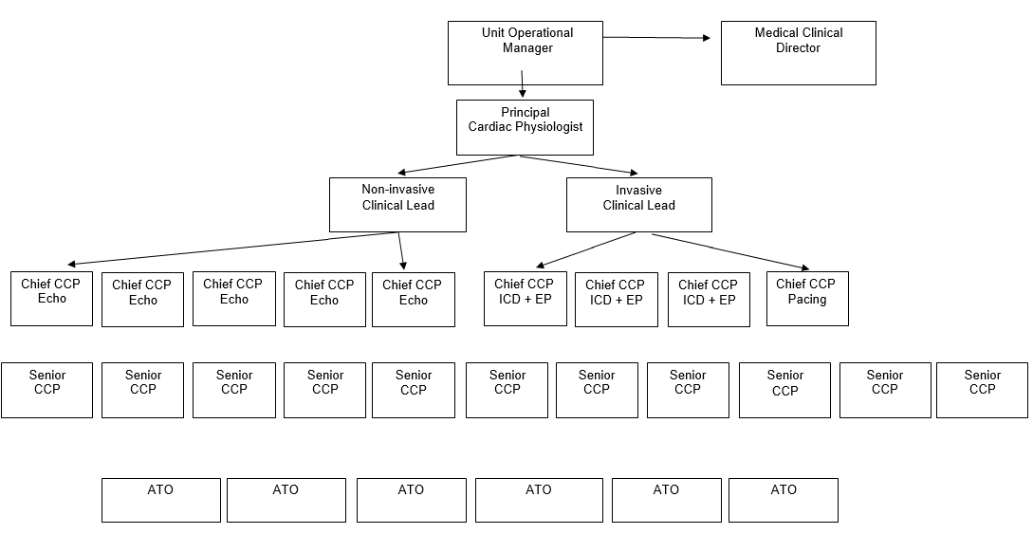
1 | Communication and relationship skills  - Verbal Communication  - Communicate complicated and/or sensitive information to patients in an encouraging, caring and professional manner, ensuring they understand what to expect during e.g. TOE procedure.  Cardiac abnormalities found during Echocardiography, which may need urgent clinical and / or surgical intervention.  - Communicate effectively with both medical and nursing colleagues during a cardiac arrest or peri-arrest situation. Empathise with any junior staff members who may not have witnessed such a situation before.  - Communicate with professional body as regards the necessary on-going training for fellow staff members in order to gain accreditation.  - Communicate with nursing staff informing them of forthcoming investigations for their patient’s +/- what if any preparation is required prior to investigation, e.g. fasting prior to TOE.  - Continuously influence, motivate, encourage and persuade CCPs ensuring they develop to their maximum potential in the field of Echocardiography.  Presentations / Lectures  - Regularly deliver short presentations and lectures to CCP’s.  - Deliver short presentations to nursing, medical and trainee ultrasound physicists when required - practical application and uses of echocardiography  - Deliver practical echocardiography training and instruction to medical colleagues at SpR training level.  - Written Communication  - Responsible for recording and maintaining accurate patient demographic information.  - Responsible for the compilation of monthly echocardiography figures for IM&T and departmental audit purposes.  - Responsible for the compilation of my personal clinical echocardiography reports, overseeing the checking accuracy of reports as performed by junior CCP’s  - Assist the Senior Chief CCP in charge of Echo during Recruitment and Selection of staff. Responsible for maintaining accurate written interview recording forms.  Required to assist the Senior Chief CCP in charge of Echo in the PDP of staff. Responsible for the recording of accurate written documentation.  - Regularly required to prepare written BSE course work for trainee CP echocardiographers.
2 | Knowledge, training and experience  - Knowledge  - Detailed Cardiac Anatomy and Physiology  - Electrocardiography + interpretation  - Detailed knowledge of Cardiac conditions including highly complex cardiac pathology drugs and terminology  - Detailed knowledge and understanding of technical cardiological investigations and associated tests and procedures.  - Theoretical and detailed practical working knowledge of a range of equipment listed in section 6  - General knowledge of NHSG Policies and Procedures including H+S  - Detailed working knowledge and understanding of the Echocardiography Departmental Policies and Procedures including H+S  - TRAINING  - At least 2 years training and experience at Senior CCP level within a Cardiology Department.  - Advanced, highly complex Echocardiography skills  - Attendance at advanced specialist and highly complex Echo courses and CPD  - Basic and Immediate Life Support  - Fire Lectures  - Infection Control – Barrier Nurse Procedures  - Manual Handling  - General management and care of patients undergoing investigations  - Maintain independent learning and development through, Internet, Intranet, researching journals and attending relevant courses and meetings.  - QUALIFICATIONS  - BSc Clinical Physiology or equivalent  - Professional Body Examination – ASCST parts 1+2  - BLS and ILS accreditation Resuscitation Council UK  - BSE Adult Proficiency Accreditation  - Voluntary member of The Registration Council of Clinical Physiologists (RCCP) or equivalent body.  - EXPERIENCE  - 6 years work experience in a non-invasive and invasive Cardiology setting.  - Highly Specialist knowledge and experience in all aspects of Echocardiography including highly complex studies.  - Training and supervisory skills  - Presentation skills  - IT literate
3 | Analytical and judgemental skills  - Patient care – priority is given to urgent or emergency cases in conjunction with the in-patient co-ordinator.  - Alerts the cardiologist of any life-threatening cardiac abnormalities detected which require urgent medical and / or surgical intervention.  - Decides most efficient and effective use of resources taking into account frequent unexpected demands or changes to workload often with little or no prior warning.  - Utilise staffing and equipment resources with maximum effect. Considers skill mix and competency of operator against complexity of the study required.  - Anticipates any potential problems, decides when to inform or seek help from Senior Chief CCP in charge of Echo.  - From a Clinical perspective, produces factual echo reports for the clinician – interprets study, deciding on content of report which will affect patient management. Performs reporting of studies performed by junior CCP staff and assists Cardiology SPRs in training with the interpretation and wording of their reports.  - Involved in the selection and decision making of new echo equipment (up to150K).
4 | Planning and organisational skills  - Takes into consideration the complexity of the echo prior to commencing the study in relation to the skill and experience of the operator as the information derived from the study is influenced by the skill of the Echocardiographer.  - The post holder has freedom to exercise discretion in planning clinic lists to achieve outcomes based on clinical priorities. The post holder has the freedom to initiate action (within broad policies) seeking advice when necessary.  - Participates in the selection and decision making of new Echo equipment (including echo machine trials). The post holder will keep up to date with new products, developments and techniques through e-learning, researching, journals and courses.  - Responsible for the day to day supervision of CCP staff working in the echo section, developing a standard of work in accordance with the BSE standard, this includes on-going coaching, mentoring, shadowing and clinical supervision of the CCP’s and medical staff in training.  - Deputises for the echo clinical lead in their absence.
5 | Physical Skills  - Frequent moving of equipment – pushing ECG trolleys, patients in wheelchairs, and occasionally heavy, cumbersome Echo machines.  - Frequent use of keyboard and VDU equipment  - Frequent use of Manual Handling – patient transfer from wheelchair to bed  - Occasionally required to perform CPR on a patient during a cardiac arrest (chest compression)  - Frequently required to endure long periods of physical strain when performing echocardiography on obese or immobile patients who are unable to position themselves in the standard position best suited for both patient and operator. This can cause the operator neck, arm and back strain (fully adjustable chair and couch used to minimise strain).  - Frequently required to endure prolonged periods of concentration while performing echo tests ie during a highly complex Echocardiography.  - Occasionally required to perform portable echocardiogram outwith the Department eg at patient’s bedside. Physical strain endured while actually pushing heavy machine as well as while performing echo at bedside without adjustable couch and chair.  - There is the great physical demand in hand to eye co-ordination allied to frequent and prolonged periods of concentration, keyboard skills and accuracy of manipulation of probe and machine controls during the performance of echocardiograms. Echocardiograms performed within a limited time frame and must be achieved by the post holder without compromising accuracy or quality of image acquisition and measurements eg Stress echo, contrast echo or TOE.
6 | Responsibilities for patient/client care  - Patient care – priority is given to urgent or emergency cases in conjunction with the in-patient co-ordinator.  - Responsible for the care and well being of patients attending for echo. (there is limited nursing support within the dept.)
7 | Responsibilities for policy and service development implementation  - Records monthly test activity figures for departmental audit and IM+T purposes  - Decides most efficient and effective use of resources taking into account frequent unexpected demands or changes to workload often with little or no prior warning.  - Contributes to the implementation and revision of echo related protocols and policies within the department.
8 | Responsibilities for financial and physical resources  - Will take responsibility for maintenance of expensive echo equipment.  - Involved in the selection and decision making of new echo equipment (up to150K).
9 | Responsibilities for human resources  Responsible for the provision of regular training and supervision of qualified CCP staff undergoing Echocardiography training in preparation for taking the BSE (British society of Echocardiography examination). In addition provides training, support and instruction to junior SpRs in echo as and when required who also may be working towards their BSE accreditation.  May be called upon to participate in interview panels for new job applicants at bandings below 7.
10 | Responsibilities for information resources  - Daybook Records – manual recording of daily activity and patient ID records.  - Patient Records – used to attain or clarify clinical information prior to test, review previous test results and file test results.  - Uses EPR to identify patient results, patient referral letters if no medical notes available.  - Uses EPR for vetting Echo referrals, allocating suitable patients to the various community hospitals  - Records monthly test activity figures for departmental audit and IM+T purposes  - Uses E-mail for general communication with colleagues both medical and technical, company representatives etc  - Uses ‘echopac’ and ‘xcelera’, computers continuously - archiving systems on the echo machines that contains patient demographics, echo reports etc  - Responsible for recording and maintaining accurate patient demographic information.  - Responsible for the compilation of monthly echocardiography figures for IM&T and departmental audit purposes.  - Responsible for the compilation of my personal clinical echocardiography reports, overseeing the checking accuracy of reports as performed by junior CCP’s
11 | Responsibilities for research and development  Participates from time to time in Research and Development, giving echo support to the Research Consultants and Medical Staff on echo related projects.
12 | Freedom to act  - Patient care – priority is given to urgent or emergency cases in conjunction with the in-patient co-ordinator.  - Decides most efficient and effective use of resources taking into account frequent unexpected demands or changes to workload often with little or no prior warning.  - Utilise staffing and equipment resources with maximum effect. Considers skill mix and competency of operator against complexity of the study required.  - Anticipates any potential problems, decides when to inform or seek help from Senior Chief CCP in charge of Echo.  - From a Clinical perspective, produces factual echo reports for the clinician – interprets study, deciding on content of report which will affect patient management. Performs reporting of studies performed by junior CCP staff and assists Cardiology SPRs in training with the interpretation and wording of their reports.  - Involved in the selection and decision making of new echo equipment (up to150K).
13 | Physical effort  - Frequent moving of equipment – pushing ECG trolleys, patients in wheelchairs, and occasionally heavy, cumbersome Echo machines.  - Frequent use of keyboard and VDU equipment  - Frequent use of Manual Handling – patient transfer from wheelchair to bed  - Occasionally required to perform CPR on a patient during a cardiac arrest (chest compression)  - Frequently required to endure long periods of physical strain when performing echocardiography on obese or immobile patients who are unable to position themselves in the standard position best suited for both patient and operator. This can cause the operator neck, arm and back strain (fully adjustable chair and couch used to minimise strain).  - Frequently required to endure prolonged periods of concentration while performing echo tests ie during a highly complex Echocardiography.  - Frequent exposure to blood and bodily fluids during invasive procedures - potential for needlestick injury eg during contrast or TOE studies.  - Occasionally required to perform portable echocardiogram outwith the Department eg at patient’s bedside. Physical strain endured while actually pushing heavy machine as well as while performing echo at bedside without adjustable couch and chair.  - There is the great physical demand in hand to eye co-ordination allied to frequent and prolonged periods of concentration, keyboard skills and accuracy of manipulation of probe and machine controls during the performance of echocardiograms. Echocardiograms performed within a limited time frame and must be achieved by the post holder without compromising accuracy or quality of image acquisition and measurements eg Stress echo, contrast echo or TOE.
14 | Mental effort  - Frequently required to endure prolonged periods of concentration while performing echo tests ie during a highly complex Echocardiography.  - From a Clinical perspective, produces factual echo reports for the clinician – interprets study, deciding on content of report which will affect patient management. Performs reporting of studies performed by junior CCP staff and assists Cardiology SPRs in training with the interpretation and wording of their reports.
15 | Emotional effort  - Dealing with one’s feelings in the aftermath following a prolonged, unsuccessful cardiac arrest.  - Endures occasional interruptions whilst scanning eg by CCP’s, receptionist and medical staff – occasionally requiring immediate attention.  - Occasionally exposed to people who can be demanding and verbally aggressive and abusive.  - Frequently and directly exposed to people with unpleasant body odour.  - Frequently and for long periods, deal with a constant, high volume, heavy demanding workload.  - Frequently and directly exposed to acutely ill patients whose recovery prognosis is poor.  - Occasionally but directly exposed to patients who have undergone acute and severe physical injury eg trauma patients.
16 | Working conditions  - Works as a sole practitioner, performing and reporting Echo for New patient Cardiology clinics at Orkney and other community hospitals within NHSG (Inverurie, Turriff, Aboyne, Peterhead(PCH) and Kincardine (KCH) )and NHS Orkney.  - Majority of working week spent alone in darkened echo lab.  - Frequent moving of equipment – pushing ECG trolleys, patients in wheelchairs, and occasionally heavy, cumbersome Echo machines.  - Frequent use of keyboard and VDU equipment  - Frequent use of Manual Handling – patient transfer from wheelchair to bed  - Occasionally required to perform portable echocardiogram outwith the Department eg at patient’s bedside. Physical strain endured while actually pushing heavy machine as well as while performing echo at bedside without adjustable couch and chair.  - Endures occasional interruptions whilst scanning eg by CCP’s, receptionist and medical staff – occasionally requiring immediate attention.

PERSON SPECIFICATION
POST/GRADE: Highly specialist cardiac physiologist band 7
LOCATION: Cardiology department
WARD/DEPARTMENT: Aberdeen Royal Infirmary based, but will require community hospital and island working (Orkney and Shetland).
The Person Specification should meet the demands of the job and comply with current legislation. Setting unnecessary standards may, for example, unfairly discriminate against one sex, the disabled or minority racial groups. Applicants should be assessed in relation to their ability to meet the real requirements of the job as laid down in the job description. With the exceptions relating to displaced and disabled candidates noted in Sections 5.3 and 5.4 of this policy, shortlisted candidates must possess all the essential components as detailed below.
GENERAL REQUIREMENTS
Factor | Essential | Desirable
Qualification & Experience | BSc in Clinical Physiology (Cardiology) or equivalent qualification along with suitable knowledge, training and experience.  BSE adult proficiency accreditation.  Highly Specialist knowledge and experience in all aspects of general echo.  BLS and ILS Resuscitation council UK certification (or equivalent). | Experienced in ETT and Holter monitoring, general cath lab duties.  ASCST Parts 1+2.  RCCP/AHCS registration (or equivalent).  Interest and experience in a specialist area of echo such as 3D or GUCH.  Willingness to participate in the cath lab on-call rota.
Circumstances & flexibility | Based at ARI but required but may be required to work in community / other hospitals within NHSG | Hold a current driving licence  Own or have access to use of a car
Particular requirements of the post | Competent IT skills.  Ability to work both as a team and a lone worker.  Good communication skills.  Good organisational and prioritising skills.  Accuracy and attention to detail.  Good interpersonal skills.  Calm and able to work under pressure.  Able to use own initiative.  Positive attitude.  Good general health -Echocardiography requires long periods of scanning. | Presentation skills.  Experience of assessing the training needs of junior staff.
Level of Disclosure check required | PVG
APPENDIX 3

