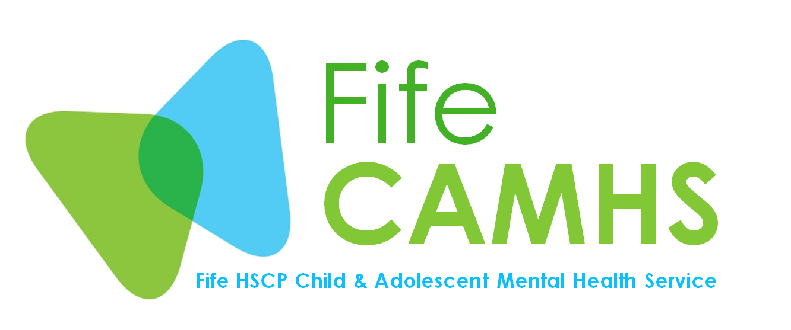

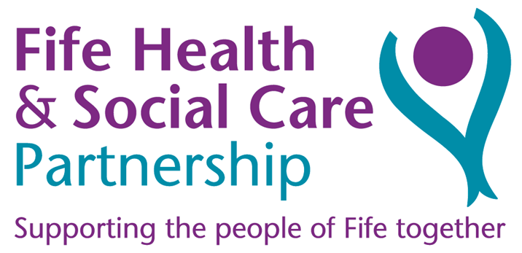

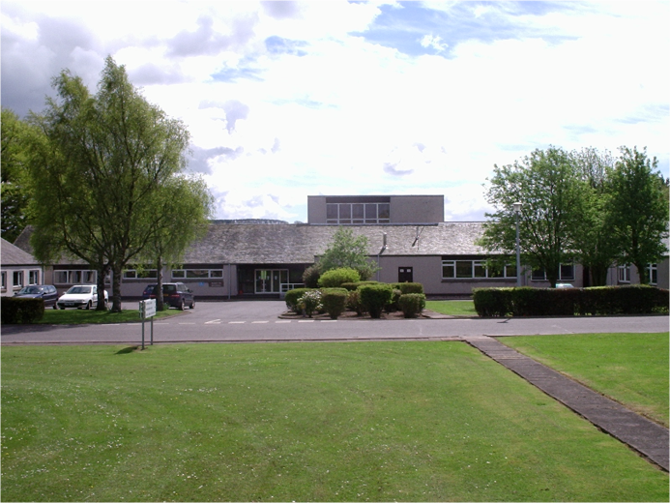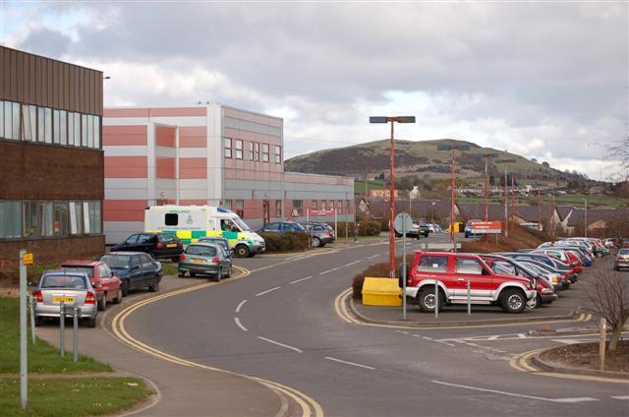

**Consultant**

**Child & Adolescent Psychiatrist**

**Up to 10 sessions**

**Contents**

|  |  |
| --- | --- |
| Introduction | 3 |
| Overview of post | 3 |
| Person specification – Consultant Child & Adolescent Psychiatrist | 4 |
| Background to the post | 5 |
| Role of the Consultant Psychiatrist | 5 |
| Work of the department | 6 |
| Duties of the post | 7 |
| Qualifications and experience | 9 |
| Additional post information | 9 |
| NHS Fife Strategic Framework | 12 |
| Appendices | 14 |

**Who to contact about the post**

For more details about the post and application information, please contact:

|  |  |  |
| --- | --- | --- |
| Dr Claudia Grimmer  Clinical Lead  CAMHS  Playfield House  Stratheden Hospital  Cupar  Fife KY15 5RR  Tel: 01334 696250  Email: claudia.grimmer@nhs.scot | or | Mr Lee Cowie  Clinical Services Manager  CAMHS  Playfield House  Stratheden Hospital  Cupar  Fife KY15 5RR  Tel: 01334 696250  Email: lee.cowie@nhs.scot |

To find out more about Fife, local psychiatry services, and the latest opportunities, please visit:

**Introduction**

Fife Child and Adolescent Mental Health Service (CAMHS) is a well-established but evolving community based service which provides care for children and young people from the age of 0 to 18 years and includes Mild Learning Disability. There is a separate service for children with moderate to severe Learning Disabilities. Fife is a mixed rural/urban area with a general population of approximately 350,000 and an under 18 population of approximately 88,000.

The Psychiatry department staffing complement is 5.0 WTE consultant psychiatrists, 1.0 speciality doctor, and one Core Trainee who changes every six months. The service is accredited for a higher trainee post from the national Higher Training Scheme.

This additional post will provide up to 10 consultant psychiatrist sessions based in EAST team covering east and central Fife.

Fife CAMHS includes a core group of experienced and well qualified clinicians from a number of disciplines including Medical, Nursing, Occupational Therapy, Dietetics, Psychology, Child Psychotherapy and Social Work. The recent expansion of Fife CAMHS through the implementation of the Scottish Government Recovery and Renewal fund has led to a number of developments and a substantial increase in the multi-disciplinary team.

The service provides Tier 3 community support for children and young people up to age 18 in two localities based teams (EAST and WEST Fife), as well as Tier 4 community support for young people with severe and complex mental health presentations through the Intensive Therapy Service (Fife wide). Practice of Family Based Therapy (FBT) for Eating disorders and Behaviour Family Therapy (BFT), as well as systemic family therapy and a dietician and psychologist in the team means that Fife has a very low admission rate to psychiatric inpatient beds. Where admission is indicated, young people can be referred to the regional inpatient unit in Edinburgh. In addition Fife CAMHS has a separate nurse-led urgent response team with dedicated medical input.

The administrative base for CAMHS is at Playfield House (East CAMHS), in the grounds of Stratheden Hospital, on the outskirts of Cupar. The West CAMHS Team operates from Carnegie Unit at Queen Margaret Hospital. Clinical services also operate from a range of community based clinics throughout Fife, including Whyteman’s Brae Hospital, Kirkcaldy and Glenwood Health centre in Glenrothes.

The establishment in 2005 of the Playfield Institute as a resource for skills development, research and the provision of information, has opened up new opportunities for the successful post holder to receive support for research and engage in a range of training events.

Linking with, and expanding the work of Playfield Institute, Fife CAMHS has a well established primary mental health worker team and two existing therapeutic services for looked after children and a third team in development focussing on those in Kinship care. The Fife CAMHS website, HANDS ON Scotland (www.handsonscotland.co.uk) provides education and links to further information and advice around all areas of child and adolescent mental health.

**Overview of post**

**The post**: Consultant Child & Adolescent Psychiatrist

**Sessions:**  up to 10 sessions

**Department**: Fife CAMHS Generic service, Base Playfield House, Stratheden Hospital, Cupar

The post will be providing 1.0 WTE outpatient Child & Adolescent Psychiatry service to children and young people in Fife in collaboration with other CAMH clinicians.

The base for the East team is at Playfield House, Stratheden Hospital Cupar and for the West team at Carnegie unit, Queen Margaret Hospital, Dunfermline.

The post holders will be part of a multidisciplinary team comprising other consultants, nursing, psychology, OT, child psychotherapy and dietetics.

**Person specification – Consultant Child and Adolescent Psychiatrist**

|  |  |  |
| --- | --- | --- |
|  | **Essential** | **Desirable** |
| Qualifications  and Registration | MB ChB and MRCPsych  Full registration with the GMC with a license to practice  Must have CCST and be entered on the Specialist Register or within 6 months of entry on the Specialist Register at date of interview. | MPhil |
| Training and  Experience | Recent significant experience and familiarity of UK CAMHS systems and practices (or equivalent)  Training in diagnosis and treatment of child and adolescent psychiatric conditions | Other relevant training in therapeutic interventions, e.g. Family therapy and Group therapy. An interest in Autism Spectrum Disorder |
| Further Training, Management, and Audit | Experience in audit  Knowledge of contemporary NHS management issues  Knowledge of contemporary political and social policy context relevant to CAMHS | Completion of a general management course or programme  Interest in medical management |
| Research,  Teaching, and  Publications | Proven teaching ability  Willingness to undertake teaching of medical  Under-graduates & postgraduates  Evidence of relevant publications in peer reviewed journals | Proven track record in research and willingness to undertake further research |
| Personal  Requirements  (e.g.  Communication  Leadership Skills, Flexibility) | Ability to form effective working relationships within a team and provide leadership  Ability to inspire, motivate and develop other staff  Ability to work independently as well as part of the team. To balance individual requirements against those of the wider NHS Organisation  Good written and verbal communication skills. Evidence of the ability to communicate with patients, colleagues and staff at all levels | Ability to gain the trust and confidence of colleagues and patients |
| Any other  General  Requirements | Ability to fulfil all the duties of the post  Must be mobile  Good Health Record  Full driving licence | Evidence of interest in the post |

**Background to the post**

The Child and Adolescent Mental Health Service is managed under Fife Mental Health & Learning Disability services which is part of Fife Health & Social Care Partnership: Complex and Critical Care Services. It enjoys close links with Adult Psychiatric services. There are currently three centres for adult in-patient provision, Queen Margaret Hospital, Dunfermline, Whyteman’s Brae Hospital, Kirkcaldy and Stratheden Hospital, Cupar.

Close links are also established with colleagues in Children’s Services including the paediatric service (both hospital and community based)- the closest being the joint input into diagnostic screening teams for Autism Spectrum Disorders and the Tier2 ADHD pathway, which is managed within the community paediatric service. This team is comprised of community paediatricians and ADHD nurses and psychology. Parental Group education on ADHD is offered in Fife. Since Mid 2017 the input of medical time into the well established Tier 3 ADHD pathway is being provided by child and adolescent psychiatry. Work is also underway to establish a multi-disciplinary neuro-developmental pathway.

**Role of the Consultant Psychiatrist**

The role of the consultant psychiatrist is crucial to the smooth, effective and safe running of all clinical services within Fife CAMHS. Consultants have an overarching role in which they provide a number of essential functions in relation to the work of all teams. This is done by

* + Responding to requests and referrals for patient consultations.
  + Promoting distributed responsibility and leadership across clinical teams.
  + Teaching.
  + Supervising junior medical staff.
  + Providing a departmental lead in relation to promoting an understanding of diagnosis, pathology and best practice guidelines for treatments.
  + Recommending organisational and systems changes which could lead to improved outcomes and safer outcomes for patients.
  + Supporting the Clinical Services Manager and Clinical Lead in their management role and their service coordination role.

The post holder will therefore offer a clinical input into a number of teams. Of particular importance is the role in relation to the Intensive Therapy Team which offers high levels of support to young people with significant mental health problems who may be at risk of requiring admission to inpatient units. The post holder will be providing clinical input and leadership to the East team jointly with the other consultants. The appointee will also have the opportunity to be actively involved in the further development of new services.

**Work of the department**

Child and Adolescent Psychiatry operate as a key discipline within Fife Child and Adolescent Mental Health Service. The key objectives of the department can be summarised as follows:

* To provide a variety of high quality general and specialist community based mental health services for children, young people and their families within the context of close partnerships with other health service providers and partner agencies.
* To engage in work right across the spectrum of complexity /severity, with a dual focus on direct work and capacity building.
* To develop the capacity of non CAMHS specialists in providing effective and early interventions for children and young people with less severe problems and where there is less complexity.
* To demonstrate a multi-disciplinary teamwork approach to complex cases which acknowledges both the unique contribution of the constituent disciplines and of the individual team members.
* To take part in service development.

All non-medical clinicians belong to the following teams:

* CAMHS Primary Mental Health Workers (PMHW)
* Family Therapy Service
* Intensive Therapy Service (ITS)
* Looked After and Accommodated Children Service (The Beeches & Springfield Project)
* Multi-disciplinary teams (East and West)
* CAMHS Urgent Response Team (CURT)
* Trauma Service (Sea View Project)

Other teams include:

* ADHD Pathway
* Autistic Spectrum Diagnostic Teams

**Medical staffing establishment**

Current posts within CAMHS (not including this post):

|  |  |  |
| --- | --- | --- |
| Dr Claudia Grimmer | Clinical Lead | 0.8 WTE |
| Dr Lynn Brown | EAST team | 0.7 WTE |
| Dr Sheela Das | EAST team | 0.8 WTE |
| Dr Farah Rozali | EAST Team | 0.8 WTE |
| Dr Mhairi McNeil | WEST Team | 0.6 WTE |
| Dr Steven Voy | WEST Team | 0.9 WTE |
| Dr Ramanujapuran (Speciality doctor) | WEST team | 0.5 WTE |
| Dr Jan Esparon | ADHD Tier 3 Service | 0.4 WTE |
| Dr Ramanujapuram (Speciality doctor) | ADHD Tier 3 Service | 0.5 WTE |

**Managers and senior staff**

|  |  |
| --- | --- |
| Lee Cowie | Clinical Services Manager |
| Dr Claudia Grimmer | Clinical Lead - Consultant Child and Adolescent Psychiatrist |
| Hilary Maddox | Head of Child and Family Psychology Service |
| Moira Shulman | Head of Child Psychotherapy: Service Lead for trauma service |
| Eugene Adams | Nurse Consultant: Service Lead for Early Intervention |
| Jane Sinclair | Head Occupational Therapist: Service Lead for Core services |
| Christopher Ward | Nurse Consultant: Service Lead for Acute services |

**Junior medical staff**

Higher trainees from the National CAP training scheme rotate to NHS Fife CAMHS for 6 months to 1 year placements.

**Duties of the post**

**Clinical Responsibilities**

* + - To provide a generic Child & Adolescent Psychiatry service to children and young people Fife area on distinct days in collaboration with other CAMH clinicians.
    - To provide a regular and consistent consultant psychiatry input to the Intensive Therapy service, working closely with team members in managing young people with severe mental health disorders who require high levels of support in a community setting and contributing to the ongoing delivery of the service to such patients and to clinical management decisions affecting them.
    - To continue to hold clinical medical responsibility for patients referred internally to the Intensive Therapy Service.
    - To carry out psychiatric assessments; often conjointly with clinicians from other disciplines; where this is indicated by the nature of a referral and or requested by CAMH clinical colleagues from across the CAMH Service.
    - To offer consultancy to other team members.
    - To offer consultancy to external agencies, potential referrers etc.
    - To become and remain actively involved in clinical liaison with community child health services, general adult psychiatrists, consultants in learning disabilities, hospital and community based paediatricians and others.
    - To undertake duties as an approved medical practitioner under the terms of the Mental Health (Care and Treatment) (Scotland) Act 2003.
    - To undertake the administrative duties associated with the care of patients and the organisational systems designed to support this care.
    - A job plan will be agreed with the person appointed. A provisional job plan for the post is appended, but will be subject to review in the light of experience and in response to service developments.

**Audit Responsibilities**

You will be supported to participate and contribute to the established multidisciplinary audit programme within the department and to further develop, in conjunction with other members of the service, a quality assurance/audit programme which will include the introduction of routine clinical outcome measures.

**Teaching and Training Responsibilities**

You will be supported to develop along with other staff, teaching programmes for those working in the CAMH Service and related professions. There is also an expectation for the appointee to share responsibility (with other team members) for the training and supervision of the junior medical staff within the department.

**Other Supporting Professional Activities**

You will be expected to maintain a programme of continuing professional development and take part in annual appraisal and revalidation as well as research and clinical governance activities.

**Other Responsibilities**

The appointee will be expected to be aware of the broader context within the NHS in which doctors operate.

* On-call
  + This post currently does not carry an out of hours on-call commitment however developments are underway to develop a Regional/National out of hours response which will include Fife CAMHS psychiatry.
  + You will be expected to respond to urgent referrals during working hours and in addition, participate in the CAMHS Psychiatry duty rota.
* Locum Policy
  + It is expected that the Consultants in Child and Adolescent Psychiatry will normally cover for each other for short periods of absence.
  + Leave arrangements will be agreed between the Consultants and authorised by the Clinical Service Manager, ensuring that the service is adequately covered at all times.
* Member of Groups
  + The post holder will be a member of:
    - Fife Division of Psychiatry
    - Other short term and long term committee responsibilities depending on specific interests and clinical responsibilities undertaken.

**Qualifications and experience**

The post holder must be a fully qualified medical practitioner fully registered with the General Medical Council and a Member of the Royal College of Psychiatrists having completed a recognised period of higher training sufficient to equip them for a Consultant post in Child & Adolescent Psychiatry.

Recognised equivalent overseas training and qualifications will be acceptable.

See also Person specification (page 4).

**Additional post information**

**Secretarial support and office accommodation**

The consultant will have consulting and administrative space within their agreed place of work. The consultant will have access to full secretarial support. In addition to the main administrative base at Playfield House the other main clinical bases are currently at Kirkman clinic in Whyteman’s Brae Hospital, Kirkcaldy, Glenrothes Hospital and Carnegie Unit Queen Margaret Hospital, Dunfermline.

**Contract, accountability and professional support**

The post holder will have a contract of employment with NHS Fife. The terms and conditions of service relating to employment are those currently set out in the Hospital Medical & Dental Staff and Doctors in Public Health Medicine and the Community Health for the Consultant Grade and the General Whitley Council Conditions of Service.

An outline job plan has been included with this job description (see Appendix 1). The post holder will agree the details of the plan with the CAMHS clinical lead at the earliest opportunity following appointment. The job plan is subject to annual review.

The post holder should make requests for annual leave and reports of sickness absence to the clinical lead and management secretary. The successful candidate is expected to contribute to management tasks.

Professional support is available through NHS Fife Medical Director and/or Director of Public Health with whom the appointee is entitled to discuss any grievance relating to their employment, or to gain advice and/or support following a failure to agree a job plan at review. NHS Fife Board act as final arbiters of disputes over job plans which cannot be resolved at local level.

**Employment details**

All NHS Fife appointments are subject to a satisfactory medical report and a PVG check.

The appointment is superannuable unless you opt out of the NHS Superannuation Scheme. Staff who choose not to be in the scheme will automatically contribute to the State Earnings Related Pension Scheme (SERPS) unless they are excluded from doing so or have arranged a Personal Pension Plan.

The annual leave entitlement for consultant staff is 33 days and 8 public holidays per annum on a pro rata basis.

The working week for this post will be agreed with the post holder , with the maximum sessions per post being 10- with a timetabled value of 4 hours each, worked between 8 am and 9 pm Monday to Friday, including emergency work.

The post will offer a maximum of 2 SPAs. 1 is guaranteed for CPD the other will be negotiated taking into account duties such as appraiser, trainer or other agreed specific tasks.

The salary on appointment (exclusive of any distinction and service awards payable to you will be determined by multiplying the number of contracted sessions (maximum of nine) by one tenth of the salary payable to a full time Consultant.

Salary Scale: £91,474 - £121,548 per annum (pro rata for part-time). Progression through seniority points will be in accordance with the provisions of Section 5 of the Terms and Conditions of service.

In addition to the duties outlined above, you may occasionally be required to undertake other duties for limited periods.

The employment is subject to three months’ notice (or longer) on either side.

Your residence shall be maintained in contact with the public telephone service. The post is non-resident, and therefore, you will be entitled to appropriate reimbursement for place of residence.

**NHS Fife Strategic Framework**

***Our Vision***

The people of Fife live long and healthy lives

***Our Mission***

Transforming health and care in Fife to be the best

***Our Values***

Safety First

Dignity & Respect

Care & Compassion

Excellence

Fairness & Transparency

**We aspire to be Person-Centred**

*Our Objectives - we will:*

* listen to what matters to you and treat you as an individual
* design services in partnership with service users, carers and communities
* give you choices and information
* create environments that encourage caring and positive outcomes for all
* develop and redesign services that put patients first, supporting independent living and self-management of health through the integration of health and social care

**We aspire to be an Exemplar Employer**

*Our Objectives - we will:*

* create time and space for continuous learning
* listen to and involve staff at all levels of the organisation
* give staff the skills, resources and equipment needed to do their jobs
* encourage and expect all staff to take appropriate decisions
* encourage staff to be ambassadors for health and social care in Fife
* create high performing multi-professional clinical teams through clinical education and development
* equip people to be the best leaders

**We aspire to be Clinically Excellent**

*Our Objectives - we will:*

* work with you to ensure you receive the best possible care
* ensure there is no avoidable harm
* achieve and maintain recognised quality standards
* ensure that NHS Fife’s environment is clean, tidy, well maintained, safe and something to be proud of
* embed patient safety consistently across all aspects of healthcare provision
* support research, innovation and quality improvement which will see NHS Fife as a centre of excellence

**We aspire to be Sustainable**

*Our Objectives - we will:*

* ensure the maximum impact of our resources in the promotion of health and wellbeing
* increase efficiency and reduce waste
* ensure that our activities are cost effective and within budget
* ensure that all service redesign and development makes the most effective use of resources and avoids waste and unwarranted variation
* develop, in collaboration with our partners, our property and assets to meet the changing needs of health and social care provision

**Appendix 1: Example job plan for a 10 session post**

This post will consist of 8 sessions of programmed activities (PA) and 2 sessions supported programmed activity (SPA). The post holder will be part of the POD (psychiatrist of the day) rota once a week.

|  |  |  |
| --- | --- | --- |
|  | AM | PM |
| **Monday** | CAMHS clinic | Admin and consultation |
| **Tuesday** | EAST team meeting and case discussion | SPA |
| **Wednesday** | ITS meeting | CAMHS clinic |
| **Thursday** | SPA | CAMHs clinic |
| **Friday** | CAMHS clinic | Admin and consultation |

The successful appointee will negotiate their own job plan in such a way as to meet the needs of the service and their professional development needs within their agreed contracted hours/sessions.