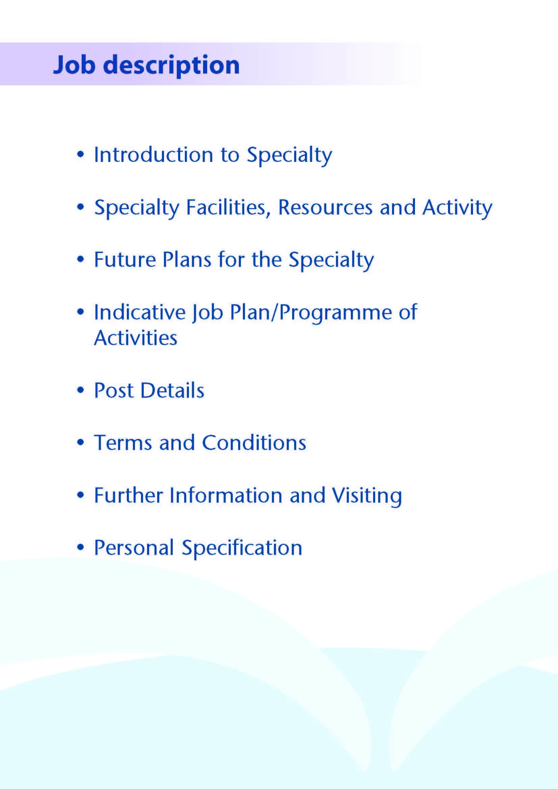



This Specialty Doctor post will be based at University Hospital, Ayr. The successful applicant will support a team of 13 Medical Consultants (2 respiratory, 4 rheumatology, 1 gastroenterolology, 5 cardiology, 1 COTE).

The successful candidate will contribute to the middle tier rota on a 1:12 basis.

University Hospital Ayr is a 343-bedded general hospital located to the south east of Ayr town. University Hospital Ayr also provides several area-wide services for Ayrshire and Arran including Rheumatology, Vascular Surgery and Urology.

The hospital is easily accessed by road, with the recently upgraded M77 providing rapid access to Glasgow (45 minutes from the University Hospital Ayr). Rail services also link Ayr to Glasgow and other surrounding towns. University Hospital Ayr provides free car parking facilities.

Ayrshire is able to provide excellent local education, competitively priced real estate and excellent leisure opportunities such as watersports, cycling and world class golf courses

**General Medical Services**

Rheumatology – There are 4 rheumatology consultants and a speciality doctor . There are multiple clinics across sites including joint injection clinics, USS clinics which the successful candidate will be able to attend. There is a rheumatology on-call consultant and clinical email box with a plan to set up a flare clinic and rheumatology MDT.

Cardiology – There are 5 cardiology consultants covering the ward including CCU , clinics ,on call and a cardiologist of the week. There is a cath lab for angiogram, pacemaker insertion, ICD with an excellent electrophysiology department .

Respiratory – There are 2 respiratory consultants and a speciality doctor who cover  the ward, clinics , respiratory referrals and respiratory procedures

Gastroenterology – we have an experienced Locum consultant who runs the gastroenterology ward,sees gastroenterology referrals and does endoscopy

COTE – This is mainly based at the Biggart hospital with the consultants seeing patients in Ayr hospital ,  a dedicated Falls and a Parkinson’s clinic with an array of ACE practitioners to help assess  frail patients

**Specialist Services**

NHS Ayrshire and Arran has been very proactive in developing enhanced nursing roles.



**Facilities**

**IMAGING**

An extensive range of imaging facilities are available including spiral CT with 3D reconstruction, MRI, MRA, nuclear medicine and digital subtraction angiography.

**ACCIDENT AND EMERGENCY DEPARTMENT**

Currently both the University Hospital Ayr and University Hospital Crosshouse provide full Accident Emergency facilities through the two departments. Both are staffed by teams of Consultants in Emergency Medicine.

**COMBINED ASSESSMENT UNIT**

The CAU is relatively new in University Hospital Ayr and opened on 17th June 2017. This is a 24 hour unit with 29 single en suite rooms, 8 ambulatory care bays, 4 ambulatory care chairs, 5 rapid assessment bays, 2 out-patient rooms and 3 initial assessment bays, Patients are referred to the unit either direct from their General Practitioner or from the Emergency Department.

**MEDICAL PHOTOGRPAHY**

The Medical Illustrations Department can provide a full service at both hospitals for clinical photography, preparation of slides and posters.

**EDUCATION CENTRES**

Excellent post-graduate facilities are provided at both hospitals, with the MacDonald Education Centre based at the University Hospital Ayr and the Alexander Fleming Education Centre based at University Hospital Crosshouse. Both centres include a full size lecture theatre, classrooms and a number of tutorial rooms. The facilities are supported with modern audio visual and information technology, including teleconferencing facilities and both centres incorporate an excellent up-to-date library with a resident librarian.



There have been a number of developments in the

Medical directorate:

A new Endoscopy Unit opened in November 2009. Endoscopy services are fully comprehensive and cover all diagnostic and therapeutic techniques currently available. The Unit at Ayr has three Nurse Endoscopists who support medical staff in delivering the endoscopy service to the residents of South Ayrshire.

A Clinical Development Fellow Programme was implemented in 2019 to bring locally employed doctors at FY2+ level into the Board. There are between 5 and 10 CDFS employed within the medical directorate at University Hospital Ayr in each year in medicine and over 100 CDFs employed within the Board.

The Specialist role will be introduced into the department in 2024/25.

The department is currently looking for new and innovative ways to develop the service.



The appointee will engage in all forms of planned and unscheduled care with opportunities to rotate through out-patient clinics in order to meet the requirements of the portfolio pathway.

It is likely that the post will attract an additional 2 programmed activities on top of the core contract to 10 PAs but candidates wishing to restrict themselves to 10 PAs will not be disadvantaged. Whatever contract is agreed PAs will be allocated to recognise the commitment to emergency duty work associated with the participation on the middle tier rota. The rota pattern is illustrated below.

Outwith periods of night shift, planned clinical activities will vary slightly depending on the sub-specialty team allocation but on a 12 PA contract this will approximately equate to the following;

* 3 specialty clinical sessions comprising outpatient clinics and specialist lists dependent on rotation (e.g.out-patient clinic,endoscopy, bronchoscopy)
* 1 Session for Clinical Administration
* 3 sessions for rota contribution (long days, weekends and nights)
* 2 sessions for supporting professional activity and portfolio pathway development.
* 3 sessions for ward clinical duties

The job plan will be reviewed with the successful candidate no later than 3 months following appointment and where possible discussion may take place in advance of appointment. Job plan review thereafter will be no less frequent than annually.

The agreed job plan will include all the appointees professional duties and commitments, including agreed Supporting Professional Activity.

**Notes on the Programme**

**Patient Administration**. This activity covers the management of individual patients including Out Patient administration, results reporting, letters/phone calls to patients, carers, GP’S and members of the wider multidisciplinary team involved in the patients care.

**Ward Rounds**: the time allocated is indicative and will be discussed with the appointee. Ward work will include teaching ward rounds as required.

**Travel:** Any travel allocation will be included within the Total Programmed Activities and will be determined by location at which Direct Clinical Care and Supporting Professional activities are carried out.

**On call arrangements**: On Call is on a 1:12 basis and a template rota is detailed below.

INSERT ROTA

**Supporting Professional Activities and Job Plan Review**:

NHS Ayrshire and Arran recognise the important role Job Planning has in ensuring SAS doctors are supported in delivering high quality, safe, sustainable clinical care to patients. It is therefore important to ensure there is an adequate balance between direct clinical care activities and activities which support both the personal and professional development of the consultant workforce and facilitates agreed contribution to activities including:

* Under and post graduate teaching/training
* Clinical Governance
* Quality and Patient Safety
* Research and Innovation
* Service management and planning
* Work with professional bodies

All Specialty Doctors on the portfolio pathway will have 2 SPA as a minimum to support job planning, appraisal and revalidation and working towards completion of portfolio pathway.

**Job Plan Review**

New appointees will have an interim Job Plan review conducted at 3 months post commencement to review the balance previously agreed. The agreed job plan will include all the consultant’s professional duties and commitments, including agreed Supporting Professional Activities.    Thereafter Job Planning will be carried out annually as part of the Boards Job Planning process.

**Teaching**: The postholder will be responsible for the training and supervision of post-graduate doctors and will be expected as part of their SPA allocation to devote time to this activity on a regular basis. In addition he/she will be expected to ensure that Junior Staff and medical students receive adequate support and advice and may act as a contact as the person responsible for overseeing their training and as an initial source of advice.



The postholder will be accountable to the Associate Medical Director for Medical Specialties who will agree the Job Plan.

**Resources**

The postholder will have access to an educational supervisor who will be able to support sign off of portfolio pathway paperwork. The postholder will have access to such general administrative support as is required for the discharge of his/her duties and responsibilities.

The postholder will receive support from such other professional staff as are employed within the Division and are deployed to his/her area of patient care.

**Duties and Responsibilities**

The main duties and responsibilities of the post include:

* Responsibility for delivery of independent GIM ward rounds
* Professional supervision and management of Junior Medical Staff.
* The postholder will be required to comply with Organisation’s Policies on Clinical Governance.
* The successful applicant will be encouraged to participate in research and to develop a subspecialty interest to complement the department, subject to resources and local priorities.
* Requirements to participate in medical audit and in continuing medical education.

**Annual Appraisal & Job Planning**

You shall also be required to participate in annual appraisal. Job planning is linked closely with, but is separate to, the agreed appraisal scheme for consultants. The job plan review will take into account the outcome of the appraisal discussion and reflect the agreed personal development plan.



Are those determined by the Terms and Conditions of the New Specialty Doctor grade (Scotland) 2022 as amended from time to time. The distance that a specialty doctor can reside from the principal base hospital, where travel time is seen as more important than mileage, is subject to the agreement of the Executive Medical Director.



# 

**Post of**: Specialty Doctor in General Internal Medicine (Portfolio Pathway)

**Location**: University Hospital Ayr

|  |  |
| --- | --- |
| Qualifications: Essential | Desirable |
| MBChB/MBBS or equivalent medical qualificationSuccessful completion of MRCP or equivalent |  |
| * Full GMC Registration with a Licence to Practice at time of appointment * Evidence of achievement of Foundation competences by time of appointment in line with GMC standards/ Good Medical Practice including:   + Good clinical care   + Maintaining good medical practice   + Good relationships and communication with patients   + Good working relationships with colleagues   + Good teaching and training   + Professional behaviour and probity   + Delivery of good acute clinical care * Completion of a minimum of 4 years full-time postgraduate training (or equivalent) with evidence of achievement of at least 2.5 years experience in competences relevant to general internal medicine at time of appointment * Eligibility to work in the UK |  |

**Skills/Knowledge/Competence**

|  |  |  |
| --- | --- | --- |
| **Requirements** | **Essential** | **Desirable** |
| **General Experience:**   * Expertise in generalist field | * Knowledge of and skill relevant to the management of general internal medicine patients. * Ability to communicate effectively with all levels of staff and patients * Ability to work efficiently and timeously * IT literacy | * Ability to develop and maintain a database of clinical practice |
| **Team Working** | * Effective Team Player |  |
| **Development** | * Evidence of relevant Continuing Professional Development  Ability to provide a complete employment history  * Evidence of satisfactory career progression * At least 24 months’ experience (at IMT1/IMT2 level) in general internal medicine (not including Foundation modules) by start of appointment |  |
| **Teaching & Training** | * Proven ability to deliver high quality teaching |  |
| **Research & Publications** |  | * Evidence of publications. |
| **Clinical Audit** | * Evidence of participation in audit |  |
| **Management and Administration** | * Proven organisational skills   All applicants to have demonstrable skills in written and spoken English adequate to enable effective communication about medical topics with patients and colleagues demonstrated by one of the following:   * + a) that applicants have undertaken undergraduate medical training in English; or   + b) have the following scores in the academic lnternational English Language Testing System (IELTS) – Overall 7, Speaking 7, Listening 6, Reading 6, Writing 6. * If applicants believe they have adequate communication skills but do not fit into one of these examples they must provide supporting evidence | * Understanding of resource management and quality assurance. |
| **Personal and Interpersonal Skills** | * A willingness to accept flexibility to meet the changing needs of the NHS in Scotland * Effective communicator * A willingness to develop special interests which conform to the needs of NHS Ayrshire and Arran * Ability to function at different levels * Open and honest | * Knowledge of recent changes in the NHS in Scotland |

**Additional Information may be obtained from the following links:**

**NHS Ayrshire & Arran Web site:** www.nhsaaa.net

**Living & Working in Scotland:** http://www.scotmt.scot.nhs.uk/living-in-scotland.aspx

**Web Sites of Interest for Candidates**

**Scottish Health on the web -** www.show.scot.nhs.uk

**Scottish Executive -**  www.scotland.gov.uk

**Local Government Councils -**

www.east-ayrshire.gov.uk

www.south-ayrshire.gov.uk

www.north-ayrshire.gov.uk

**Ayrshire and Arran Tourist Board -**

www.ayrshire-arran.com