**eHealth Job Pack 2023**

**NHS GREATER GLASGOW AND CLYDE**



**Post: eHealth Incident Manager**

**Tenure: Permanent**

**Directorate: eHealth**

**Grade: Agenda for Change Band 6**

**Salary: £37,831 - £46,100**

**Hours: Full time 37.5 hours per week**

**Location: Westward House, Paisley (with blended working)**

**Welcome from Calum Morrison, Head of eHealth Operations**



Thank you for expressing an interest in this role within the eHealth Operations service. NHS Greater Glasgow and Clyde (NHSGGC) has the largest eHealth service in NHS Scotland, one of the largest in the UK, and is at the forefront of digital transformation across the Health Service in Scotland. This role is an exceptional opportunity to further a career in manage a team of highly skilled Mail and Server Infrastructure specialists, and to work with front-line clinical teams, and wider eHealth teams. NHSGGC is an organisation which values and develops its people and joining the team provides many potential opportunities to grow and develop your career over time.

**About NHS Greater Glasgow and Clyde Health Board**

NHSGGC is the largest healthcare provider in Scotland, serving a population of approximately 1.3m, through the provision of a comprehensive range of Acute, Mental Health and Community Care services. The Board also provides cross-border and regional services.

**About the Directorate**

The eHealth Directorate has 1,640 staff of which 11 work directly in the Innovation team.  The Directorate has a revenue budget of approximately £70m (including annual Scottish Government funding), an annual capital budget of circa £7m and other non-recurring budget of approximately £13m.

The eHealth Directorate comprises of the following departments:

* **Operations** – responsible for the overall IT and Telecommunication services across NHSGGC including the maintenance and delivery of the underpinning technical infrastructure and applications to support the health and corporate directorates in NHSGGC to agreed KPI’s and SLA’s.  In addition, Information security and compliance.
* **Strategy and Programmes** - responsible for the development of the medium to long term eHealth Strategy and the delivery of a large number of highly complex programmes and projects including significant service reconfiguration and System development.
* **Innovation** – responsible for development and delivery of eHealth enabled Innovation Programmes, linking with Innovators such as clinicians, R&I, the West of Scotland Safe Haven, academic institutions, industry and SME's within NHSGGC, West of Scotland, and the broader Innovation community, both nationally and internationally
* **Information Management** – responsible for the collection and analysis of information, information governance and delivery of knowledge management services. This service comprises Knowledge Services (Libraries), Clinical Coding and Business Intelligence.
* **Health Records** - delivery of Health Records services across NHSGGC, including provision of outpatient clinics and ward clerk services
* **Business and Resource Management** – responsible for financial management, procurement & contract management, audit, risk management, Programme Management Office (PMO), Information Governance, FOI responses and overarching aspects of staff governance and organisational development, Health & Safety, general Directorate wide governance and facilities management activities.

The Directorate is fortunate to have in place strong governance structures to enable us to manage and effect change at pace and scale.  The success of the Directorate is down to the way that teams work flexibly to deliver the support that’s required.   A key element of the progress that we’ve been able to make is also down to the strong clinical leadership roles which are now embedded within the Directorate structure.  Our clinical colleagues are aligned to key programmes and operate as a clinical reference group too.

Additionally, we place a big emphasis on staff development and retention and attracting new talent and we do this through a mature performance development framework, robust workforce and succession planning and role-based training which is pivotal overall.

**About eHealth - Operations**

eHealth Operations has a complement of just over 180 staff who are responsible for ensuring that access to NHSGGC systems meet the needs of the business, both in terms of system availability and reliability across all NHSGGC sites.  eHealth Operations are responsible for the entire IT Infrastructure that supports it’s NHSGGC Customers including:

* managing the availability and performance of the Network, Server and our 40,000 end-point device estate;
* managing the availability of and access to the Applications and systems that are used across all staff groups;
* the telephone services that are used across NHSGGC or partner organisations that rely on our services;
* the delivery of Customer-centred services in the use of the above including end-point support and facilitation as well as the eHealth Service Desk;
* the IT Security and Compliance regimes that underpin all of the above.

The eHealth Operations team continually strive to meet the needs of NHSGGC and operate with the OCG ITIL Framework for the delivery of IT Services.

The eHealth Operations organisation chart is as follows:

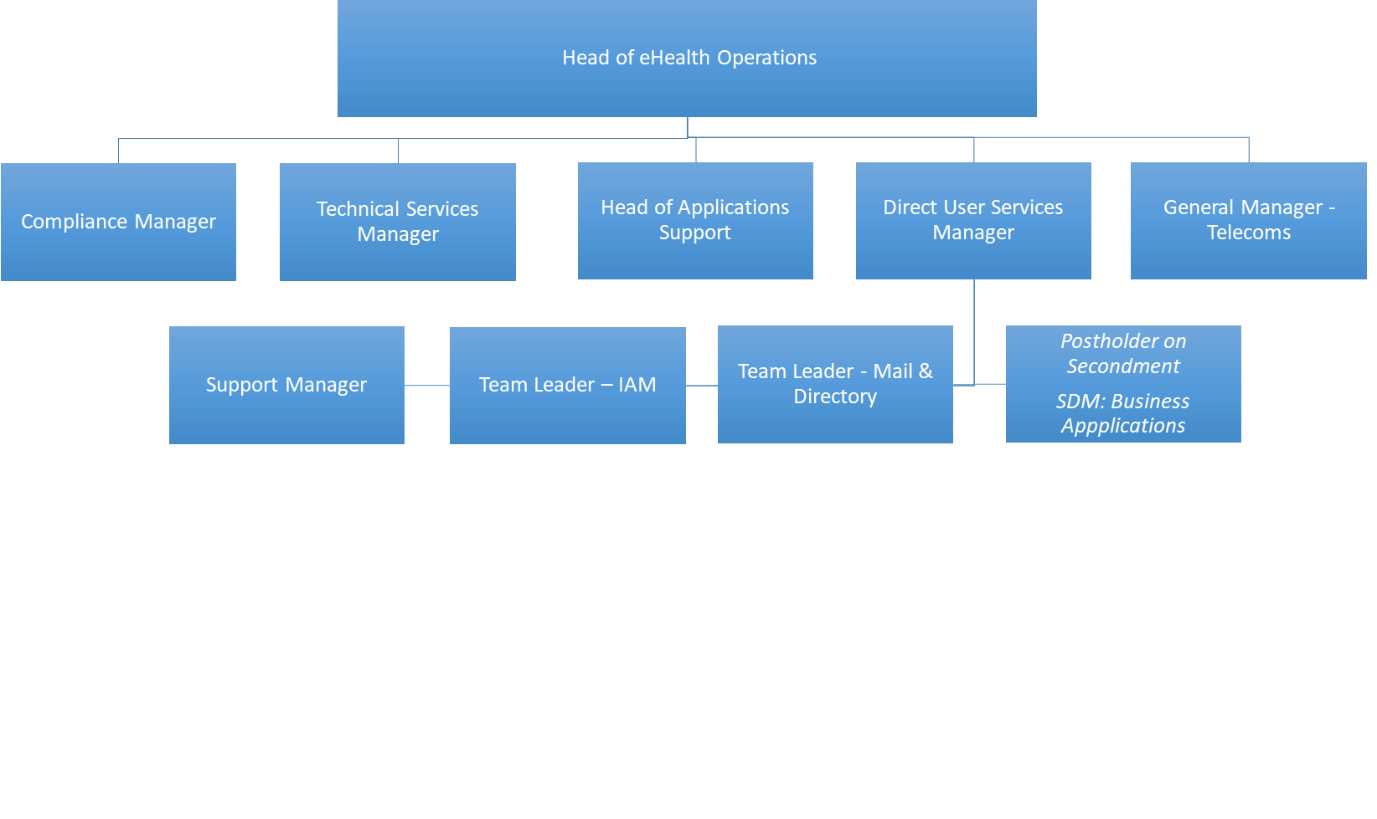

**About the Role**

This role is essential to the day to day running of the Service Desk Service (SDS) Team. The post holder will be responsible for leading the management and co-ordination of NHS GGC’s Incident Management Process, including Major Incidents, as well as leading the resolution of Problems. The SDS Team is essential to eHealth’s successful service delivery targets for it’s Customer Base User base and will provide a lead role when dealing with other eHealth Operations Teams, as well as ensuring that Event and Incident recording, as well as subsequent activities, are recorded within the Service Now Service Management system.. This post will also have a significant role to play in the Operational management of the Boards on-going use of existing and emerging technologies.

Key aspects of the role include:

* The Incident Manager will have recognised and demonstrable expertise in managing within the ITIL Framework, specifically around Incident, Problem and Change Management. Specifically, the role will entail:
  + Direct responsibility for monitoring, developing and improving the quality of incident and problem management and IT Service Desk provision to 40,000+ users across NHSGGC.
  + Identification of areas for improvement and the implementation of new processes and procedures to meet client expectations in line with organisational requirements
  + Management of incidents and problems relating to IT services and interdepartmental interaction, including Service Desk facilities which receive 20,000+ contacts per month.
  + Escalation point for all eHealth teams and Service Desk staff in relation to incidents and problems raised
  + As a key member of the SDS Team, ensure service level targets and associated processes and procedures for Service Desk Contact and Incident / Problem Management are clearly defined, implemented and met by internal staff and external suppliers.
  + Manage 3rd party supplier provision of services & fault resolution ensuring that minimal disruption to application availability, efficient application working, ensuring customer needs are met.
  + Provide specialist technical advice and guidance to IT staff in other teams within eHealth

The Service Desk Support Team sit within the Direct User Support Team in eHealth Operations as shown below.

**Direct User Support** team structure

The Direct User Support team are responsible for the provision of support services for all aspects of front-line Customer support, including Service Desk services as set out below.

**Direct User Support Team**

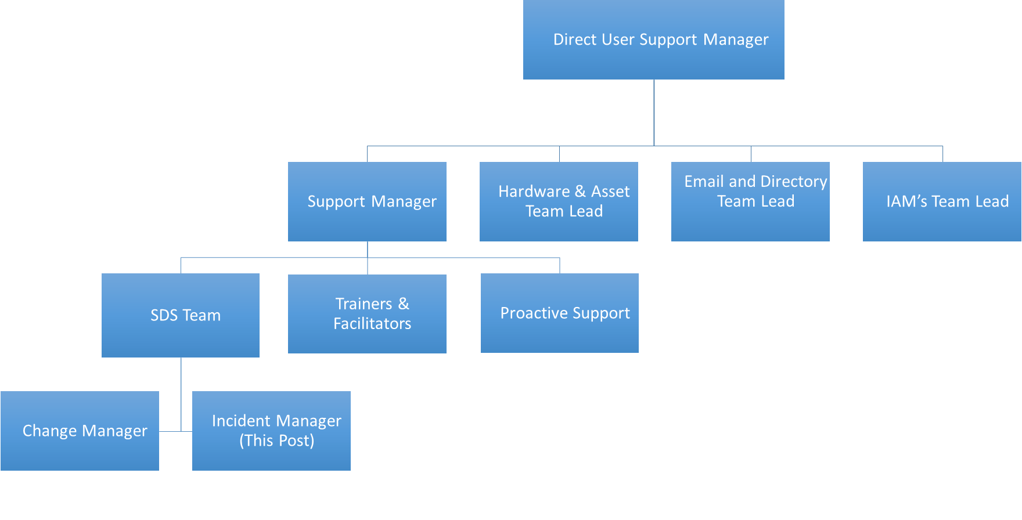

**Useful links – NHSGGC**

* NHSGGC Digital Health & Care “Digital on Demand” Strategy 2023 - 2028 - https://www.nhsggc.scot/staff-recruitment/staff-resources/ehealth/digital-strategy/
* NHSGGC Twitter - https://twitter.com/nhsggc
* NHSGGC Moving Forward Together (MFT) programme - https://www.movingforwardtogetherggc.org/
* NHSGGC “Growing Our Great Community” Workforce Plan 2022-25 - https://www.nhsggc.scot/downloads/workforce-plan-2022-2025/

**Useful links – national strategies and drivers**

* National Digital Health & Care Strategy - https://www.gov.scot/publications/scotlands-digital-health-care-strategy/

**Appendix 1 – Job Description**

|  |
| --- |
| **JOB IDENTIFICATION**  **Job Title:**  Incident Manager  **Responsible to:** Direct User Services Manager  **Department:** Operations  **Directorate:** eHealth |
| **2. JOB PURPOSE** |
| Responsible for the on-going support, improvement and communication of IT Service Desk provision to all NHSGGC users through appropriate IT teams via the use of robust ITIL processes around Incident, Problem and Change Management disciplines.  Responsible for the management of all Incidents (including major incidents) and Problems related to IT services to limit potential disruption, enabling a return to business as usual service as soon as possible.  Assist in ensuring efficient 24x7 running of the application services, clinical applications, key databases and integration technologies; and provide end user support services via the Change Management process.  Production of monthly management information relating to the management of the IT Infrastructure.  Develop, prepare, agree and communicate policies and procedures to all relevant parties.  This role is focused on managing services provided through the IT Service Desk in support of current local eHealth delivery and requirements to contribute to the development of support processes for new and changing NHSGGC and National Services. |
| **3. ROLE OF DEPARTMENT** |
| The overall aim of the eHealth Directorate is to deliver and maintain a comprehensive integrated information, technology and record management strategy in order to ensure that the right information is provided in the right place at the right time, to support highest possible levels of diagnosis, treatment and care of patients and clients, to support continuous improvement of the health of the populations we serve and to achieve more effective integration between Health and the care services of our Local Authority partners.    This includes patients’ case notes and other information for clinicians working in the community and primary care, in outpatient clinics, on the point of admission for inpatients/day cases and for review after discharge: it includes developing and supporting electronic information systems for clinical and management use: and it includes collection and analysis of data required by the Scottish Government Health Department, for local monitoring of activity or performance, and for surveillance and protection of the health of our populations.    The eHealth Directorate has approximately 1,642 staff, a revenue budget of approximately £70.7m (incl annual Scottish Government ring fenced funding), annual capital budget ranging between £7-8m and non-recurring eHealth budget of approximately £13.2m.  The eHealth Directorate comprises the following departments:   * **Operations** – responsible for the overall IT and Telecommunication service delivery to NHSGGC including the delivery of the underpinning technical infrastructure and applications to support the health and corporate directorates across NHSGGC to agreed KPI’s and SLA’s. In additional Information security and compliance. * **Strategy and Programmes** - responsible for the development of the medium to long term eHealth Strategy and the delivery of a large number of highly complex programmes and projects including significant service reconfiguration and System development. * **Innovation** – responsible for development and delivery of eHealth enabled Innovation Programmes, linking with Innovators such as clinicians, R&D, industry and SME's within NHSGGC, West of Scotland, and the broader Innovation community. * **Information Management** – responsible for the collection and analysis of information, information governance and delivery of knowledge management services. This service comprises Knowledge Services (Libraries), Clinical Coding and Business Intelligence. * **Health Records** – delivery of Health Records services across NHSGGC, including provision of outpatient clinics and ward clerk services * **Business and Resource Management** – responsible for financial management, procurement & contract management, audit, risk management, Programme Management Office (PMO), Information Governance, FOI responses and overarching aspects of Human Resource and Organisational Development, Health & Safety, general Directorate wide governance and facilities management activities. |
| **4. ORGANISATIONAL POSITION** |
|  |
| **5. SCOPE AND RANGE** |
| The post holder will have direct managerial responsibility which may include personal development, performance management and evaluation for members of their team. With changing service and technology models this is particularly challenging.  As part of operational support the job holder will be responsible for identifying service issues and develop improvement plans that can involve both processes and technologies.    Manages and resolves application support issues solutions and provides support development and implementation of applications which underpins the delivery of the Board’s business services and clinical services which form a key part of the Board’s Digital Strategy.  Provides advice on integrating local and national applications.  Manages support team priorities and key project deliverables to support strategic and business objectives.  Provides strategic applications advice in relation to the implementation and support of applications.  Lead in providing technical knowledge and as well as providing support and input on behalf of or in the absence of the Direct User Support Manager where appropriate. |
| **6. MAIN TASKS, DUTIES AND RESPONSIBILITIES** |
| The Incident Manager will have a hands-on Operational role with specific duties and responsibilities as follows:.  **Incident Management**   1. Development, agreement, implementation and management of incident management policies and procedures for all IT systems to ensure minimum disruption to service of clinical and corporate applications, therefore reducing impact on patient care. 2. Monitoring, analysing and reporting on incidents affecting the IT environment, performing tasks such as: prioritising and categorising incidents; management of major incidents and ensuring that escalations and communications are managed appropriately to limit the potential disruption to service and return to business as usual as quickly as possible. 3. Train, guide and advise other IT staff as required in incident management processes. 4. Produce monthly standard reports and respond timeously to requests for information relating to incident management activities from management and eHealth teams.   **Problem Management**   1. Development, agreement, implementation and management of problem management policies and procedures for all IT systems to ensure minimum disruption to service of clinical and corporate applications, therefore reducing impact on patient care. 2. Identification of multiple occurrences of related incidents from which problem records are created and managed, ensuring that root cause analysis is carried out as part of problem resolution, with identification of actions and their owners. 3. Ensure effective management of incidents which have a known root cause that has not yet been resolved. 4. Train, guide and advise other IT staff as required in problem management processes. 5. Monitor and ensure information relating to problems is maintained including appropriate workarounds and resolutions to reduce the number and impact of incidents over time. 6. Monitoring, analysing and reporting on problems, performing tasks such as: categorising types of problems; identifying trends, monitoring updates and ensuring proposed correct actions are completed and documented appropriately.   **Change & Client Management**   1. Directly responsible for delivering best practice IT Incident and Problem Management processes providing efficient and effective support to internal eHealth customers. 2. Develop and maintain good working relationships with regular (sometimes complex) communication with eHealth Staff and key suppliers of associated services 3. Ensure that customers' issues are addressed timeously from all IT staff and identify opportunities for improvement in service delivery, keeping abreast of industry best practise. 4. Develop and implement key performance indicators for the measurement of accurate and prompt resolution of eHealth incidents. 5. Resolving conflict or contention for service within defined priorities, escalating actions as necessary. 6. Review, assist in the development of and agree global communications for users in relation to unplanned system outages with other IT staff ensuring they are easily understood. 7. Ensure all communications are issued to agreed timetables, and directed to the right people where possible and are kept updated as appropriate if circumstances change during an outage/incident. 8. Assist in the delivery of NHSGGC’s established Change Management process in order to facilitate the delivery of service standards to agreed Service Level Agreements   The above is not exhaustive, and the post-holder may be required to fulfill any other reasonable requests for support on other computer related matters. |
| **7a&b. SYSTEMS, EQUIPMENT AND MACHINERY** |
| The post holder will use a range of standard IT and office machinery & equipment, including:   * PCs (desktop / laptops) * Other mobile / hand-held devices * Scanners / photocopiers / faxes / MFDs * Printers * Telephony   The post holder will use a range of systems and in doing so require advanced keyboard skills, including:   * Servers, network equipment, PCs, printers and other computer peripherals. * Microsoft operating systems, Microsoft Applications, Adobe Applications, Sharepoint, databases and other network systems. * E-mail Systems, Internet and Intranet. * IT Service Management system, ServiceNow Service as NHSGGC’s Desk Software Application and Reporting suite * Various Databases, such as IT Asset Register, Change Control, etc. * Business Support systems such as SSTS, eExpenses, ePayroll and eESS * There will be a requirement to support single user systems, applications, and multi user departmental systems, with operational awareness required, even if not a frequent user. * Specialist IT Clinical Systems delivery services throughout the organisation.   The post holder will use a range of manual recording and reporting systems, including:   * Files (contracts, personnel, technical & supplier literature, legislative) * All other associated systems, equipment and interfaces across NHSGGC |
| **8. DECISIONS AND JUDGEMENTS** |
| * Key areas of responsibility will be allocated by the Direct User Support Manager, following direction provided by NHSGGC eHealth Strategy. * The post holder agrees personal objectives and responsibilities, which are reviewed by Manager and operates autonomously at senior level, managing service resource to meet the department’s objectives. * The majority of the post holder’s activity will be self-initiated and proactive in response to meeting objectives of the job with freedom to act with autonomy in the following key areas:-   + Management and direction of staff   + Response to user requests including anticipation and resolution of issues   + Development of policy and procedures (in line with any Directorate wide policies)   + Communication to the rest of the ehealth Directorate   + Communication to General Management and Service Managers   + Communication to Key Clinical Users and User Groups * Deputise for Direct User Service Manager and other Support Team Managers as required. * Priorities will be established in collaboration with the Direct User Service Manager. |
| **9. COMMUNICATIONS AND RELATIONSHIPS** |
| The post holder is required to communicate with;   * Other eHealth Directorate Professionals ensuring models of service delivery are achieved, negotiating the release of resources to perform areas of work, allied to this the post holder, when required, will negotiate with the divisions main suppliers ensuring their compliance with the service delivery needs of the division. * Business Intelligence staff within the business areas. * Senior clinical staff to discuss information and data requirements during development phase of project. * Provide expert IT advice to Directorate staff at all levels. * The Boards Directors and senior managers, Business and Project Managers, both advising and negotiating the use of new and emerging technologies. * Third party software vendors, negotiating changes to software and highlighting discrepancies within the product. * The Programme Office. |
| Communication is a key element to this role. An absolute requirement is the ability to communicate effectively at all levels. Other than obvious inter-departmental communication, all users of IT equipment or services are able to converse with the post holder at any time, whether junior or senior, clinical or clerical. The nature of communication is wide ranging from technical to supportive, informative to emotive. Depending on the recipient of the communication this can be positive news regarding improvements of service, informative news regarding changes in service, negative news regarding unavoidable service outage or personnel related news such as awards of employment, disciplinary matters or even discontinuation of employment and or contracts.  Internal, via direct personal contact, e-mail, letter, telephone or presentation: -   * Close collaboration with peer IT managers, IT Service Desk, and other eHealth Directorate team members. * Senior clinical staff, General Managers, Service Managers, key clinical users, departmental managers, heads of departments and a wide range of users of IT systems and services. * Occasional contact with payroll officers on appropriate processing of duty sheets * HR representatives and management on personnel related issues and policies   External, via in person communication, e-mail, letter, telephone or presentation: -   * External suppliers, Service Desks and support staff, including 3rd party software supplier account managers, negotiating changes to software and highlighting discrepancies within the product. * Other IT professionals across NHS Scotland. This is expanding rapidly as eHealth projects are taken forward on a national and regional basis, particularly for NHSGGC provision of services to West of Scotland Health Boards. * Auditors in regards to process, output, security, risks surrounding IT provision. |
| **10. PHYSICAL, MENTAL, EMOTIONAL AND ENVIRONMENTAL DEMANDS OF THE JOB** |
| |  | | --- | | Ability to analyse and determine a course of action at times of high demand or pressure, such as major system outage, or dealing with staff on emotional or personal issues. This can involve working additional hours out with normal working hours at short notice as there are limited numbers of staff with this skill set.  Knowledge that system outages will have a major impact on clinical and medical services can create high levels of stress.  Maintaining and increasing productivity within EU Working Directives and Contracted Hours.  Maintaining knowledge in area of expertise including managerial, technical or legislative advancements and own keyboard / PC skills, whilst continuing to carry out day to day activities.  Physical demands on time management and ability to diversify due to team of staff, with varying responsibilities, skill levels and knowledge of IT.  Inter-site and intra-site mobility, including travelling anywhere as required.  Occasionally required to move or lift items of IT equipment; work in clinical / patient areas where IT services are deployed, potentially with exposure to varying levels of distress; and regular exposure to confidential/sensitive data. | |
| **11. MOST CHALLENGING/DIFFICULT PARTS OF THE JOB** |
| Providing service improvements necessary to meet the aspirations of users that have an ever-increasing dependence on continually evolving eHealth services, whilst managing limited available resources.    Ensuring maximum system uptime and scheduling downtime for the lowest impact for clinical staff and patients. This often involves working out with normal working hours at short notice.  Working with the eHealth Operations Management Team, working to promote the development of the ITIL Continual Service Improvement (CSI) discipline of ITIL across eHealth will assist with the on-going improvement cycle will present challenging and worthwhile outcomes.  Ensuring that the most appropriate solution to any given problem is offered. This is achieved through not only an understanding of the business need but also an understanding of the people who carry out the business, be they Clinicians, Managers or administration staff. The challenge is heightened by the introduction of new technologies.  Being aware of National eHealth developments within the NHS.  Influencing & directing users to ensure well informed decisions are made in support of the service. |
| **12. KNOWLEDGE, TRAINING AND EXPERIENCE REQUIRED TO DO THE JOB** |
| **Essential**  At least 3-5 year of operating within an ITIL Service Management environment will be essential to ensure minimum experience and support standards are met.  The post holder will have significant demonstrable practical experience in the analysis, specification, development and implementation of information systems within a complex environment  Previous experience of working in a complex Service Management support environment with proven ability of leading or managing staff who have diverse skills and abilities.  Good interpersonal and negotiating skills allowing post holder to influence decision making.  **Desirable**  Preferably qualified in Qualified in, ITIL IT Service Management (International standard for Best Practice in IT Service Management) to ensure ITIL service transition techniques are used to deliver successful implementation of all aspects of the service  Experience in project management and knowledge of methodology such as ELMP, Six Sigma or Prince advantageous |

**History:**

|  |  |  |
| --- | --- | --- |
| Version | Date | Comment |
|  |  |  |
|  |  |  |
|  |  |  |
|  |  |  |
|  |  |  |

**Appendix 2 – Person Specification**

**PERSON SPECIFICATION FORM**

**Job Title: - eHealth Incident Manager**

**Department: Operations**

|  |  |  |
| --- | --- | --- |
| **Qualifications** | Essential (X) | Desirable (X) |
| A recognised qualification in Incident Management, Change Control and Problem Management e.g. ITIL Foundation V3/4, Expert V3/4 or equivalent experience. | x |  |
| Educated to Degree level in an IT related subject or equivalent practical experience in this field |  | x |
| Communicate succinctly, clearly and accurately in plain simple English, both verbally and in writing | x |  |

|  |  |  |
| --- | --- | --- |
| **Experience** | Essential (X) | Desirable (X) |
| Proven understanding and experience of ITIL best practice within an operations control environment which includes Incident, Change and Problem Management | x |  |
| Experience of working in a senior role within an IT support function preferably for several years, with proven ability of leading or managing staff who have diverse skills and abilities. | x |  |
| A working knowledge of health service IT |  | x |
| Proficient in the role of IT support, and service delivery management with exceptional problem solving abilities and firm logical grounding. Familiar with the concepts, standards, technologies, tools, procedures, hardware and software in use for delivering IT services. | x |  |

|  |  |  |
| --- | --- | --- |
| **Behavioural Competencies** | Essential (X) | Desirable (X) |
| An ability to work as part of a multi-disciplinary team | x |  |
| High level of communication and negotiating skills and the ability to diplomatically deal with all levels of users, senior management and clinical staff, allowing post holder to influence decision making with relevant presentation skills | x |  |
| Ability to prioritise and meet deadlines in a time constrained environment | x |  |
| Organised approach to administration, workloads and prioritisation. Ability to exercise initiative and work independently. | x |  |
| Good interpersonal and negotiating skills allowing post holder to influence decision making | x |  |
| Ability to understand the business aspects of information systems and supported applications. | x |  |

|  |  |  |
| --- | --- | --- |
| **Other** | Essential (X) | Desirable (X) |
| Caring Competencies | X |  |
| Ability to travel across Region – driving license | X |  |
| A working knowledge of data analytics and informatics |  | X |