Physiotherapy Job Description: Additional Specialism Information
Specialism: Douglas Grant Rehabilitation Ward, North Ayrshire Grade: Band 6
Job description linked to: Band 6 Specialist Physiotherapist
Organisational position (including chart) | 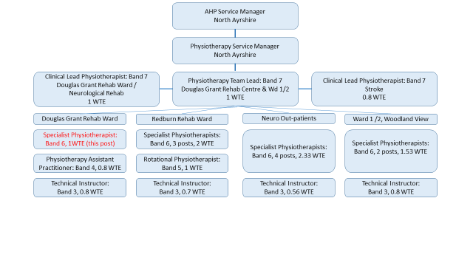  - The Physiotherapy Neuro rehab team delivers highly specialist neurological physiotherapy within Douglas Grant Rehab Ward (DGRW), offering comprehensive assessment and treatment to all patients admitted with complex physical rehabilitaiton needs as a result of neurological conditions and traumatic injury.  - This post is one of one Specialist Physiotherapist posts within the Neuro rehab team, which is part of the wider Douglas Grant Rehabilitaiton Centre and Ward 1 team, as shown in the organisational chart.
Job Purpose | - Act as a Specialist Physiotherapist in the Neuro Rehab team demonstrating specialist knowledge of evidence-based practice and clinical skills in the field of neurological physiotherapy and rehabilitation.  - Assess and treat adults with diagnosed or suspected neurological conditions from a variety of referral sources including GP, Consultant, other AHPs, Nurse Specilialists, Community and Tertiary setting.  - Undertake a lead role in the assessment, treatment, management and discharge planning of patients with a variety of neurological conditions, often with complex presentations.  - Treatments will include, but are not limited to, neurofacilitation techniques; gait re-education; balance and proprioceptive re-education; upper limb rehabilitation; provision of walking aids; assessment for and use of orthoses; use of manual handling equipment e.g. hoists and standing and walking aids such as Encore ® / Taurus ® / Stedy ® / tilt table; use of functional electrical stimulation; upper and lower limb strengthening.  - Participate in home and community visits, including working with others from MDT, community services and 3rd sector.  - Establish shared goals with MDT, patient and carers for patients who may have complex physical, communication, psychological, social, cultural and emotional needs, while considering widely differing understandings and expectations of disease status and outcome.  - Respiratory conditions treated include, but are not limited to, patients with acute and chronic respiratory conditions including pre-existing conditions such as COPD and bronchiectasis or acute conditions such as pneumonia and aspiration pneumonia.  - Respiratory treatments will include, but are not limited to, chest clearance and airway recruitment techniques for sputum retention, increased work of breathing and loss of lung volume such as Autogenic drainage; Active Cycle of Breathing Technique; Forced Expiratory Technique; positioning; mobilisation.  - Attend MDT meetings and contribute to goal setting, discharge planning & case conferences  - Lead, and participate in, local service improvement projects.  - Engage at a local and national level with relevant clinical interest, policy development and service development groups relating to Neuro rehab pathways and guidelines.
Key Result Areas | - Treat adults with complex rehabilitation needs using specialist neuro-physiotherapy skills and knowledge.  - Use highly skilled verbal and non-verbal communication to communicate effectively with patients with complex communication impairments.  - Promote a rehabilitation ethos within Douglas Grant Rehab Ward as part of the MDT.  - Empower and support individuals to be as active and independent as possible, maximising self-management where possible.  - Contribute to MDT discharge planning and goal setting.  - Make onward referrals to other services and teams as required to ensure ongoing rehab needs are met.  - Work towards completion of Major Trauma Network competency framework.
Other relevant information | - The physiotherapy team provides input to patients on Douglas Grant Rehab Ward (DGRW) and rehabilitation within Douglas Grant Rehab Centre (DGRC). DGRW comprises 19 beds, three of which are funded via the Major Trauma Pathway. Where appropriate, DGRW patients are followed up by the physiotherapy team post discharge in the community or as an out-patient. Our team goal is to deliver effective, evidence based, high quality physiotherapy assessment and treatment to adults living with a neurological condition, with the focus on optimising the individual’s potential. Physiotherapists use specialist neurological assessment and handling skills including management of upper and lower limb tone, weakness, positioning, and gait and balance re-education. Physiotherapists in this specialist neurological team offer outreach support to any clinical areas and clinicians who require support or guidance from a specialist neurological physiotherapist.

