JOB DESCRIPTION TEMPLATE

JOB IDENTIFICATION
Job Title: Waste Manager (Designated Officer For Waste Management)
Responsible to (insert job title): Head of Clinical Support Services East
Department(s): Clinical Support Services
Directorate: Infrastructure & Support Services
No of Job Holders: 1
Last Update: July 2020

2. JOB PURPOSE
Accountable for leading the operational management of all Waste Management activities at University Hospital Crosshouse (UHC) and Ayrshire Central Hospital. Additionally responsible for Waste Management staff and transfer station at UHC.
Direct responsibility for the provision and management of waste services across sites within budgetary constraints and ensuring compliance with all policies, procedures, legislative and Health & Safety requirements, ensuring the delivery of cost effective, efficient services which underpin and support both clinical and non-clinical services
Manage and develop NHS Ayrshire & Arran’s waste management policy, strategy and infrastructure ensuring that it supports both clinical and non-clinical departments and is responsive to the changing needs of NHS Ayrshire & Arran, ensuring that waste management is effective and resource-efficient throughout NHS Ayrshire & Arran and is compliant with statutory standards and good industry practice.
Professional lead for Waste Management fulfilling the role as Designated Officer For Waste Management for the board, this is a role stated as a requirement in National Guidance.
Ensure the area wide procurement of all waste contracts, ensuring the cost to NHS Ayrshire & Arran is minimised, whilst monitoring the performance of waste services across NHS Ayrshire & Arran.
Provide advice and support to the Locality Site/Support Services Managers and Managers involved in Waste Management on all of the objectives and lead implementation of strategic developments for Waste Management, including training and support to all levels of staff.

3. DIMENSIONS
Reporting to the Head of Clinical Support Services East, the post holder has direct management responsibility for the provision and delivery of a safe environment where patients, staff and visitors are protected in addition to physical assets. The post holder directly manages a team of staff employed to carry out a wide range of waste management activities.
The post holder has budgetary / staff responsibility as follows.
 | Staff (WTE) | Pay | Non-Pay | Income
Ayrshire Central Hospital |  |  | £76,305 | £1,650
University Hospital Crosshouse | 12 w.t.e. | £331,459 | £849,912 | £15010
TOTAL | 12 w.t.e. | £331, 459 | £926,217 | £16,660

Annual Waste from the Health Board 2018 / 2019
Waste  Type | Tonnes  per annum | Cost per  annum
Clinical | 1061 | £530,118
Residual | 1457 | £187,684
Recycling | 447 | £31,673
TOTAL | 2965 | £749,655

In addition the post holder is required to be flexible in developing the role and is expected to represent NHS Ayrshire & Arran at a national level, communicating with external partners and Scottish Government Departments on NHS Ayrshire & Arran and NHS Scotland issues in the development of Scottish strategies in this specialist area.
The post holder will be based at Crosshouse Hospital but is required to travel frequently between all sites.

4. ORGANISATIONAL POSITION
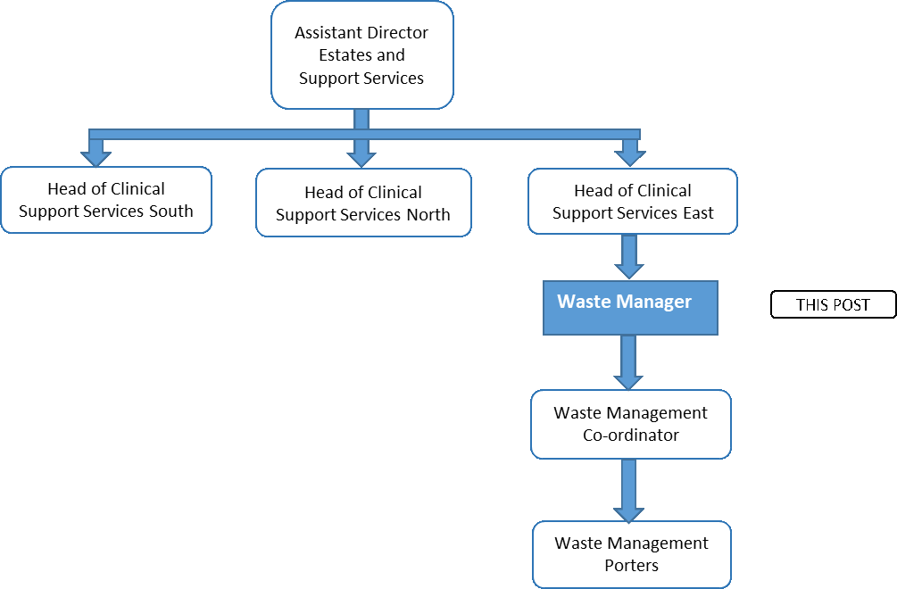

5. ROLE OF DEPARTMENT
The Directorate is responsible for delivering the following services on an organisation wide basis across NHS Ayrshire & Arran:

- Efficient and effective Digital Services, to drive transformational change.

- Managing, developing and maintaining NHS Ayrshire & Arran’s healthcare estate, including energy management, fire safety, health and safety and ensuring compliance with all statutory standards and working practices.

- Property Services including estates master planning, asset management, disposals, acquisitions, leases and rating valuations.

- Delivering safe, effective and efficient facilities to provide the highest possible standards and quality of care to patients.
- Planning and delivering the Board’s capital programmes and projects and providing project management support, guidance and professional advice.
- Delivery of effective and efficient Clinical Support Services including portering, domestic, catering, grounds maintenance, transport, security, waste disposal and decontamination services.
- Procurement and supply chains services.

6. KEY RESULT AREAS
Service Delivery
- Manage the delivery of efficient and effective Waste services to support the delivery of clinical services, providing evidence and relevant information to professional bodies to meet all legislative requirements.

- The post holder will be the first point of contact for operational Waste Management advice and lead on the implementation of best practice in waste segregation, good practice and circular economy thinking.

- Will be the Professional lead for Waste Management in the Board, including managing budget within financial parameters by monitoring, analysing and reviewing spend and developing and implementing service and cost improvement initiatives.

- Develop, monitor, maintain and update all site Waste Management plans in accordance with agreed service standards, national and local strategies, identified best practice and legal requirements.

- Contribute to and support the ongoing development of Site/Support Services through the identification of ongoing opportunities that delivers increased productivity, efficiencies and effectiveness.

- Identify risks in waste activities, which includes the systematic identification and management of risks associated with waste management.

- Continually review service development plans and capital schemes, identifying implications for Infrastructure & Support Services during the planning process, proposing changes to existing processes where necessary, ensuring legislative requirements are met.

- As a member of the Infrastructure & Support Services management team the post holder is required to contribute to the strategic decisions that are made in relation to the ongoing development of Waste Management, promoting and applying the principles of best value including the continuous review of both internal and contracted workload and services, contributing to the development of Policy and Procedures to assist in the delivery of the Infrastructure & Support Services agenda.

- Provide specialist technical advice, practical experience and leadership, regarding all aspects of Waste Management, as required to ensure consistency of approach internally and externally, and ensuring compliance with legislative requirements.

- Provide operational risk management to ensure Waste Management activities comply with Health & Safety legislation, including the completion of Datix, undertaking investigations, completion of relevant risk assessments and the development of safe systems of work.

- Monitor and make recommendations on all aspects of Health, Safety and Environment issues throughout the Waste Management service to ensure organisational requirements are met, thorough accident/incident investigation and knowledge sharing of outcomes to reduce the likelihood of recurrence.

Waste Contract Management
- Liaise with waste processing partners to identify and suggest cost effective improvement opportunities.
- Routinely identify inventory of waste materials and specialist waste via Site Waste Management Plans in all sites ensuring Waste Transfer Notes and consignment notes are meeting requirements.
- Monitor and submit the UHC Waste Management Licence data, along with Waste Tool returns (National Benchmarking System).
- Ensure UHC licenced site conditions are maintained to meet legislative requirement.
- Match collections with site records, monitor all invoices to ensure payment for only services provided, and raise queries with contractor, obtaining credit notes and adjustments where required.
- Ensure legislative requirements are met, e.g. Scottish Environmental Protection Agency (SEPA) inspections.
- Monitor the quantities and composition of waste movements within the sector to ensure safe and cost effective Waste Management.
- Monitor the performance of all recycling activities to ensure that they comply with standards for recycling and Health & Safety Regulations.
- Manage waste contracts for Acute sites and contractors on behalf of the Board to ensure appropriate and timely collection of all waste produced by NHS Ayrshire & Arran.
- Working alongside service managers and finance colleagues, manage, review and process invoices for payment.
- Plan and ensure Pre-assessment Audits are carried out to meet regulatory compliance, develop processes and training materials for all Site Waste Leads and operatives. Contribute to Waste Management targets as per Government targets and contribute to the development of the sustainability agenda for all waste management related issues and topics.
- Develop and issue monthly reports on waste arising and spend against waste contract to senior management.
- Plan and undertake audits for external Duty of Care site visits to waste contractors on a planned and ad-hoc basis.

Service Development
- Liaise with colleagues in identifying and implementing new recycling opportunities, developing proposals and markets for recycled material, with initiative to reduce the cost of all waste streams, especially Clinical Waste, in accordance with the recommendations contained in the “NHS Scotland Waste Management Action Plan”.
- Develop and implement Waste Prevention Plan and Waste Recycling and Recovery Plan
- Lead in the implementation of waste minimisation initiatives with the supply of advice, posters, bins, etc.
- Lead and implement on the development of e-learning modules and bespoke training (internal and external) ensuring this is developed to meet specific operational and service needs.
- Contribute to national/regional working groups and other initiatives ensuring that the interests of NHS Ayrshire & Arran, specifically that of Clinical Support Services are professionally represented. In addition, to be well informed of national policy/strategic developments and best practice standards.

Staff Management
Board Wide
- Monitor duties carried out by Waste Management Operatives, ensuring best practice and compliance
- Ensure Waste Management Operatives are aware of Health and Safety Regulations and Waste Legislation and in accordance with Board Policies and Procedures
- Provide advice and support to the Locality Site/Support Services Managers and Managers involved in Waste Management on all of the objectives and lead implementation of strategic developments for Waste Management, including training and support to all levels of staff

At UHC
- Responsibility for overall site management, including direct responsibility for training and development of waste management staff based at UHC
- Establish and co-ordinate all aspects of resourcing, including the recruitment and selection process, from advert to appointment, in order to maintain appropriate staffing levels, as well as develop training programmes in line with service requirements.
- Providing leadership and responsible for the planning, development and review process for directly managed staff, identifying development needs and facilitating training including succession planning. This will also include management and support for people on work placements for a variety of HR initiatives.
- Monitor workflow against a background of ever changing demands, forecast future demands and plan any developments across the service; making alterations to plans when necessary in line with best practice, unforeseen developments to ensure best use of human resource.
- First point of contact for complaints, accidents, incidents, disputes, grievances and disciplinary issues, taking appropriate investigative action, developing plans and evaluating outcomes to ensure continuous improvement.

Quality Performance
- Promote Risk Management, taking the lead on the board wide development and updating of Risk Assessments in relation to Waste Management to comply with safety standards and ensure safe systems of work. Monitor and make recommendations on all aspects of Health & Safety and Environmental working practices through the department to ensure organisational recommendations are met.
- Assist wards/departments/community sites to implement and comply with waste management best practice.
- Ensure reduction in the risk of Healthcare Associated Infections by maintaining close liaison with Control of Infection and Nursing Staff to ensure compliance with standard Infection Control Procedures and precautions.
- Ensure all data capture including KPI’s and performance data for local and national systems is consistent, accurate and is presented timeously to senior managers and supports analysis, interpretation and comparison of data, Investigates national and local benchmarking data.
- Report quarterly on waste KPIs to Estates Environment and Sustainability Group.

7. SYSTEMS AND EQUIPMENT
The post holder is required to operate and use the following IT/software systems, routinely and on a daily basis. In many instances, not only accessing available data, but identifying and influencing the development of information systems e.g. national key performance indicators for a wide range of service areas.

- Personal Computer, laptop computer and smart phone with software packages including Word, Excel and Power Point, to produce reports, spreadsheet for statistical returns and hold information on database
- TURAS
- eESS
- NHS Net email
- DATIX System
- SSTS
- PECOS, for ordering equipment and verifying orders
- Telephone, Photocopier Machine, Laminator, Fax Machine
- Digital Photography and printing
- Digital Projector for presentations

Responsibility for Records Management
All records created in the course of the business of NHS Ayrshire & Arran are corporate records and are public records under the terms of the Public Records (Scotland) Act 1937. This includes email messages and other electronic records. It is your responsibility to ensure that you keep appropriate records of your work in NHS Ayrshire & Arran and manage those records in keeping with the NHS Ayrshire & Arran Records Management Policy and with any guidance produced by NHS Ayrshire & Arran specific to your employment.

8. ASSIGNMENT AND REVIEW OF WORK
The post reports to the Head of Clinical Support Services East and is fully responsible for leading and driving progress within the identified areas of responsibility together with the parameters of legal requirements, established national and local priorities, policies and procedures. The post operates autonomously within this framework and is expected to function as a source of expertise and advice at the highest levels.
The majority of work associated with this post is initiated by the post holder in line with
broader objectives of NHS Ayrshire & Arran. However, additional tasks are also allocated by the Head of Clinical Support Services East who is the post holder’s immediate line manager.

As a consequence of the dual strategic and operational demands of the role, the post holder will attend regular meetings with a broad range of stakeholder groups and be responsible for a wide range of professional and technical reports.
The Head of Clinical Support Services East undertakes review of performance in the post through the agreement pf performance objectives and individual performance appraisal. Formal appraisal is undertaken on an annual cycle. The Head of Clinical Support Services East will undertake more frequent ongoing informal reviews of current developments and progress on major issues on an ongoing basis.
The Head of Clinical Support Services East will give authority where necessary for the post holder to proceed with matters out with the scope of his/her delegated authority.
The post holder works with clinical and non-clinical leaders up to executive management level across NHS Ayrshire & Arran in generating challenging and complex actions.

9. DECISIONS AND JUDGEMENTS
- Ensuring the NHS Ayrshire & Arran is fully understanding of and achieves critical and legal compliance in respect of Waste Management
- Delivery of a safe environment where patients, staff and visitors are protected in addition to physical assets.
- Responsible for appropriate and cost effective use of resources
- Communication with Service Users – internal and external customers
- Ensuring introduction and compliance with Policies and Procedures of NHS Ayrshire & Arran
- Deal with staff issues appropriately, diligently and creatively
- Identification of budgetary needs and expenditure requirements
- Development of strategic plans including identification of working methods, working practices and systems including identification of costs
- Development of Capital Plans, Business Case and Business Plans
- Make judgements on expenditure requirements based on analysis of financial information
- Ensure that systems are established to support achievement of recycling targets
- Interpret and define “best practice” standards, key performance indicators and value for money initiatives and exercises
- Agree and arrange introduction of remedial actions as required in response to maintenance of service delivery issues
- Applies for grants and undertakes all procurement arrangements for waste management equipment and materials with the appropriate Designated Purchasing officer.

10. MOST CHALLENGING / DIFFICULT PARTS OF THE JOB
Ensuring the ongoing provision of a safe, compliant and cost-effective Waste Management service that underpins and facilitates the safe and efficient delivery of clinical services within budgetary constraints.

Development and maintenance of a recycling and waste minimisation programme across NHS Ayrshire & Arran.

Ongoing application of robust audit and monitoring procedures to ensure correct segregation and management of all waste generated within the organisation. Implementing corrective actions and processes resulting from audit reports within all areas where waste activities occur including ward areas.

Interpreting critical and legal requirements in respect of Waste Management on behalf of NHS Ayrshire & Arran, ensuring appropriate actions are taken to achieve necessary compliance.

The post holder has a high degree of autonomy over the portfolio of Waste Management that falls within his/her remit. Typical decisions that the post holder would be expected to make in the course of a working day include major decisions over choosing if, when and how to interact with wider stakeholders over questions of particular problems, identifying if and where it is appropriate to relay decisions taken or problems to a higher authority as appropriate, e.g. the Head of Clinical Support Services East, Assistant Director of Estates and Support Services.

11. COMMUNICATIONS AND RELATIONSHIPS
The post holder must be able to communicate at all levels of the organisation through oral, written and IT methods. Strong motivational, negotiating and skills of persuasion are essential.
The post holder will demonstrate the ability to communicate with large groups of staff with varying levels of understanding.
Developing and maintaining positive working relations with service users and ‘customers’, including clinical groups, other operational and senior managers within the organisation and to participate in regional and national waste Groups and initiatives.
The post holder must be able to constantly provide and receive complex professional, technical and managerial information.
Key Links
Internal
Head of Clinical Support Services East
Operational and Support Services managers
Infection Control Staff
All Managers with line management responsibilities for Clinical Support Services
Clinical Support Services Staff
Estates Services Staff
Senior Charge Nurse/Nursing Staff
Clinical Managers and Heads of Service
Executive Management Team
Finance and Human Resources Staff
Supplies/Procurement Staff
Staff of NHS Ayrshire & Arran

External

Professional Organisations/Trade Unions
University/College personnel
Environmental Health/Local Authority Officers
Central & West Waste Management Group
National Procurement
Health Facilities Scotland
Waste Management contractors
Health Protection Scotland Scottish Environment Protection Agency (SEPA)
Health & Safety Executive (HSE)

12. PHYSICAL, MENTAL, EMOTIONAL AND ENVIRONMENTAL DEMANDS OF THE JOB
Addressing operational requirements, covering a significant geographical spread with a large number of sites, working to a “planned” agenda with the likelihood of significant interruption, working/meeting with staff, colleagues, Directors and a wide range of external people, and overseeing the maintenance and development of waste management arrangements for NHS Ayrshire & Arran.

Physical demands
- Frequent travelling across NHS sites and extensive site walkabouts
- Dexterity and accuracy exercised whilst using computers and keyboards (30% of time)
- Occasional requirement to move equipment. The post holder will occasionally be required to demonstrate electrical and other equipment.
- The post holder must demonstrate an active approach to the role involving frequent movement around the hospital meeting with staff and service users.

Mental demands
- Frequent concentration is required for two or more hours at a time when compiling/processing reports, statistical information, analysing data and investigating operational matters
- The post holder will interact in an environment where there are constant interruptions and conflicting demands on their attention and where deadlines have to be met. The demands and interruptions are of equal and high priority and will consist of staffing, service issues or complaints, which all require immediate attention which necessitate changing activities completely.
- Decision making and organisational skills required to manage competing demands of the post.
- The post holder is required to chair meetings, write minutes, reports and business cases.

Emotional demands
- Requirement to communicate effectively at all levels of the organisation.
- Ability to demonstrate emotional intelligence and excellent interpersonal skills which enables achievement of wide support and compliance from staff/users
- Dealing with Health & Safety and critical compliance issues.
- Reliance on colleagues and wider organisation to fulfil obligations that support legal and critical compliances.

Environmental
- Frequent visits to waste collection points across NHS Ayrshire & Arran sites and the need for physical inspection of waste collection receptacles, including exposure to unpleasant conditions and the requirement to utilise PPE.

13. KNOWLEDGE, TRAINING AND EXPERIENCE REQUIRED TO DO THE JOB
Educated to Master’s degree level or equivalent in Facilities Services / Business Management
Specialist technical knowledge of waste management and experience of managing a diverse workforce preferably within a large organisation.
Member of relevant professional association.
The post holder should possess, or be willing to work towards:
- Level 4 Special waste Transfer station operations (WAMITAB)
- CIWM membership and willing to work towards chartered status

The post holder will possess extensive experience within a large complex organisation, preferably in the Health Sector or equivalent knowledge gained through experience.
Advanced knowledge of Risk Assessment processes, COSHH, Risk Management and Health & Safety regulations.
A sound knowledge of NHS Financial and Procurement Systems.
Knowledge of ‘best’ practice standards and industry norms.
The post holder must be able to demonstrate effective and highly developed leadership skills and be able to work on their own initiative as well as a proactive member of a team demonstrating skills to motivate others.
Excellent communication and interpersonal skills are essential, together with effective influencing and negotiating skills.
Proven ability to working within challenging timescales and meeting deadlines.
Ability to respond appropriately to unpredictable and emergency situations.
The post holder must have the ability to cope with conflicting and changing demands through good time management and the ability to work under pressure.
Project management skills and experience of implementing change.
Ability to produce and receive complex management, professional, financial and technical information and interpret same as appropriate.
Evidence of continuing professional development.
14. JOB DESCRIPTION AGREEMENT
A separate job description will need to be signed off by each jobholder to whom the job description applies.  Job Holder’s Signature:  Head of Department Signature: | Date:  Date:

