JOB DESCRIPTION

1. JOB IDENTIFICATION
Job Title: | Admin Support Officer
Responsible to: | Admin Service Lead
Department(s): | Estates, Capital Planning & Property
Directorate: | Corporate Support Services
Operating Division: | NHS Ayrshire and Arran
Job Reference:
No of Job Holders: | 2
Last Update: | January 2019
2. JOB PURPOSE
To provide a dedicated, professional and comprehensive secretarial / administrative service to the Estates department. The post holder will be instrumental in ensuring the flow of communication, information and correspondence projecting a positive, professional image for the Department.

3. DIMENSIONS
Reporting to the Admin Service Lead, the post holder will ensure the delivery of a high quality secretarial / administrative service to the department.

The post holder will form part of the Administrative and Clerical Team, which comprises of over 30 team members across the Directorate.

Provide cross cover for other areas across the department.

4. ORGANISIONAL POSITION

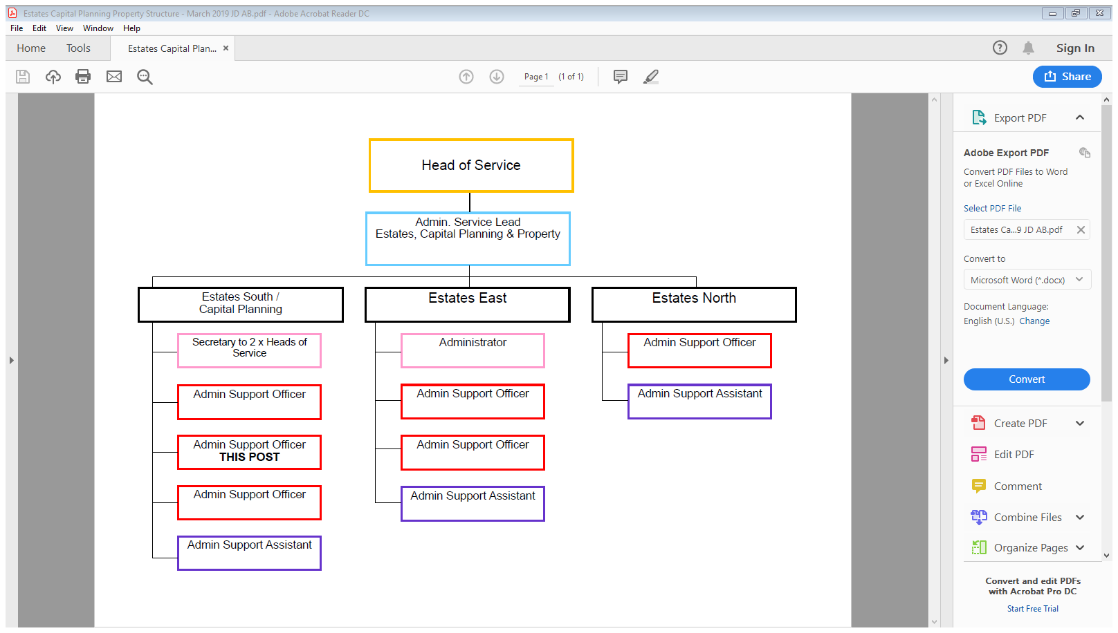

5. ROLE OF DEPARTMENT

The Directorate is responsible for delivering the following services on an organisation wide basis across NHS Ayrshire & Arran:
- Efficient and effective eHealth Services, technical infrastructure, telecoms, switchboard services and information services to drive transformation change and the delivery of secure effective and safe patient care.
- Managing, developing and maintaining NHS Ayrshire & Arran’s healthcare estate, including energy management, fire safety, health and safety and ensuring compliance with all statutory standards and working practices.
- Property Services including estates master planning, asset management, disposals, acquisitions, leases and rating valuations.
- Delivering safe, effective and efficient facilities to provide the highest possible standards and quality of care to patients.
- Planning and delivering the Board’s capital programmes and projects and providing project management support, guidance and professional advice.
- Delivery of effective and efficient Clinical Support Services including portering, domestic, catering, grounds maintenance, transport, security, waste disposal and decontamination services.
- Procurement and supply chain services.

6. KEY RESULT AREAS
• General administrative / clerical duties, which include; data collection, typing, preparation and distribution of correspondence, printing, photocopying, scanning, and filing (both manually and electronically).
• Open and sort mail for onward distribution to the appropriate department.
• Process orders via PECOS (e-Procurement) for the department, reconciling delivery slips & invoices for goods received, identifying any discrepancies and submit relevant information to finance department to ensure manager’s budget statements are up to date. Also assist in the preparation of requisitions for stock and non-stock items. Update relevant spreadsheets on shared drive are maintained and updated regularly.
• Post holder is the first point of contact for department. Responsible for co-ordinating telephone enquiries both internal and external; taking appropriate action to resolve issues within agreed parameters or forwarding the enquiry appropriately to ensure a timeous response.

- Assist with the development and updating of local Standard Operating Procedures relevant to the Department.

- Specific administrative duties, which include: diary co-ordination, resolving conflicting appointments when necessary using tact and diplomacy to achieve compromise solutions; distribution of documentation; sort and distribute mail to appropriate areas; attend meetings and take action notes/minutes as necessary etc to ensure adequate service provision and the smooth running of the department.

- Responsible for maintaining and updating Apollo database in relation to tradesmen’s timesheets which encompasses inputting of job dockets (feedback), overtime, sickness and annual leave.

- Maintenance of databases / Empower as required for recording of course attendance and course evaluations on behalf of course administrators and personnel.

- Arranging meetings, collation of correspondence / papers and taking notes in relation to Estates Officers / Supervisors within set timescales.

- Collate Overtime & call out information to produce detailed reports on monthly basis, maintaining the database for Estates personnel in relation to callouts to various locations area wide, and provide printed information when requested.

- Assist Estates Manager / Estates Officers in the tender process for Estates. Complete tender documentation for distribution to relevant Contractors, detailing schedule of works, limiting factors, methodology of response and designated timescales. Receive and record returned tenders and forward to appropriate officer. Confirm preferred candidate following decision. Notify successful / unsuccessful contractor as appropriate. Ensure agreed time-scales are consistently and equably applied.

- Produce correspondence as required, including reports, notes and statistical information to support the relevant managers and committees.

- Maintain filing and database systems, including archiving to ensure accurate retrieval of information on a day to day basis

- Liaise with appropriate manager, assess and agree requirements and undertake to source/research data when required from Internet or other sources to obtain information in support of various projects.

- Monitor and maintain stock levels for office consumables, ordering as appropriate through the Admin Service Lead to ensure adequate supplies are on hand at all times.

- Liaise with supervisors and managers to facilitate recording of information for specific area, e.g. absence, collating data and forwarding the information to the Admin Service Lead, indicating any areas of concern.

- Provide cover in relation to maintenance/breakdown Helpdesk, providing a customer oriented service for NHS Ayrshire & Arran’s Estates Department..

- Execute other duties as required, e.g. photocopying, faxing, circulation of correspondence to facilitate the operational day to day running of the department.

- Assist the Admin Service Lead in the execution of her/his duties as and when required, to ensure efficient service provision.

7a. EQUIPMENT AND MACHINERY

All equipment listed is essential in the day-to-day processes within the department:

• PC/Hard drive
• Multi-function device to print, scan and photocopy
• General office equipment e.g., laminator, shredder, binder.
• Telephone and voicemail
• Calculator
- Audio Dictation Equipment
- Projector
- Video Conferencing equipment

7b. SYSTEMS

The post holder will require having knowledge and skills to operate the
following systems.

- PECOS Internet Procurement System
- Empower
- Payment Certificate Register
- Pre-approved consultant/contractor register
- Organising electronic calendars for Senior/Project Managers
- Office filing systems including archiving, both manual and computerised
- MS Office e.g. Excel, Word, PowerPoint, Outlook, Publisher etc
- AthenA and Internet
- TURAS
- Paging System
- Estates Management System

8. ASSIGNMENT AND REVIEW OF WORK

- Workload and duties are demand lead and are assigned and monitored by the Estates Manager / Estates Officers / Supervisors and or Admin Service Lead.
- The post holder will prioritise own workload and operate autonomously while carrying out day to day tasks.
- The Admin Service Lead carries out performance reviews for this post on a regular basis, with a formal PDR carried out on an annual basis.
- Some duties are self-generated by the post holder for example filing / archiving and some are laid down by procedure/policy.
- The post holder will agree and prioritise specific objectives and determined by the Estate Management Team/Admin Service Lead.

9. DECISIONS AND JUDGEMENTS

- The post holder is required to make decisions and judgements based on knowledge and experience, using discretion and confidentiality i.e. prioritisation of activities, mail, telephone calls, emails - analysing issues, determining possible solutions within agreed parameters and knowing when to ask for assistance or guidance.
- Receive telephone call or email, assess whether the post holder can deal with the issue personally taking into account policies and procedures and own operational parameters, or refer the issue to an appropriate individual using own knowledge and experience of the department.
- In the absence of the Estates Management Team / Admin Service Lead, the jobholder may make decisions and judgements in relation to routine day to day functions of the department. Major issues should be passed to Senior Supervisors / Management.
- The post holder needs to respond to unscheduled work and re-prioritise planned work.

10. MOST CHALLENGING/DIFFICULT PARTS OF THE JOB

Managing time effectively, using initiative to prioritise and organise workload against tight timescales to meet competing demands and responding with precision at short notice.

Keeping information and knowledge up-to-date, accurate and confidential where appropriate and ensuring confidentiality is maintained and discretion applied on a range of sensitive matters.

Ability to concentrate within a busy, noisy and demanding environment whilst being constantly interrupted.

Planning and prioritising workload against tight timescales as well as producing documents and responding with precision at short notice.

Dealing with irate personnel with regard to work/repair requirements.

Ensuring goods received correspond with purchase orders, taking action when necessary to ensure a satisfactory outcome.

11. COMMUNICATIONS AND RELATIONSHIPS

Good written and verbal communication, interpersonal skills are required to ensure the satisfactory completion of tasks when dealing with:

• Internal – Liaise and consult with a variety of disciplines within NHS Ayrshire & Arran

• External - Suppliers/Representatives, Training Organisations, External Auditors, Private Contractors, Management Consultants, local Authorities, other NHS Boards, external suppliers/delivery drivers, general public.
• Communication is via personal contact, correspondence and telephone calls
• Provide information, direct and prioritise queries as appropriate to ensure service delivery.
• The post holder must acknowledge the sensitive nature of the topics
discussed and use skills of tact and diplomacy, exercising judgement when
dealing with enquiries from all levels of staff/public.

12. PHYSICAL, MENTAL, EMOTIONAL AND ENVIRONMENTAL DEMANDS OF THE JOB

Physical Effort/Skills:
- Keyboard skills (requiring degree of speed and accuracy).
• Sitting in same position for long periods.
• Standing for long periods when filing, photocopying or scanning.
• Moving and Handling skills are required on a daily basis.

Mental Effort/Skills:
• Ability to maintain high levels of concentration whilst in a busy office where there are constant interruptions from adhoc callers / face to face and telephone calls.
- In view of many interruptions and diverse situations, the post holder must have the capacity to switch from one task/problem to another efficiently as required by
the service.
• Maintain concentration when attending meetings and transcribing notes/creating reports/filing etc.
- Ability to prioritise work whilst anticipating forthcoming events and ensuring deadlines are adhered to.
- Dealing with enquiries, some of which may require tact and diplomacy.

Emotional Effort/Skills:
• Dealing sensitively with enquiries / complaints.
• Politely dealing with persistent callers
Environmental:
• Extensive use of VDU.
• Maintain safe and effective working environment.
• Confined to office for long periods.
• Busy, noisy and demanding environment.

13. KNOWLEDGE, TRAINING AND EXPERIENCE REQUIRED TO DO THE JOB

- Educated to SVQ Level III in Business / Office Administration or equivalent experience essential.
- Excellent IT and advanced keyboard skills are essential. Proficient in use of Internet.
- Ability to use own initiative and prioritise workload.
- Ability to work unsupervised.
- Confidentiality/discretion/trustworthy.
- Customer care awareness.
- Time management.
Excellent communication/organisational skills (verbal, written, literate, numerate and practical)
• Awareness of Policies/Procedures used by NHS Ayrshire and Arran i.e. Health & Safety Legislation, data protection policies, financial standing instructions, COSHH regulations, waste management policies.
• Interpersonal skills.
• Complaints procedures.
• Ability to learn new skills/advance knowledge by attending training relevant to the post.

14. JOB DESCRIPTION AGREEMENT

A separate Job Description will need to be signed off by each Job Holder to whom the Job Description applies.

Job Holder’s signature ……………………………………….. Date ………………

Head of Department signature …………………………………. Date ………………

