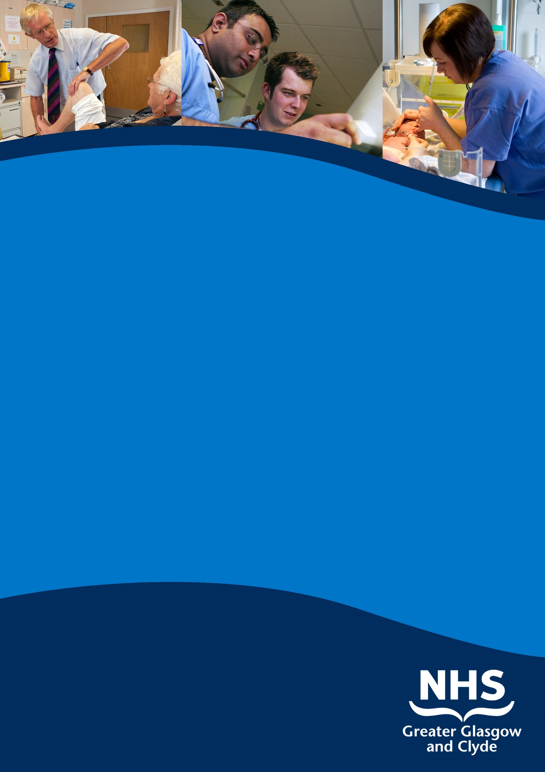

**cLINICAL FELLOW IN obstetrics & GYNAECOLOGY**

**CLYDE AREA HOSPITALS**

**Information pack**

**REF:**

**CLOSING DATE: July 2021**

**SUMMARY INFORMATION**

**Post: Clinical FELLOW {FY2 level}**

**Base: royal alexandra hospitals, vale of leven and inverclyde**

**royal hospital**

Based within Clyde Area Hospitals - Royal Alexandra Hospital, Vale of Leven and Inverclyde royal - this post is required as soon as possible for six months and is suitable for candidates at FY2 level of experience. There are outpatient clinics and day surgery at all three sites with labour ward, inpatient obstetric ward and inpatient gynaecology ward based at the Royal Alexandra Hospital (RAH) The RAH has a level 2 neonatal unit and has 4000 obstetric deliveries per year.

**NHS GREATER GLASGOW & CLYDE**

**WOMEN’S & CHILDREN’S DIVISION**

**Clinical Fellow**

**OBSTETRICS AND GYNAECOLOGY**

**CLYDE AREA HOSPITALS**

INFORMATION PACK

NHS GREATER GLASGOW AND CLYDE

Clinical Fellow

{FY2 equivalent}

OBSTETRICS AND GYNAECOLOGY

CLYDE HOSPITALS

POST REFERENCE:

**Brief Description of Hospitals**

Clyde hospitals

This post involves working in Clyde’s three units {Royal Alexandra Hospital, Vale of Leven and Inverclyde Royal}. There are outpatient clinics and day surgery at all three sites. The labour ward, inpatient obstetric ward and inpatient gynaecology ward are based at the Royal Alexandra Hospital. Paisley.

Successful applicant would work in the FY2/ST1 rota attending outpatient clinics and theatres across the three units. Resident on-call for obstetrics and gynaecology will be at the Royal Alexandra Hospital.

**Obstetrics**

The Royal Alexandra hospital houses 40 obstetric beds. There are 4000 deliveries per annum. In the labour ward facilities there are 9 delivery rooms, 2 obstetric theatres, 4 recovery beds. High risk patients are reviewed through a number of specialist clinics including dedicated services for diabetics, medical disorders etc. The Neonatal Service has 3 ITU beds, a large SCBU facility.

**Gynaecology**

A single inpatient Gynaecology department at Royal Alexandra Hospital is situated in the main hospital. This contains 22 beds and two trolleys for same day admissions.

The appointee will contribute equitably to the obstetric and gynaecology first on-call rota with 10 others. This is a partial-shift system. This is a Band 2B rota compliant with the EEC WTD.

It is essential that the candidate can communicate effectively (oral and written) and can work effectively in a multi-disciplinary team.

The department is actively involved in teaching; the appointee will be expected to contribute to this and to be involved in the teaching and training of medical, nursing and paramedical students and staff as required.

Provision of specialist/sub-specialist clinics as follows:

Gynaecology

* + General gynaecology (includes 24 hour emergency cover)
  + Social gynaecology
  + Gynaecology /oncology
  + Outpatient diagnostic services e.g. hysteroscopy, Colposcopy, ultrasound
  + Minimal access surgery

# Obstetrics

* + 24 hour cover of labour ward with appropriately trained staff
  + 4000 deliveries per year in newly refurbished building
  + Specialist services: medical obstetric services, diabetic clinic, Early Pregnancy Assessment (EPAS), and social needs in pregnancy service (SNiPS).
  + Minimum 40 hour week daytime dedicated consultant presence in labour ward (RCOG core standard)

There are regular postgraduate educational opportunities (CTG meetings, scenario training, topic sessions and formal fixed time for teaching sessions)

This post holds educational approval from the Postgraduate Dean. If appointed as a Clinical Fellow this post will not be recognised for training.

To practice medicine in the UK you need to hold both GMC registration and a licence to practice.

# TERMS AND CONDITIONS OF SERVICE

The conditions of service are those laid down and amended from time to time by the Hospital and Medical & Dental Whitley Council.

|  |  |
| --- | --- |
| **TYPE OF CONTRACT** | Fixed Term |
| **GRADE AND SALARY** | Clinical Fellow  - If appointed as an LAT (Locum Appointment for Training) the salary range will be: £29,705 to £46,708 per annum (pro rata).  - If appointed as a Clinical Fellow the salary range will be: £29,705 to £39,300 per annum (pro rata)  New Entrants to the NHS will normally commence on the minimum point of the salary scale, (dependent on qualifications and experience). Salary is paid monthly by Bank Credit Transfer. |
| **HOURS OF DUTY** | 40.00 |
| **SUPERANNUATION** | You have the option to join the NHS Superannuation Scheme, to participate in the State Earnings Related Pension Scheme or to take out a Personal Pension. Employee’s contributions to the NHS Scheme are Tiered based on your earnings and the employers contribution equates to 13.5 % of salary. Employees in the NHS Scheme are “Contracted-out” of the State Earnings Related Pension Scheme and pay a lower rate of National Insurance contributions. Employees who choose to participate in the State Earnings Related Pension Scheme pay the higher rate of National Insurance contribution. A Stakeholder Pension is also available. A Personal Pension is a private arrangement agreed with the pension provider that will be an organisation such as a Bank, Building Society or Insurance Company. |
| **REMOVAL EXPENSES** | Assistance with removal and associated expenses may be given and would be discussed and agreed prior to appointment. |
| **EXPENSES OF CANDIDATES FOR APPOINTMENT** | Candidates who are requested to attend an interview will be given assistance with appropriate travelling expenses. Re-imbursement shall not normally be made to employees who withdraw their application or refuse an offer of appointment. |
| **TOBACCO POLICY** | NHS Greater Glasgow and Clyde operate a No Smoking Policy in all premises and grounds. |
| **DISCLOSURE SCOTLAND** | This post is considered to be in the category of “Regulated Work” and therefore requires a Disclosure Scotland Protection of Vulnerable Groups Scheme (PVG) Membership which currently costs £59.00. The cost of the PVG Membership will be initially paid by NHS Greater Glasgow and Clyde and will required to be repaid through a payroll deduction mandate from the successful candidate’s first salary. |
| **CONFIRMATION OF ELIGIBILITY TO WORK IN THE UK** | NHS Greater Glasgow and Clyde (NHSGGC) has a legal obligation to  ensure that it’s employees, both EEA and non EEA nationals, are legally entitled to work in the United Kingdom. Before any person can commence employment within NHS GGC they will need to provide documentation to prove that they are eligible to work in the UK. Non EEA nationals will be required to show evidence that either Entry Clearance or Leave to Remain in the UK has been granted for the work which they are applying to do. Where an individual is subject to immigration control under not circumstances will they be allowed to commence until the right to work in the UK has been verified. ALL applicants regardless of nationality must complete and return the Confirmation of Eligibility to Work in the UK Statement with their completed application form. You will be required provide appropriate documentation prior to any appointment being made. |
| **REHABILITATION OF OFFENDERS ACT 1974** | The rehabilitation of Offenders act 1974 allows people who have been convicted of certain criminal offences to regard their convictions as “spent” after the lapse of a period of years. However, due to the nature of work for which you are applying this post is exempt from the provisions of Section 4 of the Rehabilitation of Offenders Act 1974 by virtue of the Rehabilitation of Offenders Act 1974 (Exceptions Orders 1975 and 1986). Therefore, applicants are required to disclose information about convictions which for other purposes are “spent” under the provision of the act in the event of employment, failure to disclose such convictions could result in dismissal or disciplinary action by NHS Greater Glasgow and Clyde. Any information given will be completely confidential. |
| **DISABLED APPLICANTS** | A disability or health problems does not preclude full consideration for the job and applications from people with disabilities are welcome. All information will be treated as confidential. NHS Greater Glasgow and Clyde guarantees to interview all applicants with disabilities who meet the minimum criteria for the post. You will note on our application form that we ask for relevant information with regard to your disability. This is simply to ensure that we can assist you, if you are called for interview, to have every opportunity to present your application in full. We may call you to discuss your needs in more detail if you are selected for interview. |
| **GENERAL** | NHS Greater Glasgow and Clyde operates flexible staffing arrangements whereby all appointments are to a grade within a department. The duties of an officer may be varied from an initial set of duties to any other set, which are commensurate with the grade of the officer. The enhanced experience resulting from this is considered to be in the best interest of both NHS Greater Glasgow and Clyde and the individual. |
| **EQUAL OPPORTUNITIES** | The postholder will undertake their duties in strict accordance with NHS Greater Glasgow and Clyde’s Equal Opportunities Policy. |
| **NOTICE** | The employment is subject to three months’ notice on either side, subject to appeal against dismissal. |
| **MEDICAL NEGLIGENCE** | In terms of NHS Circular 1989 (PCS) 32 dealing with Medical Negligence the Health Board does not require you to subscribe to a Medical Defence Organisation. Health Board indemnity will cover only Health Board responsibilities. It may, however, be in your interest to subscribe to a defence organisation in order to ensure you are covered for any work, which does not fall within the scope of the indemnity scheme. |

**FURTHER INFORMATION**

For further information on NHS Greater Glasgow and Clyde, please visit our website on www.show.scot.nhs.uk

**View all our vacancies** at www.nhsggc.org.uk/medicaljobs

**Subscribe to our Medical Jobs Vacancy Bulletin** Click Here

**Register for Text Alerts for medical vacancies** – email your mobile number and the grade and specialty you are interested in to gg-uhb.medicaljobs@nhs.net

Applicants wishing further information about the post are invited to contact Dr Victoria Flanagan on 0141 314 6681 with whom visiting arrangements can also be made.

**How to apply**

To apply for these posts please include your CV and names and addresses of 3 Referees, along with the following documents; (click on the hyperlinks to open)

Medical and Dental Application and Equal Opportunities Monitoring Form

Declaration Form Regarding Fitness to Practice

Immigration Questionnaire

Alternatively please visit www.nhsggc.org.uk/medicaljobs and click on the “How to Apply” tab to access application for and CV submission information.

**Return of Applications**

Please return your application by email to nhsggcrecruitment@nhs.net or to the recruitment address below;

Medical and Dental Recruitment Team

NHS Greater Glasgow and Clyde

Recruitment Services, 1st Floor

Modular Building, Gartnavel Royal Hospital

1055 Great Western Road

GLASGOW

G12 0XH

**CLOSING DATE**

The closing Date will be