

|  |  |  |
| --- | --- | --- |
| 1. **JOB IDENTIFICATION** | | |
| Job Title:  Responsible to:  Agenda for change:  Whole Time Equivalent | Advanced Practitioner, Dietitian: Cystic Fibrosis  Dietetic Clinical Team Lead – Cardiorespiratory – ID  Band 7  0.75 (27 hours 45 minutes) | |
| Department:  Base:  Directorate: | Adult Acute Dietetic, NHS Greater Glasgow & Clyde  Queen Elizabeth University Hospital  North Directorate | |
| Last Updated: | June 2025 | |
| 1. **JOB PURPOSE**  * To be responsible for the dietetic clinical leadership to the West of Scotland Adult Cystic Fibrosis Unit. * The post-holder, as an advanced practitioner in dietetics will lead in planning, development, evaluation and delivery of evidenced-based nutritional care to patients within the areas of responsibility. * The post holder will provide expert clinical advice and educational resources for the nutritional management of CF patients to medical, nursing and Allied Health Professional (AHP) staff within GGC and local hospitals. * Through leadership, employ investigative practice to evaluate clinical and operational elements of service provision to inform and implement improvement within uni/multi-disciplinary teams. * Participate in UK-wide Clinical Forums, to inform service and professional development. * Deliver care in accordance with service standards, National Professional Standards of Practice and the Health Care Professions Council Standards of Conduct, Performance and Ethics  1. **KEY ROLES AND RESPONSIBILITIES**  * As an advanced practitioner be autonomous, accountable health care professional in leading the development of dietetic practice and procedure for WoS CF service. * As an advanced practitioner - nutritionally, clinically and socially assess patients referred for nutritional care within this speciality and manage the complex caseload. * To contribute to the development and implementation of the experiential training programme for all staff within these specialities. To clinically supervise dietetic staff within this area. * To lead in the development of Dietetic Service for CF through initiating and contributing to investigative practice, improvement methodology, audit and research. * To develop and implement dietetic outcome measures within both clinical areas, working collaboratively with national framework development. * To contribute to multidisciplinary team meetings to review long term outcomes and complications of CF, e.g. bone health meetings, GI team, CF related Diabetes, annual review meetings and psychosocial meetings * To participate, communicate and share outcome of investigative practise to the multi-disciplinary health care team and wider Dietetic Profession in order to influence practice in nutritional care for CF nationally. * To contribute to the assessment and supervision of undergraduate clinical placement programmes. | | |
| 1. **ORGANISATIONAL CHART / ROLE OF DEPARTMENT/TEAM**   NHSGGC Dietetic Adult acute service employs 75wte staff (65wte dietitians), business support and dietetic support worker roles. The adult acute team comprises of a pan adult acute specialty teams with established links with community dietetic colleagues to strengthen patient pathways. This post is part of the Cardiorespiratory- ID dietetic team which is comprised of 4.2 WTE dietitians.  **Refer to Appendix** | | |
| 1. **SCOPE AND RANGE**   Advanced Practitioner, Dietitian, CF has responsibility for:-   * Provision of expert dietetic clinical care to CF patients attending the WoS CF Service. * Clinically lead the Dietetic CF Team. * Leading the development of dietetic practice and procedure for this specialist clinical area whilst managing their own complex caseload. * Prioritising own caseload and ensuring caseload is managed effectively by the team within the speciality through deployment and delegation. * Monitor, review, analysis and evaluation of current practice and service provision in conjunction with line manager with Clinical Service Manager agreement. * Provide performance management reports and recommendations to the Clinical Service Manager, AHP Leads and other professional colleagues. * Development, implementation and evaluation of the experiential training programme for dietetic and support staff within the Dietetic team. Clinical supervision of team members, including staff development and management of annual staff appraisal (TURAS). * Contribute to the planning, development, assessment and supervision of dietetic clinical placement programmes, co-ordinating sector student training programme on a day to day basis in partnership with team speciality clinical co-ordinators. * Identify areas of audit and research within area of clinical responsibility. Supporting and undertaking investigative practice in agreed priority areas. * Identify the impact on practice of national and local policies, research findings, guidelines and reports. Implement policy, procedure and guidelines in conjunction with the Clinical Service Manager. | | |
| 1. **MAIN DUTIES/RESPONSIBILITIES 4 PILLERS OF PRACTICE**   **CLINICAL PRACTICE:**   * Remain current in terms of HCPC registration and professional organisation’s guidelines and standards of proficiency and practice. * Understanding and awareness of the ethical and legal implications associated with dietetic interventions. * To provide and develop a quality and comprehensive dietetic service to the Cystic Fibrosis team for in patients, out-patients and day cases. This care will be delivered in a range of settings, e.g hospital, out –patient clinics, patient’s home, adolescent transition clinics and shared care clinics. * Assess and diagnose the nutritional status of patients with highly complex pathophysiologies and based on clinical judgement develop an appropriate individual nutritional care plan. * To act on analysis of assessment, plan, devise individual nutritional care plan to meet the macro and micro nutrient requirements, advise and communicate this plan to patients / carers (lay or professional). * To alter the dose of pancreatic enzymes depending on clinical signs, interpretation of stool results and analysis. * To advise on the prescribing of fat soluble vitamin supplements and adjust doses depending on biochemistry results and clinical condition. * Interpretation of nutritional information to inform and advise medical staff on patient medication. * To monitor, evaluate and interpret the effectiveness of dietetic interventions employed in a range of complex pathophysiologies. * Monitor and review nutritional care plans against outcome measures and adjust care plans to facilitate the achievement of treatment goals. * Collate datasets from the speciality and evaluate practice. * Manage identified patient caseload effectively, efficiently and safely. * Ensure the safe and timely transfer or discharge of patients from a dietetic episode of care. * Ensure where appropriate, shared care arrangements are agreed, communicated and implemented with community colleagues to support the delivery of clinically effective and efficient patient care. * Contribute as a member of the multidisciplinary team by attending team meetings and / or case conferences and adhering to multi-disciplinary discharge policy * Plan and decide priorities for own work area, balancing caseload with other patient related activities and professional demands. * To work with the other dietitian in the team to ensure continuity of service during periods of leave and to provide clinical supervision and support.  **FACILITATING LEARNING:**  * To provide clinical support, advice and training for dietitians working in CF across the West of Scotland. * To develop and implement the training programme for dietitians working in your specialist area, developing their knowledge and skills in the nutritional management of patients with cystic fibrosis * Contribute to the planning, development and implementation of dietetic practice placement programmes and postgraduate education within this specialist area of practice. * Identify, implement and engage in CPD activities that will enhance aspects of Service and meet Health and Care Professions Council (HCPC) requirements, demonstrating this at performance appraisal and contributing to the Personal Development Plan of self and colleagues. * Responsibility to ensure learning and education principles including supporting professional practice via clinical supervision of all staff bands within the Dietetic CF Team. * Responsible for the regular clinical supervision of the dietetic team within CF. * Contribute to the development of the Dietetic Service through the Clinical Team effective practice forum and other professional groups as appropriate. * To influence and actively contribute to the CF Dietitian’s Network. * To communicate and support education of Dietitians working in local hospitals and community teams to which acute CF patients will be discharged.   **LEADERSHIP**   * Lead in the development and implementation of standards, policies, procedures and guidelines relating to progression of dietetic practice in the post holders focused area of practice. * Continually develops and implements changes within the CF dietetic team in line with local and national direction, incorporating patient and public involvement where this impacts on the clinical management of this specialised area of practice * To develop and deliver on work plans that reflect the strategic goals of NHSGGC * Lead dietetic staff within the area of speciality providing support and advice and collaborate with colleagues across traditional geographical, service and professional structures to build on existing evidence based practice. * Demonstrate clinical leadership and be readily available to offer expertise to all members of the multi-disciplinary team * Review and evaluate workload for specialist area of practice providing appropriate feedback to line manager. * Liaise and work with other dietetic and AHP leads to ensure effective delivery of patient care. * Liaise and work with community dietetic colleagues to ensure effective delivery of patient care.   **EVIDENCE, RESEARCH AND DEVELOPMENT**   * Review and analysis of current practice and service provisions, identifying areas for research and development. * To undertakes and be involved in research and Quality Improvement initiatives to advance / improve the quality of dietetic care to service users within this specialist area of practice. * To appropriately direct the implementation of national / local policies and guidelines into practice within the context of the Clinical specialty * To contribute to national policy in CF * Identify and initiate audit and/or investigation to carryout evaluation of dietetic practice thereby contributing to ensuring practice is based on current evidence. * Contribute and participate in the delivery of the Service’s clinical governance programme. * Ensure all patient activity data is current, accurately documented and reported in accordance with professional and service standards.  1. **SYSTEMS AND EQUIPMENT**  |  |  | | --- | --- | | **Equipment/System** | **Use/Purpose** | | IT:  Computers | * Data Collection & Analysis (Trakcare, Clinical Portal), (Excel) * Electronic patient record/ Digital Clinical notes * Correspondence, report writing (Word) * Presentation Development (PowerPoint) * Internet for accessing clinical information * Email for internal/external communication | | Audio – Visual  Television, video, overhead  Projector, flip chart. | * Presentations, education and training for   patients/carers and health care staff. | | Telecommunications: (telephone, paging system) | * Internal and external communication | | Nutritional Assessment and Support Equipment:   * Scales * Stadiometer * Skinfold Calipers * Enteral Feeding Pumps and Systems | * Weighing patients * Measuring heights * Measurement of body fat stores * Administration of Nutritional Support | | *Administration:*   * Patient Record cards * Medical Notes/Nursing Notes/Care Plans * Written Dietary Information Resources * Statistic proforma * Referral and discharge   documentation | * Recording dietetic intervention * Source of patient/clinical information and communication of treatment * Patient Education Tool * To record patient contact * To inform other health care professionals for ongoing care. | | | |
| 1. **DECISIONS AND JUDGEMENTS**   Decisions and judgements will be guided and achieved by working within established protocols and procedures endorsed by the post holder. This highly skilled, autonomous practitioner will make clinical judgements and decisions relating to evidence based patient care in their area of clinical speciality. In the absence of evidence use clinical judgement based on best practice.  The post-holder is charged with monitoring workload within the clinical speciality. The post holder is responsible for effective caseload management. | | |
| 1. **COMMUNICATIONS AND RELATIONSHIPS**  * Receive, communicate and evaluate complex / sensitive medical, social, biochemical and behavioural information. Apply a high level of interpersonal and counselling skills to facilitate patients’ and carers understanding of dietetic intervention and recognise physical, emotional, cultural and educational barriers to change and take appropriate action. * Working through interpreters for language translation and to communicate with patients with additional support needs to maximise accessibility * Effectively network with healthcare professionals and multi-disciplinary teams locally, regionally and nationally such that it will contribute to the quality of patient care. * To use counselling skills with patients, families and carers, who may be anxious or distressed, to achieve prescribed dietary goals for chronic and /or terminal conditions. * Present the findings of audit/ quality improvement / investigative work undertaken to peer groups and other health care professionals at a local and national level. * Use information technology to assist in achieving the main duties and responsibilities of the post. * Communication, to line manager, of clinical developments within the speciality that has implications for Dietetic Service Provision. * Delivers presentations and contributes to CF-related professional forums. | | |
| 1. **PHYSICAL DEMANDS OF THE JOB**  * The post holder will spend the majority of time moving between clinical areas, in-patient, outpatient and home setting and may be required to manoeuvre patients to undertake anthropometric measurements. * Daily, light physical activity. * Keyboard skills to obtain medical and biochemical information from the electronic patient administration systems. * Mental - Dealing with frequent interruptions from digital technology (MS Teams) and telephone calls during periods of intense concentration in ward and clinic areas. * Emotional - Managing emotionally challenging conversations with patients and families. Dealing with in-patients who have prolonged periods of isolation, being given poor prognosis. | | |
| 1. **MOST CHALLENGING/DIFFICULT PARTS OF THE JOB**  * Implementing and maintaining evidence-based practice in a fast-evolving field. * Managing a high-risk patient caseload with complex nutritional needs. * Addressing the emotional and psychological impact of CF on patients and families. * Leading service development and staff training initiatives. * To use problem solving skills to effect evidence based changes in clinical care. * Development of clinical leadership skills to a level that will allow the post holder to influence clinical strategies within their defined area. * Developing appropriate strategies to meet the emotional demands of highly sensitive issues pertaining to patient care which is inherent with working with the acutely/terminally ill or those with lifelong chronic disease. * Continually extending and updating dietetic knowledge within the clinical area of CF. Sharing this knowledge and recommending changes to dietetic clinical practice that ensures the delivery of efficient and effective patient centred care. * Responsible for own caseload working autonomously as an expert practitioner in a uni/multi- disciplinary team setting. * Adapting to variable unpredictable demands of both clinical and managerial workload, in addition to developing and supporting the needs of the CF Team. | | |
| 1. **KNOWLEDGE, TRAINING AND EXPERIENCE REQUIRED TO DO THE JOB**  |  |  | | --- | --- | | FACTOR | ESSENTIAL | | Qualifications  Training | * BSc Human Nutrition & Dietetics or PGD / MSc Dietetics * Registered Dietitian ( Health and Care Professions Council) * Post registration Masters Level award or equivalent. * Record of CPD relevant to job title. | | Experience | Post qualification experience   * Clinical leadership experience evidenced by extensive advanced knowledge and experience of clinical practice in a setting that requires competence in critical decision making and judgements. * Worked in a specialist dietetic role. * Experience of undertaking additional responsibilities within a specialist area of practice, preferably within a multi-disciplinary setting. * Demonstrates clinical experience delivering care in CF or respiratory nutrition. * Extensive experience in the nutritional support management of patients * Audit / Research experience and evidence of peer recognition. * Acted in a clinical supervisory capacity. * Competent to facilitate teaching and learning * Providing leadership at a clinical, operational and project level | | Knowledge & Skills | * Flexible, proactive, and solution-focused approach Audit and research methodology skills * Motivational Counselling and Clinical Supervision. * Appreciate the range of nutritional assessment methodologies that can be used to assess and monitor patients. * Demonstrate clinical effective practice through ability to synthesis and analyse clinical and theoretical information. * Ability to plan, prioritise and organise clinical and operational systems. * Excellent communication (verbal and written), report writing, negotiation and networking skills. * Strong IT and data analysis proficiency. * Excellent leadership and people skills |   The post holder is expected at all times to practice competencies that demonstrate insight, understanding and mutual respect of patients, their families, carers and work colleagues. Whether in a clinical or non- clinical role the post holder is expected at all times to be an exemplar of person centred care, embracing their Code of Conduct to a high standard as part of an integrated health professional team and continuously demonstrating NHS GGC 6 Caring Behaviours. | | |
| 1. **JOB DESCRIPTION AGREEMENT** Job Holder’s Signature:   Head of Department Signature: | | Date:  Date: |

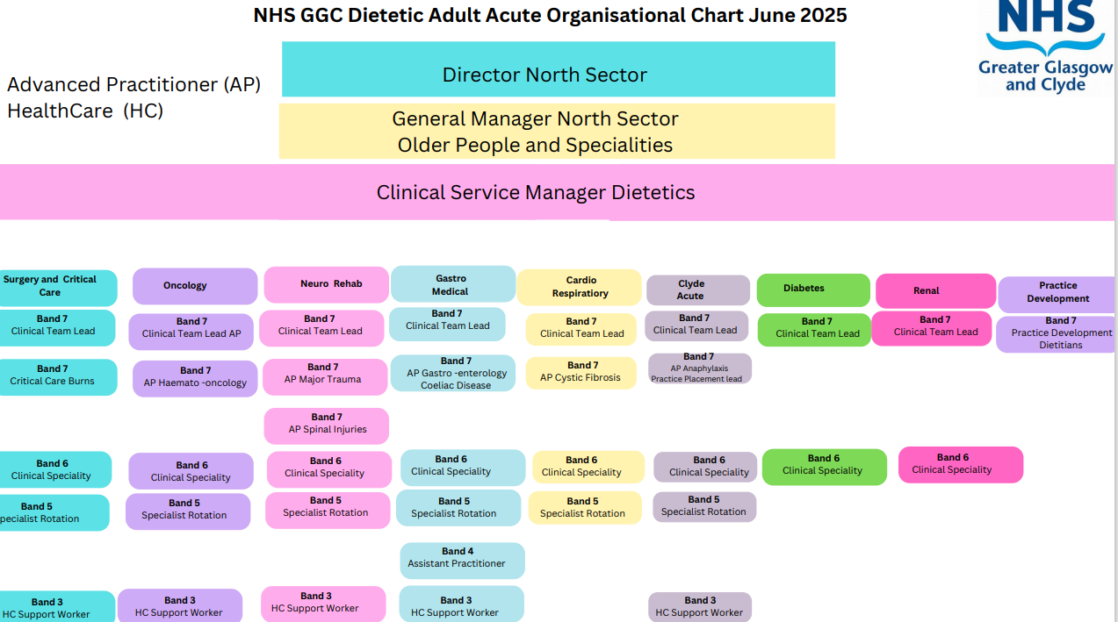

Denotes this post