

**Specialist Doctor in Sexual Reproductive Health**

Recruitment Pack

Application Closing Date: 7th August 2023

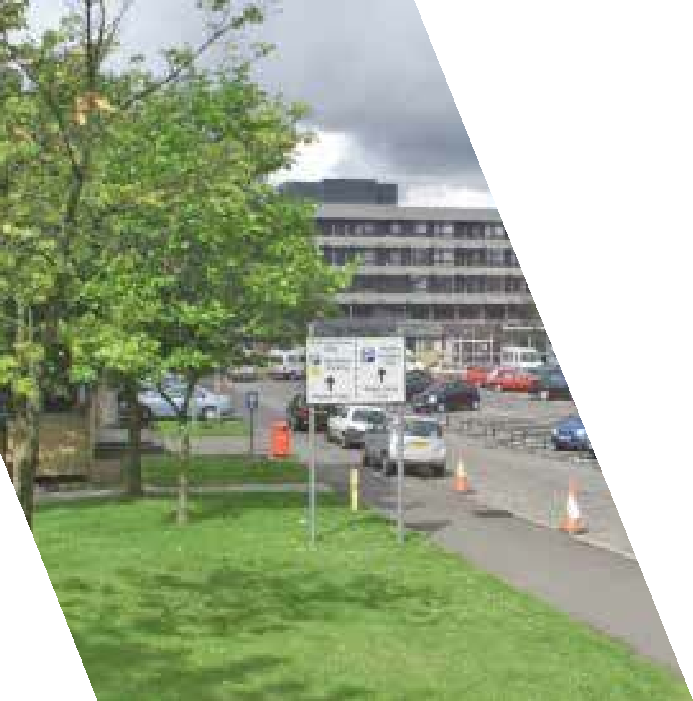

HR Medical & Dental

Law House

Airdrie Road

Carluke

ML8 5EP

  Carer Positive LEVELS LOGOS CMYK_engaged_linear.jpg

**Contents**

To assist you with your application for the post of Specialist Doctor in Sexual and Reproductive Health for NHS Lanarkshire, this pack will provide useful information about the posts, about NHS Lanarkshire and about Lanarkshire more generally.

|  |  |
| --- | --- |
| Advert 3  Job Description 6  Person Specification 13  Terms and Conditions 18  Selection Process 20  Lanarkshire – The Place 21  Our Vision 22  Our Context 25  Our Ambition 26  Useful Websites 30  Living in Lanarkshire 31 |  |
|  |  |

Specialist Doctor in Sexual and Reproductive Health



**Salary Range £83,130 - £94,350 per annum**

We welcome applications from enthusiastic individuals keen to join our dedicated Sexual and Reproductive Health team in NHS Lanarkshire.

The successful applicants will join a fully integrated genitourinary and sexual reproductive health team as specialist doctor in SRH. You will have the opportunity to develop skills and experience as a Specialist Doctor in Sexual Health and to support our vision of sexual health for all.  We are looking for someone who is passionate about providing care and improving the sexual health outcomes of our local population. The post would suit individuals contemplating a career in Sexual & Reproductive Health including doctors undertaking CESR training in Sexual and Reproductive Health.

NHS Lanarkshire is Scotland’s third largest health board and has 3 Acute Hospitals – University Hospital Hairmyres, University Hospital Wishaw and University Hospital Monklands. All services are currently working to design and realise new models of care for the replacement University Hospital Monklands which will be Scotland’s flagship digital hospital, to be built in 2028.

University Hospital Monklands is a district general hospital allowing a varied practice and is also hosts all major ENT, head and neck, and urology cases for NHS Lanarkshire as well as general surgery, vascular access, OMFS and dental services.

Situated in West Central Scotland, University Hospital Monklands is readily accessed from a wide area, allowing commuting from city, suburban and rural locales.

**Informal enquiries regarding this post will be welcomed by:**

|  |  |  |
| --- | --- | --- |
| Dr Adam Daly | Associate Medical Director H&SCPs  North Lanarkshire | 01698 858320 |
| Mr. James Duffy | General Manager, Adult Services | 01236 772229 |
| Dr Rashmi Ronghe | Consultant Sexual Reproductive Health | 01698 753662 |

All applications for the job are made through [https://apply.jobs.scot.nhs.uk/vacancies.aspx](#)

Please follow the link below should you wish any further information on NHS Lanarkshire [Recruitment | NHS Lanarkshire (scot.nhs.uk)](#)

**NHS Lanarkshire are happy to consider requests for this publication to be in another accessible format i.e. large print, braille, etc.  Please contact us via either of the undernoted methods clearly stating which format is required.**

Should you require further information regarding this post you can contact the HR Medical & Dental team or make informal enquiries with the department.

For any application queries, please contact Lynn Cliens, HR Assistant on 01698 754351 or [**medical.dentalSAS@lanarkshire.scot.nhs.uk**](#)

|  |
| --- |
| **Integrated Health and Social Care Partnerships**  Legislation requiring the integration of health and social care came into effect in April 2016. This resulted in significant change to the way we care for and improve the health of our people in their community. NHS Lanarkshire has 2 Health and Social Care Partnerships one in the North and one in the South.  NHS Lanarkshire, our Local Authority Partners in North and South Lanarkshire Councils, our third sector partners and the people of Lanarkshire recognise the importance of a system of health and social care that is robust, effective and efficient and which reliably ensures a high quality of support and care which is the right of the people of Lanarkshire.  Further details on the Integration of Adult Health and Social Care are available at: www.scotland.gov.uk/publications/2012/07/5082/0 Monklands Replacement Project (MRP) The Monklands Replacement Project (MRP) is NHS Lanarkshire’s exciting and positive vision for University Hospital Monklands and the local and wider community it serves, proposing a major investment in Lanarkshire’s hospital estate by rebuilding the hospital on a new site at Wester Moffat, east of Airdrie.  The key components planned for the new hospital which will have a significant impact on workforce are:   * Single Room ward design – In line with Scottish Government CEL 27 (2010), appropriate for all new build hospitals, in addition to effective infection control it provides increased privacy and confidentiality for patients and visitors; * Front Door Assessment Model – Proposed bed numbers remains consistent with current Monklands hospital with a reconfiguration of some downstream inpatient beds to front door assessment beds to create the front door assessment village. It is envisaged the new clinical model will support reduction in average length of stay whilst ensuring optimal patient experience. The guiding principle will be to adopt a home first approach.   Incorporating the above changes to service delivery model, population projections and epidemiology projections, healthcare planners have developed the proposed occupancy and bed requirements by specialty that links to the clinical output specification and planned models of care. Success of the new clinical model proposed for MRP and the aim to reduce length of stay and admissions requires working collaboratively with wider health service, in particular, North and South Lanarkshire HSCPs to ensure they have adequate workforce, capacity and infrastructure in the community.  NHS Lanarkshire Board met in November 2022 to consider a draft outline business case (OBC) for the new hospital. The Board agreed to submit the OBC to the Scottish Government for their consideration and approval as the next stage in the formal approval process. The Monklands Replacement Project submitted the Outline Business Case in December 2022.  Work towards Full Business Case (FBC) has commenced and will progress throughout 2023 and 2024 in partnership with service leads and staff side representatives based on healthcare panning assumptions, to continue development of workforce planning and new clinical model in advance of new hospital opening, based on workforce affordability, adaptability and availability. |

**Job Description**

1. **JOB PURPOSE**

This is a 2-year fixed term post which will be offered as a full-time post on a 10 PA basis (applications will however be considered from those wishing to work less than full-time).

The administrative base for the Sexual Health Service is in Coathill Hospital, Hospital Street, Coatbridge. However, a comprehensive, integrated Sexual Health service is provided to patients across both North & South Lanarkshire. The office is a shared space in Coathill Hospital. The post holder will have at least 0.5 WTE Secretarial/admin support, increasing accordingly if taking on any additional commitment.

The clinic commitment is to provide (in conjunction with your fellow consultants and specialty doctors) a community-based service for Lanarkshire, providing a full range of contraception and testing and treating for STIs. The Lanarkshire service covers a total population of around 570,000 with a diverse geography where there are large urban areas in the Northern part of the county and large rural areas in the Southern part of the county. The Lanarkshire area has a high level of deprived households.

The service currently deals with over 25,000 consultations a year. Currently, the Sexual Health service is an exclusively community-based service provided by two Genitourinary Medicine Consultants and a Sexual Reproductive Health Consultants supported by a skilled specialty doctor team. We operate from several community bases in the following areas: Coatbridge, Motherwell, Wishaw, Airdrie, Cumbernauld, Cambuslang & Rutherglen, East Kilbride, Hamilton, Blantyre, Viewpark & Lanark. From October 2023 the department will offer service to the residents of the Northern corridor.

The precise details on the job plan will be finalised with the General Manager and the Clinical Director after appointment. The successful candidate will support the Sexual Reproductive Health consultant.

NHS Lanarkshire is supportive of applications from individuals with well-developed ideas for improving services who are able to demonstrate a commitment to quality improvement, patient safety (including human factors training), Medical Education and Research & Development.

The Board has a well-established, bespoke Medical Education and Training Centre with simulation facilities and is developing a faculty for Human Factors training. We have a strong commitment to Patient Safety and Quality Improvement with an increasing number of consultants who are trained Patient Safety Fellows.

Specialist Doctors are initially offered 1 PA for SPA duties for a full time post. Candidates wishing to work less than full time would be offered pro rata SPA, dependant on the number of sessions worked.

|  |  |
| --- | --- |
| Number of PAs worked | SPA offer |
| 5 -10 PAs | 1 SPA |
| 3 - 4 PAs | 0.5 SPA |
| 1 – 2 PAs | 0.25 SPA |

NHS Lanarkshire is supportive of applications from individuals with well-developed ideas for improving services who are able to demonstrate a commitment to quality improvement, patient safety (including human factors training), Medical Education and Research & Development

1. **GENERAL PROVISION**

You will report to the Clinical Director, who will agree your job plan.

1. **HEALTH & SAFETY**

You are required to comply with NHS Lanarkshire Health and Safety Policies.

1. **MANAGEMENT STRUCTURE**

The supporting operational and clinical management structures are focused on enhancing patient safety, quality improvement and local delivery at hospital level, with visibility of clinical leadership and support for individual professional accountability. Our Medical Managers will provide professional leadership to medical staff, ensuring that they are effectively developed, organised, integrated and managed to support the strategic aims of each Division and meet the needs of the patient.

**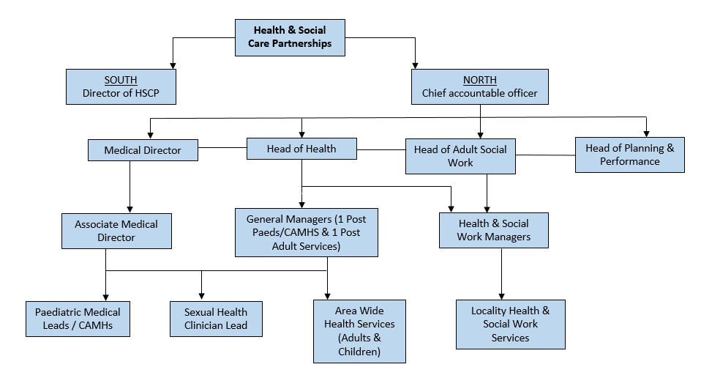**

1. **RESOURCES**

|  |  |  |
| --- | --- | --- |
| The following department resources are available:- | | |
| **Consultants** | **Special Interest** | |
| Dr Alison Currie | Genital Dermatoses | |
| Dr Rashmi Ronghe | Medical Gynaecology (Lead) | |
| Dr Laura Gillespie | Genitourinary Medicine | |
| Nursing Staff: Team Leader 1 WTE  Band 7 1 WTE  Band 6 10 WTE  Band 3 3 WTE | | |
| **Specialty Doctors** | | 4 WTE |
| **Secretarial Support:** | |  |
| WTE Senior Secretary  Band 3  Band 4 | | 1.53 WTE  1 WTE |
|  | |  |
| Receptionist  Band 2 | | 4 WTE |

1. **OFFICE SPACE**

All Medical Staff have access to shared office spaces with IT facilities. A dedicated departmental secretary provides administrative and secretarial support.

1. **JUNIOR MEDICAL STAFF/MEDICAL STUDENTS**

You will be responsible for the training and supervision of Junior Medical staff who work with you, and you will be expected to devote time to this on a regular basis. In addition, you will be expected to ensure that staff have access to advice and counselling. If appropriate, you will be named in the contracts of Doctors in training grades as the person responsible for overseeing their training and as the initial source of advice to such Doctors on their career.

1. **WORK PROGRAMME**

As required under Section 4 of the Terms and Conditions of Service, the duties and responsibilities are supported by a job plan and work programme detailed as follows:

**Job Planning/Programmed Activities**

The job plan will be dependent on the successful candidate’s subspecialty training and interests.

On taking up post a Job Plan will be agreed between the person appointed and the Clinical Director. This job plan is subject to review by the post holder and the Clinical Director as noted in the terms and conditions. The procedures set out in the ‘Terms & Conditions of Service’ must be followed if it is not possible to agree a job plan, either initially or at annual review.

The timetable is indicative and subject to negotiation with the Clinical Director. The core 10 PA working week will be based on 9 PA’s of Direct Clinical Care (DCC) duties and 1 PA of SPA time for a full-time post-holder.

The indicative weekly timetable included in the work programme shows an example of the working week, which will be subject to change and negotiation with the Clinical Director depending on service needs on commencement.

Sexual Health department in Lanarkshire has a strong history of providing training for LARC procedures (coils and implants) for GPs, nursing and midwifery staff as well as providing training and assessment for DFSRH candidates. The successful candidate will be expected to lead on training and teaching within the department and training provision for health professionals from other specialities.

|  |  |  |  |  |
| --- | --- | --- | --- | --- |
|  |  |  |  |  |
| Fixed Commitments | **Days** | **Hours** | **Type of Work** | **Location** |
| Monday | AM | Coil clinic | Glenalmond clinic, Coathill Hospital |
|  | PM | SRH complex/Coil clinic | Camglen HC |
|  | Evening (5-7pm) | Young Persons clinic | Camglen HC |
| Tuesday | AM | SRH Complex/coil clinic | Motherwell HC |
|  | PM  (1-3pm) | SRH telephone clinic | Coathill Hospital |
| Wednesday | AM | CPD/SPA | Coathill Hospital |
|  | PM | Coil clinic | Hunter HC, East kilbride |
| Thursday | AM | SRH complex / coil clinic | Airdrie HC |
|  | PM | LARC Training clinic | Coathill Hospital |
| Friday | AM | Coil clinic | Viewpark HC |
|  | PM | DCC | Coathill Hospital |

**This is an example**

A specific job plan will be negotiated with the successful applicant.

Other activities not occurring at fixed times.

* Reviewing results.
* Discussing management/investigation of patients with colleagues in other relevant specialities.
* Discussing patient management/ reviewing patients with doctors in training and Nursing Staff out with formal clinics.
* Vetting clinic referrals/ allocating appointments.
* Work towards generic and specialty objectives of the department.
* CPD and Appraisal
* Audit

1. **AUDIT & RESEARCH**

The successful candidate will be expected to participate in audit and quality improvement processes as part of appraisal and there is an active clinical audit department available to assist. NHS Lanarkshire is ambitious to build a portfolio of research projects backed by enthusiastic and dynamic individuals. It has an active Research and Development department and would welcome discussion regarding a potential research interest.

**11. CONTINING PROFESSIONAL DEVELOPMENT**

Study leave is available within the terms and conditions of service with the approval of the Clinical Director/Clinical Lead. The appointee will be required to fulfil such demands for continuing professional development as relevant bodies may make.

**Specialist Doctor in SRH**

**Person Specification**

|  |  |  |
| --- | --- | --- |
| **Criteria** | **Essential** | **Desirable** |
| Qualifications | * MBChB (or equivalent). * Current full registration with GMC with a licence to practice. * Letters of competence in SDI and IUT * DFSRH * LocMED (Faculty registered trainer) | * MFSRH * Additional Higher Degree or other Diploma. * Further educational certificates, diploma etc. |
| Training | * Completed a minimum of 10 years’ medical work (either continuous period or in aggregate) since obtaining a primary medical qualification of which a minimum of six years should have been in a relevant specialty Doctor and/or closed SAS grades. Equivalent years’ experience in a relevant specialty from other medical grades including from overseas will also be accepted. | * Training at ST/SPR level in communication, teaching or management. * Experience within UK training establishments. * Human Factors Training. |
| Experience | * Recent and relevant clinical experience and competency with wide general experience. * Recent and relevant experience and personal qualities to work in an integrated sexual health service. * Ability to supervise the clinical work of doctors in training and relevant staff in other disciplines. * Confident with indirect supervision of varying grades of doctors in training. | * Well-developed subspecialty interest. * Administrative/ Management experience. * Previous experience in organising NHS Services or equivalent. |
| Audit/  Research | * Understanding of the principles of medical audit. * Evidence of a consistent engagement and contribution to audit or quality improvement. Minimum of annual local involvement. * Awareness of principles of research with an ability to critically analyse medical literature. * Evidence of reflective practice. | * Experience and interest in Audit or the practice and experience of design and audit. * Research within the practice. * Involved in design of research relevant to the practice. |
| Publications | * Presentations/Publications relevant to the practice of Sexual Reproductive Health and Genitourinary Medicine. | * Publications in journals relevant to the practice of Sexual Reproductive Health and Genitourinary Medicine |
| Teaching | * Previous involvement in the delivery of undergraduate or postgraduate teaching.      * Experience of providing supervision and or mentorship | * Interest in and commitment to teaching and training. * Experience of organising teaching programmes. * Formal training in educational / clinical supervision. |
| Knowledge and  Skills | * Broad based knowledge and skills in diagnosis and clinical management within the Specialty and encompassing most sub-disciplines. * Evidence of continuing professional development and reflection of its impact on clinical practice. | * Further educational certificates, diploma’s, etc. |
| Managerial | * Awareness of the principles of team leadership and effective people management. * Commitment to the Values of NHS Lanarkshire:- Fairness, Respect, Quality, Working together | * Involvement in service re-design. * Involvement in project delivery. * Involvement in NHS-related meetings. |
| Leadership | * Awareness of the principles of team leadership and effective people management. * Commitment to the Values of NHS Lanarkshire:- Fairness, Respect, Quality, Working Together. | * Evidence of role as leader within groups. |
| Disposition | * Committed to Quality Patient Care. * Able to be understanding of and sensitive to the needs of patients. * Excellent communication skills (verbal and written) * Ability to work under pressure. * Ability to work effectively in a multidisciplinary team. * Responsive to change and innovation, promoting a culture for organisational development. * A flexible approach to duties, which satisfies the needs of the Service in a changing environment. * Ability to demonstrate reflective practice with evidence of regular appraisal with clear Personal Development Plan relating to Continuing Professional and Personal Development. * Good time management and organisation. * Demonstrates commitment and enthusiasm to service delivery. * Able to demonstrate reliability, initiative, and punctuality with excellent relationships and team working with patients, relatives and colleagues and good non-technical skills. Recent 360-degree feedback or consultant feedback is a good way to be able to demonstrate this and can be brought to interview. | * Problem solver/diplomat/counsellor. * A natural leader. |
| Other | * Fluent in medical English and evidence of ability to communicate in stressful situations. | * Preference to work in a District General Hospital. |

|  |  |  |  |
| --- | --- | --- | --- |
| **PERSON PROFILE** | | | |
| **Demonstrated at Pre-Employment Check** | | | |
| **Attributes** | **Essential** | | **Useful** |
| Other | Satisfactory medical clearance by NHS Lanarkshire Occupational Health Service.  Service PVG Check.  Current full driving licence and access to a vehicle (required for jobs where an immediate return to site or travel between sites is required) | |  |
| If there is any reason why a disabled person should not be considered suitable for this post, please provide details: | | **The post requires physical dexterity. Uncorrected visual or hearing defect would be incompatible with the nature of the work.** | |
|  | **Prepared By:** | | **Approved By:** |
| **Name** | **Dr Rashmi Ronghe** | |  |
| **Designation** | **Consultant in SRH, Lead clinician in Sexual Health** | |  |
| **Date** | **July 2023** | |  |

**Terms & Conditions**

1. This appointment is offered on the Terms and Conditions of the Specialist Doctor in Scotland (2022).
2. This appointment is superannuable under the NHS Superannuation Scheme. New eligible entrants to NHS Lanarkshire who are not already in a pension scheme will normally be enrolled automatically into membership of the NHS Pension Scheme.

Our pension scheme is provided by Scottish Public Pensions Agency, and all benefits are explained on the SPPA website (http://www.sppa.gov.uk/). Here you can also access an annual statement showing how much service has built up in your pension. If you wish to opt out or have previous NHS Service, you should refer to the SPPA website for further information about any implications for your pension benefits.

Superannuable pay will include basic salary (up to 10 programmed activities, but not any extra programmed activities above this level), on-call availability supplements, discretionary points, distinction awards, and any other pay or allowances agreed by the Scottish Government, to be superannuable.  Superannuable pay will be subject to HMRC legislation.

1. The employment is subject to 3 months’ notice on either side subject always to the appeal and other provisions of Schedule 2 of the Specialist Doctor in Scotland (2022)
2. The successful candidate must be contactable throughout any on-call period. NHS Lanarkshire will provide the facility for this.
3. The successful candidate, if not already employed by the NHS Lanarkshire, will be required to complete a medical questionnaire to obtain medical clearance from the Occupational Health Physician.

f) The successful candidate will be required to complete a Disclosure Scotland PVG (Protecting Vulnerable Groups Scheme) form. An e mail link will be sent to the successful candidate for completion. No approach will be made without written permission of the successful applicant who will be asked to sign and complete a disclosure PVG application, giving authorisation for the check to be undertaken. If you are a non EEA National and are currently based out with the UK a Country of Origin check/criminal records certificate will also be required from each country in which you have resided continuously or cumulatively for 12 months or more in the last 10 years.

1. NHS Lanarkshire does not negotiate salary placements. On commencement the salary will be in line with Schedule 10 Terms and Conditions of the Specialist Doctor in Scotland (2022). Appointees start on the scale minimum except in the circumstances of paragraphs 6 – 10 within Schedule 10 of the terms and conditions of service.
2. From 1st April 2022 the starting salary for the post is £83,130 per annum (based on 10 Programmed Activities per week). The successful candidate’s total salary will be dependent on his/her previous service history. Remuneration for any extra programmed activities will be dependent upon the job plan agreed at the time of appointment.
3. Dependent upon present place of residence, NHS Lanarkshire may require the successful candidate to undertake to move home to a distance acceptable to NHS Lanarkshire, normally within 10 miles of the base Hospital, in which case removal expenses will be payable in accordance with NHS Lanarkshire Policy. In some cases, however, a residence more than 10 miles distant from the base hospital will be acceptable and in this case removal expenses will be subject to the prior approval of the Associate Medical Director for such a residence. The position will be made clear to the successful candidate on application.

**Selection Process**

The Job Description and Person Specification are designed to inform potential applicants on the essential and desirable experience and personal attributes which are sought in the appointment of the post.

Assessment against this will feature throughout the recruitment and selection process for the appointment.

**Lanarkshire – The Place**

NHS Lanarkshire is the third largest health system in Scotland with around 12,500 staff and a baseline recurring budget of £1.4bn, serving a community of circa 655.000 people, through

* Three acute hospitals – University Hospital Hairmyres, University Hospital Monklands and University Hospital Wishaw
* Around 102 GP Practices with 367 wte GPs
* Spans two local authority areas – North Lanarkshire Council and South Lanarkshire Council with 2 Integration Joint Boards, North Lanarkshire IJB and South Lanarkshire IJB.

NHS Lanarkshire and North and South Lanarkshire Councils formed the North and South Lanarkshire Heath and Social Care Partnerships to develop a wide range of community facing health improvement, health and social care services with locality based planning and delivery.

The Partnerships include a range of community health and social care services, community hospitals (mainly for long term conditions and continuing care for older people), as well as a wide range of services for patients with mental health problems and learning disabilities. Services also include GP Practices providing many primary and community care services throughout Lanarkshire.

[https://www.hscnorthlan.scot/](#)

[https://www.southlanarkshire.gov.uk/slhscp/info/1/about\_us](#)

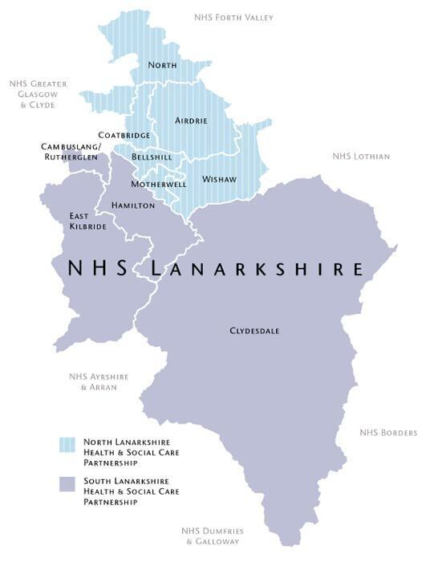

**Our Vision**

**NHS Lanarkshire will:**

* Be an exemplar anchor institution in our own NHS care delivery work and in how we support and catalyse action with our local partners.
* Build upon the learning and collaboration that has been reinforced by the pandemic to ensure that we have a resilient healthcare system for the future.
* See addressing inequalities, promoting well-being and ensuring sustainability as core ways of working both in service delivery and in partnership working. We will continue to use the opportunity of remobilisation to redesign services to achieve a reduction in healthcare associated inequalities, promote well-being, ensure cost-effectiveness, and reduce unmet need rapidly across the system.

**Our Interim Corporate Objectives**

|  |  |
| --- | --- |
| 1 | **Pandemic Response & Corporate** **Resilience**  Respond to the pandemic to ensure resilience and provide a safe environment and interventions that minimise the risk of injury or harm to our patients and staff. |
| 2 | **Recovery of Services**  Remobilise and recover services to re-establish timely and accessible health and social care to all parts of the community we serve. |
| 3 | **Workforce**  Ensure we have a diverse, flexible and appropriately trained workforce in place that delivers high quality care that meets the needs of NHS Lanarkshire’s population |
| 4 | **Development of Our Health Together**  Work in partnership to deliver ‘Our Health Together’ realising our strategic ambition to modernise and continuously improve care, engaging with our patients, partners and workforce to ensure health and social care services are sustainable, focused on prevention and early intervention and continue to meet their needs |
| 5 | **Equalities & Inequalities**  Establish NHSL as an Anchor organisation, working with partners to tackle socio-economic disadvantage and reduce inequalities and ill health that are associated with being disadvantaged |
| 6 | **Maximising Staff Wellbeing**  Promote health and wellbeing, implementing programmes that impact positively on the lives of our workforce, reflect the value we place on them, enhance engagement, and build resilience |
| 7 | **Addressing the Challenges of Sustainability and Climate Change**  Work towards delivery of net zero health and social care services, responding to climate change while delivering efficient, low carbon patient focused care. |
| 8 | **Financial Sustainability**  Provide effective financial planning that supports financial sustainability, balances budgets and provides value. |

*The Board’s Interim Corporate Objectives for 2022/23 were approved by the NHS Board in March 2022 and reflect* *that many uncertainties remain with respect to the ongoing and future impact of the global Covid-19 pandemic. NHS Lanarkshire is committed to maximising a successful and sustained recovery of services as quickly as possible. However, the impact of Covid-19 and non-Covid demands on the service in recent months has contributed to a significant deterioration in our planning assumptions. As such, the scope of our Corporate Objectives is limited in terms of our ability to accurately assess how the whole system can address the ongoing challenges of responding to the pandemic and how quickly the remobilisation process can take effect.*

**Our Values**

The NHS Lanarkshire values of Fairness, Respect, Working Together and Quality underpin our purpose, providing local focus and context for the improvement of our services and guiding our individual and team behaviours. NHS Lanarkshire’s values represent the care our patients can expect, and how this care should be delivered by our staff.

|  |  |
| --- | --- |
| **Fairness**  Ensuring clear and considerate decision making at all levels | As a team, we are responsible for being consistent and open in making decisions  As an individual I am responsible for participating in decisions and seeking clarity whenever I am unsure |
| **Respect**  Valuing every individual and their contribution | As a team, we are responsible for being courteous and professional in fulfilling our individual and collective roles  As an individual, I am responsible for recognising that we are all different and appreciating the contribution that I and others make |
| **Quality**  Setting and maintaining standards in everything we do | As a team, we are responsible for upholding our high standards in every activity, for every person, everywhere  As an individual, I am responsible for ensuring I understand and deliver our standards every time |
| **Working Together**  Thinking, growing, delivering as a team | As a team, we are responsible for creating and sustaining an environment that allows team working and collaboration to flourish  As an individual, I am responsible for communicating effectively and working well with others at all times |

**Our Context**

**The Board**

Lanarkshire NHS Board (the Board) is a strategic body, accountable to the Scottish Government Health and Social Care Directorate and to Scottish Ministers for the functions and performance of NHS Lanarkshire. The Board consists of the Chair, Non-Executive Directors (who are publicly appointed by the Scottish Ministers), Stakeholder Non- Executive Directors including the Employee Director, Area Clinical Forum Chair, representatives of North and South Lanarkshire Councils and Executive Directors.

The NHS Board’s role is to improve the health and wellbeing of the people of Lanarkshire through robust, accountable and corporate governance systems. The Board’s role is to set strategic aims, hold the executives to account for the delivery of those aims, determine the level of risk the Board is willing to accept, influence the organisation’s culture and engage with stakeholders on the stewardship of public money and the priorities of the Board.

**Composition of the Board**

|  |  |
| --- | --- |
| Non-Executive Directors | Executive Directors |
| Chair  10 Non-Executive Lay Members (including 1 Whistleblowing Champion)  Chair - Area Clinical Forum  Chair - Area Partnership Forum  2 Local Authority Elected Members - 1 from North Lanarkshire Council and 1 from South Lanarkshire Council | Chief Executive  Director of Public Health and Health Policy  Director of Finance  Medical Director  Director for Nursing, Midwives and Allied Health Professionals |

**Our Ambition**

The NHS Lanarkshire Board has recently agreed that our overall healthcare strategy will be guided by:

* The Healthcare Strategy- Our Health Together; Living our best lives in Lanarkshire
* Focusing on service recovery through the triple lens of addressing inequalities, maximising wellbeing and addressing the challenges of sustainability and climate change,
* Capitalising on the new and innovative ways of working, particularly in the use of digital technology, brought about in our response to COVID-19;
* Delivering the Outline Business Case for the replacement of University Hospital Monklands;
* Being a leading partner in contributing to improving the exacerbated socioeconomic and health inequality challenges faced by Lanarkshire since the pandemic;
* Enhancing the Board’s reputation through exploiting the opportunities that arise through our strategic partnerships with three University partners as a leading teaching Board; and
* Continuing to provide high quality sustainable services and financial prudence in line with our Local Delivery Plan, agreed with Scottish Government.

**Our Health Together: Living our best lives in Lanarkshire**

The Healthcare Strategy “Our Health Together; Living our best lives in Lanarkshire” is developing from our previous strategy “Achieving Excellence” and reflects the significant achievements made already, and takes account of the post COVID-19 world we are adapting to.

Progress is driven by a series of action plans which are coordinated by a Strategic Delivery Team and reported to the NHS Board and Planning, Performance & Resources Committee on a regular basis.

Our Health Together will address:

* **Finishing what we’ve started** – shifting the balance of care and maintaining acute services within the current bed base: one hospital, three sites. This was a key element of Achieving Excellence: success has been achieved, but more needs to be done.
* **Recovery and resilience following COVID-19** – recovery/remobilisation plan over 18 months or so and resilience planning. Meet agreed (new) clinical priorities (national and local).
* **Making A Wider Impact** – through a Whole-Lanarkshire approach to tackling both existing and COVID-19 driven health and socioeconomic inequalities, the strategy will consider inequalities, wellbeing and the challenges of sustainability and climate change. A Partnership approach with other public bodies, and third and independent sectors.

Workstreams have been established to develop the strategic ambitions for the following service areas:

* **Primary Care Redesign** – Continuation of Primary Care Improvement, adoption of post-COVID-19 service model with emphasis on reduction in physical attendance.
* **Redesigning Urgent Care** – Post-COVID-19 primary and secondary urgent care service model short, medium and long term redesign. Taking national directions of travel but creating local solutions, particularly in the short term.
* **Mental Health (incl CAMHS & Dementia)-** Delivering on the agreed Mental Health & Wellbeing Strategy and delivering a new service model for CAHMS based on the outcomes from a deep-dive exercise.
* **Frailty, Older People & Care Homes**
* **Planned Acute Care** – General Surgery, Robotic Assisted Surgery, Trauma & Orthopaedics and National Treatment & Diagnostic Centre workstreams, with a focus on post-COVID-19 recovery (backlog) and developing a service model capable of meeting future demand within the COVID-19 environment.
* **Monklands Replacement Project** – Learning the lessons from COVID-19 across services and engineering and preparing a business case for the new hospital.
* **Long Term Conditions (LTC)–** Building on the work of the LTC hub.
* **Public Health System Development**
* **Realistic Medicine**
* **Rehabilitation**
* **Staff Health & Wellbeing**
* **Unscheduled Care**

**COVID-19**

COVID-19 has undoubtedly proved to be the biggest challenge to public health and the organisation of health services in a generation. Our focus has been in supporting staff and patients during these first two years of the pandemic, and we are now moving into the remobilisation and living with Covid19 phase.

The Board has in place a Service Remobilisation Oversight Group which is chaired by the Executive Director of Nursing and Executive Medical Director. This is a whole-system oversight group established to support the operating divisions in the “standing-up” of services and the preparation of the Annual Delivery Plan (ADP).

In the recovery phase, we are working closely with our planning partners across the whole of Lanarkshire, and engagement with our planning partners is key to delivering our ambitions.

The Chief Executive, working closely with the NHS Board, will drive this agenda, working with all stakeholders across the wider Lanarkshire community and at regional and national level.

In NHS Lanarkshire we have a demonstrable track record of excellent partnership working, through meaningful and mature staff and stakeholder engagement.

**Net Zero Carbon Pathfinder Project**

The Energy Efficient Scotland Routemap requires public sector buildings to be zero carbon by 2050 and the Scottish Government has also called a Climate Emergency, committing to become a net zero carbon economy by 2045. The Net Zero Carbon Public Sector Buildings (NZCPSB) standard (“the Standard”) is a new voluntary standard which has been developed by Scottish Government to support the Public Sector in setting ambitious targets to achieve net zero outcomes for new buildings and major refurbishments.

The Standard supports a challenging, credible path to net zero carbon materials and energy supplies for all non-domestic buildings. By 2045, projects that adopt the Standard will achieve zero embodied carbon during construction and subsequently the whole life of projects, including operational energy. The Monklands Replacement Project has been selected as a pathfinder project for the new standard which has resulted in the requirement for an all-electric hospital. This demands innovative solutions and a substantial energy centre to accommodate all of the required technology.

**Scotland’s First Digital Hospital**

The construction of a new Monklands Hospital has also created the opportunity and ambition for the new Monklands University Hospital to be Scotland’s first digital hospital, directly benefitting its local community of patients, staff and visitors. Technology will be used to allow patients to access care advice and to navigate their way through the hospital easily and intuitively. The new hospital will ensure safer, better patient care and value for staff and for patients through the use of digital technology and real time information to support an efficient and effective patient journey. The hospital will have new digital systems to support patients and their clinical teams.

For further information, please visit to [www.monklands.scot.nhs.uk](#)

**Health Inequalities**

The Board is committed to addressing health inequalities throughout Lanarkshire and, working with our Community Planning Partners, there will be a renewed focus on improving the exacerbated socioeconomic and health inequality challenges faced by Lanarkshire since the pandemic.

The Board has adopted a ‘place based approach’ to regenerate what will be the vacant Monklands Hospital site, and the work we are taking forward with Strathclyde University and Professor Sir Harry Burns will form part of our wider triple lens strategic approach to tacking health inequalities in Lanarkshire.

**University Strategic Partnerships**

NHS Lanarkshire has entered into strategic partnerships with

* Glasgow Caledonian University in 2017
* the University of the West of Scotland in 2018; and
* most recently with Strathclyde University in 2019.

This resulted in the Board gaining University status from Glasgow Caledonian University and the University of the West of Scotland. Discussions are at an advanced stage for Strathclyde University to also award the NHS Board with University Status in late 2020.

**Useful Websites**

NHS Lanarkshire – [https://www.nhslanarkshire.scot.nhs.uk/](#)

Scotland’s Health on the Web (SHOW) – [www.show.scot.nhs.uk](#)

North Lanarkshire Council Website - [www.northlanarkshire.gov.uk](#)

South Lanarkshire Council Website - [www.southlanarkshire.gov.uk](#)

NHS Lanarkshire Finance –

[https://www.nhslanarkshire.scot.nhs.uk/download/annual-report-and-accounts-for-year-ending-march-2019/](#)

Link to the Interim Corporate Objectives 2002/22 (cover paper and template) [https://www.nhslanarkshire.scot.nhs.uk/download/2022-march-30-board-papers/?ind=1648622978910&filename=2022-March-30-Board-13a.-Interim-Corporate-Objectives-Cover-Paper-30-March-2022-ver-18.03.22.pdf&wpdmdl=37902&refresh=628754be1902d1653036222](#)

https://www.nhslanarkshire.scot.nhs.uk/download/2022-march-30-board-papers/?ind=1648622977160&filename=2022-March-30-Board-13b.-Interim-Corporate-Objectives-2022-23-Annex-1-Ver-22.03.22.pdf&wpdmdl=37902&refresh=628754be190b41653036222

Link to Strategy Map for Delivery of the Annual Operational Plan:

[https://www.NHSLanarkshire Strategy Map for AOP 20-21](#)

Link to Monklands Replacement Project

[https://www.nhslanarkshire.scot.nhs.uk/get-involved/consult-engage/monklands-engagement/](#)



@NHSLanarkshire



youtube.com/nhslanarkshire



facebook.com/nhslanarkshire



@nhslanarkshire

**Living in Lanarkshire**

***Living in the area***

Within the UK, Lanarkshire is situated in the heart of Scotland's central belt, the area offers an ideal combination of tranquil parks and market towns, with something for everyone.

Centrally located between Glasgow (c. 20 minutes) and Edinburgh (c. 40 minutes) you can easily commute or, should you wish to relocate, you can choose either a substantial Lanarkshire town or a more relaxed rural location and still have the attractions of two major cities on your doorstep. The county offers accessible links to major cities with easy access to major motorway/rail routes and international airports allowing you to travel across Scotland, the UK and beyond.

There are many attractions within Lanarkshire, including: -

* New Lanark World Heritage Site,
* Antonine Wall World Heritage Site,
* The Falls of Clyde,
* Summerlee - The Museum of Scottish Industrial Life,
* The National Museum of Rural Life,
* Strathclyde Country Park,
* Scottish Wildlife Reserves on the shores of the River Clyde,
* Various museums, galleries, castles, heritage centres,
* Numerous country parks.

## *Where Schools Are Located:*

The majority of Glasgow's independent schools are located just outside the city centre. [https://www.mytopschools.co.uk/private-schools-glasgow/](#)

St Aloysius’ College [https://www.staloysius.org/](#)

Hutchesons’ Grammar School [https://www.hutchesons.org/](#)

Hamilton College - [https://www.hamiltoncollege.co.uk/](#)

**To find more information about living and working in Scotland please visit:**

[www.visitlanarkshire.com](#)

[www.visitscotland.com/destinations-maps/glasgow-clyde-valley/](#)

[www.southlanarkshire.gov.uk](#)

[www.northlanarkshire.gov.uk](#)

[https://www.scotland.org/](#)

[https://www.talentscotland.com/](#)

[https://moverdb.com/moving-to-glasgow/](#)