JOB DESCRIPTION 

JOB IDENTIFICATION
Job Title: GP Out of Hours (OOH) Data Analyst
Responsible to: GP OOH Performance Manager
Grade: Band 4
Department(s): GP OOH

JOB PURPOSE
The post holder will be a member of the GP OOHs Performance Team and will participate in a range of analytical activities with a focus on clinical activity data.

The post holder will develop, analyse, maintain and interpret information sources and systems in order to produce clear, accurate and timely information to support the clinical and managerial decision-making process across NHS Greater Glasgow and Clyde.

The post holder will support the development and delivery of a comprehensive Information Management reporting system which will align with the operational and performance monitoring requirements of the GP OOH Service.

- ROLE OF DEPARTMENT
The GP OOH Service provides urgent care during the out-of-hours period; Monday – Friday 18:00 – 08:00hrs and 24 hours at weekends and Bank Holidays. Service users access the service via NHS 24. NHS 24 assess the patient and if clinically appropriate will refer the patient to the OOH service. Patients may receive a remote consultation by telephone or video or a face to face consultation, either by appointment at one of Primary Care Centres or in their home or homely setting.

The GP OOHs HUB at Caledonia House provides a single point of access for an integrated, appropriate response. This includes collaborative working with Scottish Ambulance Service, NHS GGC Laboratory’s and Community Pharmacies in NHS GGC.

All aspects of this work require specialised support from the Data Analyst.

- ORGANISATIONAL POSITION
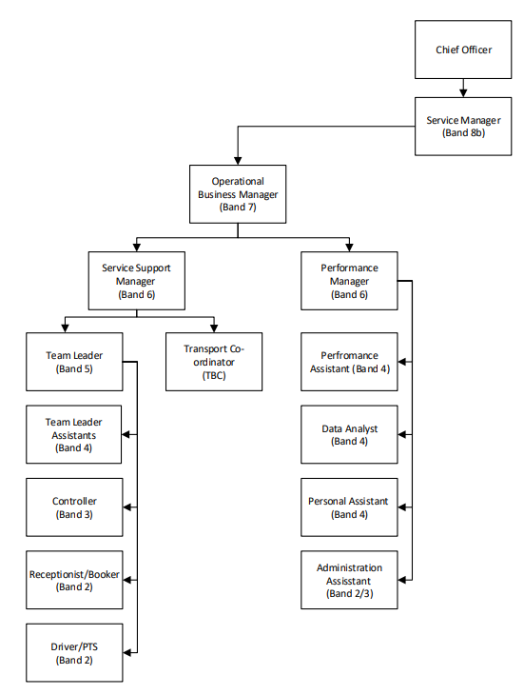
- SCOPE AND RANGE
The post has general responsibilities to the Performance Team within the GP OOHs service and is integral in terms of providing specific specialist input to data analysis, including information and ‘intelligence’ on aspects of utilisation. There are a number of routine monthly, quarterly and annual reports required by management and clinical staff.

- MAIN TAKS, DUTIES AND RESPONSIBILITIES
- Support the priorities of the Performance Team within the GP OOHs service.
- Report progress to the Performance Manager within the Performance Team on a regular basis.
- Develop collaborative working relationships with relevant GP OOHs personnel and other strategic partners to coordinate the development of reporting systems.
- Work with the Performance Manager to develop systems for and provide information on utilisation in NHS GG&C.
- Communicate regularly with the Performance Manager within the Performance Team, on results of analysis and audit projects.
- Work with the Performance Team within the GP OOHs service on ways in which data management, analysis and presentation could be improved.
- Responsible for the effective collation, analysis and distribution of data to support the management.
- Interrogate current methods of data collection, analysis and interpretation, seeking constant improvement and resolving any failures to meet targets.
- Introduce and implement effective data auditing procedures, with the aim of providing information about performance and influencing change.
- Close information gaps by working with colleagues to develop new and existing frameworks for data collection. This may include system specification, data capture, spreadsheet and database development and training small numbers of users from other departments to analyse the data themselves.
- Analyse, investigate and resolve statistical/analytical queries and issues by considering a range of solutions, e.g. problems in reporting system that, when resolved, can improve the accuracy and quality of data being reported.
- Liaise with relevant personnel in Performance Team to improve the accuracy and ensure the utility and validity of information, thus informing practice and influencing change.
- Develop a portfolio of reports for the Performance Team and facilitate delivery of targets on schedule.
- Participate in appropriate meetings and provide meaningful presentations to assist senior managers and colleagues to understand the complexity of information under discussion.
- Support the Performance Team, including preparing progress and quality reports, to include budget monitoring, and highlighting issues of concern.
- Ensure effective communications and collaboration with key stakeholders across NHSGGC.
- Ensure compliance with the General Data Protection Regulations (GDPR) and the Computer Misuse Act and all security procedures to protect sensitive and confidential data from disclosure.
- To produce regular data in line with the Senior Management Team meetings.

7a. EQUIPMENT AND MACHINERY
The principal responsibility is maintaining the project information system in support of overall project management. The post holder will also be expected to utilise a range of equipment for presentational purposes, including OHP, Power Point projection etc.
- PC/laptop
- Printer
- Photocopier
- Telephone

7b. SYSTEMS
A range of IT applications will be employed including Access, Excel, Business Objects, along with all the standard packages within Microsoft Office; Word, PowerPoint, Outlook.

The post holder is required to support the development and maintenance of a number of information systems. These systems will facilitate a more accurate and comprehensive reporting system aligning to both local and national standards, with review on a regular basis to ensure their efficiency.

The post holder requires advanced computer literacy and advanced keyboard skills and will have a highly developed knowledge of data capture, databases, analysis and business intelligence.
The post holder is expected to demonstrate ability to develop skills in new / existing software packages.
- Microsoft Office
- Adastra
- SSTS
- RotaMaster
- Business Objects
- Datix
- TURAS

- DECISIONS AND JUDGEMENTS
The post holder works with a degree of autonomy in response to the priorities of the Performance Team within the GP OOH service.

The post holder frequently analyses and interprets facts or situations, particularly in trend analysis, utilising specialist knowledge of data, definitions, standards and processes, e.g. the post holder must exercise judgement and determine the most appropriate interpretation and presentation of the information. The post holder must use own discretion regarding format and content when supplying information that may be considered highly contentious/sensitive.

The post holder will be responsible for managing their own workload, prioritising requests and ensuring timetables for collection, submission, analysis and dissemination of information for various reports are followed. The post holder will have to re-prioritise their workload frequently as urgent ad-hoc requests for information arise.

ASSIGNMENT AND REVIEW OF WORK
The post holder’s work will be mainly self-directed towards the achievement of agreed objectives under the broad guidance of the Performance Team within the GP OOHs service and the Senior Management Team means of monitoring performance against agreed objectives and deadlines.

The post holder will be directly managed by Performance Manager.

- COMMUNICATIONS AND RELATIONSHIPS
The post holder will develop working relationships and communicate regularly with a wide range of individuals, clinical and non-clinical, internal and external to NHS GG&C. These will include:

Internal: -
- GP OOHs Senior Management Team
- Medical Staff
- Nursing and Midwifery staff
- Technical staff
- Corporate Support functions; Human Resources, Finance, Procurement, IT eHealth.
- Complaints department
- Payroll

External: -
- SAS
- NHS 24
- Pharmacies within GGC
- GP Practices

Routine communication within the Performance Team may involve discussion of information needs and requirements (which can be of a sensitive or contentious nature), the dissemination of information and advice on the format and content of information that is provided along with analyses of the data.

Such communication takes various forms including individual/group meetings, e-mail, phone calls and occasionally presentations at meetings, illustrating findings from analysis of data.

- PHYSICAL, MENTAL, EMOTIONAL AND ENVIRONMENTAL DEMANDS OF THE JOB
Physical
Advanced keyboard skills accuracy for prolonged periods. VDU staring at the screen for prolonged periods. Long periods of concentration studying figures and analysing their meaning

Mental
Frequent high levels of concentration are required when checking, analysing and preparing complex information. This may occasionally be for prolonged periods of time. The post holder is required to have extensive attention to detail and accuracy. There will be a need to change tasks when ad-hoc queries require an immediate response.

Emotional
The post holder will rarely be exposed to any distressing or emotional circumstances. Potential conflict situations may arise where sensitive or contentious data or analysis is presented and discussed.

Working conditions
Most work is in an office environment.

The post holder is required to work to tight deadlines on various projects, while identifying the issues and requirements of end users and considering any implications the provision of particular information may have.

MOST CHALLENGING/DIFFICULT PARTS OF THE JOB
Remaining open-minded, flexible and adaptable; identifying problems and finding (often innovative) solutions to a range of information needs.

Ensuring that all statistics, irrespective of their complexity are accurately interpreted and are presented in a way which enables understanding and utilisation by their target audience; communicating both in writing and orally to staff at all levels in the organisation.

Developing an information culture that can influence clinical practice, by promotion of awareness amongst clinical staff of how accurate and timeous analysis and reporting can bring tangible improvements to patient care.

Keeping up to date with new IT developments producing statistical analysis. Understanding what information is required is and having the ability to transcribe the information in a meaningful format; e.g. excel spreadsheet, pie chart or pivot table.

The majority of the work undertaken requires regular input by the post holder, as such the ability to work alone and to meet deadlines is essential as is time management.

13. KNOWLEDGE, TRAINING AND EXPERIENCE REQUIRED TO DO THE JOB
Qualifications and Education  Excellent understanding and experience using Microsoft Office  Business Objects  Microsoft Office qualification  Educated to an HND qualification or equivalent experience | Essential  *  * | Desirable  *  *
Experience  A high level of advanced keyboard skills to manipulate a range of data using a variety of computer-based databases and spreadsheets  Co-ordination of complex, inter-related programmes of work requiring highly developed organisational and time management skills  Experience of working across organisational and/or professional boundaries | *  *  *
Knowledge  Proven knowledge and understanding of databases and experience of using data analysis techniques (ideally within a health information setting) and a basic knowledge of statistical theory and techniques. | *
Experience and understanding of health information and health information systems e.g.  - Patient Administration Systems – TrakCare, Adastra  - HR Information system – eESS, SSTS, TURAS  - RotaMaster  - DATIX |  | *
Skills  Excellent organisational, communication and interpersonal skills and the ability to work to tight deadlines with conflicting priorities  Excellent presentational and communication skills; both written and oral  Demonstrate an ability to use initiative in solving complex problems  The ability to use highly developed analytical skills  Present complex data to a variety of audiences in a way that provides easy interpretation  Excellent time management skills  Experience of multidisciplinary team working | *  *  *  *  *  *  *

14. JOB DESCRIPTION AGREEMENT
A separate job description will need to be signed off by each jobholder to whom the job description applies.  Job Holder’s Signature:  Head of Department Signature: | Date:  Date:

