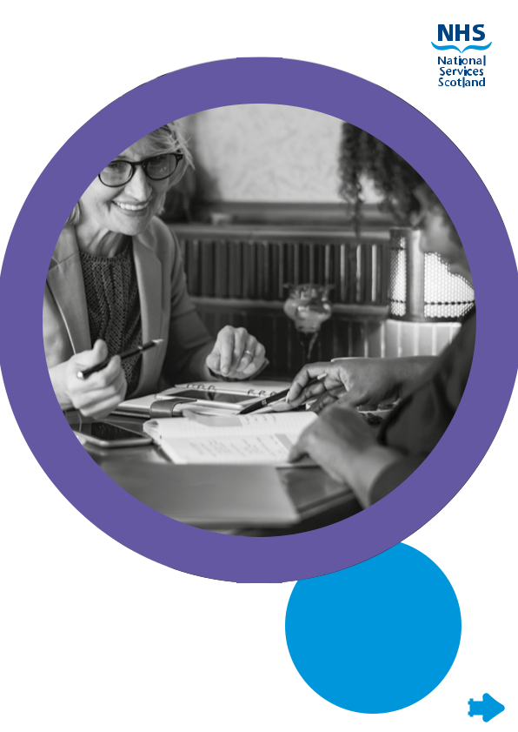

**National Services Scotland**

**Programme Management Services Candidate Pack**

**May 2023**

**NHS National Services Scotland (NSS)**

We’re a national NHS Board operating right at the heart of NHS Scotland. Through our services we provide invaluable support and advice. A role we also extend to the wider public sector.

NSS supports customers to deliver their services more efficiently and effectively. We offer shared services on a national scale using best-in-class systems and standards. Our aim is to help our customers save money and free up resources so they can be re-invested into essential services. We also provide consultancy and support to help public bodies join up health and social care. Our priority is always the same. To support Scotland’s health. We do this by offering whatever’s needed, whenever and wherever it’s needed and to whoever needs it.

**We aim to achieve this through 4 strategic objectives:**

* Put customers at the heart of everything we do
* Increase our service value
* Improve the way we do things
* Ensure that we're a great place to work

**Our Values**

In 2009, our staff came together to develop a set of Values for NSS, because we believe the way we behave is just as important as the services we deliver.

We agreed that we will ‘work together with **respect and care**, **openness and integrity**, to **focus on our customers**, demonstrate **commitment** to each other and **excel and improve**

**Our Structure**

National Services Scotland is made up of 9 Directorates, these are:

* Central Legal Office (CLO)
* Clinical
* Digital and Security (DaS)
* Finance
* HR and Workforce Development
* Practitioner and Counter Fraud Services (P&CFS)
* Procurement, Commissioning and Facilities (PCF)
* Scottish National Blood Transfusion Service (SNBTS)
* Strategy, Performance and Service Transformation (SPST)

**[Image illustrating our services in brand circles, which include:
Scottish National Blood Transfusion Service
Digital and Security
Specialist Healthcare Commissioning
Practitioner Services
Counter Fraud Services
Central Legal Office
National Procurement
National Logistics
Programme Management Services
Antimicrobial Resistance and Healthcare Associated Infection (ARHAI) Scotland
NHS Scotland Assure
Health Facilities Scotland](#)**

For more information on NSS including our structure, strategy and services please look at our website: www.nss.nhs.scot

**Programme Management Services (PgMS)**

Programme Management Services (PgMS) is part of Strategy, Performance and Service Transformation Directorate and we are one of the largest and fastest growing centres of excellence in portfolio, programme and project management in Scotland.

PgMS is proud to operate as a strategic partner for NHS Scotland’s health and social care as part of NHS National Services Scotland. It makes us uniquely qualified to deliver for customers in health boards, government, and the public sector.

We are a national provider of specialist transformation services to the NHS and wider public sector, working with clients across a range of programmes to solve problems, co-design and co-deliver transformational change and improve outcomes.

PgMS is leading on the design of new NHS Scotland services, as well as supporting a range of priority engagements which underpin the Scottish Government’s 5-year strategic plan for NHS Scotland.

Operating out of our North, East and West Hubs our reach is Pan-Scotland and our work spans diverse areas. We have over 220 staff covering disciplines including project and programme management, business analysis, Lean and user design. Our staff bring extensive experience in the design and delivery of complex national programmes and a proven track record in large-scale transformational change.

Our experience includes a diverse range of programmes including the launch of new national health bodies, transformation of patient and diagnostic services across Scotland to the successful delivery of multi-million-pound capital construction programmes.

Recently our work has seen us redesign services to make them more responsive to patient needs, lead strategic programme that will underpin transformative healthcare delivery over the next 20 years as well as harness opportunities and innovations that emerged during the pandemic.

We are proud to be part of the NHS driving change in the NHS and PgMS operates a not-for-profit cost recovery model, reinvesting in health transformation knowledge and capability.

The Team

We have a growing, skilled workforce of transformation professionals – currently our staff roles include:

* National Programme Director
* Portfolio Manager
* Programme Manager
* Project Manager
* Project Support Officer
* Content Designer
* User Researcher
* Business Analyst
* Service Designer

Our Locations

PgMS provides services to the whole of Scotland, we have three main regional hubs. North hub based in Dundee, East hub based in Edinburgh and West hub based in Glasgow.

Our team are currently working in a hybrid working model, working from home, our key hub sites and on some occasions at our client sites.

Our engagements

Our work within NHS Scotland supports a large and varied number of engagements. We work primarily with the NHS Scotland Health Boards and Scottish Government.

Deployment of staff

We support a wide range of engagements and try where possible to deploy staff to meet their strengths, interests, and skill set.

The type of support we offer our clients ranges from full project and programme team being deployed on our client site to lead a national piece of work to individuals being assigned to work within and support a customer’s own team.

Our deployment model is flexible allowing us to support rapid response for priority engagements such as the recent pandemic. With this in mind, it is sometimes the case our staff are re-deployed within a few days’ notice to meet increasing demand and priorities.

Matrix Management

We work in a matrix management environment meaning all staff have a line manager supporting wellbeing, professional and personal development. Additionally, staff have a work manager who supports and directs day to day work. In some instances, depending on the deployment the line and work manager will be the same person.

Programme Management Office

Within our structure we have a small PMO team. This team provides both PMO services and business support services including recruitment, on boarding, training, first line support for our time recording system and are responsible for managing our financial processed to support our cost recovery model.

Support

All new staff are supported through a buddy scheme, where they are paired with an experienced peer.

Professional Development

We are committed to professional development and have an established training programme for all roles within our team.

Promoting from within our own cohort of staff is something we do well, and our team has grown considerably over the past number of years, and we see this continuing in future years. We develop our staff so they can move towards in their career when the time is right for them.

Salary

All of our posts fall under Agenda for Change (AfC) terms and conditions. The latest pay scales can be viewed here: www.sehd.scot.nhs.uk/pcs/PCS2023(AFC)02.pdf

Generally new staff start on the bottom of the relevant pay scale. Where candidates can demonstrate a higher current salary, this is open to negotiation.

Benefits on Offer

The NHS has a national pay system for all directly employed staff; this means we have a framework of salary ranges that apply right across the NHS in Scotland, and which rewards you based on your experience and skills.

We offer other great benefits including:

* Flexible working patterns, with a maximum standard working week of 37.5 hours
* Defined benefit public sector pension scheme
* Holiday entitlements of 27 days per year, plus eight general and public holidays, rising to 29 days after 5 years’ service, and 33 days after 10 years’ service
* Career and salary progression based on the application of knowledge and skills
* Annual personal development review to support your career aspirations

We also offer a range of other great benefits, including flexible working opportunities; excellent work life balance policies, such as enhanced maternity and parental leave; a confidential Employee Assistance Programme; and life insurance.

If you are currently employed by the NHS, you may also be able to carry your service over to be considered in some benefits such as salary progression, pension rights and annual leave.

Interview process

Shortlisting

We aim to aim to complete shortlisting in as quick a turnaround as possible and in most cases do this in parallel with the live job advert, noting where application volumes are higher this may take a little longer.

If your application has been shortlisted, you will be updated and invited to the next stage of the process.

Assessment centre/first interview

It is likely you will be asked to participate in an assessment centre type scenario as part of the next stage of the interview process. Depending on the role, this may include an online video interview, a short telephone interview, preparing a presentation, a group exercise, or an individual assessment. The specific details will be provided to you as you are invited to this stage. This will be a remote exercise.

Successful candidates will be updated and invited to the next stage of the process.

Panel Interview

If you are successful to this stage, you will be invited to attend a panel interview. This will a competency and values-based interview and will be conducted online via MS Teams, depending on the role this will be around 45mins to 75mins in duration, the specific details will be provided to you as part of the invitation along with details on requesting any accessibility support measures.

Additional support

We are happy to discuss any special arrangements or measures that may need to be put in place to allow you to take a full part in the interview process.

Candidate ID

Employers are legally required to check the “Identity” and “Entitlement to work in the UK” of all prospective employees.  Therefore, you will be required to send photocopies of your ID ahead of any interview **and** present them on the day – details on these requirements are covered in your interview invite.

If you are successful at interview, as part of the pre-employment checks you will be asked to provide original ID documentation either in person or via secure post. These will be sighted and verified by the Chairperson at the conditional offer stage and copies will be taken for your employment file.

Preparing for your interview

We strongly recommend using the STAR method when preparing for your interview.

**THE STAR METHOD**

The STAR method is a structured manner of responding to a behavioural-based interview question by discussing the specific **s**ituation, **t**ask, **a**ction, and **r**esult of the situation you are describing.

**Situation:** Describe the situation that you were in or the task that you needed to accomplish. You must describe a specific event or situation, not a generalized description of what you have done in the past. Be sure to give enough detail for the interviewer to understand. This situation can be from a previous job, from a volunteer experience, or any relevant event.

**Task:** What goal were you working toward?

**Action:** Describe the actions you took to address the situation with an appropriate amount of detail and keep the focus on YOU. What specific steps did you take and what was your particular contribution? Be careful that you don’t describe what the team or group did when talking about a project, but what you actually did. Use the word “I,” not “we” when describing actions.

**Result:** Describe the outcome of your actions and don’t be shy about taking credit for your behaviour. What happened? How did the event end? What did you accomplish? What did you learn? Make sure your answer contains multiple positive results.

Make sure that you follow all parts of the STAR method. Be as specific as possible at all times, without rambling or including too much information. Often candidates have to be prompted to include their results, so try to include that without being asked. Also, eliminate any examples that do not paint you in a positive light. However, keep in mind that some examples that have a negative result (such as “lost the game”) can highlight your strengths in the face of adversity.

**SAMPLE STAR RESPONSE:**

**Situation (S):** Advertising revenue was falling off for my college newspaper, *The Review*, and large numbers of long-term advertisers were not renewing contracts.

**Task (T):** My goal was to generate new ideas, materials and incentives that would result in at least a 15% increase in advertisers from the year before.

**Action (A):** I designed a new promotional packet to go with the rate sheet and compared the benefits of *The Review* circulation with other ad media in the area. I also set-up a special training session for the account executives with a School of Business Administration professor who discussed competitive selling strategies.

**Result (R):** We signed contracts with 15 former advertisers for daily ads and five for special supplements. We increased our new advertisers by 20 percent over the same period last year.

See  https://www.vawizard.org/wiz-pdf/STAR_Method_Interviews.pdf for more examples and tips on how to prepare

Next Steps

Unsuccessful candidates

Unsuccessful candidates are notified via the recruitment system alerts. This alert will **not** include feedback on the interview, but PgMS are more than happy to provide feedback to any candidate requesting it. Initially this feedback will be provided by our PgMS PMO team using the panel summary. If it is appropriate, we can also arrange a specific feedback session with the panel chair too.

Successful candidates

In most instances the PgMS PMO team will advise successful candidates by way of a phone call, they will explain the offer being made to the candidate and answer any immediate questions the candidate may have. The HR team will then be the primary point of contact as you move through pre-employment checks.

Pre-employment checks

Our HR team will manage all pre-employment checks, these include an occupational health check as well as reaching out to your references. Only once ALL checks are complete would your offer move from a conditional offer to a unconditional offer and then a start date agreed and your contract of employment be issued.

Unfortunately, we are unable to give an exact timeline as to how long this process will take but our HR team will keep you informed throughout.

Anticipated start dates

We will be able to discuss and agree a start date with you once all your pre-employment checks have been completed. Once the start date is agreed our HR team will then be able to issue your contract of employment.

Offer to on boarding

At the point of offer it is unlikely that we will know your project and your line manager but as we move closer to your start date, we will update you on both pieces.

Given the nature of our work, it is unlikely we will be able to share project specific information before you start, partly due to client confidentiality and sometimes we must reprioritise projects so whilst you may be earmarked to join a specific project this may need to change.