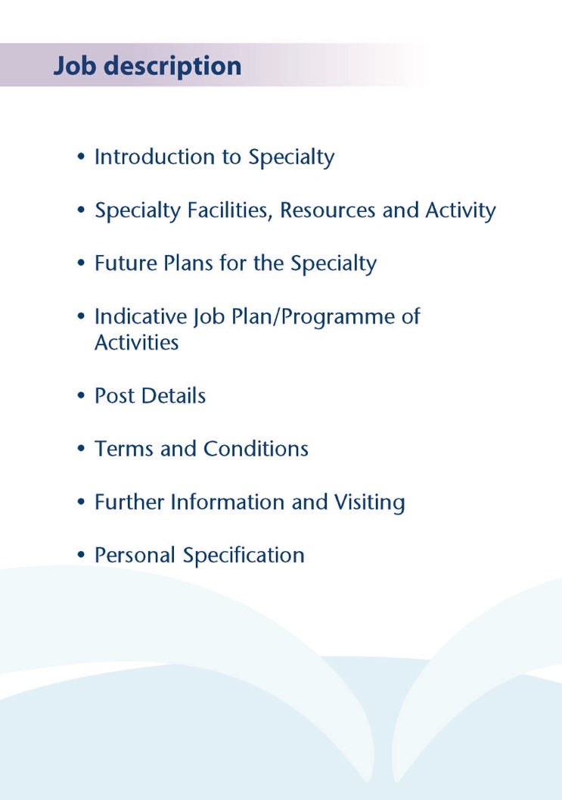



These posts in Elderly Mental Health in NHS Ayrshire and Arran benefit from working with the Consultants to look after patients from a locality based on GP practice throughout their illness. The service also benefits from modernised service models involving Care Home Liaison and Hospital Liaison teams. The Community Mental Health Team for the Elderly provides an excellent service, with nursing, OT and Psychology team members.

The posts are based in Mental Health service localities which are within easy reach of Glasgow. Several Consultant and SAS doctors are based in the same localities and as such there is peer support available, both informally as well as being part of a formal peer group locally. The post holder will share a Medical Secretary and a Medical Audio Typist with the Consultants covering the localities.

Inpatient wards are provided in the purpose build Woodland View facility in Ayrshire Central Hospital, where 15 organic beds (Ward 3) and 15 functional beds (Ward 4) are provided for Elderly Mental Health across Ayrshire and Arran. Two of the posts would provide some inpatient experience with junior doctor support, although the majority of the clinical time will be community based.



**Medical Staff Resources**

**Consultant Grade:**

**ADULT**

**East Locality**

Dr Morag Henderson

Dr Aileen Guthrie (CD)

Dr Anna Ulanova

Vacancy

**North Locality**

Dr Everett Julyan

Dr Alison MacRae (CD)

Vacancy

Dr Alex McLean

Dr Eilidh Orr

**South Locality**

Dr Jacqui Scott (CD)

Dr Tim Johnston

Dr Alistair Gibb

Dr Adrian Nitu

**Liaison**

Dr Malcolm Cameron (perinatal)

Dr Kim Newlands

Dr Ben Chetcuti (CD)

Dr Julie Langan-Martin

**Psychotherapy**

Dr John Prestwich

**Forensic and Inpatient**

Dr Partha Gangopadhyay

Dr Dawn Carson (CD Inpatients and Forensic)

Dr Gillian Howieson

Dr Ishbel MacFarlane

**Rehabilitation**

Dr Krzysztof Tyczynski

**Elderly**

Dr Stephanie Cowan

Vacancy

Dr Gillian Scott

Dr Debbie Brown (DMD)

Dr Mark Luty (CD EMH Community)

Dr Susan Maxwell

Dr Alan Spratt (Liaison)

Dr Joe Sharkey (Liaison)

**CAMHS**

Dr Helen Smith (CD)

Dr Tahir Ali

Vacancy

Vacancy

**LDS**

Dr Claire Hughes (CD)

Dr Omer Rashid

Dr Douglas Paterson

**Addictions**

Dr Beinn Wilson (CD)

Dr Karthik Kessavalou

Dr Caroline Woolston

Dr Claire Duncan

**Non Consultant Grade:**

The 40 or so consultant posts are supported by 6 Specialty Grade Doctors, more than 20 junior trainees (FY2/ST1-3) and up to 6 Senior Psychiatric Trainees (ST4-6s)

**Admin Support**

The post holder will have Medical Secretarial Support share with the Consultant for the locality, based at Ayrshire Central Hospital (post 1) and North West Kilmarnock Area Centre (posts 2 and 3)

**Education**

Woodland View has its own library and training facilities on site for local Postgraduate teaching.

University Hospital Crosshouse and University Hospital Ayr have the Alexander Fleming Education Centre and MacDonald Education Centre, respectively. These facilities have well stocked libraries with good electronic facilities, a lecture theatre with state-of-the-art equipment and meeting rooms.

The post holder will be expected to participate in the local postgraduate psychiatric training programme and to be involved in the teaching of medical undergraduates.



.

The Elderly Mental Health team in NHS Ayrshire and Arran is undergoing an exciting and service development as part of the wider “Caring for Ayrshire” programme.

Plans have been submitted for expansion in both Consultant and non-consultant medical staffing as part of a review completed in 2023 aimed at further developing the Elderly Mental Health community teams.

The award winning Woodland View hospital was purpose built on the Ayrshire Central Hospital site in 2016 and this is the base for acute admissions for older patients with functional mental illness (ward 4) and organic conditions (ward 3).



The posts are full time fixed term (one year) Specialty Doctor post which will consist of 10 programmed activities, but it may be adapted to applicants wishing to work 8 or 9 sessions. The post has been created to attract high calibre of applicants by including one programmes activity per week for relevant activities such as Quality Improvement and Teaching in addition to one programmed activity for CPD/appraisal activities, which will be agreed through job planning.

The posts may be of particular interest to those who have completed core psychiatric training and are looking for an opportunity to take a break from training or to help develop skills and experience in Old Age Psychiatry.

The post holder will benefit from weekly supervision from an experienced Old Age Psychiatry Consultant. The nature and timing of activities shown in the timetable are indicative and the precise nature of the duties will be agreed with the successful candidate at a job planning meeting with the Clinical Director. Timetables may be adapted in future to meet the changing needs of the service but any changes would be subject to discussion and job planning.

Post 1- North Ayrshire indicative timetable. Available from February 2024 (August 24 start date also welcome)

|  |  |  |  |  |  |
| --- | --- | --- | --- | --- | --- |
|  | Mon | Tues | Wed | Thur | Fri |
| am | Clinical admin /  Home visits/  Telephone reviews | Ward Round ward 4 | Community Mental Health Team Meeting  Supervision with Consultant | SPA  Eg Attending teaching programme | OutpatientClinic  Woodland View |
| pm | SPA session  Teaching/  research/ QI | Outpatient clinic  Woodland VIew | Ward Round Ward 3 | Home Visits/ Clinical Admin | Clinical Admin/  Informal ward reviews |

Post 2- Kilmarnock locality. Vacant from February 2024

|  |  |  |  |  |  |
| --- | --- | --- | --- | --- | --- |
|  | Mon | Tues | Wed | Thur | Fri |
| am | Clinical admin /  Home visits/  Telephone reviews | Ward Round ward 3 | Community Mental Health Team meeting | SPA | OutpatientClinic  North West Kilmarnock |
| pm | Home visits | Ward round ward 4  Woodland View | Clinic  (North West Kilmarnock) | Supervision with Consultant Home Visits/ Clinical Admin | Clinical Admin/urgent visits/  Informal ward reviews |

Post 3- Community and Elderly Mental Health Liaison. Vacant from February 2024 (August 24 start date also welcome)

|  |  |  |  |  |  |
| --- | --- | --- | --- | --- | --- |
|  | Mon | Tues | Wed | Thur | Fri |
| am | Liaison meeting 9-10am  Liaison visits | Outpatient clinic -East Ayrshire Community Hospital) | CMHTE meeting followed by consultant  Supervision | SPA time  Eg attendance at Teaching. | Liaison meeting 9-10am  Liaison visits |
| pm | Liaison visits1-4pm  Liaison  feedback meeting 4-5pm | Quality Improvement/ Teaching  SPA time | Outpatient Clinic | Clinical admin/  Community Reviews | Clinical admin/urgent reviews. Liaison feedback meeting 4-5pm |

**Proposed Weekly Programme**

The above timetable is indicative and subject to amendment through job planning.

Notes on the Programme

Travel: Any travel allocation will be included within the Total Programmed Activities and will be determined by location at which Direct Clinical Care and Supporting Professional Activities are carried out.

On call arrangements: The postholder will not be expected to take part in an on call rota.

**Supporting Professional Activities**: NHS Ayrshire and Arran recognise the important role Job Planning has in ensuring Specialty Doctors are supported in delivering high quality, safe, sustainable clinical care to patients.

The post holder can expect 1 SPA as a minimum to support job planning, appraisal and revalidation, plus 1 SPA for relevant QI/teaching/research activities.

**Job Plan Review**

New appointees will have an interim Job Plan review conducted at 3 months post commencement to review the balance previously agreed. The agreed job plan will include all the Doctor’s professional duties and commitments. The post is fixed term for one year, but may be renewed for a further one year if mutually agreed.

Special Interest

The post holder may by mutual agreement through job planning pursue relevant professional interests during the post eg special interest in teaching or management.

**Private Practice:** If the post-holder wishes to undertake any private practice, they are obliged to inform their employer at the time of appointment of their intentions to do so. This should be submitted in writing to the Clinical Director.



The main duties and responsibilities of the Specialty Doctor are:

* Medical input into the Elderly Mental Health Services within NHS Ayrshire and Arran into the North, or East Ayrshire Health and Social Care Partnerships
* Diagnose, treatment and management of older patients with mental health difficulties within this locality under Consultant Supervision.
* Assist in providing senior medical input into inpatients admitted to the Woodland View inpatient unit from this locality, under Consultant Supervision.
* For post 3, attendance is expected at the online Liaison Team meeting via MS Teams on Liaison days, followed by Liaison work and then attendance at feedback meeting on Teams, from 4-5pm
* Provide twice weekly outpatient clinics, with Consultant Old Age Psychiatrist supervision.
* Provide medical input to the multidisciplinary team through support, advice and guidance on clinical mental health issues to assure high quality patient interventions.
* To provide support to the care home liaison nurse in order to, where possible, avoid inappropriate admission to both general hospital and mental health beds.
* Develop effective working relationships with partner organisations
* Maintain compliance with legal requirements covering all aspects of clinical management to support NHS Ayrshire and Arran to meet its statutory requirements in delivering safe, efficient patient services.
* The successful applicant will be encouraged to develop a relevant subspecialty interest, subject to resources and in line with local priorities.



Terms and Conditions of Service are those determined by the Terms and Conditions of Service – Specialty Doctor (Scotland) (2022).



For further information or to arrange an informal visit please contact Dr Mark Luty Clinical Director on 01292 513981 or Dr Debbie Browne, Deputy Medical Director on 01294 323514.



**POST OF : Specialty Doctor IN OLD AGE PSYCHIATRY**

## LOCATION : North West Kilmarnock Area Centre, or Ayrshire Central Hospital, Irvine

## DURATION : Fixed term one year (renewable up to one further year if mutually agreeable)

## QUALIFICATIONS:

|  |  |  |
| --- | --- | --- |
| **Attributes** | **Essential** | **Desirable** |
| **Education and Qualifications:** | Full registration with the General Medical Council;  At least four years’ full-time postgraduate experience at least two years of which will be in Psychiatry, least one year of the specialty experience will have been working within the NHS.  Driving licence and access to a car.  Willingness to seek approval under section 22 of the Mental Health Act. | MRCPsych or equivalent.  MRCGP, MRCP or Diploma in Geriatric medicine, MSc or equivalent    Section 22 Approval under Mental Health (Care and Treatment)(Scotland) Act 2003 |
| **Experience:**   * **Expertise in generalist field** * **Expertise in sub-specialty field** | Experience of working within an elderly mental health environment. |  |
| **Team Working** | Committed to working effectively within a multi-disciplinary team evidenced with examples |  |
| **Teaching & Training** | Demonstrate evidence of ongoing continuing professional development.  Enthusiastic individual with good interpersonal skills. | Interest in teaching and training in psychiatry. |
| **Research & Publications** |  | Participation in research.  Evidence of published research within Psychiatry. |

|  |  |  |
| --- | --- | --- |
| **Clinical Governance** | Demonstrate knowledge and understanding of Clinical Governance relevant to Mental Health. | Experience of improving the quality (safety and effectiveness) of services or other clinical governance activities.  Evidence of audit cycle completion |
|  |  |  |
| **Personal and Interpersonal Skills** | Excellent verbal and written communication. | Demonstrate effective multi-disciplinary team working utilising effective contribution of all professionals. |