JOB DESCRIPTION 

JOB IDENTIFICATION
Job Title: Medical Education Administrator

Responsible to: ScotGEM Lead Coordinator

Department(s): Medical Education Services

Directorate: Medical Director’s Directorate

Job Reference:

No of Job Holders: 1

Last Update: 6th June 2023

2. JOB PURPOSE
To provide reception cover for the Education Centre, primarily at Victoria Hospital, Kirkcaldy, with travel to other sites across NHS Fife as required.
To carry out the administrative activities associated with Medical Education Services (MES) and provide a point of contact for all service users.
To provide secretarial support to the Senior Leadership Team and administrative support to the wider MES team.

3.DIMENSIONS
Medical Education Services is a busy department operating across multiple sites in NHS Fife, with Education Centres in Victoria and Queen Margaret hospitals.

Significant activity for the department includes:
- Coordination and delivery of clinical placements to approximately 800 undergraduate medical students in partnership with 4 University Medical Programmes.
- Coordination and delivery of postgraduate training to approximately 250 trainee-grade doctors.

4. ORGANISATIONAL POSITION
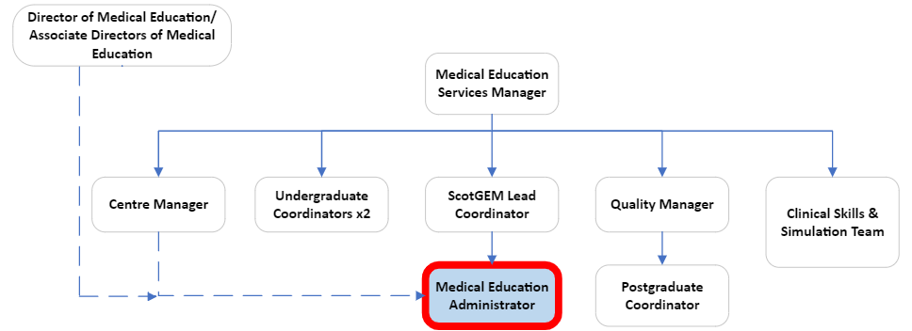

5. ROLE OF DEPARTMENT
The Medical Education department facilitates and coordinates activities required to deliver high quality, hospital-based clinical teaching programmes for medical undergraduates and graduates within NHS Fife.

The department manages two education centres that provide space through which medical education is delivered by clinicians. These are based in Victoria Hospital, Kirkcaldy (VHK) and Queen Margaret Hospital, Dunfermline (QMH).

Undergraduate:

The undergraduate team coordinates the delivery of medical education in the form of over 4000 placements for 800 medical students: partnership working with the universities of Edinburgh, St Andrews, Dundee and Aberdeen is a key activity.

Postgraduate:

The postgraduate team coordinates the delivery of core teaching programmes for our 250 Foundation Doctors, GP trainees and Clinical Fellows. The rotation of these trainees and rota monitoring are significant management exercises, undertaken in partnership with HR, and NHS Education Scotland.

Medical Education partners with SEFCE (the South East Scotland Faculty of Clinical Educators) to gain GMC recognition and approval for our NHS Fife Education Supervisors and Clinical Supervisors.

Clinical Skills and Simulation

The department has a dedicated clinical skills team to support training of students and doctors in VHK and QMH. This service has recently been expanded with the opening of Fife Simulation Training Centre.

6. KEY RESULT AREAS
- Provide a comprehensive and professional administrative service for Medical Education Services:
  - Helpful and approachable first point of contact at reception with a professional telephone manner.
  - Process booking requests for our teaching rooms for regular and ad-hoc events and meetings.
  - Set up teaching rooms and provide technological support to our educators. An expert in Microsoft Teams who can also support virtual teaching.
  - Have an awareness of bookings in the centre each day; anticipate and respond to any issues or set-up requirements.
  - Record trainee attendance at teaching events.
  - Liaise with Centre Manager around upkeep of the centre, logging maintenance requests to estates and porters as required.
  - Manage stock levels of consumables and submit accurate procurement orders for these and other items as requested by the team.
  - Manage generic department inboxes; respond to or direct requests in a timely and professional manner.
  - Fact-check the internal and external webpages. Submit updates when informed of changes.
  - Prioritise own workload when given competing demands from members of the team and service users.
  - Effectively escalate issues to the right member of staff when required.
  - Create and maintain essential records for the department e.g. asset register, procurement log, estates/porters/IT service requests.
  - Carry out monthly fire safety checks and adopt role of Fire Warden in an emergency.
  - Assist with printing, photocopying and laminating.
  - Update and maintain information databases, spreadsheets, mailing lists, correspondence, presentations, charts, leaflets and reports.

- Secretarial support to the Senior Leadership Team:
  - Diary management for the Director and Associate Directors of Medical Education.
  - Organise meetings including booking rooms, typing and distributing the agenda, maintaining distribution lists and collating and distributing meeting papers and minutes.
  - Accurate minute-taking of confidential meetings.

7a. EQUIPMENT AND MACHINERY
- Office equipment: PC/laptop, monitor, phone, printer/copier, laminator.
- Teaching equipment: TV screens (fixed and portable), Video Conferencing system, Clickshare.
- Centre equipment: motorised racked seating, iPads.

7b. SYSTEMS
- Office 365, particularly Outlook, Teams, Forms, Word and Excel.
- Microsoft Access.
- NHS systems including but not limited to:
  - PECOS: procurement orders
  - MICAD: estates requests
  - D&I Service Desk: IT requests
  - Web Room Booking: booking of teaching rooms
  - Tutorial Booking System: recording of attendance at training

8. ASSIGNMENT AND REVIEW OF WORK
Routine tasks are managed by the post holder and line management support is provided by periodic informal meetings / ad hoc meetings.

The post holder will recognise that practices will evolve over time to reflect changes to training and education recommendations from the various governing bodies.

All members of the team will depend on the post-holder for ad-hoc administrative support.

The post holder will work closely with the Centre Manger around room bookings and issues concerning the centre.

The DME/ADMEs will liaise directly with the post holder regarding their diaries and meetings.

Annual formal appraisal will be scheduled with line manager.

9. DECISIONS AND JUDGEMENTS
There is a need to use initiative to anticipate and resolve problems daily, working with minimal direct supervision.

The post holder is expected to make decisions regarding workload priorities.

The line manager and centre manager will be available to advise on more complex matters out-with the immediate scope of the post holder.

10. MOST CHALLENGING/DIFFICULT PARTS OF THE JOB
Working with a number of different internal and external departments.

Ensuring information is of high quality and shared appropriately to the correct people in a timely manner.

Liaising with busy junior and senior clinicians who have different priorities.

The need to switch between activities with frequent interruptions.

Meeting the competing needs of various team members.

11. COMMUNICATIONS AND RELATIONSHIPS
Strong written and verbal communication skills are essential to this role as the information handler between all stakeholders. Clear and concise written communication is required for formal letters and emails.

A pleasant and efficient telephone manner is required, as the administrator is often the first point of contact for service users.

Ability to establish and maintain professional working relationships with a wide range of personalities is key to success in this role.

The post holder will frequently liaise with:
- Medical Education Services staff regarding tasks and service demands.
- Undergraduate medical students seeking support or directions.
- Clinicians and/or their secretaries requiring room bookings or technical assistance.
- Director/Associate Director(s) of Medical Education requiring secretarial support or regarding their diaries.
- Estates department regarding minor works and maintenance.

12. PHYSICAL, MENTAL, EMOTIONAL AND ENVIRONMENTAL DEMANDS OF THE JOB
Physical Demands (on a daily/frequent basis)
- Keyboard skills requiring high degree of speed and accuracy.
- Potentially long periods checking accuracy of electronic data.
- Movement of audio-visual equipment e.g. TV screens, computer trolleys.
- Moving classroom furniture to suit the requirements of the educator.

Mental Demands (on a daily/frequent basis)
- Concentration required for short and longer periods depending on tasks despite frequent interruptions in person or by phone calls.
- Working unsupervised for most of the day.
- Prioritising conflicting demands.
- Requires a high degree of flexibility to respond rapidly to changing situations.

Emotional Demands (on a daily/frequent basis)
- Exposure to sensitive information.
- Ability to respond calmly in the event of technical issues.
- Occasionally dealing with upset or anxious students.
- Occasionally dealing with disgruntled service users.

Working Conditions (on a daily/frequent basis)
- Continuous use of VDU

13. KNOWLEDGE, TRAINING AND EXPERIENCE REQUIRED TO DO THE JOB
Knowledge
- Proficient in the use of Microsoft 365.
- Familiar with routine office procedures.

Training
- Educated to Standard Grade level (or equivalent).

Experience
- Experience of working in an office or reception environment at a junior level (or administration qualification).

14. JOB DESCRIPTION AGREEMENT
A separate job description will need to be signed off by each jobholder to whom the job description applies.  Job Holder’s Signature:  Head of Department Signature | Date:  Date:

