- JOB IDENTIFICATION

Job Title: | PA / Administrator – Corporate Planning
Department: | NHSGGC Planning Team
Accountable to: | Director of Planning
Job Reference Number
- JOB PURPOSE

The PA / Administrator is responsible for providing comprehensive administrative and business support to the NHSGGC Planning Team.

The post holder will provide comprehensive, administrative support to the team including diary management, arrangement of meetings, minute taking, prioritising and answering routine correspondence and e-mails as directed.
The post holder will also work closely with, and provide support to the Director of Planning to establish effective and thorough diary, inbox and meeting management to ensure the best use of the Director’s time.
Discretion and confidentiality are essential in this role, as is outstanding organisational skills and the ability to prioritise your workload to ensure that the coordination of emails, meetings and reports are managed in a professional and efficient manner.
The post-holder will also be responsible for managing and maintaining the Corporate Planning Team’s SharePoint folders as well as supporting a variety of high level strategic and operational meetings.
- ORGANISATIONAL POSITION

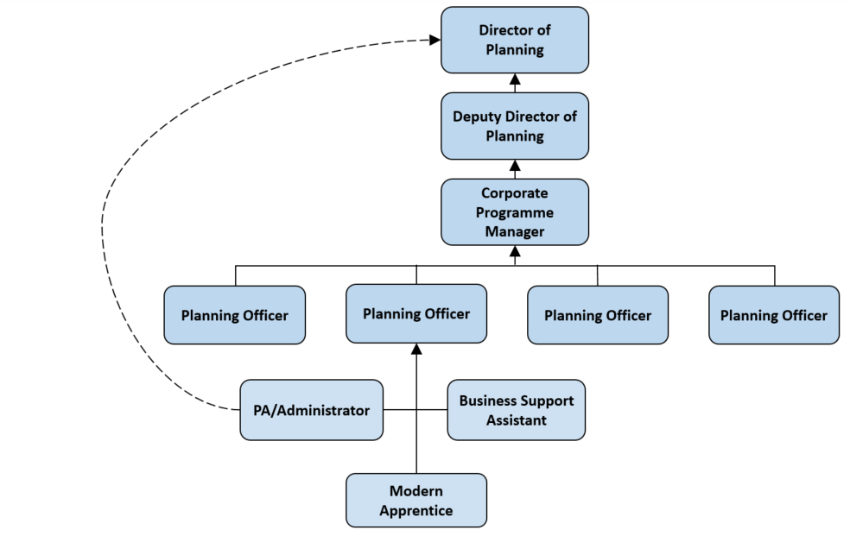

- Scope and Range

NHS Greater Glasgow and Clyde serves a population of 1.1million; with a revenue budget of £3,004.5m and capital budget of £ 179.5m; a workforce of circa 40,000 staff.

The Board is organised into 6 Health and Social Care Partnerships and a single Acute Division. A number of Directors will carry responsibilities to work as part of the Acute Division as well as leading Board wide functions and activities. This is the basis for alignment of the Corporate Planning function.

NHS Greater Glasgow & Clyde Acute Services Division is the largest of its kind in NHS Scotland. The role of the Acute Sector is to provide specialist and general acute care provision on a local, regional and in some cases national basis.

The Acute Division is to be managed in 3 Geographical Sectors and 3 Specialist Cross GGC Directorates. The three geographical Sectors cover North Glasgow, South Glasgow and Clyde. The Cross GGC Directorates include Regional Services, Women’s and Children’s Services and Diagnostics.

- Main Duties and Responsibilities

- Provide comprehensive and flexible business and administrative support to all elements of the Corporate Planning Team
- Work closely with the Director/Deputy Director of Planning providing comprehensive diary, inbox and meeting management, ensuring e-mails are up to date and any actions/deadlines are followed up.
- Organise and facilitate meetings, events and conferences as required including venue/room booking, sending out invitations, taking minutes and ensuring any required IT/video conferencing equipment is in place and ready for use
- Undertake day to day business support activities, including ordering goods, copying, printing, filing and other ad hoc duties.
- Act as first point of contact for the Corporate Planning Team and manage any correspondence

- Maintain and operate efficient and effective record keeping and filing systems ensuring they are updated, and information is stored appropriately

Establish and maintain an effective shared filing system and resources, including maintenance and development of Corporate Planning SharePoint sites

- Support the preparation of agendas and collation of relevant supporting papers, ensuring meeting papers are ready and circulated within agreed timescales

- Support the development of documents, briefing papers, reports, spreadsheets and presentations

Develop and circulate action logs following meetings with appropriate follow up to ensure completion of agreed actions within appropriate timescales
- Collate and present statistical information for inclusion in reports, papers and presentations

- Responsible for own efficient work planning/time management to ensure work is completed within appropriate timescales.

- SYSTEMS AND EQUIPMENT
The post holder should have advanced PC skills and a sound understanding of information systems particularly the storage and retrieval of electronic reports and spreadsheets and project documentations. They should be able to collate information and produce and format reports.

The post holder is required to use Microsoft Office 365 software and associated applications including, SharePoint, Word, MS Teams, Outlook – (email system), Power Point Excel and Project.

This post regularly utilises general office equipment including PC, Laptop, Telephone, Photocopier and video conferencing equipment

7. DECISIONS & JUDGEMENTS

Work is carried out on own initiative with minimum supervision. The postholder will exercise judgement on matters which need to be brought to the attention of the members of the Corporate Planning Team and will exercise judgement on those matters which may require a wider audience.
The postholder will use judgement in matters relating to arranging and facilitating meetings, in pursuing follow-up actions and in identification of key priorities.
The postholder will identify and develop protocols for the administration of meetings and groups, including assisting the Chair to prepare standing documents for circulation.

The postholder will undertake work-plan and personal development planning on a regular basis in accordance with the Board’s policy on Personal Development Planning.

- COMMUNICATIONS & RELATIONSHIPS
The post holder is expected to communicate at all levels across NHS Greater Glasgow and Clyde, with partner agencies and the general public.
- Internal
- Senior Planning Team
- Sector and Directorate Management Teams
- Public Health
- Corporate Communications
- Business Intelligence
- Finance
- Administration staff

- External
- Scottish Government
- National Organisations
- HSCP and Local Authority colleagues
- Voluntary Organisations
- Community reps and members, e.g., service users, young people.

- PHYSICAL, MENTAL, EMOTIONAL AND ENVIRONMENTAL DEMANDS OF THE JOB

Physical

- Advanced Keyboard and laptop/PC use on a daily basis.
- Moving and handling non-patient activity e.g. stationary, files, presentation equipment etc.
- Occasional travel to other sites.

Mental

- Frequent prolonged concentration
- The post holder will be required to respond to unpredictable situations on a daily basis.
- Manage time and maintain priorities to deliver against tight timescales to the highest of standards
- Ability to work with sensitive information and to control the release of that information

Emotional

- The post holder may be required to record staff absence such as sickness and compassionate leave.
- Balancing multiple and often conflicting requirements.

- THE MOST CHALLENGING PARTS OF THE JOB

Prioritising workload which may involve resolving conflicting demands and interruptions to planned activity.

Completing complex tasks in short timescales.

Utilising good communication skills to nurture a close working relationship with internal / external contacts to ensure continued effectiveness of the service.
- KNOWLEDGE, TRAINING AND EXPERIENCE REQUIRED TO DO THE JOB

Person Specification

Qualifications/Registration | Essential (√) | Desirable (√)
Recognised qualification in Administration equivalent to HNC in Secretarial Studies or Business Administration, or SVQ in Administration at Level 3, or significant relevant equivalent practical experience. | √

Experience | Essential (√) | Desirable (√)
Familiar with office procedures and systems and able to demonstrate prior experience of working in a secretarial or administrative PA role for at least 2 years | √
Experience of organising and facilitating meetings including room booking, minute taking and collation of meeting papers | √
Competence in the use of range of computer packages evidenced by experience or formal qualification e.g. ECDL |  | √
Excellent organisational skills, including ability to deal with a range of non-routine tasks, apply proactive problem solving and manage conflicting demands. | √
Excellent working knowledge of Sharepoint / MS365 or evidence of ability to learn this |  | √
Knowledge of NHSGGC structures, policies and procedures |  | √
Experience of diary, inbox and meeting management | √

Behavioural Competencies, Skills, Competencies and Disposition | Essential (√) | Desirable (√)
High degree of organisational ability and time management skills, together with excellent analytical, written and oral communication skills | √
Enthusiastic, self-motivated, flexible and able to work on own initiative, a self-starter able to manage, prioritise workload, including matters of a highly confidential and sensitive nature. | √
Ability to apply a sense of perspective on dealing with multiple tasks | √
Ability to engage with senior members of staff in all disciplines including directors and members of the executive team | √
Ability to understand and communicate matters of a highly confidential and possibly contentious or sensitive nature. | √

