

JOB DESCRIPTION

1. JOB IDENTIFICATION
Job Title: Clinical Technologist Associate Practitioner (Imaging Physics and Radiation Protection)

Responsible to: Clinical Technologist Team Lead (Imaging Physics and Radiation Protection) Department(s): Medical Physics

Directorate: Diagnostics, Anaesthetics, Theatres & Critical Care (DATCC)

Operating Division: Acute Services

Job Reference: 148423

No of Job Holders: 1

Last Update: December 2021

2. JOB PURPOSE
Provide medical equipment management services to a range of NHS and other customers, supporting the clinical use of a range of diagnostic imaging equipment in areas including radiology, critical care units, theatres, general wards, community and domiciliary sites. This includes 1st line fault-finding, triaging of faults, performing scheduled preventive maintenance, assisting with surveys, safety checks and calibrating medical equipment following standard operating procedures (SOPs) in line with legislative requirements and national guidelines.

3. DIMENSIONS
Clinical Technical

The Imaging Physics (IP) and Radiation Protection (RP) sections provide services to Radiology departments and clinics within NHS Lothian and NHS Fife. This includes 4 teaching hospitals, 2 DGHs and 12 other Hospitals or clinics and to the Community Dental Services in the two Health Board areas (approximately 70 separate clinics).

The quantity of radiology imaging equipment involved comprises approximately 400 items, 160 of which is for dental radiography. Of the remainder approximately 45 installations have a high capital value (£200K plus) with other X-ray equipment (approximately 205 items) having values in the range £20K to £100K. There are 185 ultrasound scanners ranging in value between £20K to £100K (50% of which are >£50K).

The diagnostic imaging equipment value supported has an estimated value of £28 million.
The sections also provide support for therapeutic lasers and UV equipment with a total value of £1.4 million.

The service includes monitoring staff radiation doses reports for approximately 1000 individuals working in about 90 separate staff groups.

The technical team provide a range of highly specialised clinical technical support involving ionising, non-ionising and imaging equipment [this involves the testing, calibration and evaluation of X-ray equipment, CT scanners, diagnostic ultrasound scanners, therapeutic lasers and phototherapy light equipment] used in the diagnosis and therapeutic treatment of patients.

The post holder is employed within NHS Lothian and there may be a requirement to work flexibly across Lothian to meet service demands.
This post is the part of the technical team with the following responsibilities:

Financial Responsibilities:

Maintains stock control and order parts/supplies when necessary.
Maintains inventory and schedules calibrations for a range of specialist high cost testing equipment

4. ORGANISATIONAL POSITION
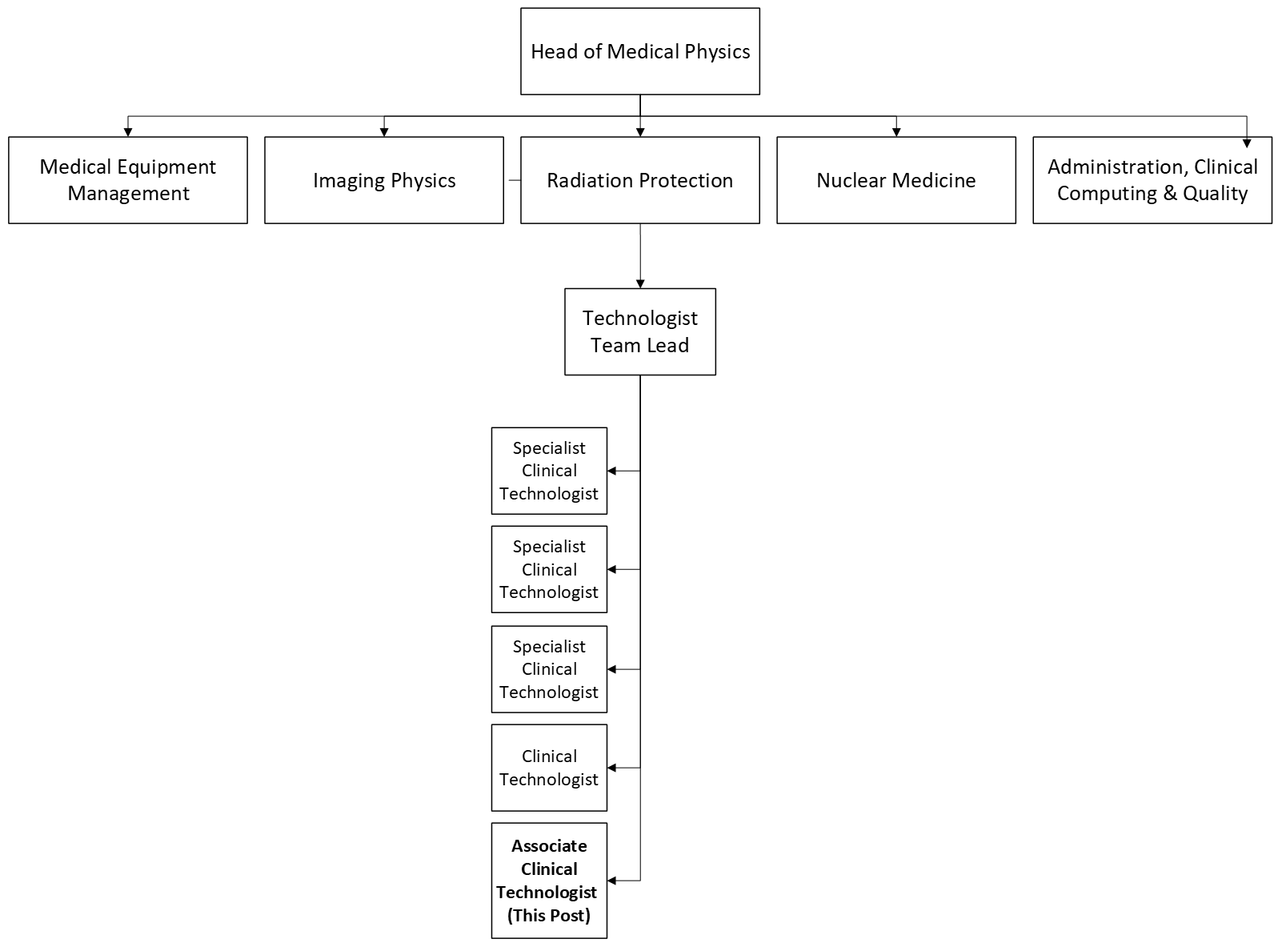

5. ROLE OF DEPARTMENT
The role of the Medical Physics Department is to facilitate the introduction of new and existing medical technology and scientific methods into healthcare and to ensure their safe and effective use. The Department provides a range of specialised clinical and clinical technical services and highly specialised expertise to NHS Lothian, NHS Borders, NHS Fife and to other organisations with which it has contractual arrangements. The department employs Healthcare Science staff with a variety of scientific and technical expertise, including physics, electronic engineering, software engineering and mechanical engineering. The Department is highly committed to translating research and development into routine clinical practice to design future diagnostic and treatment approaches, equipment and techniques.

The Department is organised into five sections that specialise in different areas of physics and engineering applied to medicine. These sections are:

Clinical Computing, Administration & Quality
Radiation Protection
Imaging Physics
Nuclear Medicine Physics
Medical Equipment Management

Medical Physics is an accredited training centre for the following Modernising Scientific Careers pathways:

Practitioner Training Programmes for Clinical Technologists (to achieve registration on PSA approved register)
Medical Physicist and Clinical Engineer Training Programmes for Clinical Scientists (to achieve HCPC registration)

6. KEY RESULT AREAS
Clinical/Technical

The post holder provides equipment testing support within the technical team in a range of activities for diagnostic imaging, ionising and non-ionising equipment:

1. Commissioning and acceptance of new medical devices: Carry out acceptance checking and installation of new medical devices [ultrasound probes, phototherapy lamps, non-complex ultrasound scanners] to ensure that devices are fit to use and are set-up according to agreed local configurations, so as to be in a safe condition for staff and patients.

2. Scheduled inspections: Carry out a quality assurance programme in accordance with the Department’s quality system, consisting of planned inspections (electrical safety, functional performance and calibration) on medical devices at periodic intervals to ensure functional performance, accuracy and safe handling for staff and patients.

3. Repair and maintenance: Carry out a reliable, repeatable and economic 1st line response service for a competency-based range of non-complex patient critical medical devices. Where appropriate, liaise with manufacturers or their agents who are responsible for carrying out work on medical devices under contract or on an ad-hoc basis.

4. Decommissioning of equipment: Decommission imaging equipment as and when required, following protocols and being mindful of environmental and information governance regulations relating to the disposal of medical equipment and ensuring that local procedures are followed; thereby ensuring that equipment is in an appropriate condition for disposal.

5. Safety alerts/field safety notices/radiation incidents: Support with implementing responses to safety action notices, safety alerts, field safety notices and other notices issued by the Department of Health, MHRA, SEHD or manufacturers regarding safety of medical devices that are supported by the service. Assist with radiation incident monitoring, reviewing and triaging to senior colleagues.

6. Assist with the Radiation Protection Shielding Program (positioning and collation of dose monitoring badges and on shielding surveys).

7. Record keeping: Maintain complete, contemporaneous, and accurate records (both electronic and written) in relation to all medical equipment and team survey activities, in accordance with local procedures, clinical governance standards and best practice from the MHRA and Scottish Government.

Administrative
8. Participate in regular meetings, reviews and audits with fellow team members, other section staff and/or the Head of Service.

9. Be responsible for the inventory and scheduled calibration of specialist testing kit and phantoms

Teaching, training and research

10. Support the teaching and training of various staff groups [MSC students, physicists, radiology fellows] in the use of ultrasound scanners and other non-ionising equipment.

11. Assist senior staff with the evaluation of new medical equipment.

Professional

12.Attend relevant technical courses to ensure continuing knowledge of current medical devices. Keep abreast of medical and technical developments by participating in appropriate continuing professional development (CPD) conferences, meetings and workshops.

13. May demonstrate their own role to less experienced members of the team.

General standards

14. Work within the framework of the Departmental Quality Management System.

15. Ensure that all activities conform to statutory regulations and Board procedures, including Health and Safety regulations, NHS Lothian incident reporting procedures and mandatory training. Adheres to the health and safety responsibilities laid down in the Department Safety Handbook. Carries out the procedures required under the Health and Safety at Work Act1974 to ensure a safe working environment for patients, visitors and employees.

16. To support NHS Lothian’s values of quality, teamwork, care and compassion, dignity and respect, and openness, honesty and responsibility through the application of appropriate behaviours and attitudes.

7a. EQUIPMENT AND MACHINERY
Equipment
The following are examples of equipment which will be used when undertaking the role.
The general types of diagnostic and therapeutic medical devices that the post holder may be required to have an awareness of, are:
Dental X-ray systems,
X-ray equipment
Diagnostic ultrasound scanners
Therapeutic ultrasound devices
Therapeutic UV phototherapy devices

The post holder will be authorised to support and maintain a range of devices in accordance with the service’s competence and authorisation quality framework and subject to the successful completion of training.
The post holder will be required to use the following types of test equipment:
Standard electronic servicing equipment (e.g. oscilloscopes, multimeters, soldering iron and associated equipment and small hand tools), and specialised medical device test equipment (e.g.UV radiometers, electrical medical safety analysers, imaging test phantoms).
Note: New equipment may be introduced as the organisation and technology develops, however
training will be provided.

7b. SYSTEMS
IT Equipment, Computers, Commercial Software and Database Systems

The following are examples of systems which will be used when undertaking the role:
The post holder will work on both isolated medical devices and non-complex interconnected diagnostic imaging systems. When analysing problems with medical devices, the post holder will be required to consider the whole operating environment; this will include the patient, the clinical staff, the hospital network and the medical device or devices in use.
Examples of such systems include: [Wi-Fi connected POC ultrasound scanners,]

The post holder will be required to use a range of operational technical, quality and clinical applications as required, including the organisation’s medical device management system and the Department’s Quality Management system.

Note: New systems may be introduced as the organisation and technology develops, however training will be provided.

8. ASSIGNMENT AND REVIEW OF WORK
The post holder works independently with senior staff available for advice if required.
The post holder is required to follow standard policies and procedures and to ensure that statutory regulations are followed.
The technical team lead allocates specific duties and operational project work
to the post holder, monitors overall progress and provides advice and guidance.
The post holder will have a personal development plan and be reviewed by the technical team lead.

9. DECISIONS AND JUDGEMENTS
The post holder can be unsupervised or self-directing (depending on work), working within Departmental policies and procedures, exercising their judgement to help solve problems. This may include discussion with senior staff on making a risk assessment in relation to the status and criticality of a device, taking into account the complexity of the device and the environment in which it is used; or making a recommendation to their team lead

To exercise judgement in prioritising their tasks and allocating time to the different aspects of their work by analysing and comparing the various options (e.g. routine maintenance work may need to be stopped mid-task to prioritise the assessment and support of surveys /or activities that is critical to patient flow and equipment downtime within the hospital).
Diagnoses of faults on non-complex medical devices [basic ultrasound scanners and probes] and makes decisions as to how triage in line with SOPs and manufacturers’ recommendations in order to get the device back into operation as soon as possible, where necessary referring to a more senior colleague for assistance.

10. MOST CHALLENGING/DIFFICULT PARTS OF THE JOB
Balancing the clinical requirement to maintain medical device uptime against the need to maintain and triage complex medical devices in a timely fashion, particularly in critical care areas.
Locating mobile medical devices and liaising with clinical staff for access to equipment.
Dealing with staff on a daily basis with tact, diplomacy and sensitivity, when they require quick and efficient support with items of medical equipment.

11. COMMUNICATIONS AND RELATIONSHIPS
Daily communication with team members within the RPIP sections, discussing operational activities and service priorities. There are regular team meetings at which all staff will participate and will be expected to take minutes on a rotating basis.

There is frequent communication with other services within the Department of Medical Physics in relation to items of diagnostic imaging equipment for which there is a degree of shared responsibility.

There is frequent internal communication with staff at all levels within the organisation, including nursing, medical and managerial staff, communicating to understand and convey technical and operational issues in relation to access to equipment

There is frequent communication with manufacturers and suppliers of medical devices (and their representatives) in relation to scheduling of demonstration of equipment & organisation/quotes for service call outs and availability of ultrasound probes
Communication is by Teams, telephone, e-mail, face-to-face, teams and through written reports, as appropriate.

12. PHYSICAL, MENTAL, EMOTIONAL AND ENVIRONMENTAL DEMANDS OF THE JOB
Physical skills and effort

Manual dexterity: Good hand to eye co-ordination when setting up of test equipment to make accurate measurements using a wide range of complex test equipment. Unpacking, collecting and repositioning diagnostic imaging equipment [e.g ultrasound scanners for QA testing and acceptance testing on a frequent basis [3-4 times weekly].

To transport test equipment from base to clinical departments on other sites involving up to 4 cases of equipment weighing between 5 and 20 kg.

To move expensive sensitive equipment by trolley from car park to hospital, often across ground ill-suited for the purpose in line with manual handling protocols.

Mental effort

Frequent requirement for periods of concentration, for example when diagnosing and solving combinations of technical and user-related problems with medical devices, while subject to unpredictable working patterns and interruptions.

Emotional effort

Dealing with occasional emotional circumstances involving clinical colleagues who are trying to manage clinical risks, while the post holder is subject to working under pressure of time, to resolve a technical issue.

Working conditions

May be required to work in locations where the following risk factors may be present:
Ionising and non-ionising radiations and radioactive sources
electricity and water combinations when QA testing of ultrasound equipment
blood-borne viruses and other infection control risks (when testing scanner probes),
confined working spaces wearing the required PPE (heavy lead aprons, laser protective eyewear),

Consequently, the post holder is required to understand the hazards posed by the above risks and take appropriate precautions to mitigate these risks and ensure compliance with statutory regulations and local health and safety rules.

13. KNOWLEDGE, TRAINING AND EXPERIENCE REQUIRED TO DO THE JOB
Professional science/engineering knowledge to SCQF level 8 (e.g. HND/SVQ4 in
Electrical/Electronic Engineering or a HNC/SVQ3 plus short courses) or equivalent training and experience.

Skills and experience
Experience of electronics/physics including fault-finding.
Evidence of continuing professional development by, for example, attendance at appropriate courses.
Experience in the use of a range of general applications and database systems.
Effective interpersonal skills and a commitment to a multi-disciplinary team-based working environment.

Scientific, technical and clinical knowledge

Knowledge of how to carry out tests on non-complex medical devices.
Knowledge of calibration and safety testing of medical imaging equipment using appropriate test equipment.
Knowledge of relevant legislation and safety regulations pertaining to ionising and imaging equipment.

An understanding of the clinical context in which medical devices are used and how they contribute to patient care and patient/staff safety.

14. JOB DESCRIPTION AGREEMENT
A separate job description will need to be signed off by each job holder to whom the job description applies.  Job Holder’s Signature:  Head of Department Signature: | Date:  Date:

