NHS TAYSIDE – AGENDA FOR CHANGE

JOB DESCRIPTION

- JOB IDENTIFICATION  SCO6-1288  Band 5 | Job Title | Therapeutic Radiographer
 | Department(s)/Location | Radiotherapy Department  Ninewells Hospital
 | Number of job holders | 6

JOB PURPOSE

The post holder will be a Health and Care Professions Council registered Therapeutic Radiographer, who will participate in a clinical team in the pre-treatment or treatment delivery sections of the Radiotherapy Department.

The post holder will participate in the On Call system.

ORGANISATIONAL POSITION

The post holder will be a Therapeutic Radiographer employed in Tayside Cancer centre, Radiotherapy Department.

The position of the post and the management and reporting structure is illustrated in the organisation chart below.

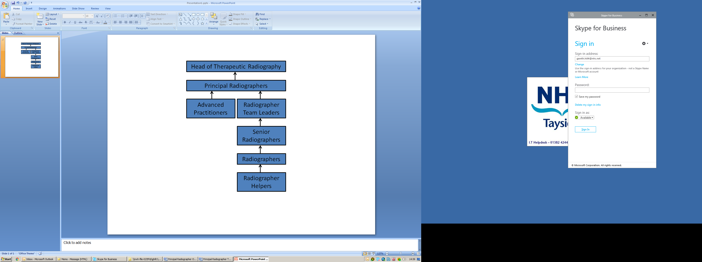

SCOPE AND RANGE

Radiotherapy services are provided for the population of Tayside and North East Fife, delivering around 1400 new courses each year. The department delivers radiotherapy services for a broad spectrum of cancers comprising of common cancers as well as specialist treatments including brachytherapy and SABR. The post holder will work as part of team to provide a highly specialist clinical and technical services to NHS Tayside. The work is within a multi-disciplinary team with close liaison with Clinicians, Physicists, Radiographers, Radiotherapy Support Workers, Radiotherapy Technicians, Nurses and Clerical staff. The radiography led treatment planning service includes the production of both routine and highly complex radiotherapy treatment plans and requires accurate entry of complex data onto departmental computer systems.

The post holder will

take professional responsibility for their own actions, but will always work in a team where a senior practitioner is available for guidance and advice when required.

participate in the safe and accurate delivery of radiation treatment and supportive care to people with cancer, numbering up to 45 per normal working day.

safely and appropriately use designated complex pieces of equipment capable of delivering ionising radiation, with a total value of several million pounds. The equipment consists of three Varian linear accelerators, one Canon Aquillion Wide Bore CT scanner, mould room facilities, HDR brachytherapy facilities and Raystation treatment planning system.

participate in the training and supervision of students and support staff in the team.

develop own skills and competence in practice to at least the standards set out in the “Linked Grade Framework” and develop the ability to move flexibly between teams.

pursue continuing professional development, maintaining a portfolio to be available as a reference at appraisal.

MAIN DUTIES/RESPONSIBILITIES
The post holder will

- actively participate, as a member of a team, in CT, pre-treatment preparation and delivery of treatment, using current techniques and the full range of equipment available.

- understand the function, limitations and potential dangers of radiotherapy equipment and ensure that it is used safely by themselves and anyone under their supervision.

- participate in the daily quality assurance checks of individual pieces of equipment prior to clinical use.

- participate in the CT for individual patients, recording all data crucial for accurate treatment delivery.

- undertake treatment calculations using both manual and computer assisted methods.

undertake the input of critical treatment parameters into the Verify and Record system, crucial to the safe and accurate delivery of treatment.
- deliver radiotherapy treatment, as described in the treatment plan, using the correct mode and energy of radiation, applying immobilisation accessories and treatment fields to ensure accurate application of treatment dose to the patient’s target volume.

- Assess treatment accuracy based on reviewing verification images jointly with a senior practitioner.

- give patients appropriate information and advice on matters related to their treatment and expected treatment reactions.

- observe and report on patient’s condition during their treatment course, reporting any concerns to the senior practitioner in charge of the unit.

- observe performance of radiotherapy equipment, reporting any concerns to the senior practitioner in charge of the unit.

- assist in the accurate completion of records of patient and unit activity.

- implement agreed protocols throughout the clinical process. The post holder may suggest changes via the lead senior practitioner or the section head practitioner.

- be aware of, and comply with, Ionising Radiation (Medical Exposure) Regulations 2017 and Department Quality Policy in all activities.

- take appropriate action, in accordance with NHS Tayside policy, in the event of incidents, accidents or complaints involving patient, visitor, staff or equipment.

- be aware of and comply with NHS Tayside policies on infection control, fire and medical emergencies.

- participate in the collection of data for research projects and clinical trials being undertaken in the department.

- maintain an up to date knowledge of clinical and technical radiotherapy developments.

The above duties, in any combination, many of them simultaneously, are normally undertaken by the post holder 100% of their working day. The post holder will require to be flexible and adaptable to meet constantly changing clinical need.

COMMUNICATIONS AND RELATIONSHIPS

Methods of communication will include face to face interactions, telephone conversations, hand-written entries in patient records and the use of information technology systems.

The post holder

will be approachable and capable of effective communication with a wide range of people, both internal and external to the organisation. They will include;

Patients/relatives/carers

Oncology medical staff

Oncology nursing staff

Oncology secretarial staff

Allied Health Professionals
Members of their own team

Radiotherapy students and student visitors to the department from other professions
Colleagues in other teams within the department
Ambulance staff and porters

will require excellent interpersonal skills to enable them to communicate in a clear and empathetic manner with patients and carers, the highly complex and sensitive information relating to their disease, radiotherapy treatment, treatment preparation and treatment reactions. There is a particular need for sensitivity when asking young persons about their pregnancy status, when the nature of the treatment about to be given could make them infertile or require them to have a termination before commencement of treatment.

may require to use negotiation skills when discussing treatment scheduling and appointments with patients who would prefer an alternative time to that allocated.

will require to maintain communication with all members of the multidisciplinary team to ensure that there is an effective flow of information relating to the care of every patient and to promote mutual respect and understanding of professional roles and responsibilities.

may need to sensitively diffuse tense situations caused by anxious patients or respond to complaints made by patients or members of the public.

will require to participate in regular radiotherapy staff meetings, at which they may be asked to present on specific topics.

will be required to promote the profession to interested potential candidates for training.

KNOWLEDGE, TRAINING AND EXPERIENCE REQUIRED TO DO THE JOB

Degree, or equivalent qualification, accepted by the Health Professions Council (HCPC) for State Registration as Therapeutic Radiographer.

Knowledge and understanding of Ionising Radiation Medical Exposure Regulations 2017

ESSENTIAL ADDITIONAL INFORMATION

- SYSTEMS AND EQUIPMENT

The post holder will be able to use a personal computer and will be competent to use all of the following, in any combination, some of them simultaneously throughout the working day :-

- Linear accelerators that have the ability to deliver multiple modes and energies of radiation and are equipped with multileaf collimators and sophisticated imaging systems.

- Radiotherapy CT simulator.

- Patient immobilisation and positioning devices

- Computerised radiotherapy dosimetry planning system.
.
- Computer based verify and record system, networked throughout the department, and used daily for entry and manipulation of data vital for scheduling, electronically verifying and recording individual patient treatments.

- Computer based quality assurance system documentation via the NHS Tayside intranet.

Responsibility for Records Management
All records created in the course of the business of NHS Tayside are corporate records and are public records under the terms of the Public Records (Scotland) Act 2011. This includes email messages and other electronic records. It is your responsibility to ensure that you keep appropriate records of your work in NHS Tayside and manage those records in keeping with the NHS Tayside Records Management Policy and with any guidance produced by NHS Tayside specific to your employment.

PHYSICAL DEMANDS OF THE JOB

The post holder will require stamina and to be physically fit with the ability to walk quickly in and out of treatment rooms, via long maze corridors, up to 350 times during the working day. They will require to physically assist patients on and off of couches and will be required to lift patients several times per day with the aid of equipment provided. They will also be required to lift equipment frequently. It will be necessary to push and manoeuvre patients in wheelchairs and beds in and out of the treatment room several times per day.

The post holder will require good eyesight in order to read the multiple VDUs associated with treatment machines and simulators. Excellent hand eye co-ordination skills and manual dexterity are required to manoeuvre equipment to treat within accuracy of 2mm on every set-up.

The ability to concentrate is required to assess, plan and treat patients while performing other related tasks. The post holder requires to concentrate on the planning or delivery of each patient’s treatment to ensure that highly complex information is translated into a safe and accurate clinical application.

The post holder will have to meet the needs of a wide range of cancer patients, from newly diagnosed to the terminally ill. This may often be emotionally difficult and demanding and will require the post holder to recognise when to seek personal support.

The post holder is likely to be exposed to unpleasant odours, fungating tumours, body fluids and infectious diseases at any point during their working day.

The post holder may also be exposed to risk of needlestick injury while tattooing patient skin marks and to exposure to chemical spills from drips attached to patients having concomitant chemotherapy.

The post holder needs to be aware patients for whom the crisis management protocol should be followed, and may occasionally be involved with crisis management if end of life events occur within the Radiotherapy Department.

DECISIONS AND JUDGEMENTS

The practitioner will

make assessments on the accuracy of equipment about to be used based on the quality assurance checks that they have personally carried out

make assessments about the physical and mental wellbeing of patients about to undergo treatment based on their own observations and communication with the patient.

In both cases they will raise any concerns with the senior practitioner in charge of the unit.

Assess each individual patient’s desire and ability to cope with information relating to their disease and its management and then provide, what in their judgement, is appropriate and timely information.

MOST CHALLENGING/DIFFICULT PARTS OF THE JOB

Maintaining effective patient focused care while developing own skills and competencies in use of unfamiliar equipment and techniques.

Developing and maintaining communication with all members of the multidisciplinary team, being aware of department etiquette.

Developing professional ability to cope with the emotional demands of treating seriously ill patients on a daily basis.

JOB DESCRIPTION AGREEMENT
The job description will need to be signed off using the attached sheet by each postholder to whom the job description applies .

JOB DESCRIPTION AND ESSENTIAL ADDITIONAL INFORMATION FORM – SIGNATURE OF AGREEMENT

Post Title

Reference Number

The attached job description and essential additional information will be used as part of the Agenda for Change assimilation exercise and therefore the job matching panel may wish to seek further clarification on any issues contained within the documents. Should this be necessary please identify an appropriate Manager and Staff representative who can be contacted.

Responsible Manager

Contact No.

Staff Representative

Contact No.

I/we the undersigned agree the attached document is an accurate reflection of the requirements of the post. The essential additional information provides accurate information of additional job related factors.

Signed :- (Manager)

Staff Members:
NAME  (BLOCK CAPITALS PLEASE) | SIGNED | POST NO.  (office use only)

