APPENDIX 5


.

JOB DESCRIPTION

1. JOB IDENTIFICATION
Job Title: Advancing Roles and Prescribing Clinical Advisor

Responsible to : Lead Nurse for Advancing Roles and Non-Medical prescribing

Department(s): Corporate Nursing

Directorate:

Operating Division:

Job Reference: 155594

No of Job Holders: 1

Last Update (insert date): April 2023

2. JOB PURPOSE
To work with the Lead Nurse for Advancing Roles and NMAHP Non-Medical Prescribing on designated workstreams and projects.
As part of the advancing nursing roles agenda, the post holder will provide highly specialised support and guidance to services for registered and non-registered practitioners within Primary Care and Community Services.
To support the quality agenda for prescribing by planning and leading on a programme of assurance, audit and analysis of prescribing data, working closely with clinical services to inform and plan programmes of improvement work for NMAHP prescribers.
To contribute to the planning and delivery of education and development sessions relevant to the role, including a range of professional prescribing and advanced practice issues

3. DIMENSIONS
The post holder’s responsibilities will impact on all NHS Lothian services

Staffing Responsibilities:
The post holder has responsibility for supporting governance and NMAHP independent and supplementary prescribers both in training and fully qualified within NHS Lothian. The post holder will also support workstreams for advancing roles for registered and non-registered healthcare professionals and includes acute services, HSCP’s, Primary Care, and Mental Health.

Approximately:

200 advanced clinical practitioners.
200 specialist practitioners.
1000 prescribing practitioners.
150 practitioners per year undertaking training for NMAHP advanced and prescribing roles.

No direct line management responsibilities

Financial Responsibilities:
No financial responsibilities.

The postholder is employed within NHS Lothian and there may be a requirement to work flexibly across Lothian to meet service demands.

4. ORGANISATIONAL POSITION
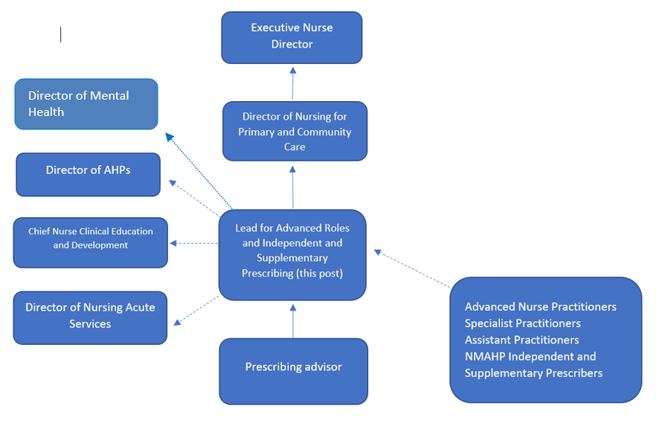
Advancing Roles and Prescribing Advisor
(this post)

5. ROLE OF DEPARTMENT
NHS Lothian has a responsibility to ensure that those employed in advanced, specialist and prescribing roles have the appropriate training and governance to support their clinical role and to deliver effective and efficient clinical services with the development of these roles.

Driven by national strategy and professional regulatory requirements, this role will support the Lead Nurse for Advancing Roles and NMAHP Prescribing, to provide robust governance processes and ensure that frameworks are in place and will provide a single system approach to strategy and policy for all aspects of advanced roles.

Provide visible leadership inclusive of direction and governance advice for service areas in relation to advancing roles and prescribing.

Provide prescriber and managers with high quality, timeous information, analysis, and advice to assist them to deliver effective prescribing management.

Provide Clinical Education to support evidence-based development of advancing roles and prescribing.

Support the Delivery of effective and efficient clinical services with the development of advancing roles and prescribing.

Provide up to date legislative and regulatory knowledge and information to inform governance advice.

6. KEY RESULT AREAS
- Provide highly specialist prescribing advice to a range of NMAHP healthcare professionals to ensure the safe and effective use of medicines. Apply specialist professional knowledge and judgement to analyse complex patient management and prescribing systems to optimise prescribing information and evidence to create reports and support and advise on best practice.

- Lead on the implementation of an agreed programme of audit and assurance in relation to medicines use and identify areas of risk and best practice. Work with clinical services to develop relevant improvement plans based on outcomes and findings.

- Responsible for identifying governance issues relating to NMAHP prescribing and ensuring that agreed standards and policies relating to prescribing governance are implemented and audited.

- To contribute to the development and implementation of policies and guidelines within NHS Lothian to support the governance and advancing roles, share best practice and to contribute to safe, patient centred practice.

- Provide a visible link with prescribing staff to improve and steam line prescribing practice by working with and supporting clinical teams, including GPs and Practice Managers to identify, plan and agree priorities on matters relating to advancing roles and non-medical prescribing.

- Build robust communication links and relationships with key clinicians and managers across primary and secondary care. Liaise and strengthen links with clinical services as well as establishing joint initiatives and opportunities to support the advancing roles and prescribing agenda

- Support NMAHP prescribing in clinical practice when required, in response to their learning needs in relation to prescribing and planning and updating therapeutic formularies.

- Support with the selection process of NHS Lothian NMAHP staff to undertake independent prescribing V300 module in collaboration with HEIs (Higher Education Institution), to ensure that all regulatory and organisational criteria are met.

- Coordinate and deliver CPD and information sessions relevant to role within NHS Lothian, linking in with clinical educational teams and HEIs where necessary.

- Where necessary support the investigation of NMAHP prescribing incidents across the organisation. Work with individual prescribers and wider clinical teams to formulate ongoing recommendations and action plans to ensure safe, cost effective and person-centred prescribing practice.

- Support the development and review of relevant organisational governance guidelines and frameworks, working closely with stakeholders and informed by the most up to date regulatory and legislative policy and guidance to ensure relevance to clinical practice.

- Maintain personal practice, knowledge and competence through continuing education, professional updating, and involvement in professional groups. Pro-actively identify own areas of personal development, in particular in relation to legislative and regulatory changes pertinent to role.

- Deputise for Lead Nurse at relevant local, regional and national meetings.

- Take part in research studies and activities to ensure that the wider advancing practice and prescribing agenda is research led, supporting best clinical practice and excellence. Promote and disseminate research evidence-based practice relevant to role.

- In collaboration with Education and Employee Development team, support the Lead Nurse to provide expert advice and support clinical services on the governance of advanced and prescribing roles and medicine management for registered and non-registered staff.

- To support NHS Lothian’s values of quality, teamwork, care and compassion, dignity and respect, and openness, honesty and responsibility through the application of appropriate behaviours and attitudes.

7a. EQUIPMENT AND MACHINERY
The following are examples of equipment which will be used when undertaking the role.

Required to use a PC and printer.
Presentation equipment.

In a training or clinical setting.
Beds – hydraulic/manual.
Clinical observation equipment and devices manual/electric.
Waste disposal system.
Moving and handling aids.
Infusion devices.

Note: New equipment may be introduced as the organisation and technology develops, however training will be provided.

7b. SYSTEMS
The following are examples of systems which will be used when undertaking the role:

Microsoft Office, i.e, Word, Excel and power point will be used regularly to analyse data and maintain register and database of prescribers and advanced practitioners, create reports for audit purposes and to present to a wide range of audiences at conferences or lectures.

Risk assessment and incident reporting systems.
TRAK – Patient administration systems.
PRISMS and HEPMA (Hospital Electronic Prescribing and Medicines Administration) – electronic prescribing systems to generate and analyse reports.
SWISS/Ees – workforce data systems.
Yellow Card reporting and MHRA medical Devices reporting.

Note: New systems may be introduced as the organisation and technology develops, however training will be provided.

8. ASSIGNMENT AND REVIEW OF WORK
Responsible to Lead Nurse for Advancing Roles and NMAHP Non-Medical Prescribing regarding professional management, work review and formal appraisal.

Projects and work streams will be agreed and delegated, but the post holder will be expected to work under their own initiative and organise workload to achieve results and in response to the demands of the service.

9. DECISIONS AND JUDGEMENTS
The post holder will have a high degree of autonomy in setting own workload, priorities and decision making and will make autonomous leadership and professional decisions daily.

Makes decisions in relation to application of policy and procedure to support, guide and direct staff
and services within area of responsibility. Policies and Frameworks would include: NHS Lothian
Independent and Supplementary Prescribing Framework, NHS Lothian Advancing Roles Policy, NHS Lothian Safe Use of Medicine Policy, NHS Lothian Advanced Nurse Practice Strategy, NHS Lothian HealthCare Support Worker Administration of Medicine Framework. The post holder would be expected to interpret and contextualise policies and procedures to support services with the governance of advanced and prescribing roles.

Recognising and addressing governance issues and areas of risk timeously, taking corrective action and continuously monitoring to ensure a positive outcome is achieved, for example, facilitating audit of prescribing activity for individuals or clinical teams and working with services to identify best practice and to support a programme of improvement where required.

10. MOST CHALLENGING/DIFFICULT PARTS OF THE JOB
Developing and maintaining working relationships across Lothian to influence best practice and change, regarding advancing roles and prescribing, and where they may be competing priorities and views.

Provide expert specialist advice to services which carries significant clinical risk and using professional judgement to analyse and find solutions when faced with highly complex issues, sometimes with a range of options.

Engaging and communicating effectively and accurately across boundaries to varied and often large groups of staff and to a wide range of stakeholders.

Maintaining an up to date and accurate knowledge of legislative and regulatory policy regarding prescribing and medicines management in order to provide expert advice and direction.

11. COMMUNICATIONS AND RELATIONSHIPS
In order to develop and maintain key stakeholder relationships, the post holder will be required to have a high level of verbal, non-verbal, written communication and presentation skills and use a range of communication techniques to members of the mutli- disciplinary teams across a variety of services in Lothian.
The post holder will be expected to be part of relevant professional groups with the ability to express professional views and to present formal presentations to senior management and external agencies such as HEIs.
Presenting and teaching to large groups including local education sessions and professional updates.

12. PHYSICAL, MENTAL, EMOTIONAL AND ENVIRONMENTAL DEMANDS OF THE JOB
Physical Skills and Effort:
Standard keyboard skills.
Working at a PC for extended periods.
Mental Effort:
Prolonged concentration required when analysing and interpreting prescribing data and to produce reports.

Post holder will be required to advise and support others to provide solutions to a wide range of advanced and prescribing issues. This workload can be unpredictable with competing demands, frequent interruptions, and the requirement to reprioritise at short notice.

Emotional Effort:
Regular exposure to concerns and anxieties from services and staff regarding prescribing and the and governance of these roles. The post holder will have to deal with multi professional issues and use tact and diplomacy to reach agreement on areas of dispute.
Occasional exposure to complex issues which can become emotive, for example when supporting incidents and the investigation of complaints or fitness to practice and regarding prescribing roles and supporting the staff and services involved.

Environmental Conditions:
Frequent requirement to travel across sites and locations 3-4 times a week.

Occasional risk of exposure to body fluids when supporting and advising staff in a clinical setting.
Occasional risk of exposure to physical and verbal aggression in clinical areas.

13. KNOWLEDGE, TRAINING AND EXPERIENCE REQUIRED TO DO THE JOB
Healthcare professional annotated to NMC or HCPC register.
V300 Independent and Prescribing Qualification (SCQF Level 11).
Quality improvement qualification, e.g., Scottish Improvement Leader Programme (ScIL) or significant experience in using quality improvement methodology and analysis of data.
Experience of project management.
Completion of Leadership Programme i.e. completion of Leading Better Care modules, Institute of Leadership and Management (ILM) or equivalent demonstratable experience.
Experience of development and delivery of education and teaching sessions.
Ability to demonstrate effective communication and time management skills.
IT skills.
Audit experience.
Evidence of problem-solving skills.

14. JOB DESCRIPTION AGREEMENT
A separate job description will need to be signed off by each job holder to whom the job description applies.  Job Holder’s Signature:  Head of Department Signature: | Date:  Date:

