FINAL DRAFT

**Scottish Ambulance Service   
Job Description**

**1. JOB IDENTIFICATION**

Job Title: Call Taker

Department(s): Emergency Medical Dispatch Centre –Edinburgh / Glasgow

Job Holder Reference: MLPR057

No of Job Holders: Multiple Post Holders

Job Description/ Agreed 28th November 05 1

FINAL DRAFT

|  |  |  |  |
| --- | --- | --- | --- |
| 1. **JOB PURPOSE**   **To provide the first link in patient care through the effective registration of emergency and urgent calls, maintaining Service Protocols and the appropriate use of pre-arrival advice and reassurance to the public, NHS stakeholders and the Emergency Services.** | | | |
| 1. **DIMENSIONS**   There are 3 Emergency Medical Dispatch Centres providing National coverage. Each EMDC covers 2 of the 6 autonomous Divisions (West = West Central/South West, East = South East/ East Central and North = North & West/ North East).  The role of each EMDC is as follows:-   * Receiving and prioritising calls in accordance with service protocols and key performance indicators (KPI’s) in order to ensure appropriate deployment of ambulance resources. * Provide, as appropriate, pre-arrival advice to callers thereby helping to provide optimum level of patient care. * Provide a centralised information and communication service both internally and externally in relation to all matters concerning emergency medical dispatch (i.e. first point of contact). * To communicate with the NHS at Major Incidents with mass patient evacuation. To facilitate contact between the public and other NHS resources via NHS 24. | | | |
|  | West EMDC | East EMDC | North EMDC |
| Staff | 7 x JO2, 54 ORA’s | 9 x JO2, 67 ORA’s | 7 x JO2, 38 ORA’s |
| No. of Calls | 30,000 | 25,000 | 20, 000 |
| No. of vehicles  responsible for  deploying | 250 | 146 | 108 |

Job Description/ Agreed 28th November 05 2

FINAL DRAFT

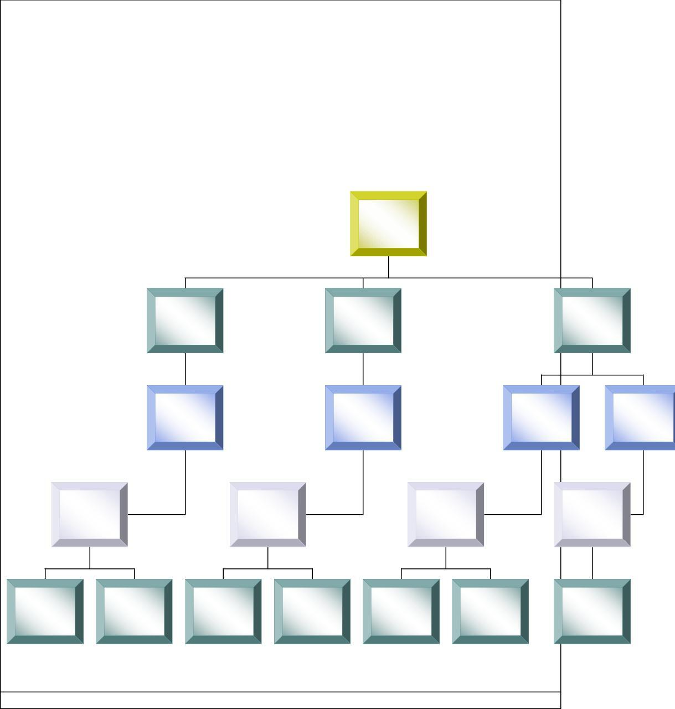

4. **ORGANISATIONAL POSITION**

Dispatcher

EMDC Supervisors

Call Taker

Head of Control   
Services   
North

EMDC Managers

Dispatcher

EMDC Supervisors

Call Taker

Head of Control   
Services   
West

EMDC Managers

Director of Operations

Dispatcher

EMDC Supervisors

Call Taker

EMDC Managers

Head of Control   
Services   
East

Air desk Dispatchers

Air desk Supervisors

Air Desk Manager

Job Description/ Agreed 28th November 05 3

FINAL DRAFT

5. MAIN TASKS, DUTIES AND RESPONSIBILITIES

1. Receiving and registration of Emergency and Urgent telephone calls from the general public, NHS stakeholders and the Emergency Services using AMPDS and CAD systems.
2. Provision of pre-arrival/post dispatch advice to callers using the AMPDS and CAD systems.
3. Operation of computer terminals utilising CAD, AMPDS and Windows systems and applications.
4. Operation of ACD telephone equipment.
5. Attendance at prescribed training courses and satisfactory achievement of appropriate skills and competencies.
6. Participation in Continued Development Education programmes to reinforce and expand skills and AMPDS re-accreditation requirements.
7. Participation in AMPDS AQUA quality assurance programme.
8. Maintenance of personal and corporate quality standards.
9. Liaison with Scottish Ambulance Service personnel, Operations Rooms, General Practitioners, NHS Health Boards/Trusts and the Emergency Services.
10. Participation in the development of a quality culture within the workplace, adhering to Service Protocols/SOPs and completing documentation accurately and appropriately.
11. Initiation of Major Incident procedures in accordance with Service protocols. Assists line manager(s) as required with risk assessment of tasks carried out and ensures that safe working practices are followed at all times in line with Service Policy and current legislation.
12. Ensures that any accidents, near misses or hazards are reported immediately to line manager using the Health & Safety Accident & Incident Reporting Form, the Vehicle Accident Report Form and/or REPD Incident Report Form as appropriate.
13. Undertaking such other reasonable and appropriate duties as may be allocated by the Duty Supervisor/Manager.

Job Description/ Agreed 28th November 05 4

FINAL DRAFT

**6 EQUIPMENT AND MACHINERY**

Telephone System - Meridian

Computer - Command and Control System C3 AMPDS protocol, Atlas Operations RTO,

MACU Systems

**7. SYSTEMS**

**CCS Call Taking including ProQA** – EMDC Emergency Call Taking System – used to record details for 999, Dr Urgent and Planned A&E incidents. Data sources include live emergency incoming calls from the public and other healthcare providers and faxed information from the NES Area Service Offices. In addition to processing calls, the ProQA software displays questions to be asked by the EMD. The recorded answers lead to call prioritisation and the display of pre-arrival instructions including telephone CPR advice. All users of the software must be qualified EMD’s.

**8 DECISIONS AND JUDGEMENTS**

Using the AMPDS and CAD systems the call taker must decide on the most appropriate pre-arrival/post dispatch advice to callers.

Call takers may have decide when a difficult, or problematic call should be referred to a more senior member of staff for assistance

Call takers must be able to use discretion when dealing with particularly difficult or sensitive situations

Job Description/ Agreed 28th November 05 5

FINAL DRAFT

9 **COMMUNICATIONS AND RELATIONSHIPS**

General Public

Scottish Ambulance Service Personnel and Managers

NHS Health Boards

General Practitioners

Emergency Services

As first point of patient contact, receives and communicates sensitive information on a high frequency.

There are often barriers to communication as the caller may be distressed, seriously unwell, be disabled or may not be able to speak English either clearly or fluently.

Call takers as the first point of patient care must be able to persuade callers to follow the appropriate pre-arrival advice until the ambulance crew take over.

10**. PHYSICAL, MENTAL AND EMOTIONAL DEMANDS OF THE JOB**

Physical Skills – fast and accurate keyboard skills

Physical Effort – Sitting for prolonged periods of time in restricted position, as job requires postholder to be keyboard, attached to headset for most of the duration of the shift.

Mental and Emotional Effort – Dealing with the public at point of contact in often very extreme and difficult circumstances on a very frequent basis can be highly stressful. Levels of concentration must be high in order to receive and give appropriate advice as accuracy is essential.

- Using ProQA call takers are involved in giving basic life support over the phone

which can often be difficult and highly stressful.

- Throughout any given shift the call taker will have to deal with a frequent   
number of emotional situations which can be emotional for the post holder too.

- Using computer software which may occasionally produce errors can be   
frustrating

Job Description/ Agreed 28th November 05 6

FINAL DRAFT

1. **MOST CHALLENGING/DIFFICULT PARTS OF THE JOB** The nature of the work is largely unpredictable making it a very challenging role.

As first point of contact for the public, the post holder must be able to respond well to pressure in dealing with emergency type calls which are of high volume and are difficult in nature.

Maintaining high standards of personal and corporate quality standards for audit purposes.

1. **KNOWLEDGE, TRAINING AND EXPERIENCE REQUIRED TO DO THE JOB** ESSSENTIAL
2. Ability to operate IT equipment.
3. No formal educational qualifications are required but candidates must pass entrance tests and annual/bi-annual re-accreditation of skills/knowledge.
4. Must have a minimum typing speed of 35 w.p.m. with a high level of accuracy.
5. Able to use Windows based applications.
6. Must have an ability to problem solve and make decisions.
7. Must be able to communicate clearly and effectively and have good listening skills.
8. Works well under pressure.
9. Clear Disclosure Scotland check.
10. Resides within a reasonable travelling distance from place of work.

Job Description/ Agreed 28th November 05 7

FINAL DRAFT

10.Ability to work shifts.

DESIRABLE

1. Should be able to function within the confines of an operations room.
2. To have 3 Standard grades or equivalent – English, Numerical and Biology
3. To hold recognised IT qualification.
4. To have had previous or current employment in a similar environment utilising telephone or radio equipment would be beneficial.
5. Customer care experience would be an advantage.
6. Recognised First Aid Certificate or experience.

|  |  |
| --- | --- |
| **13. JOB DESCRIPTION AGREEMENT**  Job Holder’s Signature:  Head of Department Signature: | Date: Date: |

Job Description/ Agreed 28th November 05 8