

**JOB DESCRIPTION**

|  |
| --- |
| **1. JOB DETAILS**  Job Title: Senior Project Manager – Medical Education  Responsible to (insert job title): Medical Education Manager  Department(s): Medical Education  Directorate: Medical Directors Directorate  Job Reference:  No of Job Holders: 1  Last Update (insert date): 25th January 2024 |

|  |
| --- |
| **2. JOB PURPOSE** |
| The Senior Project Manager(s) will support the Medical Education Team to deliver improvement and change projects utilising project management and improvement methodologies in NHS Fife.  The post holder will manage projects in line with the prioritised corporate objectives and lead collaborative change with key stakeholders to meet the set objectives.  To ensure that all projects are planned, controlled and that progress is made in line with agreed plans. To motivate and direct associated work within and outwith Medical Education  To deliver the required project objectives and service changes to agreed standard and specification. |

|  |  |
| --- | --- |
| **3. DIMENSIONS** |  |
| * ~4000 undergraduate placements * 3 University Medical Schools (St Andrews, Edinburgh, Dundee and the postgraduate entry degree ScotGEM) * Development of new medical programme ScotCOM * 30 medical and surgical specialties * 42 consultant lead tutors * 150 consultants involved in undergraduate teaching | |

|  |
| --- |
| **4. ORGANISATION CHART** |

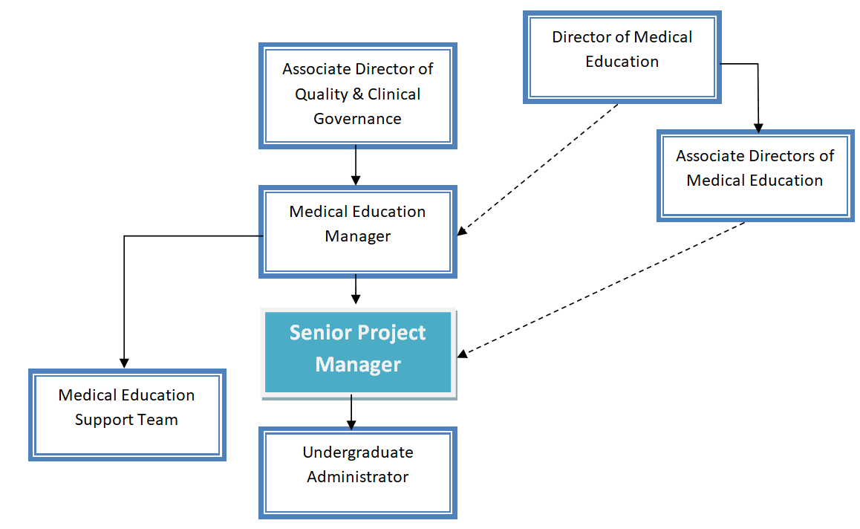

|  |
| --- |
| **5. ROLE OF THE DEPARTMENT** |
| The team coordinates the delivery of medical education within NHS Fife for over 800 medical students and around 220 postgraduate doctors in training. Partnership working with the universities of Edinburgh, St Andrews, Dundee and Aberdeen is a key activity. The annual rotation of doctors in training is also a significant management exercise, undertaken in partnership with the local HR, and NHS Education Scotland.    Medical Education also undertakes rota design and New Deal Contract monitoring. It also manages the delivery of the core teaching programmes of Foundation doctors and GP trainees.    Medical Education partners with SEFCE (the South East Scotland Faculty of Clinical Educators) so help NHS Fife Education Supervisors and Clinical Supervisors to gain GMC recognition and approval.    The department manages two education centres that provide space through which medical education is delivered by clinicians. VHK is the primary centre with QMH used for regional and national events and NHS Fife events requiring half and whole day bookings.  The department has a dedicated clinical skills team to support training of students and doctors in VHK and QMH. This service has recently been expanded with the opening of Fife Simulation Training Centre. |

|  |
| --- |
| **6. KEY RESULT AREAS** |
| 1. The post holder is responsible for the day to day management and planning of their assigned priority project(s) and other ad hoc projects. This responsibility includes the monitoring of achievement against plans, resource planning, scheduling; ensuring robust control and reporting mechanisms and monitoring to assure adherence to project plans and objectives across multiple departments. The post holder will proactively assess issues and risks, facilitate the recommended course of action or escalate to the Medical Education Manager. 2. The post holder is responsible to ensure the delivery of resourced work meeting the requirements of the project leads, Medical Education and other appropriate health and social care stakeholders. 3. To develop and manage quality criteria and processes including outcome indicators to which the projects outputs are measured and considered to be fit for purpose. 4. The post holder is responsible for ensuring the project is aligned with the strategic objectives of NHS Fife and Fife Health and Social Care Partnership. 5. The post holder is responsible to provide direction, support and motivation to the wider teams as required including advice on improvement and project methodology and project strategy; across a wide multi-disciplinary team of operational managers and senior clinicians to assure achievement of project objectives that meet project quality standards. 6. To utilise project staff as appropriate in supporting project work. To liaise with other senior managers, trainers and clinical coordinators to meet the training needs of all staff as appropriate. 7. To communicate effectively with the project leads, , senior Medical Education staff and stakeholder groups to ensure awareness of progress, issues and risks and develop and maintain a project communication plan for all stakeholders. |

|  |
| --- |
| **7. ASSIGNMENT AND REVIEW OF WORK and DECISIONS AND JUDGEMENTS** |
| The post holder generally works within a defined plan although it is sometimes necessary to prioritise their own and the teams work in order to meet deadlines.  Project Issues – technical, procedural, organisational, operational, quality and service issues are assessed by the post holder who will recommend a course of action, escalate when needed or where possible resolve.  Project Risks – assessment and entry into the risk log with suggested actions and risk weighting, escalation to the Medical Education Manager when required. |

|  |
| --- |
| **8. COMMUNICATIONS AND RELATIONSHIPS** |
| * The post holder is required to motivate, support and inform the project team & stakeholders on a regular basis. This information may include a diverse range of complicated issues affecting multiple teams. * The post holder will present complex information to the project teams and sensitively discuss, persuade and negotiate organisational issues affecting working practises within the environment to gain stakeholder buy-in. * The post holder is required to liaise with the project leads, Portfolio Lead and Manager(s) to communicate and resolve complex project and operational issues. * Strategic direction of the project is given by the project leads, Medical Education Manager and A/DMEs. * Regular contact with the key stakeholders and project leads. This includes detailed project planning; resolution of issues, contractual discussions and risk management. These topics may require a degree of negotiation and persuasion over issues that are potentially contentious. |

|  |
| --- |
| **9.MOST CHALLENGING PARTS OF THE JOB**  The post holder will have to analyse complex, interdependent plans, issues and risks.  The post holder must be able to manage diverse and at times contentious organisational issues.  The post holder must be able to manage conflicting priorities of the clinical staff, project plans and strategic priorities.  The post holder will have to successfully manage the project while working with organisational constraints.  The work is dynamic and therefore the post holder must be able to deal with constant change. |

|  |
| --- |
| **10. SYSTEMS** |
| Frequent use of a PC/laptop for generating information and reports, communicating via email, maintaining an electronic diary, and use of internet/intranet.IT systems and software packages extensively used and may include:  * **MS Office**   The post holder will be expected to be competent on the MS Office suite of programs   * **Other systems used in NHS Fife**   The post holder will use any other system used in NHS Fife including, eExpenses, NHS Mail, etc. |

|  |
| --- |
| **11. PHYSICAL, MENTAL, EMOTIONAL EFFORT** |
| PHYSICAL EFFORT  * Regular detailed and complex planning and resource analysis requiring long periods of concentration. * Multi-tasking of equal priority issues, covering diverse subjects and departments on a daily basis. * Frequent interruptions. * Continually working to deadlines to meet delivery. * Managing conflict from contentious organisational issues. * Role ambiguity between detailed work and strategic planning. * Long periods of static sitting during meetings and working at the PC. Using a keyboard and mouse * High percentage of work undertaken in office conditions. * Occasional driving.  MENTAL EFFORT/EMOTIONAL EFFORT The ability to think on one’s feet and offer support, either by email, face to face or telephone to a range of stakeholders on a host of Project and Programme queries and issues. Attendance at frequently scheduled meetings is common. There is a need for periods of concentration working on project plans and attending project meeting. This is sometimes very difficult due to regular interruptions such as dealing with project issues. The location of some meetings requires travel.  Attention to detail is important as reporting will be through project escalation as defined.  Exposure to distressing or emotional circumstances is rare. However due to the nature and demands of the project, the jobholder may find that at certain times demands placed on them within tight timescales could cause a degree of pressure.  The post holder will require excellent planning and organisational skills to maintain the appropriate work/life balance. |

|  |
| --- |
| **12. ENVIRONMENTAL/WORKING CONDITIONS & MACHINERY AND EQUIPMENT** |
| Standard Office conditions: Regular requirement to use laptop/PC  Some travel throughout Fife may be required. |

|  |  |
| --- | --- |
| **13. KNOWLEDGE, TRAINING AND EXPERIENCE REQUIRED TO DO THE JOB**   * Educated to degree level or equivalent experience * Relevant experience of managing complex projects preferable. * Evidence of relevant continued professional development. * Broad understanding of complex systems. * Excellent communication skills to convey concepts to technical and non-technical users. * Influencing and negotiation. * Ability to prioritise and work to tight deadlines. * Leadership skills * Commitment to updating skills and life-long learning. * Change Management skills * Ability to travel throughout the local area and attend meetings throughout Scotland. * Good working knowledge of Microsoft office packages   “Mandatory Induction Standards and Code of Conduct for Healthcare Support Workers – NHS Circular CEL(2010)23  Your performance must comply with the “Mandatory Inductions Standards for Health Care Support Workers in Scotland” 2009; and with the Code of Conduct for Health Care Support Workers, both as amended from time to time, which will be issued with your contract (further copies can be obtained from Human Resources). Failure to adhere to the Standards or to comply with the code may result in poor performance measures or disciplinary action and could lead to dismissal; or if you are self-employed, such failure will be deemed to be a breach of an essential term of your contract, allowing us to terminate with or without notice." | |
| **14. JOB DESCRIPTION AGREEMENT** |  | |
| Job Holder’s Signature: | Date: | |

PERSON SPECIFICATION

**JOB TITLE: SENIOR PROJECT MANAGER GRADE: Band 7**

|  |  |
| --- | --- |
| **ESSENTIAL** | **DESIRABLE** |
| Qualifications Educated to degree level or equivalent experience  Relevant experience of managing complex projects. | Management qualification or equivalent experience at senior level. |
| Skills Excellent planning, organising and prioritising skills.  Strong motivational, influencing and negotiating skills.  Ability to interpret local and national strategic documents  Be able to analyse complex data and design data systems  Competent IT skills, particularly in the use of spreadsheets and databases.  Ability to present and explain numerical data and project plans.  Excellent oral and written skills. | Knowledge and applied understanding of the context and challenges of leaders in the NHS. |
| Experience & Knowledge Experience in the delivery of complex projects  Knowledge of the principles of change  Experience and knowledge of health service delivery  Experience of engaging and working effectively with colleagues of all disciplines across the NHS.  Ability to identify and assess project risks and develop actions to mitigate them. | Knowledge of service improvement tools and techniques  Experience of staff management.  An understanding of the principles of Realistic Medicine |
| Personal Characteristics Ability to meet deadlines, prioritise multiple strands of work and work under pressure.  Diplomatic and able to engage with people in a positive way.  Adaptable, flexible and innovative approach to work.  Committed, driven and able to display tenacity to overcome challenges.  Personal insight to strengths of self and team  Self motivation and ability to motivate others  Demonstrate ethics, values and personal qualities / behaviours consistent with the vision, culture and values of NHS Fife. |  |