

**Working for NHS Lanarkshire**

**Clinical Fellow – General Medicine**

**NHS Lanarkshire**

**Recruitment Pack**

**Application Closing Date: Thursday 4th July 2024**

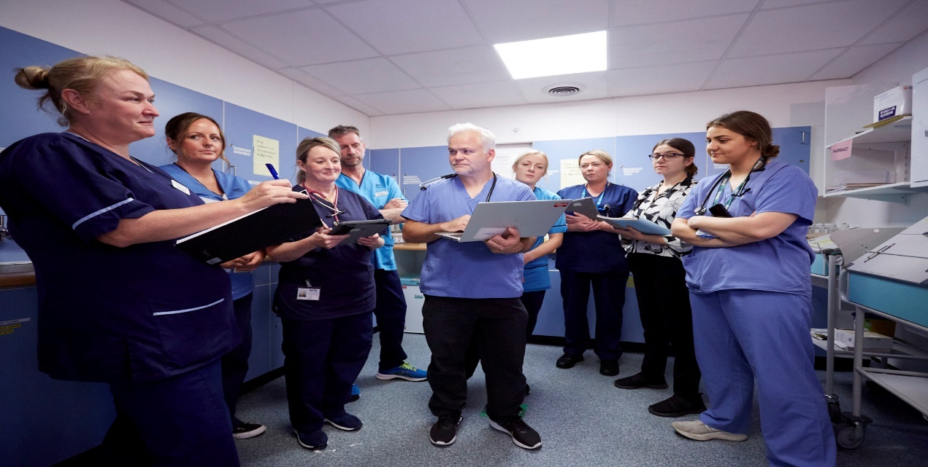

HR Medical & Dental

Law House

Airdrie Road

Carluke

ML8 5EP





|  |
| --- |
| **Contents** |

|  |  |  |
| --- | --- | --- |
| **Section** |  | **Page** |
| Section 1: | How to Apply | 3 |
| Section 2: | Contact Information | 4 |
| Section 3: | Person Specification | 5 |
| Section 4: | The Post | 6 |
| Section 6: | Working for Lanarkshire | 6 |
| Section 7: | Terms and Conditions of Employment | 7 |

|  |
| --- |
| **This post requires the post holder to have a PVG Scheme membership/record. If the successful applicant is not a current PVG member for the required regulatory group i.e. child and/or adult, then an application will need to be made to Disclosure Scotland and deemed satisfactory before the successful post holder can commence work.** |

|  |
| --- |
| **Section 1: HOW TO APPLY** |

**In order to apply:**

Applicants are required to complete an Application Form via the following link: https://apply.jobs.scot.nhs.uk/vacancies.aspx. Please note that you can upload your CV, however this will only be used to pre-populate part of the application form. CV`s are **not** accepted instead of a completed Application Form. Your CV **will not** be visible to the panel.

**Please complete applications by MIDNIGHT ON THE CLOSING DATE.**

**You will receive an email acknowledging receipt of your application once submitted.**

To find out more about the role and our recruitment process please visit NHS Scotland Recruitment Portal

Recruitment | NHS Lanarkshire (scot.nhs.uk)

**Application Process:**

The first part of the process is to complete the gateway questions applicable to the role you are applying for. Should you meet the requirements of the gateway questions you will then have the opportunity to complete the full application form, which asks you to complete your top three preferences of location and specialty.

**It is important that you demonstrate you meet the eligibility criteria detailed in the person specification on your application.**

**Shortlisting Process:**

**Stage 1**

Applications will be longlisted in line with the person specification for the job. If you are successful, you will receive an email from Jobtrain advising you have been successful. Successful candidates from longlisting will be emailed a Clinical Situation and asked to provide feedback on this in the form of a one page document. If you are successful after this stage you will receive an invite to interview email.

**Stage 2**

Interview and Competency Assessment.

|  |
| --- |
| **Section 2: Contact Information** |

**Programme / Post Queries**

Prospective applicants are encouraged to make contact with:

Dr F Farquhar

Consultant / Clinical Director

(Email: fiona.farquhar@lanarkshire.scot.nhs.uk)

Dr Catie Sykes

Consultant/Rota-Ordinator

(Email: Catriona.sykes@lanarkshire.scot.nhs.uk)

Dr I Howat

Consultant

(Email: Isabel.howat@lanarkshire.scot.nhs.uk)

**Application Queries**

If you have any queries regarding the application process please email Gill Swinburne at medical.dentalrecruitment@lanarkshire.scot.nhs.uk

**NHS Lanarkshire is committed to working towards equal opportunities for all.**

|  |
| --- |
| **Section 3: Person Specification** |

|  |  |  |  |
| --- | --- | --- | --- |
| **PERSON PROFILE – Clinical Fellow: General Medicine** | | | |
| Attributes | **Essential** | | **Useful** |
| Qualifications | MBchB or equivalent  Successful completion of UK Foundation Programme **OR CREST FORM** | |  |
| Training | At least six months’ general medicine with exposure to acute medical problems  In-patient management of medical patients. | | 1 year or more post registration training, particularly in medicine for the elderly or primary care. |
| Experience | In-patient management of medical patients  Eligible for full registration with the GMC at time of application and hold a current licence to practice * (\***Overseas Registration and Qualifications -**  NHS Lanarkshire will check you have the necessary professional registration and qualifications for this role. You will need to provide an official translation of qualifications notarized by a solicitor of your overseas qualifications to be checked by the recruiting panel. Please ensure that this is available before applying for the post. | | Out Patient experience |
| Personal Skills | * Able to work effectively under pressure * Able to remain objective in stressful situations * Adaptable to changing situations and able to recognise when a situation is changing * Sound decision making * Awareness of own limitations and when to seek help * Able to communicate effectively with others * Able to manage time effectively * Caring personality * Able to work well within a team structure * Able to organise and prioritise well. | | * Advanced procedural experience * Experience of supervising junior staff |
| If there is any reason why a disabled person should not be considered suitable for this post, please provide details: | | The post requires physical dexterity. Uncorrected visual or hearing defect would be incompatible with the nature of the work. | |

|  |
| --- |
| **Section 4: The Post** |

We are looking for a Clinical Fellow to join our team in the Department of General Medicine. The post would be ideal for someone who has completed foundation training and who is looking for more experience prior to applying for specialty training

The post is based at University Hospital Monklands in Airdrie. University Hospital Monklands is a busy general hospital with over 400 inpatient beds. It is situated in the west of Scotland within commuting distance of both Edinburgh and Glasgow.

We are a friendly department with a wide range of medical specialties on site including the regional renal and infectious diseases unit.

The appointee will be assigned a clinical/educational supervisor and a Personal Development Plan will be agreed based on their previous experience and educational needs. They will meet their supervisor regularly throughout so they can provide support in meeting their PDP goals.

Day to day work will involve reviewing in-patients and progressing with their investigation and management, performing necessary procedures, liaising with family and communicating with primary care.

The appointee will also take part in the acute medical receiving rota, reviewing newly admitted patients. There is a full shift out-of-hours component to the rota, with evening, night-shift and weekend cover. There is appropriate senior supervision at all times.

The hospital runs an educational program with both hospital wide and general medicine specific education sessions. There is also opportunity to take part in clinical audit and quality improvement projects.

**Out of hours (OOH)**

For candidates who have trained out with the UK, joining the out of hours rota will be following a successful completion of the extended Soft Landing Induction. (The Soft Landing induction is a period of shadowing and integration for those at the start of their post so that they have efficient time to acclimitise to the working environment.

|  |
| --- |
| **Section 5: Working for NHS Lanarkshire** |

For more information on the role please visit **NHS Lanarkshire Careers Website**

|  |
| --- |
| **Section 6: Terms and Conditions of Employment** |

|  |  |
| --- | --- |
| **TYPE OF CONTRACT** | Fixed Term (12 months) |
| **GRADE AND SALARY** | Clinical Fellow  £40,995 to £64,461 per annum (pro rata) |
| **HOURS OF WORK** | Full Time |
| **SUPERANNUATION** | New entrants to NHS Lanarkshire who are aged sixteen but under seventy five will be enrolled automatically into membership of the NHS Pension Scheme. Should you choose to "opt out" arrangements can be made to do this via: www.sppa.gov.uk |
| **REMOVAL EXPENSES** | Assistance with removal and associated expenses may be awarded |
| **EXPENSES OF CANDIDATES FOR APPOINTMENT** | NHS candidates who are requested to attend an interview will be given assistance with appropriate travelling expenses. Re-imbursement shall not normally be made to employees who withdraw their application, refuse an offer of appointment. Non NHS employees are not normally awarded travel expenses. |
| **DISCLOSURE SCOTLAND** | This post is considered to be in the category of “Regulated Work” and therefore requires a Disclosure Scotland Protection of Vulnerable Groups Scheme (PVG) Membership. |
| **CONFIRMATION OF ELIGIBILITY TO WORK IN THE UK** | NHS Lanarkshire are required to check the entitlement to work in the UK of all prospective employees, regardless of nationality or job category. UK Visas & Immigration rules are available at www.bia.homeoffice.gov.uk. Prospective applicants are encouraged to check eligibility in advance of applying for vacancies in NHS Lanarkshire. |
| **MEDICAL NEGLIGENCE** | In terms of NHS Circular 1989 (PCS) 32 dealing with Medical Negligence the Health Board does not require you to subscribe to a Medical Defence Organisation. Health Board indemnity will cover only Health Board responsibilities. It may, however, be in your interest to subscribe to a defence organisation in order to ensure you are covered for any work, which does not fall within the scope of the indemnity scheme. |
| **NOTICE** | Employment is subject to one month notice on either side. |
| **PRINCIPAL BASE OF WORK** | You may be required to work at any of NHS Lanarkshire sites as part of your role. Your base will be clarified for expenses purposes. |
| **REFERENCES** | All jobs are only offered subject to receiving two satisfactory references. At least one reference must be from your current/most recent employer or your course tutor if you are currently a student. If you have not been employed or have been out of employment for a considerable period of time, you may give the name of someone who knows you well enough to confirm information given and to comment on your ability to do the job. |