JOB DESCRIPTION

JOB IDENTIFICATION
Job Title: Risk Management Support Assistant
Responsible to: Senior Risk Management Advisor
Department: Risk Management Team
Directorate: Medical Directorate
Job Reference:
No of Job Holders: 4
Last Update: March 2022

2. JOB PURPOSE
The Risk Management Support Assistant post is located within the Risk Management Department. The Department supports services, across NHS Ayrshire & Arran in the delivery of safe, effective and person centred care.

The postholder works very closely with the Risk Advisors, supporting them by maintaining the quality and content of data held within information systems, support analytical work, input and process information in accordance with procedures, respond to enquiries; and provide administrative and secretarial support to the team. There will be the need to ensure cover across the department at times which will involve linking to the other teams within the department.

3. DIMENSIONS
NHS Ayrshire & Arran serves a population of approximately 376,000 people and employs around 11000 staff. The Board provides a full range of primary and secondary clinical services covering the mainland of Ayrshire and the islands of Arran and Cumbrae and three Local Authority areas i.e. North, South and East Ayrshire.
The post holder is part of the Risk Management Team, which sits within the Medical Directorate.
The Team provides risk management support across all of NHS Ayrshire & Arran.
There are no line management or budgetary responsibilities aligned to this post.

4. ORGANISATIONAL POSITION

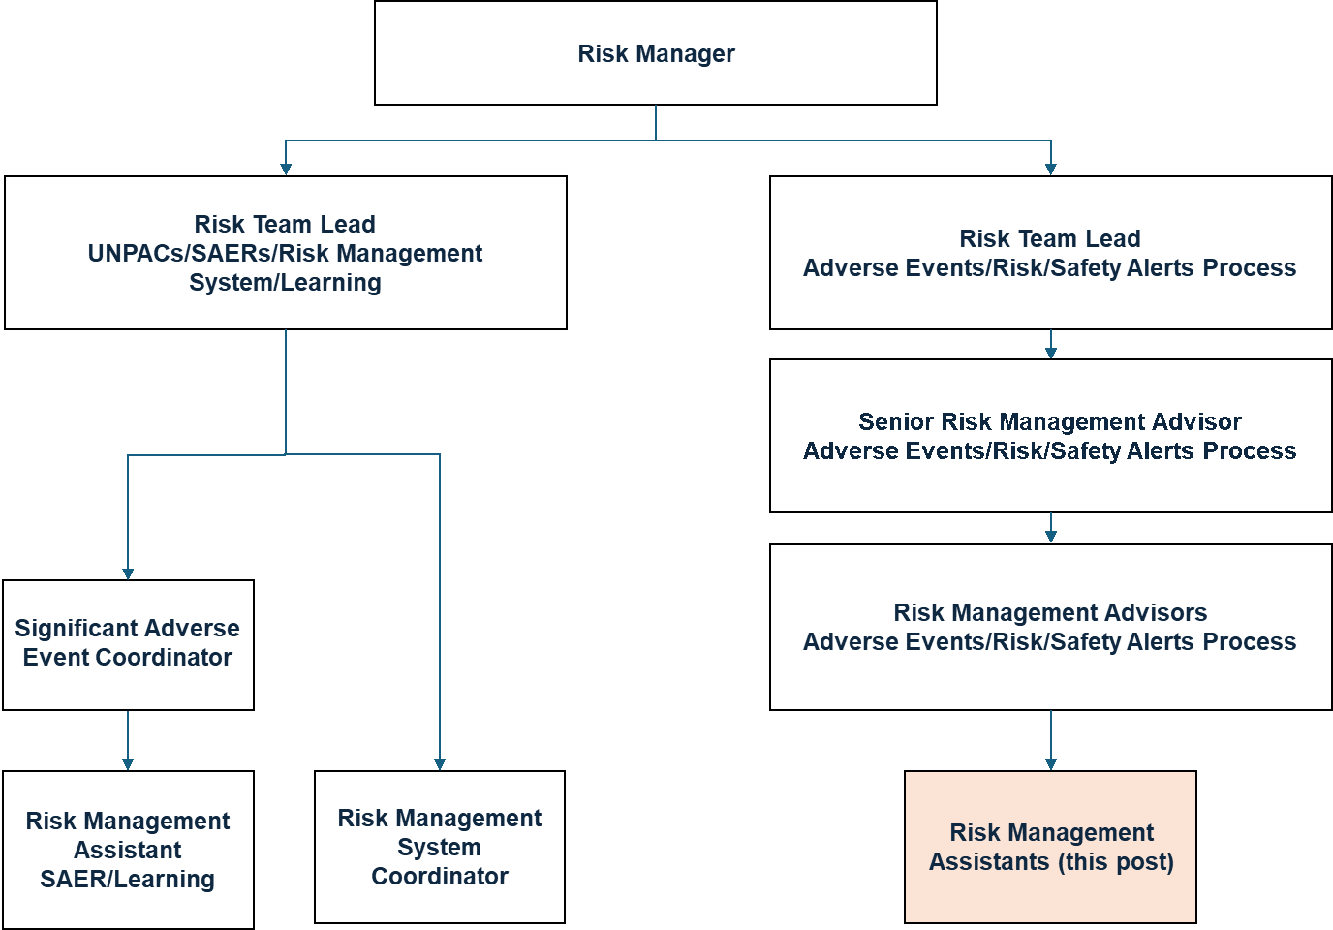

5. ROLE OF DEPARTMENT
As a key governance function the role of the Risk Management Department is to embed risk management processes wherever possible into the organisation’s existing philosophy, practices and business processes to deliver quality improvement in relation to patient and staff safety and organisation learning.

To lead the Board’s risk management function, working with Directors to ensure comprehensive, integrated and effective risk management processes within the Board and to ensure that adverse events and risks are appropriately identified, mitigated and reported on an ongoing, real time basis.

6. KEY RESULT AREAS
Information and Communication
- Provide initial point of contact for queries, issues and requests regarding the daily use of the Risk Management (DATIX) System within the organisation maintaining and promoting a responsible approach to confidentiality;
- Inputting, extracting and analysing data and information from the DATIX system, to produce reports in different formats for staff across the organisation, as well as for use in governance reports for Board-level committees and groups;
- Monitor organisational communications for relevant impacts on the Risk Management (Datix) System and alert Senior Risk Management Advisor / Risk Management Advisor;
- Work within organisational and professional policies and procedures, to create and maintain Standard Operating Procedures for the department;
- Implements departmental policies within own work area, proposes changes to working practices as a result of new guidelines, legislation or improvement changes;
- Gathering of information to support the production of responses to Freedom of Information requests and other statistical/quality/performance reporting;
- Organise and maintain knowledge and information resources contained in the Risk Management (DATIX) System, intranet pages and documents;
- Distribution and management of all Safety Action Notices received including reviewing quality of responses for Directorates, ensuring receipt of responses in accordance with the organisations Safety Action Notice policy;
- Distribution and management of all Organisational Learning Summaries in accordance with the organisations Learning Summary Guidance;
- To establish and maintain effective systems of documentation management which complies with the Corporate Records Management Policy;
- Support the coordination and administration of all requests for Unplanned Activity (UNPAC) funding. Assess and determine appropriate course of action, including gathering appropriate information, seeking expert clinical and financial advice, as necessary. Provide advice and expertise on these matters to patients, individual clinical practitioners, ensuring they have robust, co-ordinated and integrated information to inform decision making to provide the best possible outcome for the patient;
- Develop, adapt and maintain UNPAC information systems for the safe storage of information pertaining to UNPAC work which is patient identifiable and containing potentially sensitive clinical information;
- To provide administrative support to ensure effective and efficient management of all organisation-wide significant adverse events (SAE). This will include communicating with team members, arranging meetings, recording and preparing action notes detailing decisions made and follow up actions required, timely submission of reports, action plans and learning summaries including updating the SAE Review tracker;
- To establish and maintain effective systems of documentation management for all significant adverse events to ensure information held is readily accessible to support the function’s work in an expeditious way and which complies with the Records Management Policy
System Support
- Assist in the design of document templates, forms, queries, reports, Risk Management (DATIX) system improvements and upgrades;
- Within defined parameters, contribute to improving quality of the data within the system by:
  - Monitoring adverse event reports for accuracy and pro-actively amend records where necessary
  - Monitoring adverse event reports to ensure serious adverse events are included in the escalation process
  - Cleanse data as directed to ensure accuracy and integrity of records and maintenance of security
  - Updating adverse event reports, as instructed by Risk Management staff
- Maintain Risk Management (DATIX) System user accounts, including addition, amendment and removal in line with policy.

Training
- Developing and delivering training sessions to key stakeholders across the organisation, in relation to DATIX admin training for staff and Adverse Event Reviewer/Final Approver training;
- Provide advice and support to all staff regarding navigation and use of all modules to support accurate and appropriate data entry;
- Co-ordinate training schedules;
- Develop own skills and knowledge and provide information to others to help their development.

7a. EQUIPMENT AND MACHINERY
The post holder is required to have a high degree of knowledge of various office equipment:
- Photocopier
- Scanner
- Printers
- Ability to set up multimedia equipment for meetings
7b. SYSTEMS
The post holder is required to have a high degree of computer literacy.
- Advanced knowledge of Microsoft Excel required to undertake statistical analysis
- Confident user of Microsoft Word, Excel, Access and Powerpoint
- Internet and Intranet including developing and maintaining web pages;
- Experience of NHS Information Systems
- Knowledge of Microsoft Office 365 programs
- Knowledge in Risk Management systems, in particular DATIX.
- Ability to communicate and work with wide range of other professionals in the Health Service.
- NHS Ayrshire & Arran intranet (AthenA)

8. ASSIGNMENT AND REVIEW OF WORK
The post holder will be allocated work by the Senior Risk Management Advisor and the Risk Advisors and be directed by the organisation’s Risk Management Strategy.
Annual objectives will be agreed and formally reviewed, and work will be reviewed on an informal basis at regular intervals throughout the year.

9. DECISIONS AND JUDGEMENTS
- The post holder is required to work on their own initiative within the context of agreed objectives;
- Works within organisational and professional policies and procedures; seeks advice as necessary, operates on own initiative and taking advice from manager, as required
- The post holder must be able to balance priorities and manage the complexities/diversities of the job and competing demands within tight timescales whilst driving forward initiatives;
- The post holder will be expected to use their experience and knowledge, using own initiative to identify and address potential problems and challenges before and as they arise;
- Demonstrate a high degree of discretion with handling highly confidential health information
- Plan and prioritise own workload, as appropriate, prioritising unpredictable and conflicting demands

10. MOST CHALLENGING/DIFFICULT PARTS OF THE JOB
- Maintaining commitment and positive professional relationships in an fast paced changing environment;
- Unpredictability of workload and managing conflicting priorities
- Communicating, influencing and collaborating with a diverse range of colleagues, partners, patients and the public.

11. COMMUNICATIONS AND RELATIONSHIPS
In support of our core purpose of Working together to achieve the healthiest life possible for everyone in Ayrshire and Arran we are committed to a culture that is Caring Safe and Respectful. The post holder is required to work collaboratively in a safe, caring and respectful way.

Excellent communication skills, both verbal and written, with the ability to communicate confidently and effectively at all levels, both internal and external to organisation;

Communication is verbal, e.g. face to face and over the telephone, written and through a variety of meetings, groups, committees, training, presentations and other interactions;

Liaison with:
All wards and departments within clinical boards and support services – all levels of staff including managers
IM&T – IT services, service desk
Other NHS Boards
External IT contractors
Healthcare partners

12. PHYSICAL, MENTAL, EMOTIONAL AND ENVIRONMENTAL DEMANDS OF THE JOB
Physical Demands
- Use of keyboard and VDU for majority of working day, paying particular attention to speed and accuracy.
- Manual Handling of office sundries.

Mental Demands
- Frequent periods of prolonged concentration due to the varied and unpredictable work pattern;
- Workload is subject to a high degree of unpredictability and work will need to be adjusted accordingly.

Emotional Demands
- Management of complex and sensitive information requires to be delivered in a tactful and diplomatic way.
- Requirement to manage staff demands and expectations which may require negotiation.

13. KNOWLEDGE, TRAINING AND EXPERIENCE REQUIRED TO DO THE JOB
Must have previous experience of working in a busy office.

Must be competent in Microsoft Word and Excel and some knowledge of databases, would be an advantage.

Good communication skills, have a good level of literacy, a flexible attitude, be able to work under pressure, in addition to having a tactful, diplomatic telephone manner.

Qualifications & Experience
Essential
- HND or equivalent in a relevant subject
- Have previous experience of working in a busy office
- Evidence of applying risk management principles and continuous professional development
- Have experience of developing training sessions and ideally delivering them, in a related/similar field
- Knowledge and up to date understanding of IM&T systems and in depth knowledge of word processing, data management, analytical and presentation IM&T packages
- Competent in the use of Microsoft Office software
- Good knowledge and skill using MS Excel is required for the production of accurate reports
- Good communication and interpersonal skills
- Team working ability
- Able to be flexible in accommodating unpredictable workload
- Able to work under pressure
- Willingness to undergo further training as required for the post

Desirable
- Risk Management qualification
- Experience in working in the NHS
- Knowledge compiling stats/audit/survey methodology
- Knowledge and experience in research methods and results with the ability to interpret and present complex data and information

14. JOB DESCRIPTION AGREEMENT
A separate job description will need to be signed off by each jobholder to whom the job description applies.  Job Holder’s Signature  Head of Department Signature: | Date:  Date:

